Notes
Output Created |  | 02-NOV-2026 12:12:16
Comments
Input | Data | C:\Users\aSUS\Downloads\Statics\FilteredData.sav
Input | Active Dataset | DataSet3
Input | Filter | <none>
Input | Weight | <none>
Input | Split File | <none>
Input | N of Rows in Working Data File | 11933
Missing Value Handling | Definition of Missing | User-defined missing values are treated as missing.
Missing Value Handling | Cases Used | Statistics are based on all cases with valid data.
Syntax |  | FREQUENCIES VARIABLES=DMDEDUC2  /ORDER=ANALYSIS.
Resources | Processor Time | 00:00:00.02
Resources | Elapsed Time | 00:00:00.01

Notes
Output Created |  | 02-NOV-2026 12:13:34
Comments
Input | Data | C:\Users\aSUS\Downloads\Statics\FilteredData.sav
Input | Active Dataset | DataSet3
Input | Filter | <none>
Input | Weight | <none>
Input | Split File | <none>
Input | N of Rows in Working Data File | 11933
Missing Value Handling | Definition of Missing | User defined missing values are treated as missing.
Missing Value Handling | Cases Used | All non-missing data are used.
Syntax |  | DESCRIPTIVES VARIABLES=DMDEDUC2  /STATISTICS=MEAN STDDEV MIN MAX.
Resources | Processor Time | 00:00:00.02
Resources | Elapsed Time | 00:00:00.01

FREQUENCIES VARIABLES=DMDEDUC2
/ORDER=ANALYSIS.

Frequencies

Notes
Output Created |  | 02-NOV-2026 12:13:52
Comments
Input | Data | C:\Users\aSUS\Downloads\Statics\FilteredData.sav
Input | Active Dataset | DataSet3
Input | Filter | <none>
Input | Weight | <none>
Input | Split File | <none>
Input | N of Rows in Working Data File | 11933
Missing Value Handling | Definition of Missing | User-defined missing values are treated as missing.
Missing Value Handling | Cases Used | Statistics are based on all cases with valid data.
Syntax |  | FREQUENCIES VARIABLES=DMDEDUC2  /ORDER=ANALYSIS.
Resources | Processor Time | 00:00:00.02
Resources | Elapsed Time | 00:00:00.01

Statistics
Education level - Adults 20+
N | Valid | 7783
N | Missing | 4150

Education level - Adults 20+
 |  | Frequency | Percent | Valid Percent | Cumulative Percent
Valid | 1 | 373 | 3.1 | 4.8 | 4.8
Valid | 2 | 666 | 5.6 | 8.6 | 13.3
Valid | 3 | 1749 | 14.7 | 22.5 | 35.8
Valid | 4 | 2370 | 19.9 | 30.5 | 66.3
Valid | 5 | 2625 | 22.0 | 33.7 | 100.0
Valid | Total | 7783 | 65.2 | 100.0
Missing | 9 | 11 | .1
Missing | System | 4139 | 34.7
Missing | Total | 4150 | 34.8
Total |  | 11933 | 100.0

EXAMINE VARIABLES=RIDAGEYR
/PLOT BOXPLOT STEMLEAF HISTOGRAM
/COMPARE GROUPS
/PERCENTILES(5,10,25,50,75,90,95) HAVERAGE
/STATISTICS DESCRIPTIVES
/CINTERVAL 95
/MISSING LISTWISE
/NOTOTAL.

Explore

Notes
Output Created |  | 02-NOV-2026 12:16:36
Comments
Input | Data | C:\Users\aSUS\Downloads\Statics\FilteredData.sav
Input | Active Dataset | DataSet3
Input | Filter | <none>
Input | Weight | <none>
Input | Split File | <none>
Input | N of Rows in Working Data File | 11933
Missing Value Handling | Definition of Missing | User-defined missing values for dependent variables are treated as missing.
Missing Value Handling | Cases Used | Statistics are based on cases with no missing values for any dependent variable or factor used.
Syntax |  | EXAMINE VARIABLES=RIDAGEYR  /PLOT BOXPLOT STEMLEAF HISTOGRAM  /COMPARE GROUPS  /PERCENTILES(5,10,25,50,75,90,95) HAVERAGE  /STATISTICS DESCRIPTIVES  /CINTERVAL 95  /MISSING LISTWISE  /NOTOTAL.
Resources | Processor Time | 00:00:00.50
Resources | Elapsed Time | 00:00:00.51

Case Processing Summary
 | Cases
 | Valid |  | Missing |  | Total
 | N | Percent | N | Percent | N | Percent
Age in years at screening | 11933 | 100.0% | 0 | 0.0% | 11933 | 100.0%

Descriptives
 |  |  | Statistic | Std. Error
Age in years at screening | Mean |  | 38.32 | .234
Age in years at screening | 95% Confidence Interval for Mean | Lower Bound | 37.86
Age in years at screening | 95% Confidence Interval for Mean | Upper Bound | 38.78
Age in years at screening | 5% Trimmed Mean |  | 38.08
Age in years at screening | Median |  | 37.00
Age in years at screening | Variance |  | 655.462
Age in years at screening | Std. Deviation |  | 25.602
Age in years at screening | Minimum |  | 0
Age in years at screening | Maximum |  | 80
Age in years at screening | Range |  | 80
Age in years at screening | Interquartile Range |  | 49
Age in years at screening | Skewness |  | .086 | .022
Age in years at screening | Kurtosis |  | -1.414 | .045

Percentiles
 |  | Percentiles
 |  | 5 | 10 | 25 | 50
Weighted Average(Definition 1) | Age in years at screening | 3.00 | 5.00 | 13.00 | 37.00
Tukey's Hinges | Age in years at screening |  |  | 13.00 | 37.00

Percentiles
 |  | Percentiles
 |  | 75 | 90 | 95
Weighted Average(Definition 1) | Age in years at screening | 62.00 | 73.00 | 79.00
Tukey's Hinges | Age in years at screening | 62.00

Age in years at screening

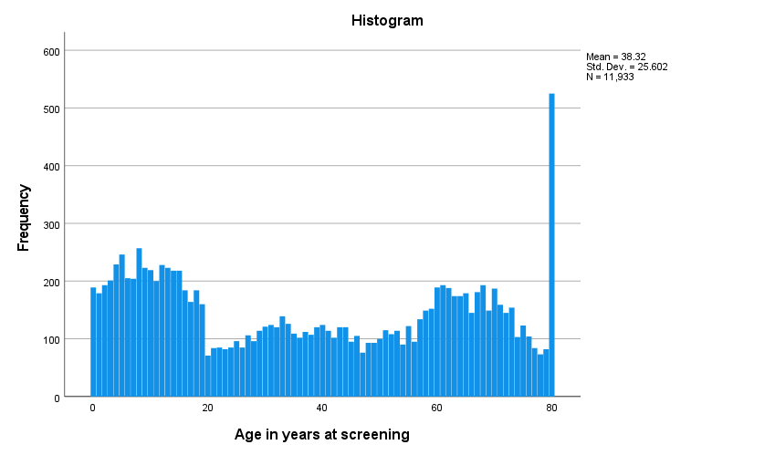

Age in years at screening Stem-and-Leaf Plot

Frequency Stem & Leaf

991.00 0 . 00000000000000001111111111111112222222222222222333333333333333334444444444444444444
1135.00 0 . 5555555555555555555566666666666666666777777777777777778888888888888888888889999999999999999999
1088.00 1 . 0000000000000000001111111111111111122222222222222222223333333333333333333444444444444444444
910.00 1 . 555555555555555555666666666666666777777777777778888888888888889999999999999
407.00 2 . 0000001111111222222233333334444444
497.00 2 . 55555555666666677777777788888888999999999
630.00 3 . 0000000000111111111122222222223333333333334444444444
550.00 3 . 555555555666666667777777778888888889999999999
580.00 4 . 00000000001111111112222222233333333334444444444
462.00 4 . 555555556666666667777778888888899999999
527.00 5 . 0000000011111111112222222223333333334444444
652.00 5 . 555555555566666666777777777778888888888889999999999999
918.00 6 . 0000000000000000111111111111111122222222222222223333333333333344444444444444
847.00 6 . 5555555555555556666666666667777777777777778888888888888888999999999999
748.00 7 . 000000000000000011111111111112222222222223333333333333444444444
466.00 7 . 555555555566666666677777778888889999999
525.00 8 . 00000000000000000000000000000000000000000000

Stem width: 10
Each leaf: 12 case(s)

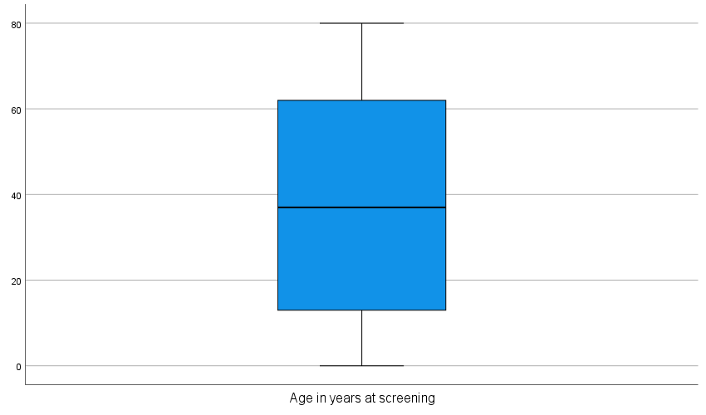

EXAMINE VARIABLES=INDFMPIR
/PLOT BOXPLOT STEMLEAF HISTOGRAM
/COMPARE GROUPS
/PERCENTILES(5,10,25,50,75,90,95) HAVERAGE
/STATISTICS DESCRIPTIVES
/CINTERVAL 95
/MISSING LISTWISE
/NOTOTAL.

Explore

Notes
Output Created |  | 02-NOV-2026 12:17:24
Comments
Input | Data | C:\Users\aSUS\Downloads\Statics\FilteredData.sav
Input | Active Dataset | DataSet3
Input | Filter | <none>
Input | Weight | <none>
Input | Split File | <none>
Input | N of Rows in Working Data File | 11933
Missing Value Handling | Definition of Missing | User-defined missing values for dependent variables are treated as missing.
Missing Value Handling | Cases Used | Statistics are based on cases with no missing values for any dependent variable or factor used.
Syntax |  | EXAMINE VARIABLES=INDFMPIR  /PLOT BOXPLOT STEMLEAF HISTOGRAM  /COMPARE GROUPS  /PERCENTILES(5,10,25,50,75,90,95) HAVERAGE  /STATISTICS DESCRIPTIVES  /CINTERVAL 95  /MISSING LISTWISE  /NOTOTAL.
Resources | Processor Time | 00:00:00.45
Resources | Elapsed Time | 00:00:00.45

Case Processing Summary
 | Cases
 | Valid |  | Missing |  | Total
 | N | Percent | N | Percent | N | Percent
Ratio of family income to poverty | 9892 | 82.9% | 2041 | 17.1% | 11933 | 100.0%

Descriptives
 |  |  | Statistic | Std. Error
Ratio of family income to poverty | Mean |  | 2.7082 | .01679
Ratio of family income to poverty | 95% Confidence Interval for Mean | Lower Bound | 2.6753
Ratio of family income to poverty | 95% Confidence Interval for Mean | Upper Bound | 2.7411
Ratio of family income to poverty | 5% Trimmed Mean |  | 2.7250
Ratio of family income to poverty | Median |  | 2.5000
Ratio of family income to poverty | Variance |  | 2.789
Ratio of family income to poverty | Std. Deviation |  | 1.67012
Ratio of family income to poverty | Minimum |  | .00
Ratio of family income to poverty | Maximum |  | 5.00
Ratio of family income to poverty | Range |  | 5.00
Ratio of family income to poverty | Interquartile Range |  | 3.32
Ratio of family income to poverty | Skewness |  | .120 | .025
Ratio of family income to poverty | Kurtosis |  | -1.400 | .049

Percentiles
 |  | Percentiles
 |  | 5 | 10 | 25 | 50
Weighted Average(Definition 1) | Ratio of family income to poverty | .3200 | .6200 | 1.1800 | 2.5000
Tukey's Hinges | Ratio of family income to poverty |  |  | 1.1800 | 2.5000

Percentiles
 |  | Percentiles
 |  | 75 | 90 | 95
Weighted Average(Definition 1) | Ratio of family income to poverty | 4.5000 | 5.0000 | 5.0000
Tukey's Hinges | Ratio of family income to poverty | 4.5000

Ratio of family income to poverty

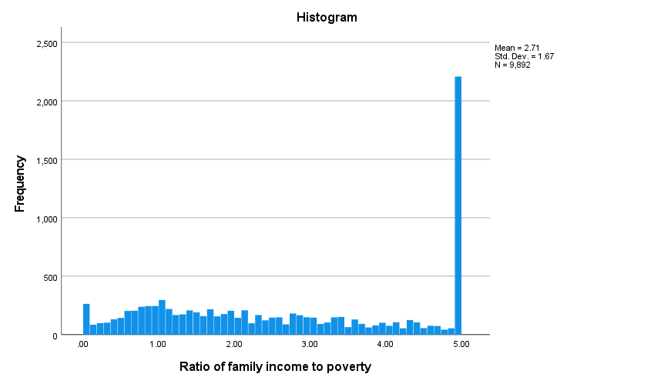

Ratio of family income to poverty Stem-and-Leaf Plot

Frequency Stem & Leaf

357.00 0 . 0000000000001111
229.00 0 . 22222333333
343.00 0 . 4444444455555555
493.00 0 . 6666666666677777777777
516.00 0 . 88888888888889999999999
550.00 1 . 0000000000000011111111111
419.00 1 . 2222222233333333333
390.00 1 . 44444444455555555
395.00 1 . 66666666677777777
415.00 1 . 8888888888999999999
391.00 2 . 00000001111111111
278.00 2 . 2222223333333
317.00 2 . 444444445555555
318.00 2 . 666666777777777
298.00 2 . 8888888899999
285.00 3 . 0000000011111
266.00 3 . 222222233333
263.00 3 . 444444445555
195.00 3 . 666666777
174.00 3 . 88889999
208.00 4 . 000011111
210.00 4 . 223333333
180.00 4 . 44445555
125.00 4 . 666677
128.00 4 . 888999
2149.00 5 . 00000000000000000000000000000000000000000000000000000000000000000000000000000000000000000000000000

Stem width: 1.00
Each leaf: 22 case(s)

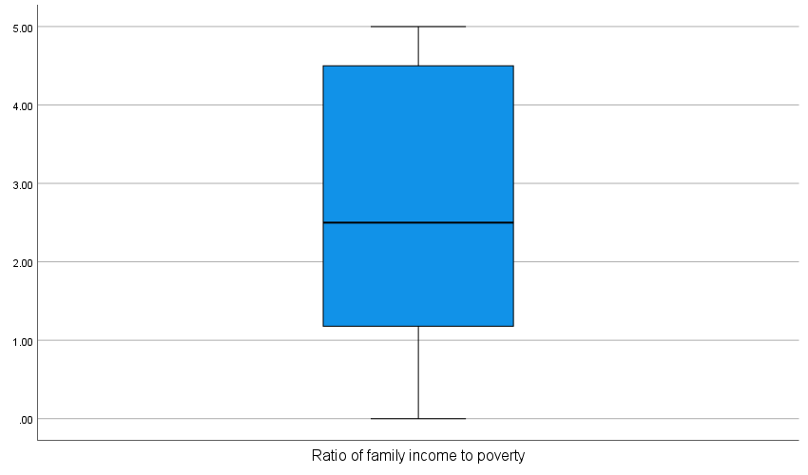

EXAMINE VARIABLES=PHQ9_Total
/PLOT BOXPLOT STEMLEAF HISTOGRAM
/COMPARE GROUPS
/PERCENTILES(5,10,25,50,75,90,95) HAVERAGE
/STATISTICS DESCRIPTIVES
/CINTERVAL 95
/MISSING LISTWISE
/NOTOTAL.

Explore

Notes
Output Created |  | 02-NOV-2026 12:18:15
Comments
Input | Data | C:\Users\aSUS\Downloads\Statics\FilteredData.sav
Input | Active Dataset | DataSet3
Input | Filter | <none>
Input | Weight | <none>
Input | Split File | <none>
Input | N of Rows in Working Data File | 11933
Missing Value Handling | Definition of Missing | User-defined missing values for dependent variables are treated as missing.
Missing Value Handling | Cases Used | Statistics are based on cases with no missing values for any dependent variable or factor used.
Syntax |  | EXAMINE VARIABLES=PHQ9_Total  /PLOT BOXPLOT STEMLEAF HISTOGRAM  /COMPARE GROUPS  /PERCENTILES(5,10,25,50,75,90,95) HAVERAGE  /STATISTICS DESCRIPTIVES  /CINTERVAL 95  /MISSING LISTWISE  /NOTOTAL.
Resources | Processor Time | 00:00:00.36
Resources | Elapsed Time | 00:00:00.32

Case Processing Summary
 | Cases
 | Valid |  | Missing |  | Total
 | N | Percent | N | Percent | N | Percent
PHQ9_Total | 5455 | 45.7% | 6478 | 54.3% | 11933 | 100.0%

Descriptives
 |  |  | Statistic | Std. Error
PHQ9_Total | Mean |  | 4.1333 | .06452
PHQ9_Total | 95% Confidence Interval for Mean | Lower Bound | 4.0068
PHQ9_Total | 95% Confidence Interval for Mean | Upper Bound | 4.2598
PHQ9_Total | 5% Trimmed Mean |  | 3.5809
PHQ9_Total | Median |  | 2.0000
PHQ9_Total | Variance |  | 22.711
PHQ9_Total | Std. Deviation |  | 4.76557
PHQ9_Total | Minimum |  | .00
PHQ9_Total | Maximum |  | 26.00
PHQ9_Total | Range |  | 26.00
PHQ9_Total | Interquartile Range |  | 5.00
PHQ9_Total | Skewness |  | 1.639 | .033
PHQ9_Total | Kurtosis |  | 2.643 | .066

Percentiles
 |  | Percentiles
 |  | 5 | 10 | 25 | 50 | 75
Weighted Average(Definition 1) | PHQ9_Total | .0000 | .0000 | 1.0000 | 2.0000 | 6.0000
Tukey's Hinges | PHQ9_Total |  |  | 1.0000 | 2.0000 | 6.0000

Percentiles
 |  | Percentiles
 |  | 90 | 95
Weighted Average(Definition 1) | PHQ9_Total | 11.0000 | 14.0000
Tukey's Hinges | PHQ9_Total

PHQ9_Total

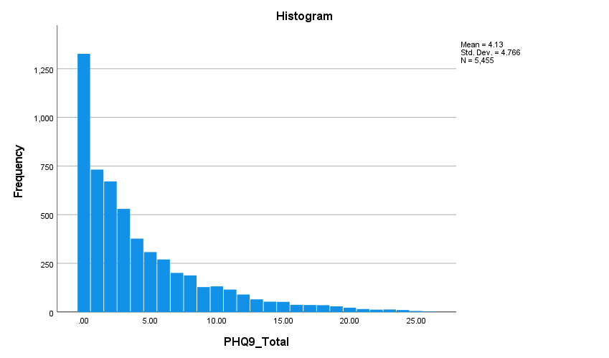

PHQ9_Total Stem-and-Leaf Plot

Frequency Stem & Leaf

1327.00 0 . 00000000000000000000000000000000000000000000000000000000000000000000000000000000000000000000000
.00 0 .
732.00 1 . 0000000000000000000000000000000000000000000000000000
.00 1 .
671.00 2 . 000000000000000000000000000000000000000000000000
.00 2 .
530.00 3 . 00000000000000000000000000000000000000
.00 3 .
377.00 4 . 000000000000000000000000000
.00 4 .
308.00 5 . 0000000000000000000000
.00 5 .
270.00 6 . 0000000000000000000
.00 6 .
201.00 7 . 00000000000000
.00 7 .
188.00 8 . 0000000000000
.00 8 .
128.00 9 . 000000000
.00 9 .
132.00 10 . 000000000
.00 10 .
115.00 11 . 00000000
.00 11 .
90.00 12 . 000000
.00 12 .
65.00 13 . 00000
321.00 Extremes (>=14.0)

Stem width: 1.00
Each leaf: 14 case(s)

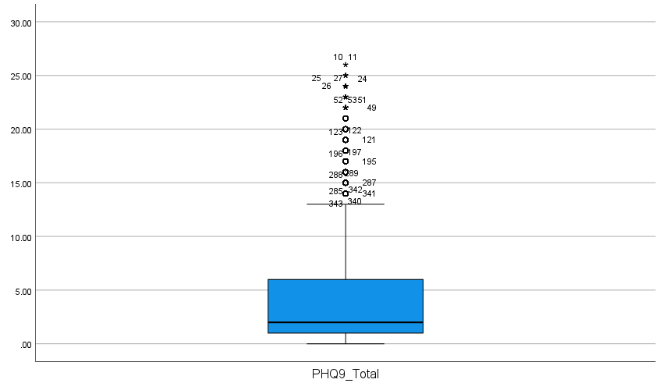

USE ALL.
COMPUTE filter_$=(RIAGENDR = 2 AND RIDAGEYR >= 20AND RHQ010 >= 6 AND RHQ010 <= 19).
VARIABLE LABELS filter_$ 'RIAGENDR = 2 AND RIDAGEYR >= 20AND RHQ010 >= 6 AND RHQ010 <= 19 (FILTER)'.
VALUE LABELS filter_$ 0 'Not Selected' 1 'Selected'.
FORMATS filter_$ (f1.0).
FILTER BY filter_$.
EXECUTE.
EXAMINE VARIABLES=RHQ010
/PLOT BOXPLOT STEMLEAF HISTOGRAM
/COMPARE GROUPS
/PERCENTILES(5,10,25,50,75,90,95) HAVERAGE
/STATISTICS DESCRIPTIVES
/CINTERVAL 95
/MISSING LISTWISE
/NOTOTAL.

Explore

Notes
Output Created |  | 02-NOV-2026 12:19:32
Comments
Input | Data | C:\Users\aSUS\Downloads\Statics\FilteredData.sav
Input | Active Dataset | DataSet3
Input | Filter | RIAGENDR = 2 AND RIDAGEYR >= 20AND RHQ010 >= 6 AND RHQ010 <= 19 (FILTER)
Input | Weight | <none>
Input | Split File | <none>
Input | N of Rows in Working Data File | 2843
Missing Value Handling | Definition of Missing | User-defined missing values for dependent variables are treated as missing.
Missing Value Handling | Cases Used | Statistics are based on cases with no missing values for any dependent variable or factor used.
Syntax |  | EXAMINE VARIABLES=RHQ010  /PLOT BOXPLOT STEMLEAF HISTOGRAM  /COMPARE GROUPS  /PERCENTILES(5,10,25,50,75,90,95) HAVERAGE  /STATISTICS DESCRIPTIVES  /CINTERVAL 95  /MISSING LISTWISE  /NOTOTAL.
Resources | Processor Time | 00:00:00.23
Resources | Elapsed Time | 00:00:00.24

Case Processing Summary
 | Cases
 | Valid |  | Missing |  | Total
 | N | Percent | N | Percent | N | Percent
Age when first menstrual period occurred | 2843 | 100.0% | 0 | 0.0% | 2843 | 100.0%

Descriptives
 |  |  | Statistic | Std. Error
Age when first menstrual period occurred | Mean |  | 12.45 | .032
Age when first menstrual period occurred | 95% Confidence Interval for Mean | Lower Bound | 12.39
Age when first menstrual period occurred | 95% Confidence Interval for Mean | Upper Bound | 12.51
Age when first menstrual period occurred | 5% Trimmed Mean |  | 12.43
Age when first menstrual period occurred | Median |  | 12.00
Age when first menstrual period occurred | Variance |  | 2.932
Age when first menstrual period occurred | Std. Deviation |  | 1.712
Age when first menstrual period occurred | Minimum |  | 6
Age when first menstrual period occurred | Maximum |  | 19
Age when first menstrual period occurred | Range |  | 13
Age when first menstrual period occurred | Interquartile Range |  | 2
Age when first menstrual period occurred | Skewness |  | .189 | .046
Age when first menstrual period occurred | Kurtosis |  | .491 | .092

Percentiles
 |  | Percentiles
 |  | 5 | 10 | 25 | 50
Weighted Average(Definition 1) | Age when first menstrual period occurred | 10.00 | 10.00 | 11.00 | 12.00
Tukey's Hinges | Age when first menstrual period occurred |  |  | 11.00 | 12.00

Percentiles
 |  | Percentiles
 |  | 75 | 90 | 95
Weighted Average(Definition 1) | Age when first menstrual period occurred | 13.00 | 15.00 | 15.00
Tukey's Hinges | Age when first menstrual period occurred | 13.00

Age when first menstrual period occurred

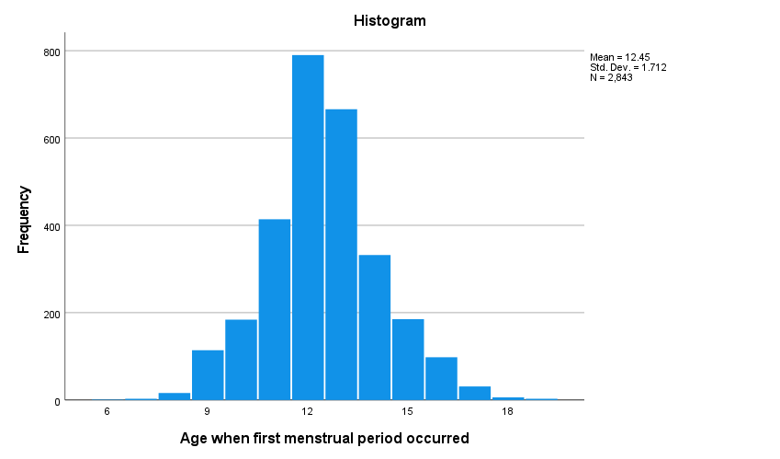

Age when first menstrual period occurred Stem-and-Leaf Plot

Frequency Stem & Leaf

4.00 Extremes (=<7.0)
16.00 8 . 00
.00 8 .
114.00 9 . 00000000000000
.00 9 .
184.00 10 . 00000000000000000000000
.00 10 .
414.00 11 . 0000000000000000000000000000000000000000000000000000
.00 11 .
790.00 12 . 000000000000000000000000000000000000000000000000000000000000000000000000000000000000000000000000000
.00 12 .
666.00 13 . 00000000000000000000000000000000000000000000000000000000000000000000000000000000000
.00 13 .
332.00 14 . 00000000000000000000000000000000000000000
.00 14 .
185.00 15 . 00000000000000000000000
.00 15 .
98.00 16 . 000000000000
40.00 Extremes (>=17.0)

Stem width: 1
Each leaf: 8 case(s)



