Agentic Artificial Intelligence: A Literature Review
Research Student
Department of Computer Science and Engineering
Email: student@university.edu
Abstract—Agentic artificial intelligence (AI) refers to systems that extend large language models (LLMs) with autonomous planning, tool use, memory, and multi-step interaction to pursue complex goals in dynamic environments. This literature review synthesizes recent academic and industry research on agentic AI, spanning foundational paradigms such as ReAct and Toolformer, architectural frameworks including LangGraph and AutoGen, evaluation benchmarks such as AgentBench and GAIA, and emerging protocols for tool connectivity and multi-agent coordination. We organize the literature along three axes—reasoning, acting, and interacting—and discuss open challenges in evaluation methodology, safety, cost efficiency, and reproducibility. The review concludes with research directions for building reliable, controllable, and production-ready agentic systems.
Index Terms—Agentic AI, large language models, autonomous agents, ReAct, multi-agent systems, tool use, evaluation benchmarks, literature review.
I. INTRODUCTION
The emergence of large language models (LLMs) has catalyzed a paradigm shift from passive text generation toward autonomous, goal-directed artificial intelligence. Agentic AI denotes systems in which an LLM serves as a cognitive controller that perceives context, reasons about goals, selects actions, invokes external tools, and adapts behavior through environmental feedback over extended trajectories [1], [2]. Unlike traditional NLP pipelines that map inputs to single outputs, agentic systems operate in closed-loop control cycles, pursuing multi-step objectives in software environments, web interfaces, scientific workflows, and enterprise automation [3].
This review addresses the rapid proliferation of surveys, benchmarks, and frameworks that has nonetheless left the field fragmented. Wang et al. [1] provide a holistic survey of LLM-based autonomous agents, while Pati [4] offers a comprehensive treatment of technologies and societal implications published in IEEE Access. More recent work by Xi et al. [2] categorizes agentic LLMs along reasoning, acting, and interacting dimensions, and Guo et al. [5] formalize agentic architectures using partially observable Markov decision process (POMDP) control loops. Our contribution is to synthesize these perspectives into a unified literature review suitable for researchers entering the field, with emphasis on architectural patterns, evaluation practice, and deployment challenges. An interactive companion guide (agentic_ai_explorer.html) provides curated papers, frameworks, and a structured learning path.
II. RELATED WORK
Prior surveys address complementary facets of the agentic AI landscape. Wang et al. [1] survey LLM-based autonomous agents with emphasis on construction and applications. Xi et al. [2] organize agentic LLMs along reasoning, acting, and interacting axes. Pati [4] publishes a broad IEEE Access survey covering societal implications. Guo et al. [5] adopt an engineering-focused POMDP control-loop perspective. Chen et al. [20] review multi-agent collaboration, while recent evaluation surveys [3], [7] stress multi-dimensional benchmarking. Table III positions this review relative to prior work.
TABLE III
COMPARISON WITH PRIOR SURVEYS
Survey | Focus | Year
Wang et al. [1] | Construction & applications | 2024
Xi et al. [2] | Reasoning/acting/interacting | 2025
Pati [4] | Technologies & society (IEEE) | 2025
Guo et al. [5] | Architecture & POMDP loop | 2026
This review | Unified synthesis + evaluation | 2026

III. BACKGROUND AND DEFINITIONS
A. From LLMs to Agents
Classical autonomous agents in AI research operated within isolated environments with hand-crafted knowledge representations [1]. LLMs pretrained on web-scale corpora provide a qualitatively different foundation: broad world knowledge, in-context learning, and natural-language interfaces that lower the barrier to tool integration [6]. An LLM agent typically comprises four modules: a profile (role and constraints), memory (short- and long-term), planning (decomposition and reflection), and action (tool invocation and environment interaction) [1], [5].
B. Agentic AI vs. Generative AI
Generative AI focuses on producing content—text, code, or images—from prompts. Agentic AI extends generation with agency: the capacity to observe state changes, revise plans, and execute sequences of operations until a termination condition is met [4], [7]. Recent surveys argue that enterprise adoption hinges on evaluating not only output quality but also latency, cost, reliability, safety, and multi-agent coordination under production constraints [7], [8].
C. Agent Environments
Agents operate in environments classified along multiple axes: static versus dynamic, fully versus partially observable, deterministic versus stochastic, and single- versus multi-agent [30]. Environmental complexity directly affects planning horizon, tool selection, and the need for memory and reflection. Web-browsing agents face stochastic, partially observable environments; code agents operate in deterministic sandboxes with clear termination conditions [22], [24].
IV. FOUNDATIONAL PARADIGMS
A. ReAct: Reasoning and Acting
Yao et al. [9] introduced ReAct (Reasoning + Acting), interleaving chain-of-thought rationales with executable actions and environment observations. The trajectory τ = {o₁, z₁, a₁, o₂, z₂, a₂, …} grounds reasoning in external feedback, reducing hallucination compared to latent chain-of-thought prompting alone [5], [9]. ReAct remains the de facto scaffold for modern agent benchmarks and frameworks, though it is vulnerable to error propagation and myopic planning when early mistakes trigger unproductive loops [5].
B. Tool Use and Function Calling
Schick et al. [10] proposed Toolformer, demonstrating that LMs can learn to invoke APIs through self-supervised fine-tuning. Subsequent systems expose tools via JSON schemas, OpenAI function calling, and standardized protocols such as the Model Context Protocol (MCP), which decouples tool providers from agent runtimes [11]. Tool-augmented agents enable retrieval-augmented generation (RAG), code execution, database queries, and web browsing, substantially expanding the feasible task space [2], [12].
C. Reflection and Self-Improvement
Reflexion [13] extends ReAct with an evaluator–reflector loop that generates verbal reinforcement cues from failed trajectories, enabling iterative self-correction without weight updates. Self-Refine and related methods apply similar actor–critic decompositions at inference time [2]. These approaches improve robustness on coding and reasoning tasks but increase token cost and latency, raising questions about cost-efficiency in production deployments [14].
TABLE I
COMPARISON OF FOUNDATIONAL AGENTIC PARADIGMS
Paradigm | Year | Key Idea | Limitation
ReAct [9] | 2022 | Interleave thought and action | Error propagation
Toolformer [10] | 2023 | Self-supervised tool learning | Training overhead
Reflexion [13] | 2023 | Verbal self-reflection | Higher inference cost
AutoGPT [15] | 2023 | Autonomous goal loops | Stability concerns

D. Memory Architectures
Long-horizon agent tasks require memory beyond the context window. Hierarchical memory systems combine working memory (current trajectory), episodic memory (past interactions), and semantic memory (retrieved knowledge) [2], [31]. Frameworks such as Mem0, Letta, and LangChain memory modules implement vector-store retrieval, graph-based knowledge, and self-managed memory augmentation [31]. MemInsight demonstrates that autonomous memory tagging and filtering can substantially improve multi-session task performance.
V. ARCHITECTURES AND FRAMEWORKS
A. Single-Agent Orchestration
Community frameworks such as AutoGPT and BabyAGI popularized fully autonomous loops with goal decomposition and persistent memory [1], [15]. LangChain and LangGraph introduced controllable orchestration through explicit state graphs, enabling developers to define nodes, edges, and conditional transitions rather than unconstrained LLM loops [5], [11]. Guo et al. [5] contrast autonomous loops with controllable graphs, arguing that production systems require explicit workflow structure to manage failure modes.
B. Multi-Agent Systems
Multi-agent LLM systems assign specialized roles—planner, coder, critic—to collaborating agents. Frameworks including CAMEL [16], AutoGen [17], MetaGPT [18], and CrewAI implement topologies such as chain, star, mesh, and hierarchical workflows [5], [19]. Chen et al. [20] survey multi-agent collaboration mechanisms, while MASEval [21] demonstrates that framework choice can impact performance as much as backbone model selection within a capability tier.
C. Agent Protocols
Interoperability standards are emerging to connect agents with tools and other agents. The Model Context Protocol (MCP) standardizes tool and resource discovery; the Agent Communication Protocol (ACP) and Agent-to-Agent Protocol (A2A) address cross-agent messaging [11], [12]. These protocols reduce integration friction but introduce new attack surfaces related to prompt injection and unauthorized tool invocation [12].
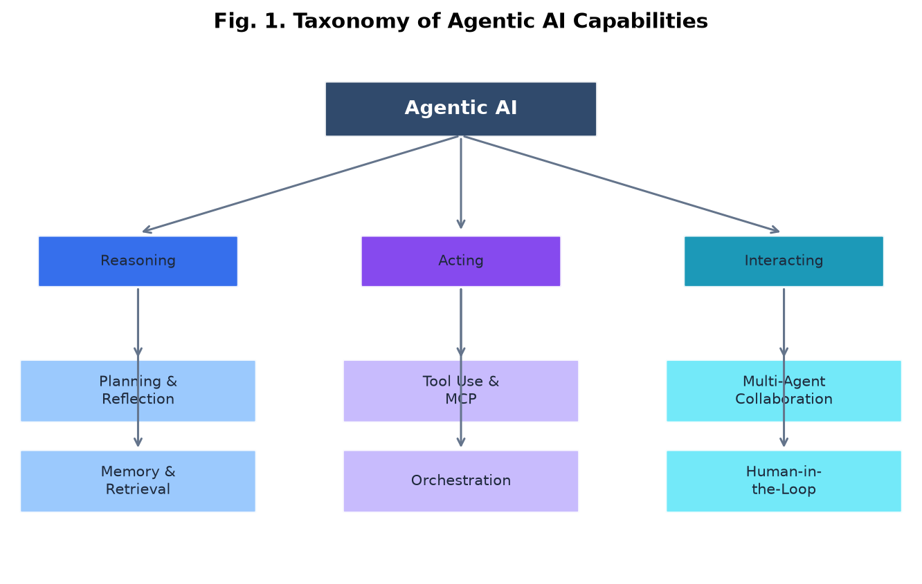
Fig. 1. Taxonomy of agentic AI organized along reasoning, acting, and interacting axes.
TABLE IV
AGENT FRAMEWORK COMPARISON
Framework | Paradigm | Multi-Agent | Production
LangGraph | State graph | Yes | High
AutoGen | Conversation | Yes | Medium
CrewAI | Role-based teams | Yes | Medium
MetaGPT | SOP simulation | Yes | Medium
smolagents | Code-as-action | Limited | Emerging

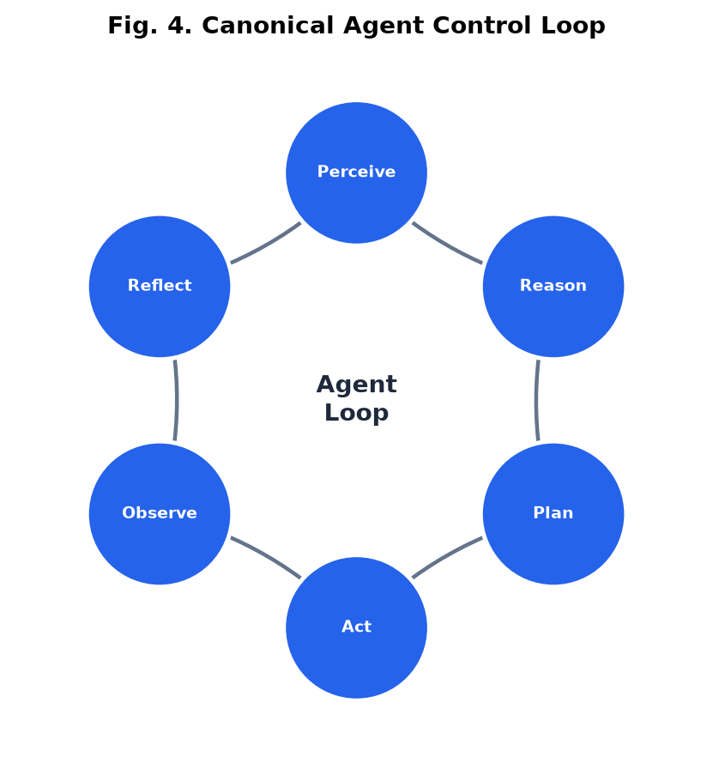
Fig. 2. Canonical perceive–reason–plan–act–observe–reflect control loop.
VI. EVALUATION AND BENCHMARKS
A. Benchmark Landscape
Evaluation has shifted from static NLP metrics toward interactive, environment-grounded assessments. Liu et al. [22] introduced AgentBench spanning eight environments including operating systems, databases, and web shopping. Mialon et al. [23] proposed GAIA for general AI assistants requiring tool use and multi-step reasoning. Jimenez et al. [24] released SWE-bench for software engineering agents, while Yao et al. [25] developed τ-bench for conversational service tasks with simulated users [3], [7].
B. Evaluation Gaps
Despite benchmark proliferation, several gaps persist. First, most evaluations are model-centric, conflating backbone LLM capability with framework implementation [21], [14]. Second, laboratory benchmarks underrepresent cost, latency, and reliability requirements of enterprise deployment [7], [8]. Third, multi-dimensional evaluation taxonomies—covering safety, factuality, coordination, and tool correctness—remain inconsistently applied [3], [26]. Ling et al. [3] propose a unified framework standardizing seven benchmarks as instruction–tool–environment triplets under a fixed ReAct scaffold to isolate capability measurement.
TABLE II
REPRESENTATIVE AGENTIC AI BENCHMARKS
Benchmark | Domain | Key Metric | Ref.
AgentBench | Multi-environment | Success rate | [22]
GAIA | General assistance | Level-wise accuracy | [23]
SWE-bench | Software engineering | Issue resolution | [24]
τ-bench | Customer service | Task completion | [25]
BFCL | Function calling | Tool invocation accuracy | [27]
MASEval | Multi-agent systems | System-level score | [21]

VII. APPLICATIONS
Agentic AI has been applied across scientific discovery, software engineering, healthcare, finance, and education [1], [4], [12]. Wang et al. [1] catalog applications in social science (simulation and survey automation), natural science (experiment planning and literature synthesis), and engineering (code generation and DevOps). In software engineering, agents such as SWE-Agent [28] demonstrate that specialized interfaces and ReAct-style loops can resolve real GitHub issues. Biomedical and materials-science agents integrate domain tools for hypothesis generation and structured data retrieval [12]. Nevertheless, domain-specific customization often outperforms general-purpose agents on specialized benchmarks, though recent studies show narrowing gaps on several tasks [14].
VIII. CHALLENGES AND OPEN PROBLEMS
A. Reliability and Safety
Agentic systems amplify LLM failure modes: hallucinated tool calls, infinite loops, and cascading errors across multi-step trajectories [5], [9]. Safety benchmarks including Agent-SafetyBench [29] and red-teaming studies reveal vulnerabilities to prompt injection, data exfiltration via tools, and unsafe action sequences [12]. Production systems require guardrails, human-in-the-loop approval, and formal verification of critical actions [4], [7].
B. Cost and Efficiency
Each reasoning step, reflection cycle, and tool call incurs API latency and token cost. Exgentic [14] reports wide variation in cost-per-task across agent architectures and notes that open-weight models exhibit "generality sinks"—collapse on specific architectures or benchmarks absent in frontier closed-source models. Efficient agent design must jointly optimize accuracy, latency, and dollar cost [7], [8].
C. Reproducibility
Non-deterministic sampling, evolving APIs, and live web environments hinder reproducible evaluation [3], [7]. Recent frameworks adopt static environment snapshots, fixed scaffolds, and open trace logging to improve comparability [3], [14], [21].
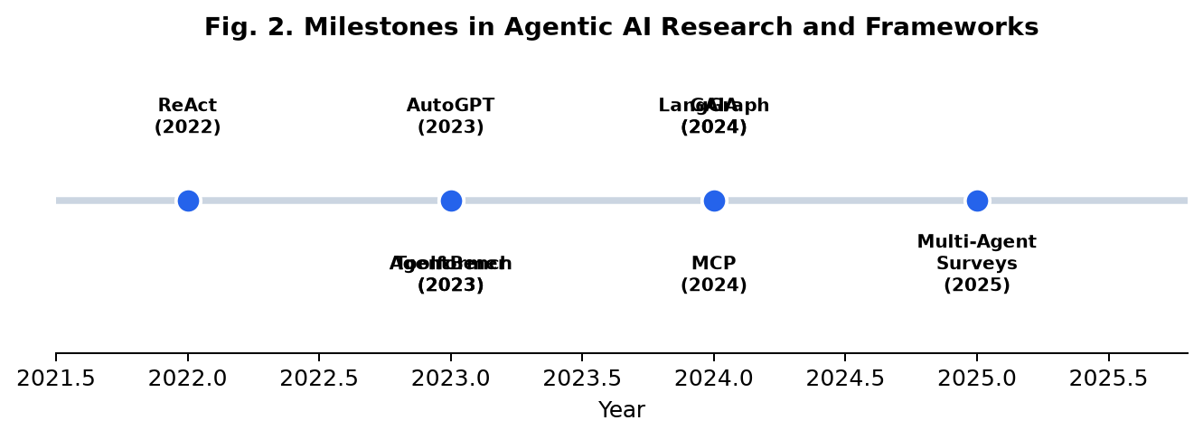
Fig. 3. Selected milestones in agentic AI research (2022–2025).
D. Societal and Ethical Implications
Pati [4] and related work highlight alignment risks, accountability gaps, and labor displacement concerns as agents gain autonomy in customer service, software engineering, and scientific research. Dual-use capabilities—autonomous code execution, web access, and data exfiltration via tools—require governance frameworks, audit trails, and human oversight for high-stakes decisions [4], [29].
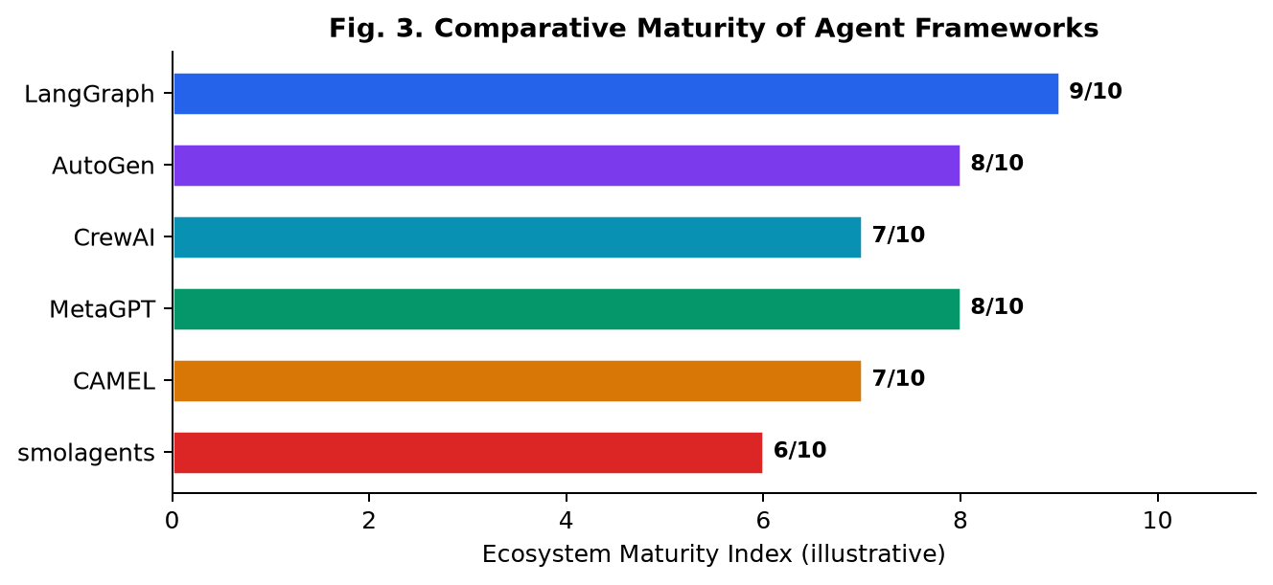
Fig. 4. Illustrative framework ecosystem maturity comparison.
IX. FUTURE RESEARCH DIRECTIONS
The literature points to several high-impact research directions: (1) system-level evaluation that treats framework topology and orchestration as first-class variables [21]; (2) unified, multi-dimensional benchmarking spanning safety, cost, and coordination [7], [8]; (3) reinforcement learning for dynamic tool selection and long-horizon planning [12]; (4) standardized agent protocols with formal security models [11]; (5) neuro-symbolic integration for verifiable reasoning in high-stakes domains [4]; and (6) human-agent collaboration frameworks that balance autonomy with accountability [2], [4].
X. CONCLUSION
Agentic AI represents a maturing research field that unites LLM reasoning, tool-augmented action, and multi-agent interaction into deployable systems. Foundational paradigms from ReAct to Reflexion established the inference-time control loop; frameworks from LangGraph to AutoGen operationalized multi-agent workflows; and benchmarks from AgentBench to GAIA began measuring real-world competence. Yet the transition from impressive demonstrations to dependable production systems requires advances in system-level evaluation, safety engineering, and cost-aware architecture design. This review provides a structured entry point for researchers and practitioners navigating this rapidly evolving landscape.
ACKNOWLEDGMENT
The author thanks the open research community for maintaining survey repositories and benchmark suites that made this review possible. An interactive learning companion (agentic_ai_explorer.html) accompanies this paper.
REFERENCES
[1] L. Wang et al., "A survey on large language model based autonomous agents," Frontiers of Computer Science, vol. 18, no. 6, Art. no. 186345, Dec. 2024.
[2] Y. Xi et al., "Agentic large language models, a survey," arXiv preprint arXiv:2503.23037, 2025.
[3] Y. Ling et al., "A unified framework for the evaluation of LLM agentic capabilities," arXiv preprint arXiv:2605.27898, 2026.
[4] A. K. Pati, "Agentic AI: A comprehensive survey of technologies, applications, and societal implications," IEEE Access, vol. 13, pp. 151824–151837, 2025.
[5] Y. Guo et al., "Agentic artificial intelligence (AI): Architectures, taxonomies, and evaluation of large language model agents," arXiv preprint arXiv:2601.12560, 2026.
[6] T. Brown et al., "Language models are few-shot learners," in Proc. Adv. Neural Inf. Process. Syst. (NeurIPS), 2020.
[7] Anonymous, "Evaluation and benchmarking of generative and agentic AI systems: A comprehensive survey," Preprints.org, 2025.
[8] Stanford HAI, "Artificial Intelligence Index Report 2025," Stanford Univ., Stanford, CA, USA, 2025.
[9] S. Yao et al., "ReAct: Synergizing reasoning and acting in language models," arXiv preprint arXiv:2210.03629, 2022.
[10] T. Schick et al., "Toolformer: Language models can teach themselves to use tools," in Proc. Adv. Neural Inf. Process. Syst. (NeurIPS), 2023.
[11] Anthropic, "Model Context Protocol specification," 2024. [Online]. Available: https://modelcontextprotocol.io
[12] H. Wang et al., "From LLM reasoning to autonomous AI agents: A comprehensive review," arXiv preprint arXiv:2504.19678, 2025.
[13] N. Shinn et al., "Reflexion: Language agents with verbal reinforcement learning," in Proc. Adv. Neural Inf. Process. Syst. (NeurIPS), 2023.
[14] Exgentic Research, "General agent evaluation," arXiv preprint arXiv:2602.22953, 2026.
[15] Significant Gravitas, "AutoGPT: An autonomous GPT-4 experiment," GitHub repository, 2023.
[16] G. Li et al., "CAMEL: Communicative agents for mind exploration of large language model society," in Proc. Adv. Neural Inf. Process. Syst. (NeurIPS), 2023.
[17] Q. Wu et al., "AutoGen: Enabling next-gen LLM applications via multi-agent conversation," arXiv preprint arXiv:2308.08155, 2023.
[18] S. Hong et al., "MetaGPT: Meta programming for multi-agent collaborative framework," in Proc. Int. Conf. Learn. Represent. (ICLR), 2024.
[19] J. Xi et al., "The rise and potential of large language model based agents: A survey," arXiv preprint arXiv:2309.07864, 2023.
[20] L. Chen et al., "Large language model-based multi-agents: A survey of progress and challenges," in Proc. IJCAI, 2024, pp. 8048–8057.
[21] O. Wiest et al., "MASEval: Extending multi-agent evaluation from models to systems," arXiv preprint arXiv:2603.08835, 2026.
[22] X. Liu et al., "AgentBench: Evaluating LLMs as agents," in Proc. Int. Conf. Learn. Represent. (ICLR), 2024.
[23] G. Mialon et al., "GAIA: A benchmark for general AI assistants," in Proc. Int. Conf. Learn. Represent. (ICLR), 2024.
[24] C. Jimenez et al., "SWE-bench: Can language models resolve real-world GitHub issues?" in Proc. Int. Conf. Learn. Represent. (ICLR), 2024.
[25] S. Yao et al., "τ-bench: A benchmark for tool-agent-user interaction in real-world domains," arXiv preprint arXiv:2410.24185, 2024.
[26] Y. Xi et al., "The rise and potential of large language model based agents: A survey," ACM Comput. Surv., 2025.
[27] S. G. Patil et al., "Gorilla: Large language model connected with massive APIs," in Proc. Adv. Neural Inf. Process. Syst. (NeurIPS), 2024.
[28] J. Yang et al., "SWE-agent: Agent-computer interfaces enable automated software engineering," arXiv preprint arXiv:2405.15793, 2024.
[29] Z. Zhang et al., "Agent-safetybench: Evaluating the safety of LLM agents," arXiv preprint arXiv:2412.13178, 2024.
[30] S. Russell and P. Norvig, Artificial Intelligence: A Modern Approach, 4th ed. Pearson, 2020.
[31] Y. Wang et al., "MemInsight: Autonomous memory augmentation for LLM agents," arXiv preprint arXiv:2503.21760, 2025.

