SpaceX Stock Information Report
Ticker: NASDAQ: SPCX | Report Date: June 15, 2026

Executive Summary
Space Exploration Technologies Corp. (SpaceX) completed the largest initial public offering in history on June 12, 2026, listing on the Nasdaq under ticker symbol SPCX. The company priced its IPO at $135 per share, raising $75 billion and achieving an initial valuation of approximately $1.75 trillion. On its first trading day, shares surged 19.2% to close at $160.95, pushing market capitalization above $2 trillion. As of June 15, 2026, SPCX trades near $171.91 per share.

1. IPO Overview
Metric | Value
Ticker Symbol | SPCX (NASDAQ)
IPO Date | June 12, 2026
IPO Price | $135.00 per share
Shares Offered | 555.5 million
Capital Raised | $75 billion
IPO Valuation | $1.75 trillion
First-Day Open | $150.00
First-Day Close | $160.95 (+19.2%)
Current Price (Jun 15) | $171.91
Market Capitalization | ~$2.1 trillion
Lead Underwriters | Morgan Stanley, Goldman Sachs, JPMorgan
Retail Allocation | ~20–22% of shares

2. Stock Price Performance
Figure 1 illustrates SPCX price movement from the final private-market estimate on June 11 through the IPO debut and current trading levels. The stock opened above its IPO price and has continued to attract strong institutional demand in pre-market and regular sessions.
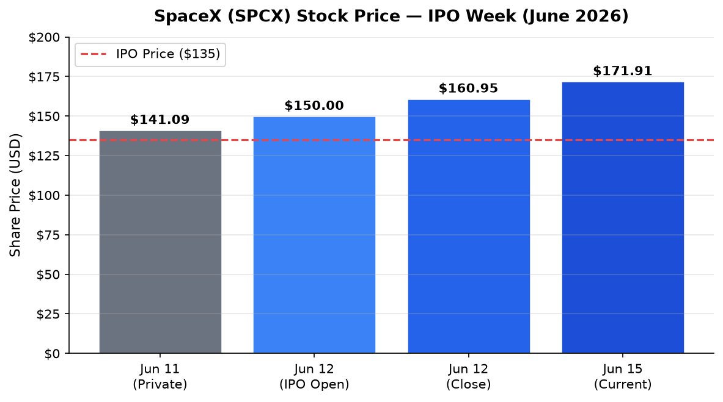
Figure 1: SPCX share price during IPO week (June 2026)

3. Financial Performance (2025)
Financial Metric | 2024 | 2025 | YoY Change
Total Revenue | $14.1B | $18.7B | +33%
Starlink Revenue | $7.7B | $11.4B | +48%
Adjusted EBITDA | $4.9B | $6.6B | +35%
GAAP Net Income | — | -$4.9B | Loss
Starlink Operating Profit | $2.4B | $4.4B | +83%
Starlink Subscribers | 4.6M | 9.0M | +96%
Operational Satellites | ~7,000 | ~9,000+ | +29%

Starlink is SpaceX's primary revenue and profit driver, accounting for 61% of total revenue in 2025. The launch services division and emerging AI/compute initiatives (including the February 2026 xAI merger) comprise the remainder. Figure 2 shows the revenue breakdown.
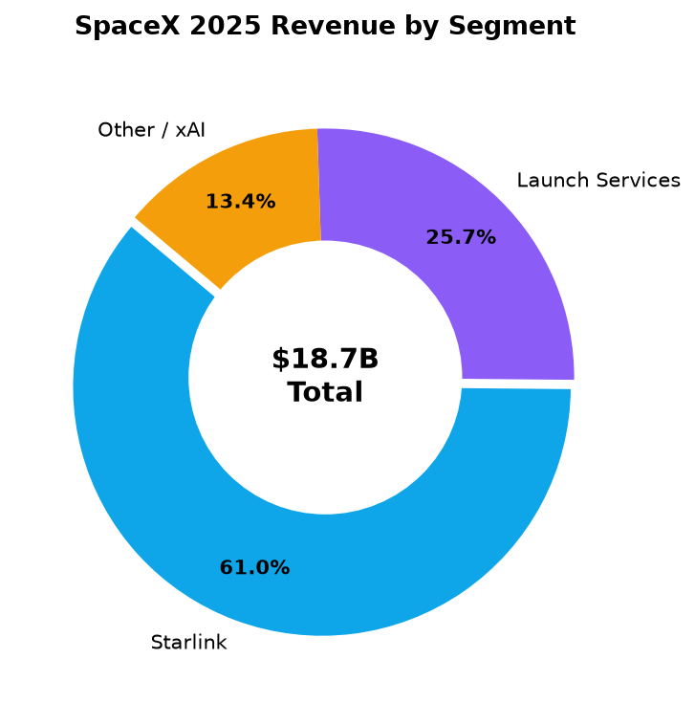
Figure 2: SpaceX 2025 revenue by business segment ($ billions)

4. Valuation History
SpaceX's valuation has grown rapidly through secondary share sales and the xAI merger before reaching its historic IPO valuation. Figure 3 tracks key valuation milestones.
Date / Event | Share Price | Valuation
July 2025 (Secondary Sale) | $212 | $400 billion
December 2025 (Tender Offer) | $421 | $800 billion
February 2026 (xAI Merger) | — | $1.25 trillion
June 12, 2026 (IPO Pricing) | $135 | $1.75 trillion
June 15, 2026 (Market) | $171.91 | ~$2.1 trillion

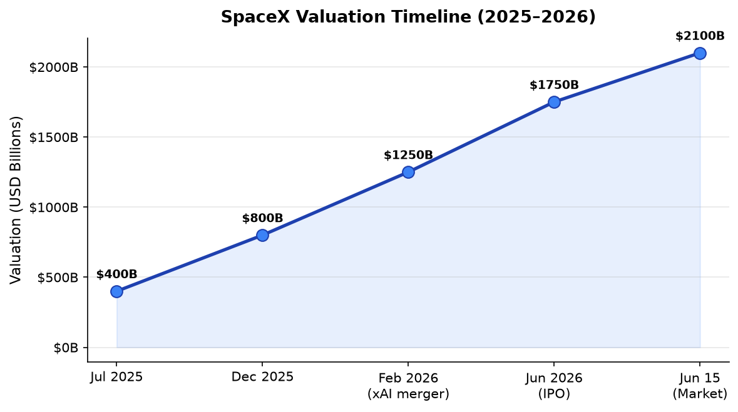
Figure 3: SpaceX valuation milestones from 2025 to June 2026

5. Starlink Growth
Starlink reached approximately 10 million subscribers by February 2026, doubling its subscriber base year-over-year. Average revenue per user (ARPU) declined to roughly $81/month as lower-cost consumer plans expanded the addressable market. Figure 4 shows subscriber growth.
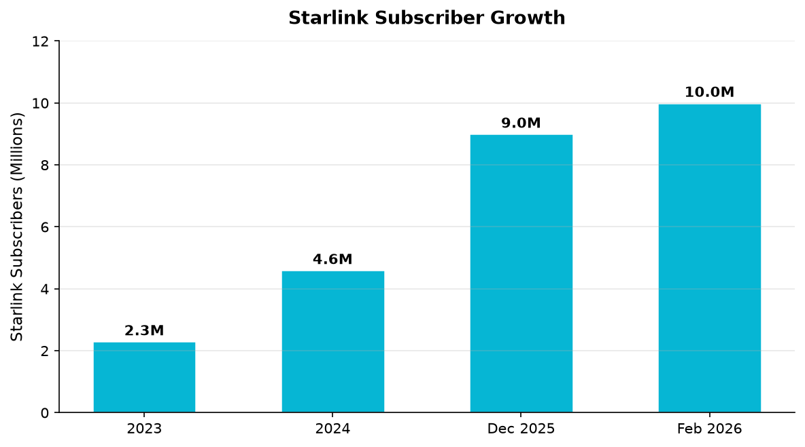
Figure 4: Starlink global subscriber growth (millions)

6. Key Investment Considerations
Factor | Detail | Implication
Profitability | GAAP net loss of $4.9B in 2025 | Heavy capex & AI spending weigh on earnings
Starlink | $4.4B operating profit | Core profit engine supports valuation
Governance | Class B shares (10 votes each) | Musk retains voting control post-IPO
Index Inclusion | Nasdaq-100 eligible after 15 days | Passive fund buying expected
AI Exposure | xAI merger + Anthropic GPU deal | Growth catalyst but adds risk
Valuation | ~9x revenue at IPO | Premium vs. traditional aerospace peers

7. How to Invest
SPCX is now publicly traded and can be purchased through any standard brokerage account (Fidelity, Schwab, Robinhood, etc.). Investors may also gain indirect exposure through ETFs such as ERShares Private-Public Crossover ETF (XOVR), Tema Space Innovators ETF (NASA), and KraneShares AI & Technology ETF (KOID), which held SpaceX positions prior to the IPO.

8. Sources
- Nasdaq Private Market — SpaceX company profile and IPO data
- The Motley Fool — SpaceX IPO debut analysis (June 12, 2026)
- MarketBeat — SPCX stock debut and sector rotation analysis
- Sacra — SpaceX revenue, valuation & funding estimates
- Morningstar — 6 Charts on SpaceX S-1 Financials
- BitMEX Research — SpaceX IPO Guide and S-1 breakdown
- SpaceX Form S-1/A filing (SEC, June 2026)
Disclaimer: This report is for informational purposes only and does not constitute investment advice. Stock prices and financial figures are based on publicly available sources as of June 15, 2026.

