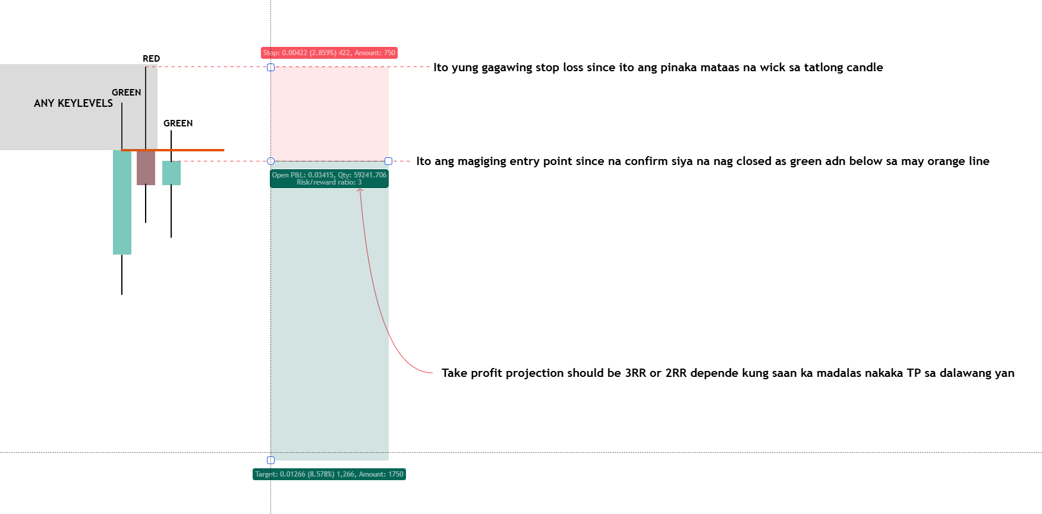
TAMAD STRATEGY
Alam natin gaano ka komplikado ang trading when it comes to technical analysis.
If may paraan paano gawing simple ang isang bagay bagay mas mapadali natin ang proseso.
Na build ko ang approach na ito base lang din sa ayaw ko nang komplikadong pamamaraan
The simplier the better ika nga nang nakakarami. Kung kaya mong maituro sa grade school na bata na kaya nilang e interpret nang walang difficulty meaning understandable siya at beginner friendly. You cannot explain what you do not understand. Tinawag tong TAMAD STRATEGY dahil sa pang tamad siya na approach kasi no need nang complex analysis, simpleng color coding kung iisipin and lastly isang time frame lang ang need.
As a beginner ang pinaka common na itatanong when it comes to an approach sa market ay ang mga sumusunod :
-Anong TIMEFRAME ba to applicable?
-Kailan ba mag ENTRY?
-Ano ang CONFIRMATION before mag enter?
-Saan valid ilagay ang STOPLOSS at ano ang TAKE PROFIT projection?
Lahat nang mga katanongan na to if ma define mo bawat isa pwedi mo na gawing approach and kunan mo nang STATISTICAL DATA para ma confirm mo kung sustainable ba siya in the long run and then gawin mo nang SYSTEMA. Walang valid na systema na mabubuo basta walang baseline sa data.
EXPLANATION AND VISUAL REPRESENTATION
Ang TAMAD STRATEGY ay naka base sa repeating pattern niya in terms of 3 consecutive candle color.
But with a certain logic behind sa simpleng tatlong kulay nang kandila.
If ma identify mo na ang tatlong kulay na yan hindi ka basta basta na lang mag decide na pumasok na sa isang trade dapat alamin mo muna ang context nang naturing possible set up.
BIAS AND SET UP
Tatlong magkakasunod na kandila lang ang hahanapin natin na gagawin nating kombinasyon nang bias at possible entry set up if mag confirm sa context and key levels.
BEARISH SET UP AND BIAS
GREEN – RED – GREEN
BULLISH SET UP AND BIAS
RED – GREEN – RED
NOTE : KUNG ANO YUNG KULAY NANG MIDDLE CANDLE YAN YUNG MAGIGING BIAS
-If red ang middle candle ang trade natin is SHORT/SELL
-If green and middle candle ang trade natin is LONG/BUY
-All three candle should have a wick both high and low for it to be valid.
-TIMEFRAME ang pinaka minimum is 15minutes but nagpapakita siya sa lahat nang timeframe
-Kunan mo lang nang data kung saan ka mas maraming trade na tumatama gamit ang tamad strategy it’s either 15mins-30mins-1H-4H
-Kapag naman nakita mo siya sa DAILY -WEEKLY-MONTHLY timeframe ay gawin niyo nalang higher timeframe bias kasi it takes time kung e trade siya sa higher timeframe tapos 2RR or 3RR lang ang profit projection.
SHORT SET UP CRITERIA
First candle should close as GREEN
Second candle should close as RED
Third candle should close as GREEN and mag wick lang siya sa given orange line which is the closing and opening of the first and second candle.
If all criteria ay na confirm entry trigger is at the closing price of the third candle.
Stoploss is kung saan ang may pinakamataas na wick sa 3 consecutive candle nay an dun ilalagay ang SL.
Take Profit area is fix at 3RR or 2RR since naka base lang din sa statistical data
With a win rate of 52% if 2RR and projection TP while 46% lang kapag 3RR.
But overall mag iiba pa rin yan depende sa nag trade so e backtest muna and kunan nang data kung saan ka mas madalas maka TP hit sa 2RR ba or sa 3RR.
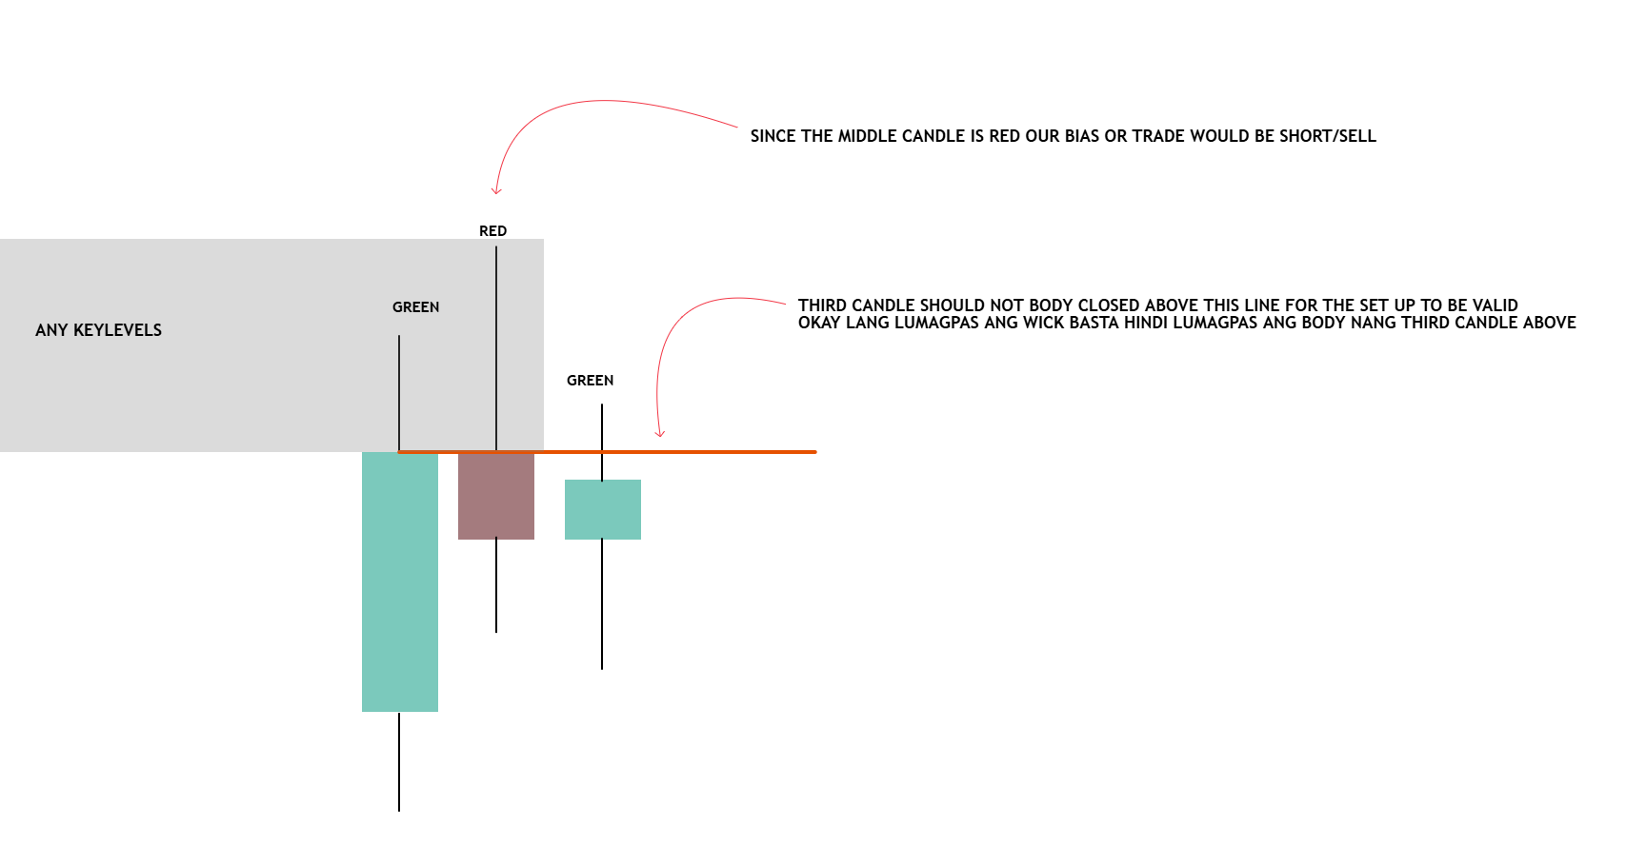
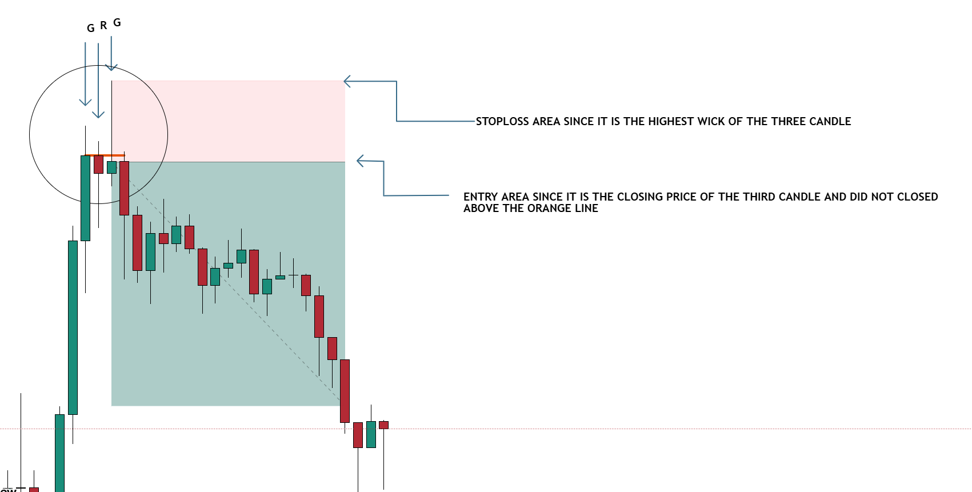
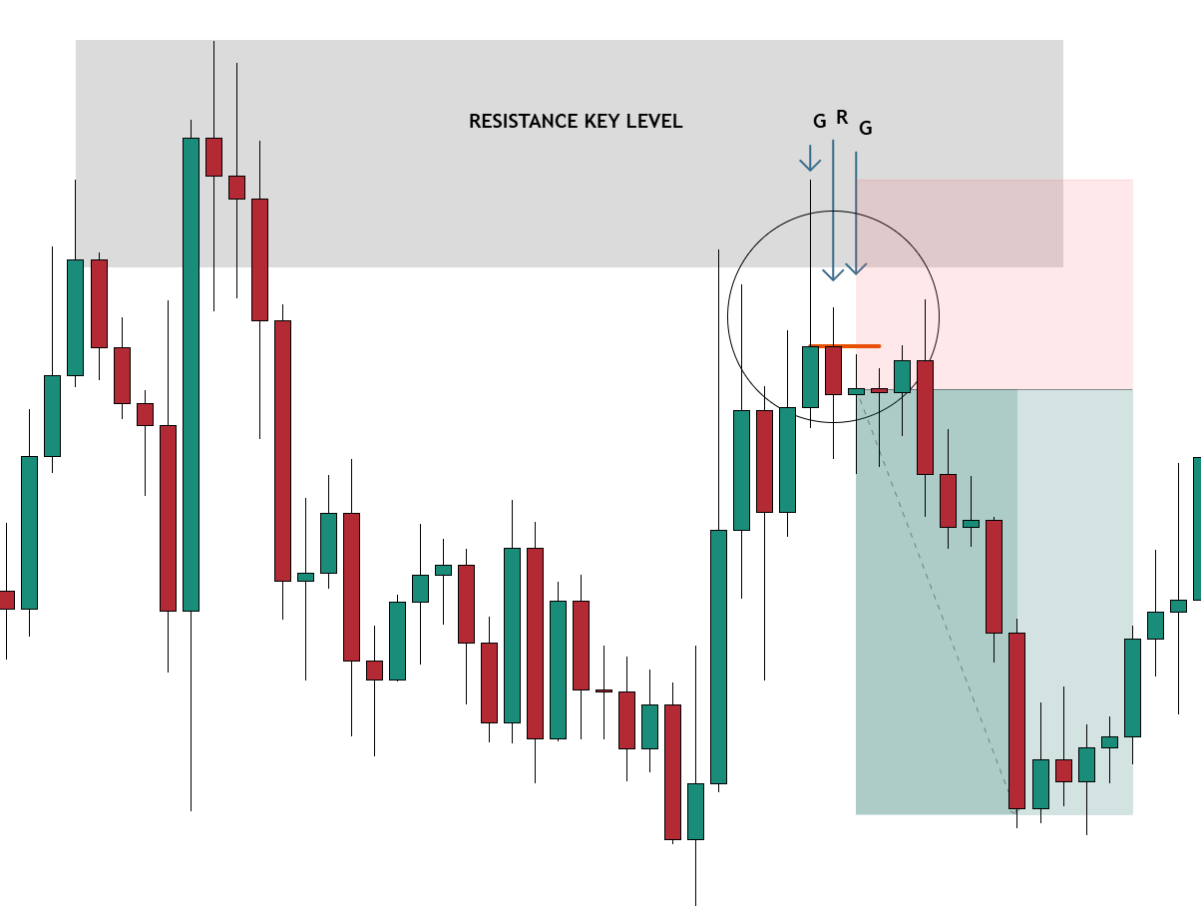
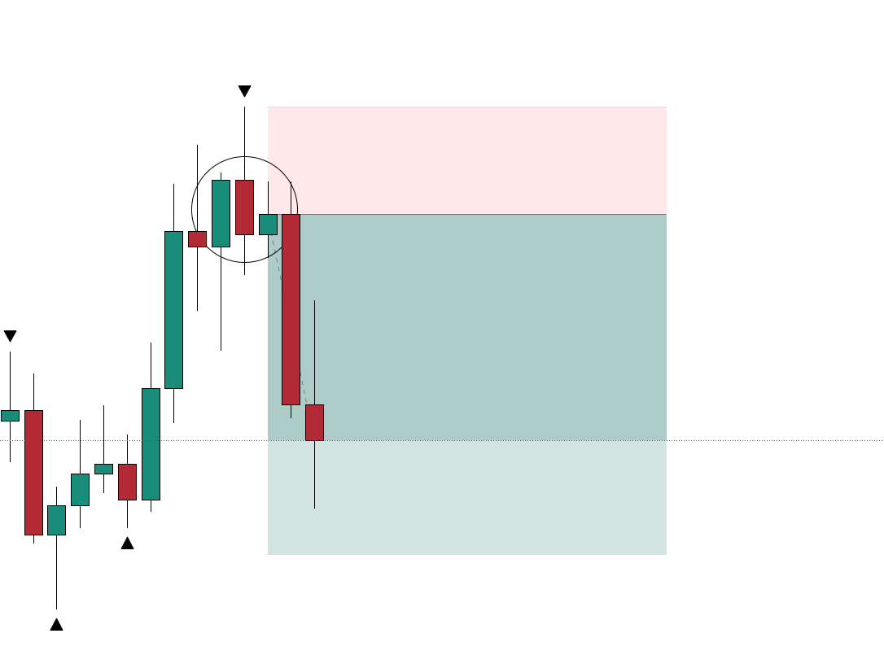
Before mag entry make sure na nasa ideal zone or key levels ang three canldes na yan.
For short/sell set -up dapat nasa resistance , pullback or retracement level area nakita or nabuo ang three candle na yan.
If may higher timeframe narrative or market structure mapping make sure na hindi naka salungat.
LONG SET UP CRITERIA
First candle should close as RED
Second candle should close as GREEN
Third candle should close as RED and mag wick lang siya sa given orange line which is the closing and opening of the first and second candle.
If all criteria ay na confirm entry trigger is at the closing price of the third candle.
Stoploss is kung saan ang may pinakamataas na wick sa 3 consecutive candle nay an dun ilalagay ang SL.
Take Profit area is fix at 3RR or 2RR since naka base lang din sa statistical data.
With a win rate of 52% if 2RR and projection TP while 46% lang kapag 3RR.
But overall mag iiba pa rin yan depende sa nag trade so e backtest muna and kunan nang data kung saan ka mas madalas maka TP hit sa 2RR ba or sa 3RR yun ang susundin mo.
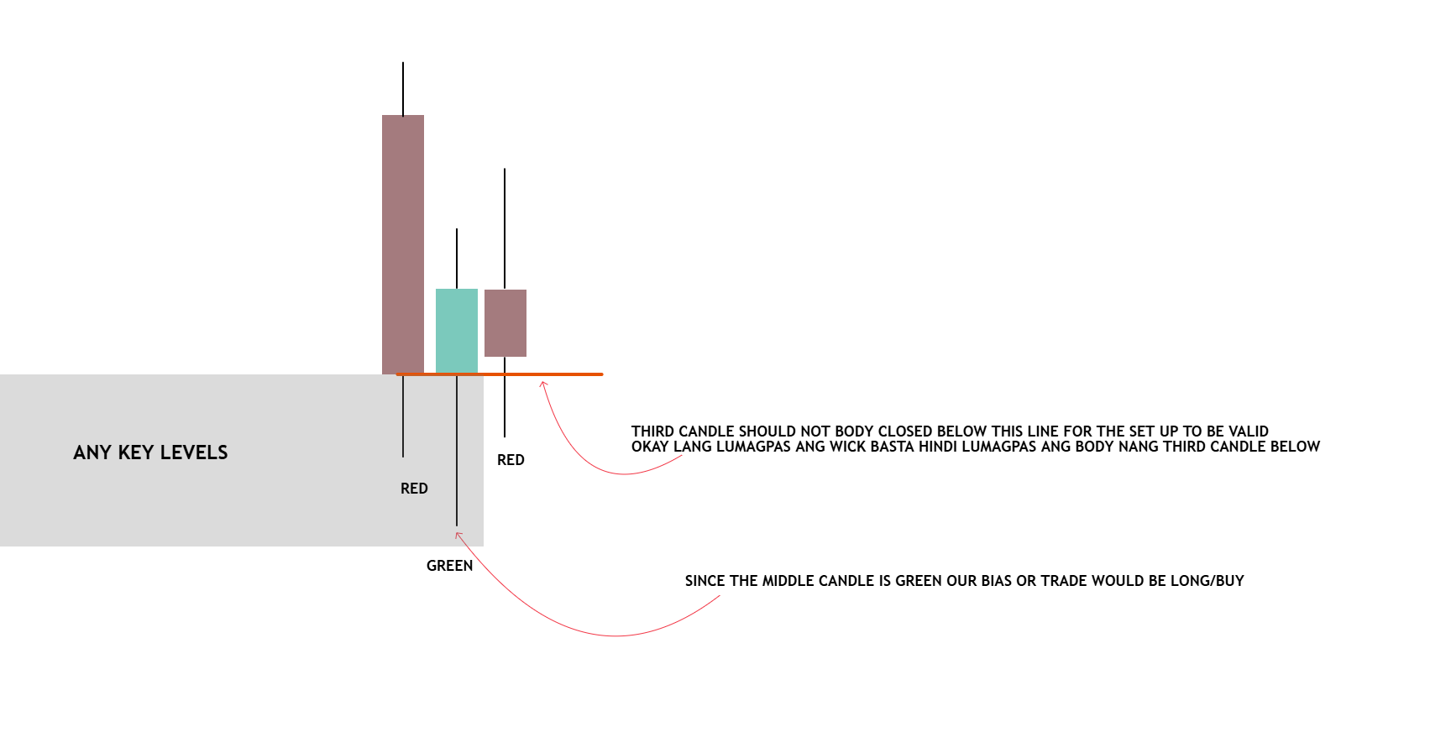
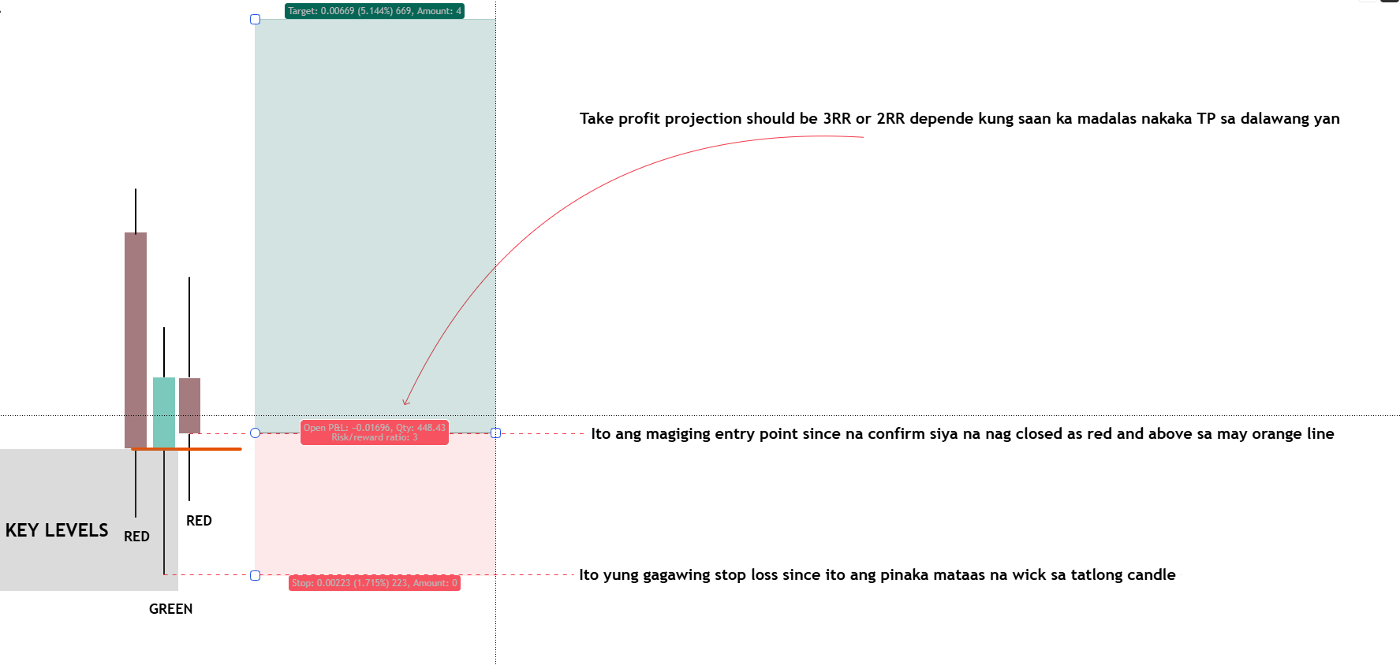
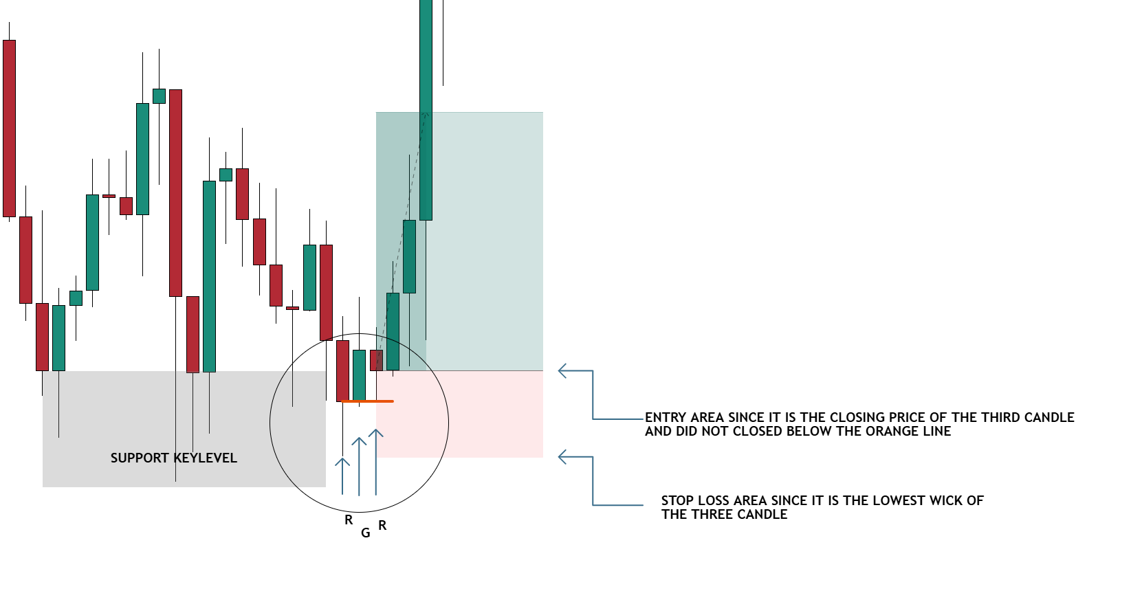
Before mag entry make sure na nasa ideal zone or key levels ang three canldes na yan.
For short/sell set -up dapat nasa support , pullback or retracement level area nakita or nabuo ang three candle na yan.
If may higher timeframe narrative or market structure mapping make sure na hindi naka salungat.
KEY LEVELS AS OUR BASELINE FOR A SET-UP
Sa mga area na to nagpapakita ang ang TAMAD SET-UP
Which is kung bullish tayo RED-GREEN-RED and kung bearish naman is GREEN-RED-GREEN
-SUPPORT AND RESISTANCE
-PULLBACK AND RETRACEMENT
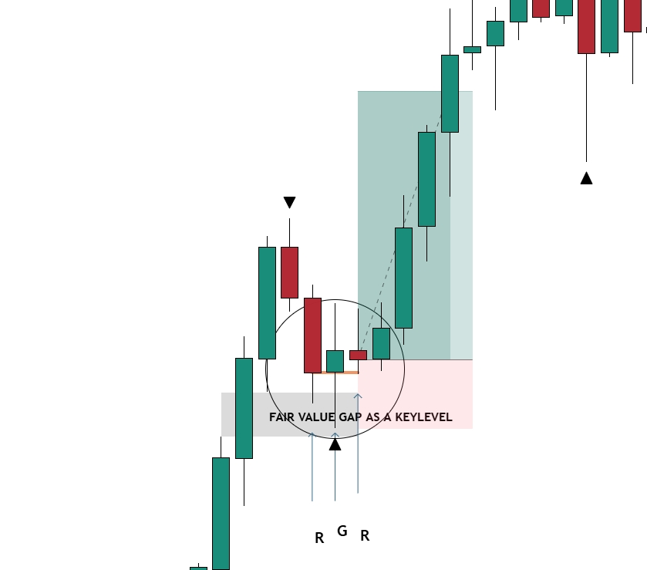
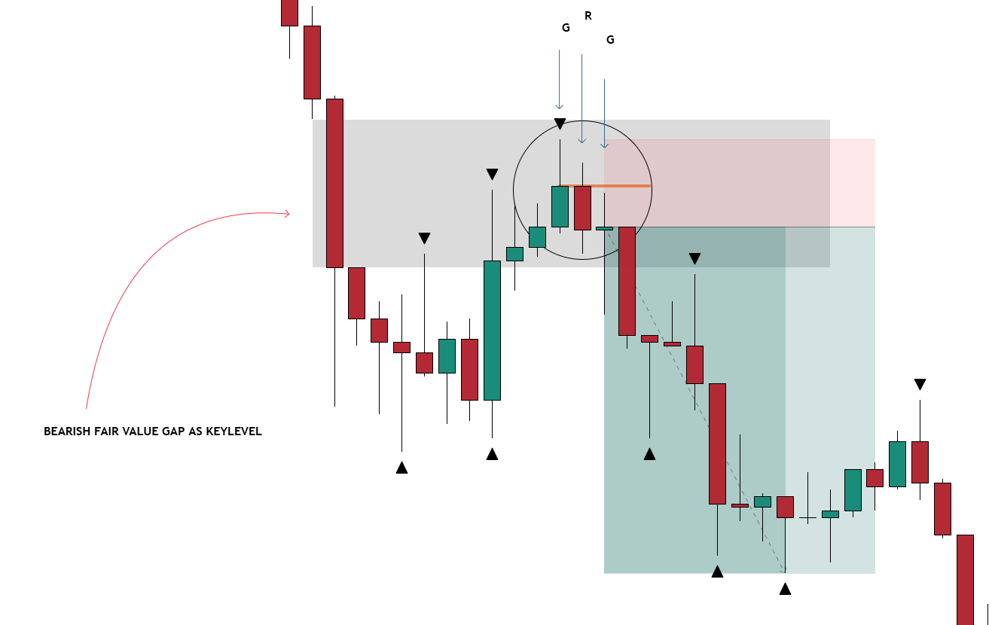
SUPPORT – any swing formed below the current price
RESISTANCE – any swing formed above the current price
PULLBACK /RETRACEMENT- a counter-trend from a recent formed trend
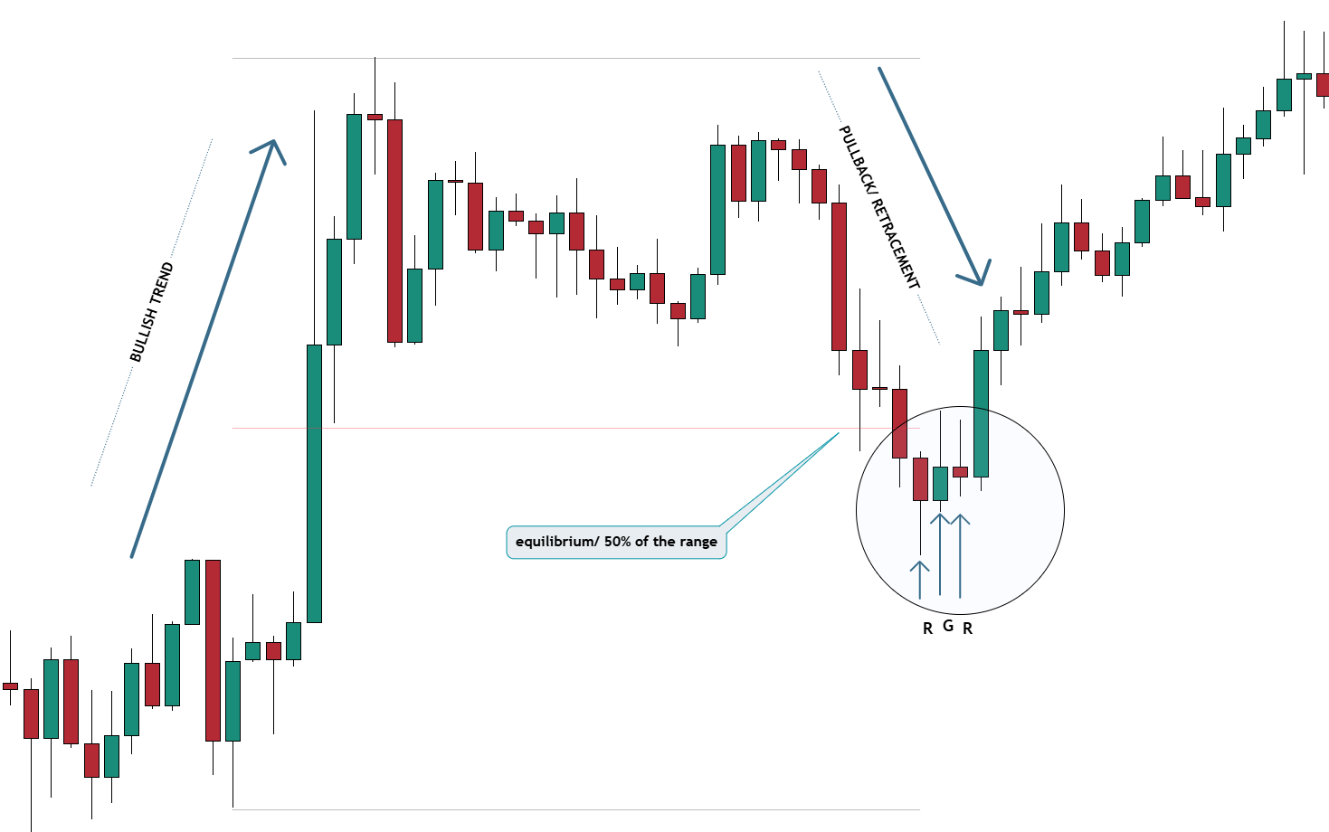
BULLISH KEYLEVELS AT EQUILIBRIUM
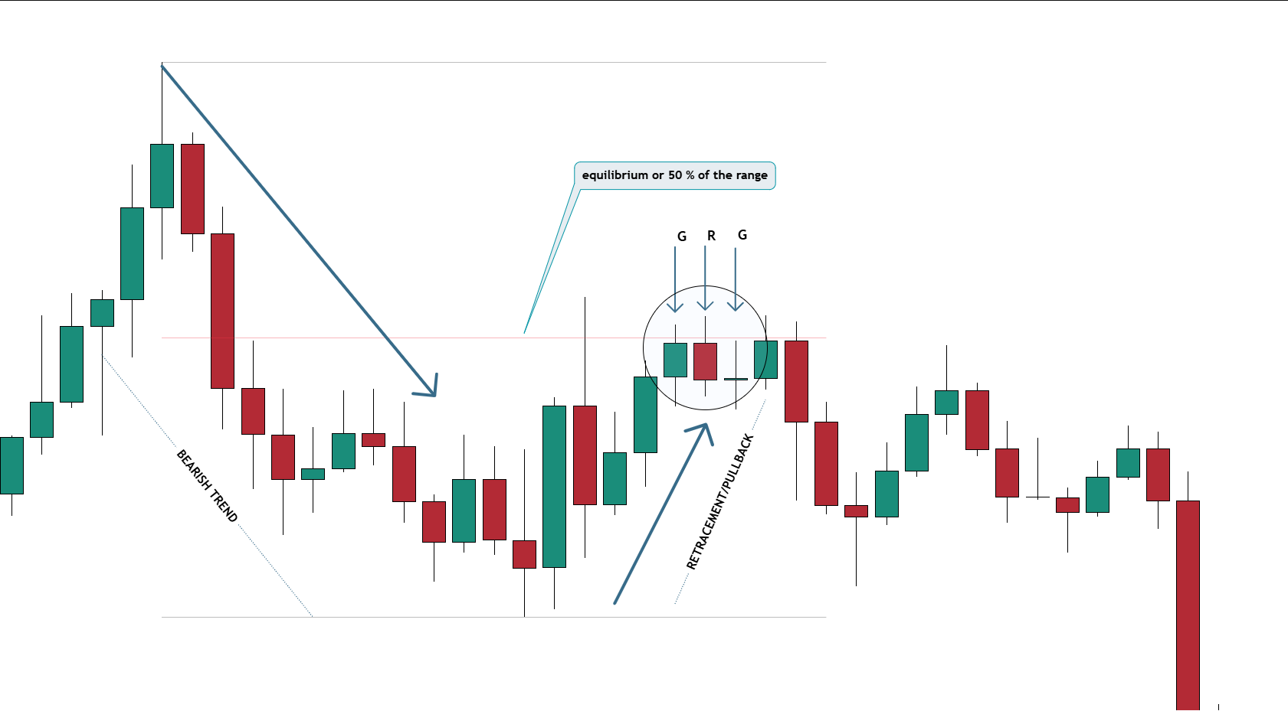
BEARISH KEYLEVELS AT EQUILIBRIUM
SUPPORT AND RESISTANCE KEY LEVELS
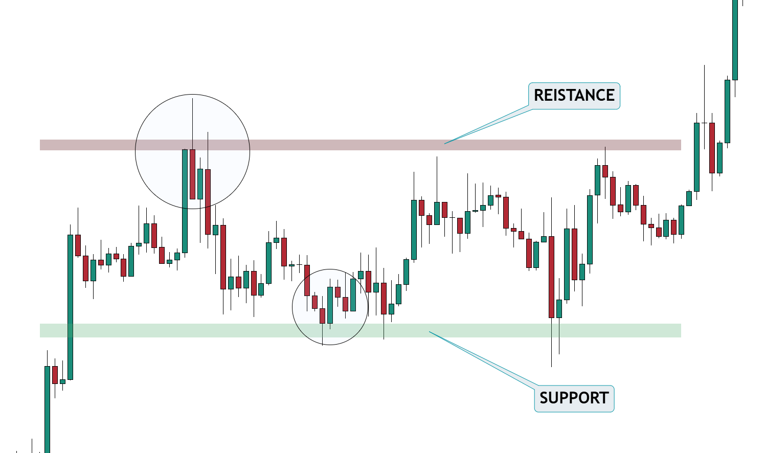
BULLISH FAIR VALUE GAP AS KEY LEVEL
BEARISH FAIR VALUE GAP AS KEY LEVEL

