# Graphics 2

By David Zuniga Navarro

## How to build:

1. Project is made and compiled in VS2019.
2. Open the solution file, and make sure configuration is set to x64, Debug/Release.
3. Release is recommended for a better experience.

## How to use:

* WASD - Move the camera in X and Z axis
* QE - Move the camera in the Y axis
* Mouse - While left clicking moves the camera
* F5 - Turn ON/OFF blur effect on second scene (left)
* F6 - Turn ON/OFF black & white effect
* F4 - Enter play mode (can control character with WASD)

## Screenshots and code bits:

### Uses an off-screen texture:

void cSceneManager::lastPass(GLFWwindow* window)

in the cSceneManager.cpp file renders “everything to a quad.

### Stencil:

void cSceneManager::updateStencil(GLFWwindow* window)

makes the stencil effect.

### Scene rendered to another scene:

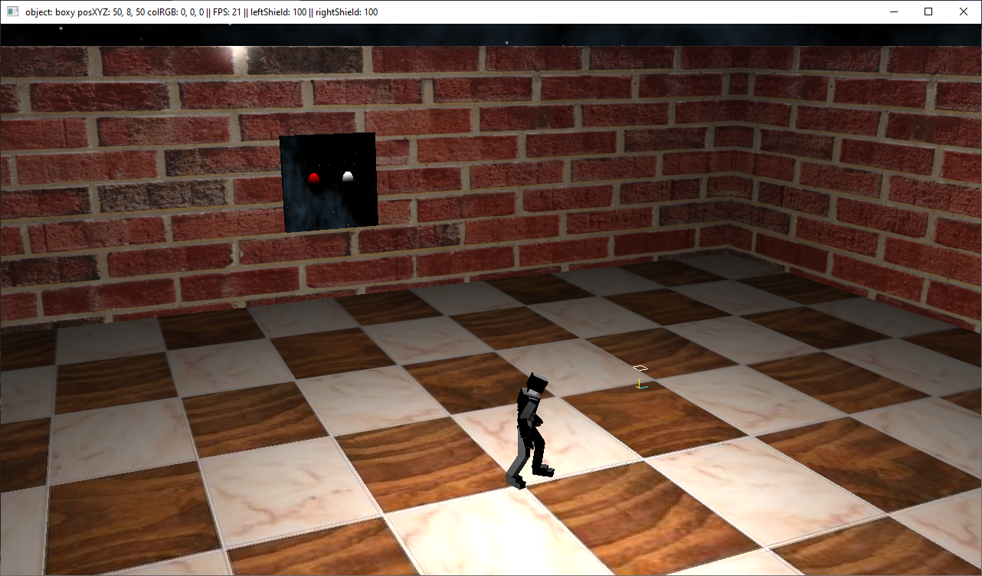

### Stencil effect:

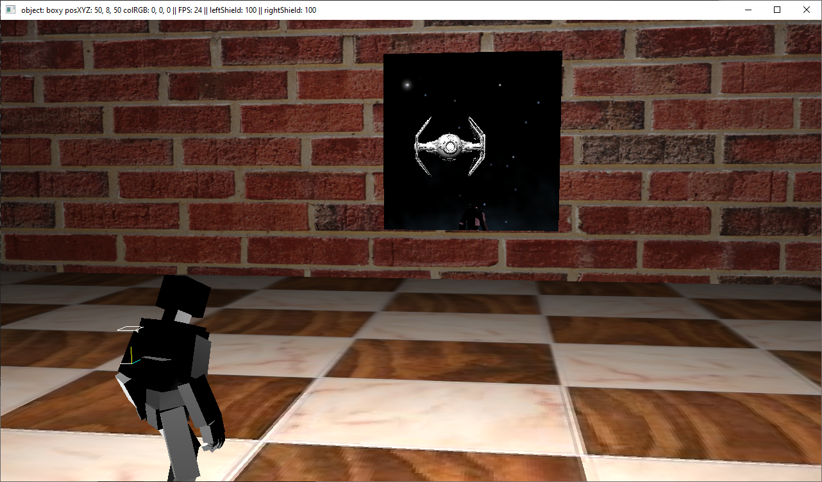

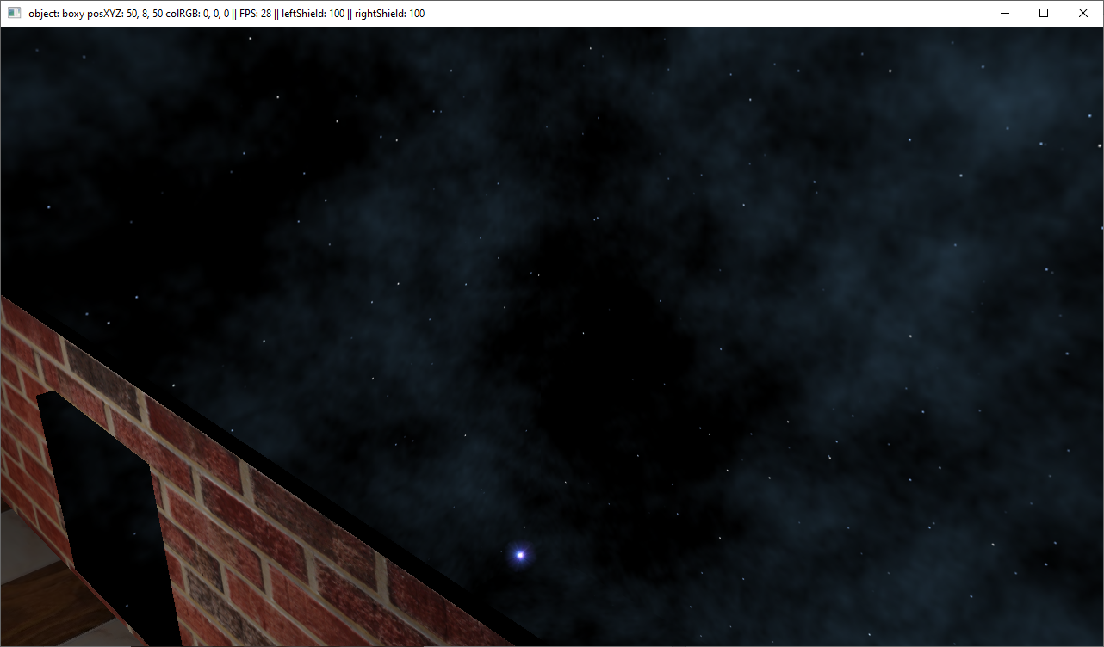

### Reflection and Refraction:

