1. Install glassfish(I used 6.2.5)
archlinux$ yay -S glassfish
# /opt/glassfish

2. Install netbeans(I used 13.1)
archlinux$ sudo pacman -S netbeans

3. Install java(I used java17)
archlinux$ sudo pacman -S jdk17-openjdk

4. Create java web project with ant in Netbeans
File>New Project(Ctrl+Shift+N)>Java with Ant>Java Web>Web application
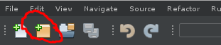

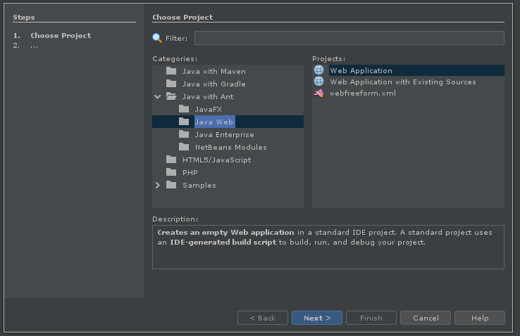

add glassfish server:
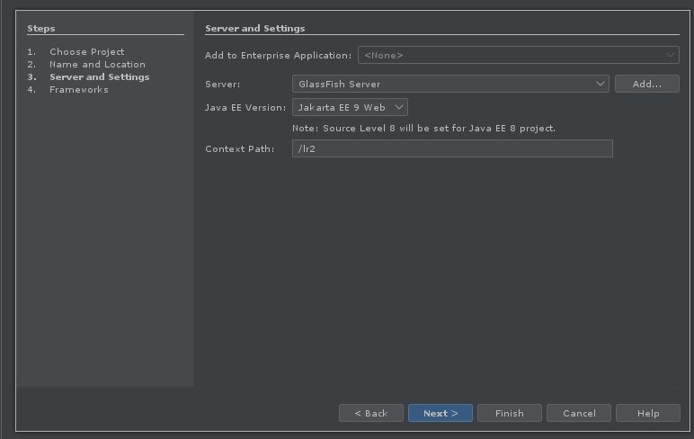

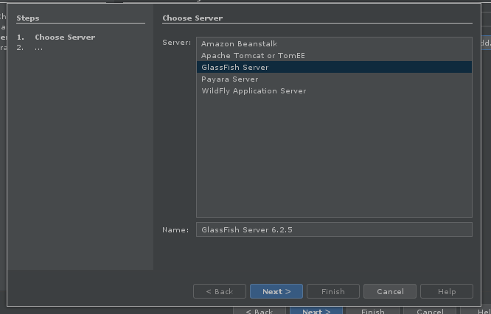
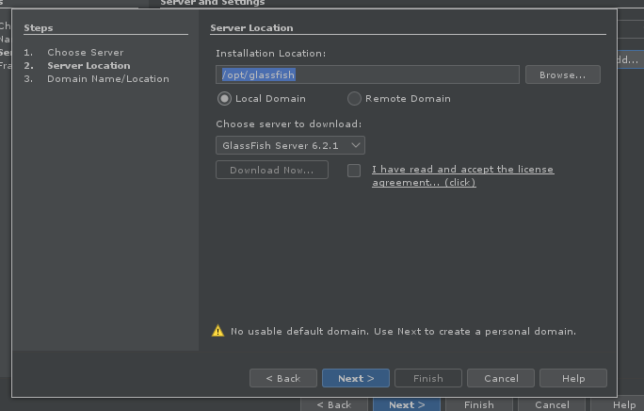

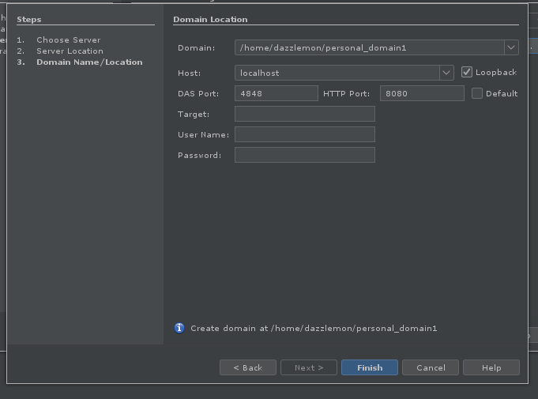
5. Start glassfish
Change java version(if you have multiple installed it might auto detect the wrong one):
In your project: Services>Servers>Glassfish Server(Right click)>Properties>Java>Manage Platforms
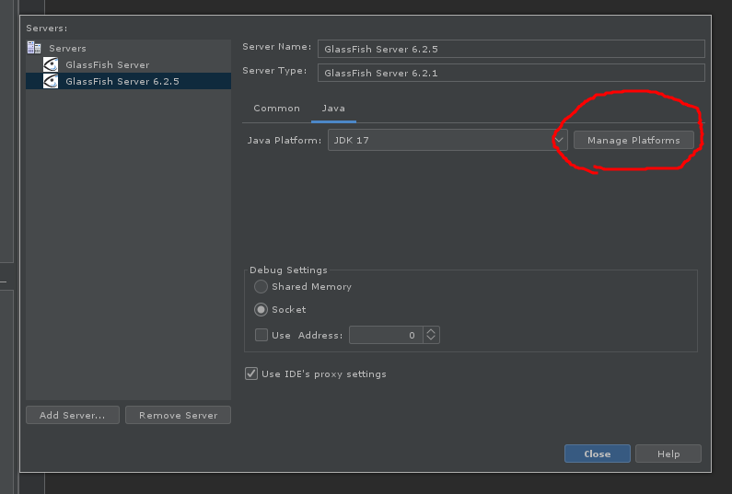

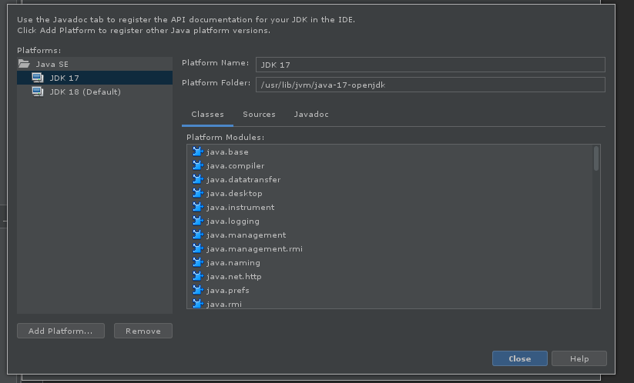
In your project: Services>Servers>Glassfish Server(Right click)>Start

6. Open glassfish console
In your project: Services>Servers>Glassfish Server(Right click)>View domain admin console

7. Create Destination Resource
In glassfish console: Resources>JMS Resources>Destination Resources>New
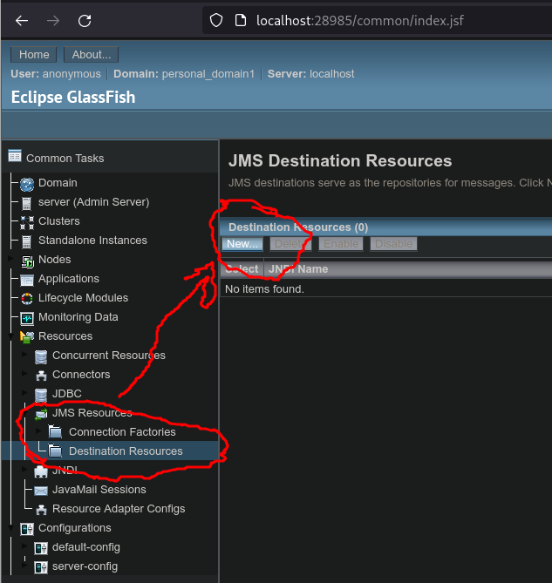

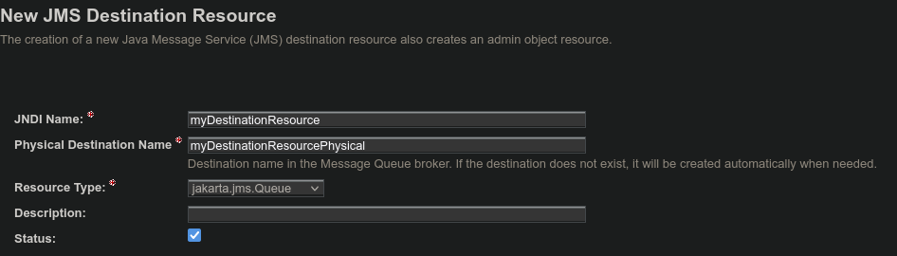

8. Create Connection Factory
In glassfish console: Resources>JMS Resources>Connection Factories>New
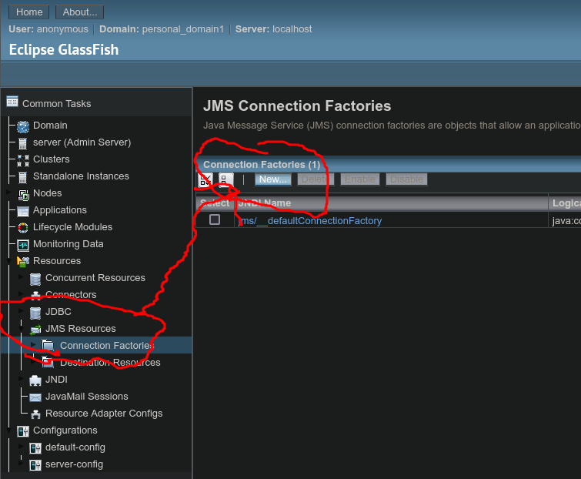

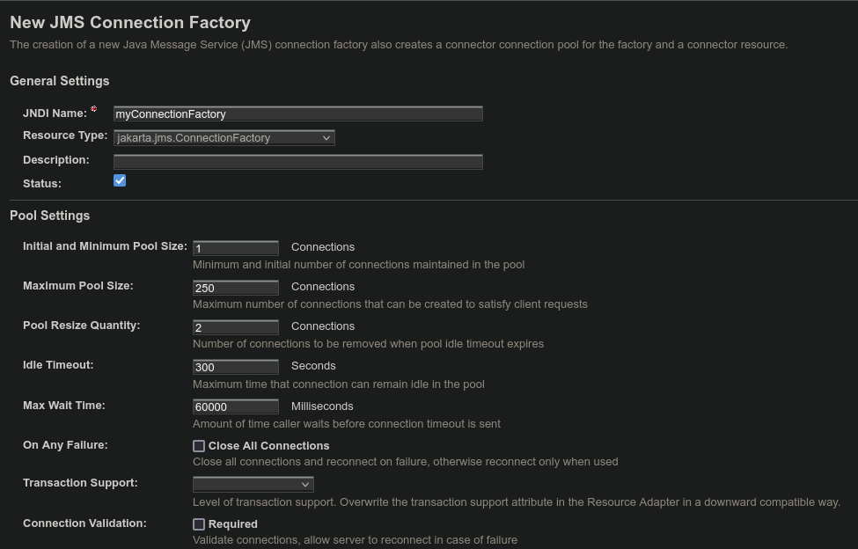

9. Restart Glassfish
in Glassfish console: server>restart

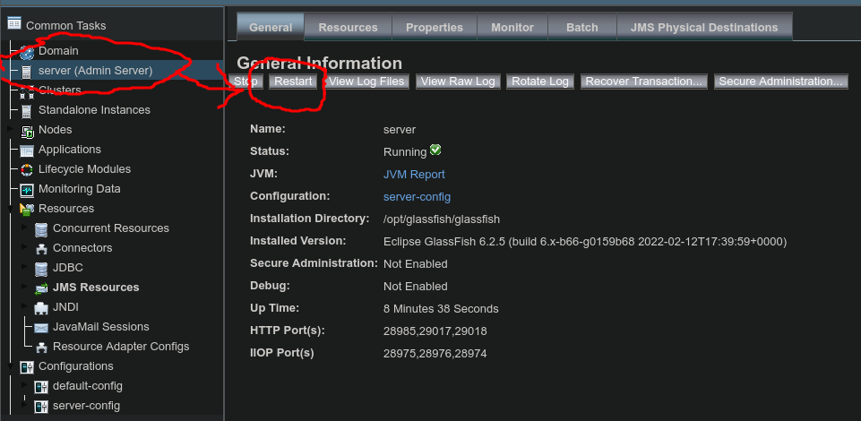

Here are our resources in netbeans
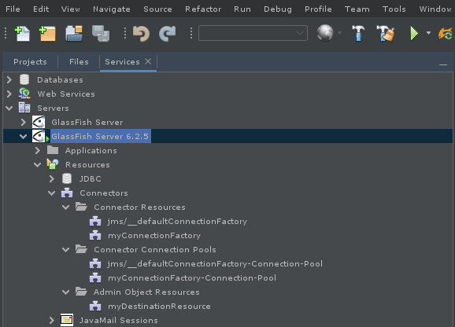

10. Create servlet:
Your project(Right click)>New>Servlet
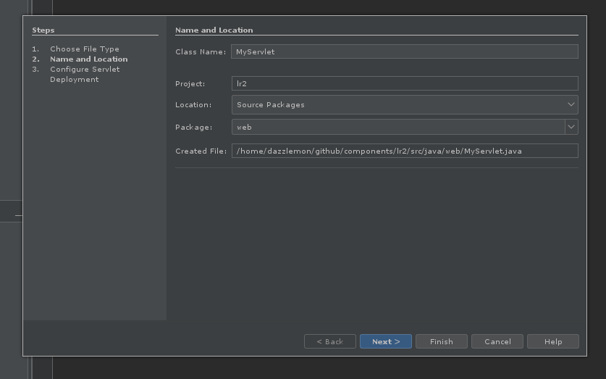

11. Edit index.html
<!DOCTYPE html>
<!--
Click nbfs://nbhost/SystemFileSystem/Templates/Licenses/license-default.txt to change this license
Click nbfs://nbhost/SystemFileSystem/Templates/JSP_Servlet/Html.html to edit this template
-->
<html>
<head>
<title>TODO supply a title</title>
<meta charset="UTF-8">
<meta name="viewport" content="width=device-width, initial-scale=1.0">
</head>
<body>
<div>Enter a name</div>
<<form action="MyServlet" method="get">
<input type="text" name="name"/>
<button type="submit">Submit</button>
</form>
</body>
</html>
12. Edit MyServlet.java
/*
* Click nbfs://nbhost/SystemFileSystem/Templates/Licenses/license-default.txt to change this license
* Click nbfs://nbhost/SystemFileSystem/Templates/JSP_Servlet/Servlet.java to edit this template
*/
package web;

import java.io.IOException;
import java.io.PrintWriter;
import jakarta.servlet.ServletException;
import jakarta.servlet.annotation.WebServlet;
import jakarta.servlet.http.HttpServlet;
import jakarta.servlet.http.HttpServletRequest;
import jakarta.servlet.http.HttpServletResponse;

/**
*
* @author dazzlemon
*/
@WebServlet(name = "MyServlet", urlPatterns = {"/MyServlet"})
public class MyServlet extends HttpServlet {

/**
* Processes requests for both HTTP <code>GET</code> and <code>POST</code>
* methods.
*
* @param request servlet request
* @param response servlet response
* @throws ServletException if a servlet-specific error occurs
* @throws IOException if an I/O error occurs
*/
protected void processRequest(HttpServletRequest request, HttpServletResponse response)
throws ServletException, IOException {
// Reading inputs from form
String name = request.getParameter("name");

response.setContentType("text/html;charset=UTF-8");
try ( PrintWriter out = response.getWriter()) {
/* TODO output your page here. You may use following sample code. */
out.println("<!DOCTYPE html>");
out.println("<html>");
out.println("<head>");
out.println("<title>Servlet MyServlet</title>");
out.println("</head>");
out.println("<body>");
out.println("<h1>Your name is " + name + "</h1>");
out.println("</body>");
out.println("</html>");
}
}

// <editor-fold defaultstate="collapsed" desc="HttpServlet methods. Click on the + sign on the left to edit the code.">
/**
* Handles the HTTP <code>GET</code> method.
*
* @param request servlet request
* @param response servlet response
* @throws ServletException if a servlet-specific error occurs
* @throws IOException if an I/O error occurs
*/
@Override
protected void doGet(HttpServletRequest request, HttpServletResponse response)
throws ServletException, IOException {
processRequest(request, response);
}

/**
* Handles the HTTP <code>POST</code> method.
*
* @param request servlet request
* @param response servlet response
* @throws ServletException if a servlet-specific error occurs
* @throws IOException if an I/O error occurs
*/
@Override
protected void doPost(HttpServletRequest request, HttpServletResponse response)
throws ServletException, IOException {
processRequest(request, response);
}

/**
* Returns a short description of the servlet.
*
* @return a String containing servlet description
*/
@Override
public String getServletInfo() {
return "Short description";
}// </editor-fold>

}
13. Build project
14. run project(it will open in your browser)

