FIRST TESTING
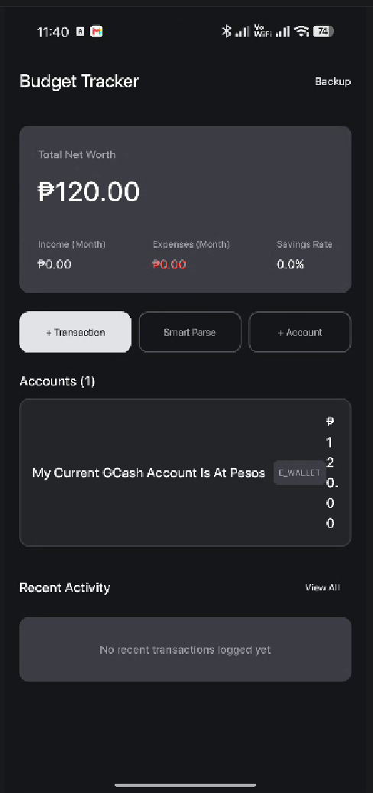
DASHBOARD
The dashboard must be compact and add a little bit of round in corners.
The first hero card on the top is the Total Networth simple card with pesos sign and make it compact. Remove the labels, just the total.

Under that hero card is the accounts, compact cards also with the icons of every account and it should be 2 cards per row and 4 cards at max, a total of 4 cards in the accounts section. Add see more to go to more of their accounts (which is the accounts section)

The 3 cta buttons after that is not in my vision. Add a floating cta with + icon in white circle and when clicked it will popup overlay with a smooth animation the income or expense, meaning it is an add transaction cta positioned in bottom right corner of the screen.

In the bottom of the dashboard show the recent transactions that has been done, not all the actions, just the transactions such as income, expense, adjustments etc.

Add bottom menu consists of Dashboard, Smart Parser, Accounts
I tried the smart parse, I said my current gcash is at 120 pesos, the ai made the account name into that full sentence. It supposed to name the account to Gcash.

LOGGING TRANSACTIONS
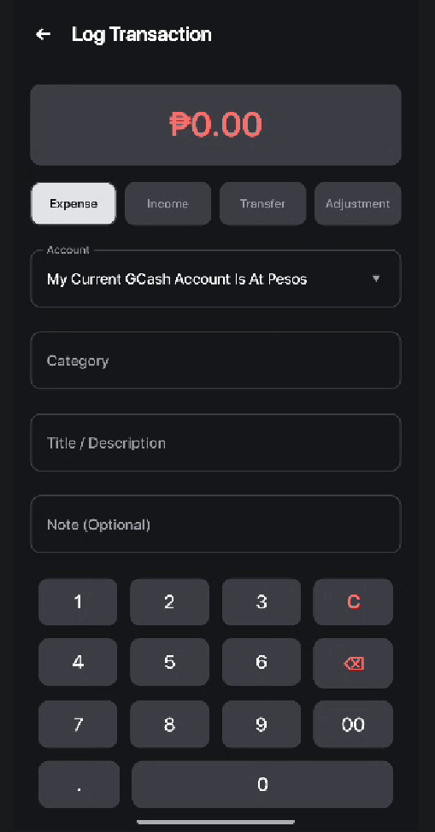
Move the total of transaction at the bottom of the log transaction, in the amount. Make it green if it’s income, transfer white, installment red.
Replace the adjustment with installment, because we have paylaters right or credit cards? So put that in there.
The installment fields will be;
Category of expense
Name of transaction
Select account to deduct (compact rectangle icons that has icons and name of the account and balance for every account)
Total Purchase including interest
Total number of installments
--------------------------------------------
For all the logging of transactions, the accounts must be cards for easy logging, like I said earlier, compact cards with icons and balances to it.
Log Category (changing every type of transaction like expense and income, add a dropdown of relevant categories and it can be also customized if they want to add their categories)
Name of transaction (they can save name of transaction for future input)
Amount, when amount is clicked it will slide up a calculator
For the calculator, it must be a complete calculator buttons like AC, divide, multiply, backspace, add, minus, equal, point, +/- and equal and a check to confirm the amount. In this way they can manually just use the calculator instead of using their calculator, avoiding switching of apps.

Also the issue of the current calculator is the clickable on the buttons is only the text numbers, when I touch it, it’s just tapping the middle of the button, make it click the whole button in the calculator. Change the buttons color lighter when it’s being clicked or hold. Also they can paste on the calculator, only numbers. Add an indicator on the top of our sliding up calculator that it can be slide up, just like this.

The calculator will occupy only 30% of the bottom of the screen.

