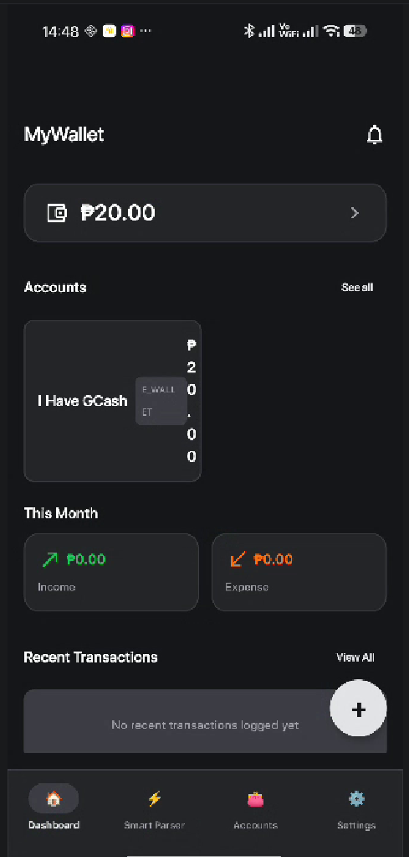
SECOND TESTING
DASHBOARD
- there’s so much space on the upper part of the title, look at the space between my wallet and under my notification or status bar.
- remove the notification bell on the top right corner
- add a title to the total asset card because it only shows the amount of total without label

- the account cards is still not working properly, the amount is compressed to right because of the long name of the account name, put the category of the account under the account name. Make the account cards look like this. 2 each row and 4 at max.

The bottom nav icons are off, it uses emoji. Search for icons that is minimalistic same as the design like this.
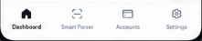
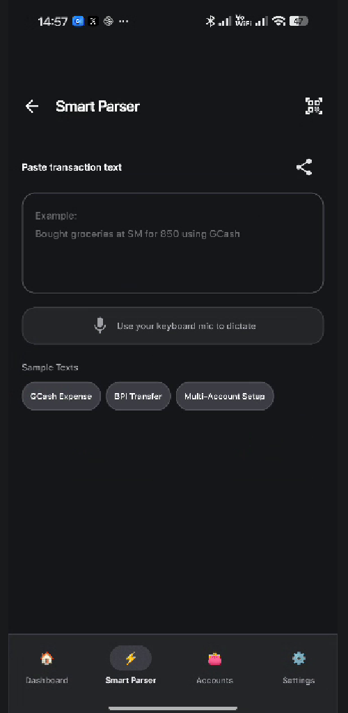
SMART PARSER
- the paste icon is share icon, change it to the right icon. It must be a clipboard
- there’s a bug, earlier when I said I have 20 pesos gcash right now and our AI named the account to “I have Gcash” it supposed to be Gcash only.
And they can set a name of that GCash account under that smart parser and other account creation, they can name it.
ACCOUNTS
- don’t put any other content in the accounts page, just a minimalist card that I showed you earlier with the floating add button for adding a new account
- when the card is clicked, there is an edit button to edit the account name and they can adjust the balance after that the user must confirm if they want to include it to transaction history or no
- quick add presets will show in the add account modal, not in the bottom of the accounts page

SETTINGS
- make the theme of the system default is white, and it can be changed in the settings either follow the device theme or choose for light theme and dark theme.
- the financial glossary is jumping when I try to scroll down to check for more glossary, fix that
- add more knowledge to the glossary

ADDING TRANSACTION
- remove the back bottom completely, add x button to the upper right side.

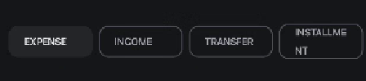
- the cards is not uniform because of long words, fix this, keep it one row.
- on the accounts, make it cards, not a dropdown like this
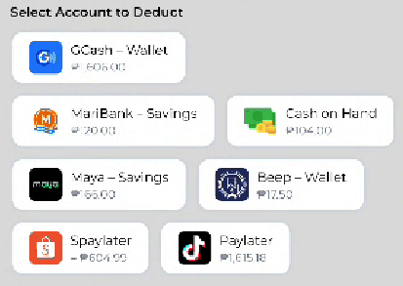

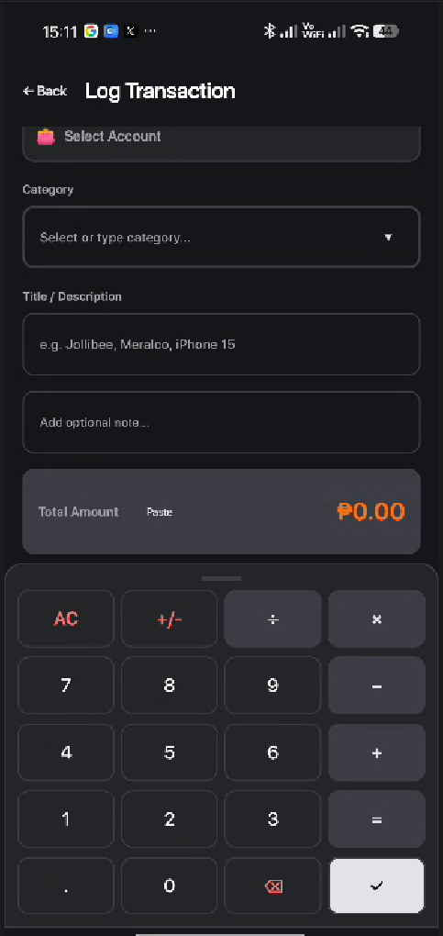
The calculator is always at the bottom of the log transaction page, make it only appear or slide up when the amount or the last thing to fill in is clicked. There is also a bug to it, it’s not working, it doesn’t work when I click on the keyboard. Make sure also that the keyboard can do basic math calculations, include a pop-up if the calculation is invalid or invalid mathematical expression.
- remove the paste text or button on the amount, just make they can paste number on the amount field.
- make the calculator can slide down if the upper lid of the calculator is touch to down
-

