THIRD TESTING
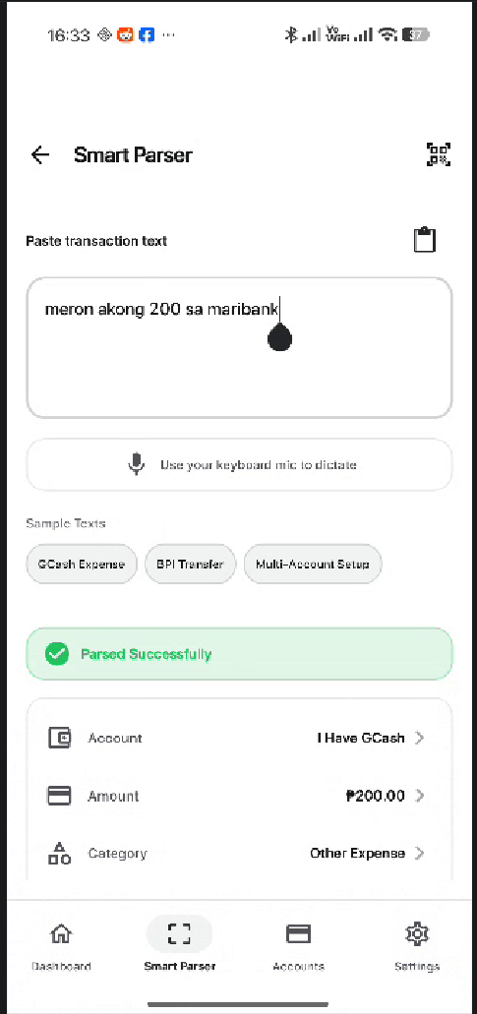
SMART PARSER
- there is a huge gap like from the dashboard between the name of the page and my phone’s tool bar. Fix it
- remove entirely the back button and the qr scanning buttons
- I use tagalog words and tried dictate of my gboard, it does input and I modify some of the text on the text but it parsed automatically, make it submit first before reading by our AI
- I think that our AI doesn’t understand really understand the input properply. For example in the image, it adds on the gcash account but the text said he has a 200 in maribank (no maribank account yet)
- add a clear text icon on the top right corner inside the text box
- make the use your keyboard dictation as a tip, small tip outside bottom right corner of the text box.
- for the sample texts or formats, move it to the top of the text box, make it before the transaction text label

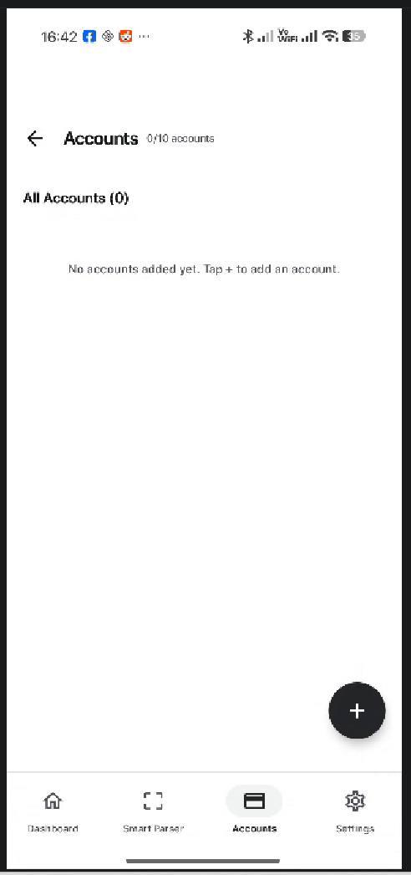
ACCOUNTS
- there is a huge gap like from the dashboard between the name of the page and my phone’s tool bar. Fix it
- remove the back button at the top
- remove the 0/10 accounts text beside the title of the page
- remove entirely the all accounts label at the top

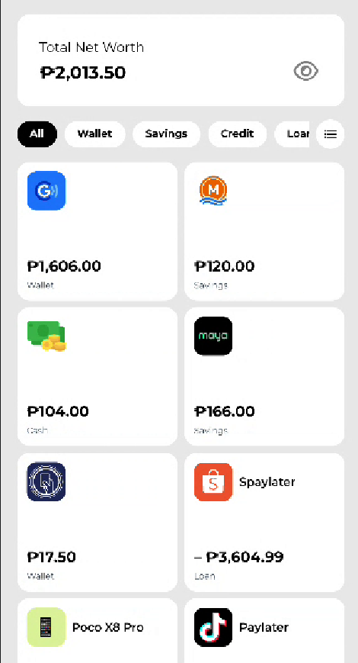
- this is from the other budget app, I want the account page look like this, make the category filter like that (show all the category of the accounts that we have) and the cards of the accounts look like this but reduce a bit the height so the amount and icon are not far
- add the total net worth to the account page, same at the top
- remove the cta floating from our current account page, replace it with like this

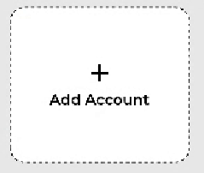

ADD ACCOUNT MODAL
- remove the presets at the top

When adding account
- the modal must be fields first of the name
- account type

OTHER FIXES
- change the wording of total balance to total net worth
- the theme settings is not working, it’s not changing

QUESTIONS
- how do we put the logo of the wallets so it will show in our app?

