Task: Database design
We choose: Variant 2: Database “Fitness Center Managment”

ER-Diagram:

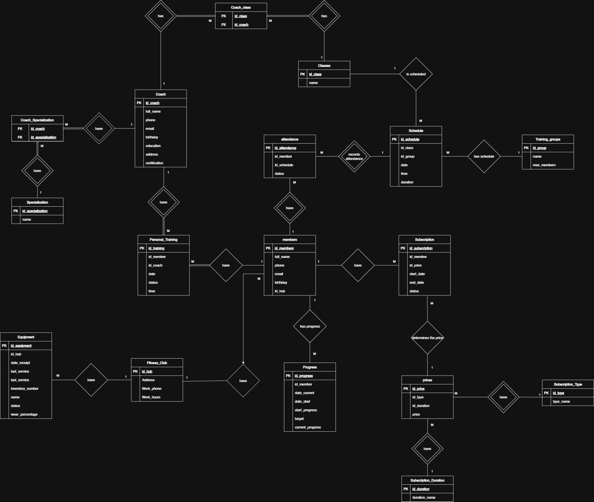

Picture1 ER - Diagram

The ER diagram shows the structure of a database for a fitness club information system. The database is designed to store information about club members, coaches, classes, schedules, subscriptions, prices, attendance, client progress, and equipment.
The main table is members, which stores data about fitness club clients: full name, phone number, email, date of birth, and the club to which the member belongs. The Fitness_Club table contains information about the club itself: address, work phone, and working hours. One fitness club can have many members and many pieces of equipment, so it has a one-to-many relationship with the members and Equipment tables.
The Coach table stores information about coaches: full name, contact details, education, address, and certification. Coaches can have different specializations, so the Specialization table and the intermediate Coach_Specialization table were created for this purpose. This makes it possible to implement a many-to-many relationship, because one coach can have several specializations, and one specialization can belong to different coaches.
The Classes table was created for training classes, and the intermediate Coach_class table is used to connect coaches with classes. It shows which coaches can conduct certain classes. The schedule itself is stored in the Schedule table, where the class, group, date, time, and duration are specified. The Training_groups table contains information about groups and the maximum number of members in them.
Members’ attendance is recorded in the attendance table. It connects a specific member with a specific schedule record and stores the attendance status. The Personal_Training table is used for personal training sessions, where the member, coach, date, time, and training status are specified.
Client subscriptions are stored in the Subscription table. It contains information about the member, selected price, start date, end date, and subscription status. The Prices table was created for prices, and it is connected with the Subscription_Type and Subscription_Duration tables. Because of this, the subscription type and duration are not duplicated in the main subscription table, but are defined through separate reference tables.
The database also includes the Progress table, which is used to store information about members’ progress: initial state, goal, current result, and related dates. Overall, this database structure is logical, because all main fitness club entities are separated into individual tables, and many-to-many relationships are implemented through intermediate tables. This helps avoid data duplication and makes the database more convenient for further use.

Joins
In the created ER diagram, relationships are established between the tables to show how the data is connected.
The Fitness_Club table has a one-to-many relationship with the members table, because one fitness club can have many members, but each member belongs to only one club. Fitness_Club also has a one-to-many relationship with the Equipment table, because one club can have many pieces of equipment.
The Coach table is connected to the Personal_Training table by a one-to-many relationship. This means that one coach can conduct many personal training sessions. The members table also has a one-to-many relationship with Personal_Training, because one member can register for many personal training sessions.
A many-to-many relationship between Coach and Specialization is implemented through the intermediate table Coach_Specialization. This is needed because one coach can have several specializations, and one specialization can belong to many coaches.
There is also a many-to-many relationship between Coach and Classes through the Coach_class table. One coach can conduct many classes, and one class can be conducted by different coaches.
The Classes table has a one-to-many relationship with the Schedule table, because one type of class can appear many times in the schedule. The Training_groups table also has a one-to-many relationship with Schedule, because one group can have many classes in the schedule.
The Schedule table is connected to attendance by a one-to-many relationship. This means that one scheduled class can have many attendance records. The members table is also connected to attendance by a one-to-many relationship, because one member can have many attendance records.
The members table has a one-to-many relationship with the Progress table, because one member can have many records about their progress.
The members table also has a one-to-many relationship with the Subscription table, because one member can have several subscriptions during different periods of time.
The Prices table has a one-to-many relationship with the Subscription table, because one price can be used by many subscriptions. The Subscription_Type table has a one-to-many relationship with Prices, because one subscription type can have different prices depending on the duration. The Subscription_Duration table also has a one-to-many relationship with Prices, because one duration can be used for different subscription types.
Therefore, the diagram uses 1:M and M:M relationships. Many-to-many relationships are implemented through intermediate tables, which makes the database more correct and reduces data duplication.
Some intermediate tables use composite primary keys. This means that the primary key consists of two fields at the same time, not only one field. In this database, composite primary keys are used in the Coach_Specialization and Coach_class tables.

DBML Diagram
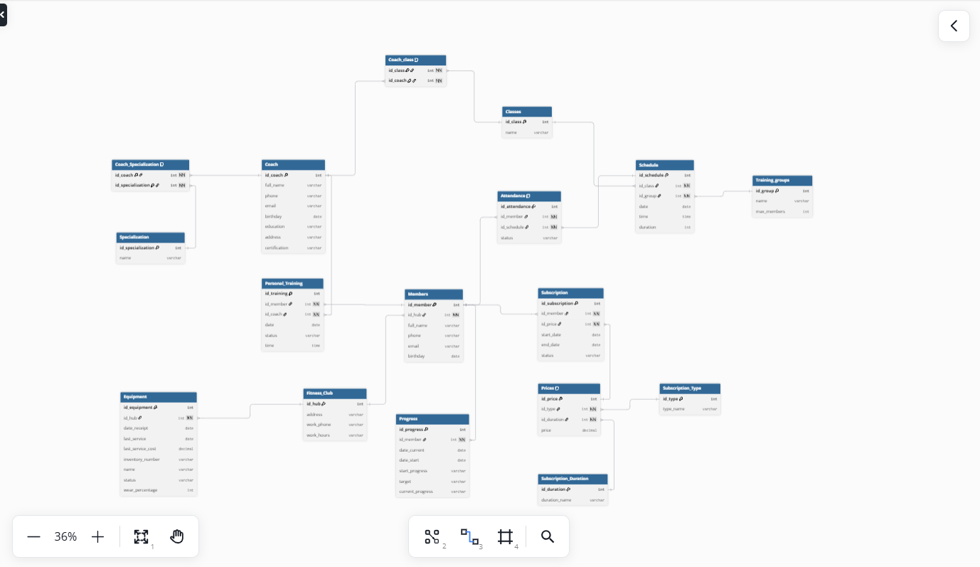
Picture 2 DBML Diagram
DBML Code:
Table Coach {
id_coach int [pk]
full_name varchar
phone varchar
email varchar
birthday date
education varchar
address varchar
certification varchar
}

Table Specialization {
id_specialization int [pk]
name varchar
}

Table Coach_Specialization {
id_coach int [not null, ref: > Coach.id_coach]
id_specialization int [not null, ref: > Specialization.id_specialization]

indexes {
(id_coach, id_specialization) [pk]
}
}

Table Classes {
id_class int [pk]
name varchar
}

Table Coach_class {
id_class int [not null, ref: > Classes.id_class]
id_coach int [not null, ref: > Coach.id_coach]

indexes {
(id_class, id_coach) [pk]
}
}

Table Fitness_Club {
id_hub int [pk]
address varchar
work_phone varchar
work_hours varchar
}

Table Equipment {
id_equipment int [pk]
id_hub int [not null, ref: > Fitness_Club.id_hub]
date_receipt date
last_service date
last_service_cost decimal
inventory_number varchar [unique]
name varchar
status varchar
wear_percentage int
}

Table Members {
id_member int [pk]
id_hub int [not null, ref: > Fitness_Club.id_hub]
full_name varchar
phone varchar
email varchar
birthday date
}

Table Personal_Training {
id_training int [pk]
id_member int [not null, ref: > Members.id_member]
id_coach int [not null, ref: > Coach.id_coach]
date date
status varchar
time time
}

Table Training_groups {
id_group int [pk]
name varchar
max_members int
}

Table Schedule {
id_schedule int [pk]
id_class int [not null, ref: > Classes.id_class]
id_group int [not null, ref: > Training_groups.id_group]
date date
time time
duration int
}

Table Attendance {
id_attendance int [pk]
id_member int [not null, ref: > Members.id_member]
id_schedule int [not null, ref: > Schedule.id_schedule]
status varchar

indexes {
(id_member, id_schedule) [unique]
}
}

Table Progress {
id_progress int [pk]
id_member int [not null, ref: > Members.id_member]
date_current date
date_start date
start_progress varchar
target varchar
current_progress varchar
}

Table Subscription_Type {
id_type int [pk]
type_name varchar
}

Table Subscription_Duration {
id_duration int [pk]
duration_name varchar
}

Table Prices {
id_price int [pk]
id_type int [not null, ref: > Subscription_Type.id_type]
id_duration int [not null, ref: > Subscription_Duration.id_duration]
price decimal

indexes {
(id_type, id_duration) [unique]
}
}

Table Subscription {
id_subscription int [pk]
id_member int [not null, ref: > Members.id_member]
id_price int [not null, ref: > Prices.id_price]
start_date date
end_date date
status varchar
}

