# Problem 1: Four-Arc Caplet

*Change TITLE to a descriptive problem that you have addressed*

## Input

*What is given? How is it represented? What does it mean? What are the assumptions and constraints?*

We started with four points that represent two circles. S is the center of one circle, with L being a point on the circumference, and E is the center of the second circle with R being on the circumference. One assumption is that point L will be above the line going through the centers of the two circles, and point R will be below that same line. More assumptions are that these two circles do not intersect and that circle S will be on the left side of the screen, and E on the right.

## Objectives

*What do you want to compute?*

From these two circles, we will compute the four-arc caplet. To do this, we will find the circular arc that connects point L with circle E, such that the arc is tangential to both at the point of intersection. We will do the same with point R and circle S, and then complete the shape by drawing the remaining arcs that lie on the original circles.

## Output

*How exactly will it be represented? How will it be visualized?*

The result will be a four-arc caplet outline, filled in with a color. The points can be moved around after initial calculation and the new caplet will be created with each new frame.

## Validation

*How will it be visualized? How will you know that your solution is correct?*

The result should be a smooth curve all the way around, and contain all four points, E, S, R, and L within a continuous shape. The caplet should completely cover the two original circles, and the edge of the caplet should not intersect with itself at any point.

## Outline of your approach

*High-level intuitive overview: no details, no special cases*

To accomplish this, we found the point where vectors normal to point L and circle E would meet such that the distance between this new point, Q, and the two circles would be equivalent. Then we did the same vector logic for point R and circle S. Once we had all of the appropriate points,

## Results

*When does it work? How well? When does it fail? Why?*

Our algorithm works in most cases if all our assumptions listed above are held true (Figure 1). The only case where it fails is when the two tangential arcs intersect each other. In that case, we do not get one continuous shape, but instead get three separate sections (Figure 2) because that is the shape that is defined by the four curves in that instance. All other failures are due to one of our assumptions not being true. If L and R are not on the correct side of the circle relative to line SE, then we fail to draw the correct arc on the original circles because we assume the arc will go clockwise around the shape, and in this case, it will actually go counter-clockwise (Figure 3). Lastly, if the original circles intersect, the caplet will be one continuous shape unless one of the points is found within the other circle (Figure 4). In this case, the outline of the caplet will intersect itself and therefore the drawing won’t be a smooth curve overall.

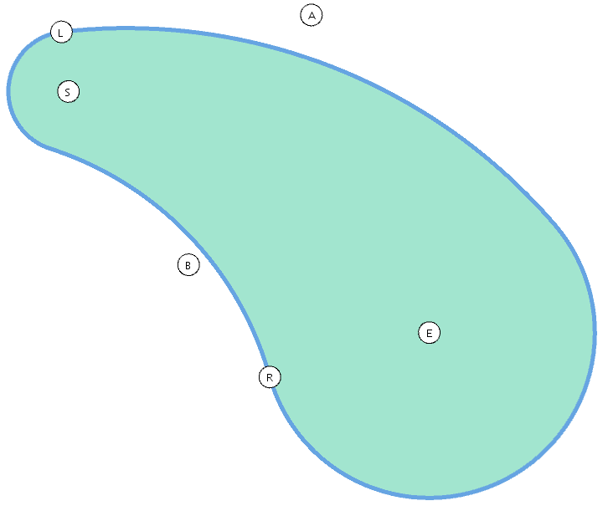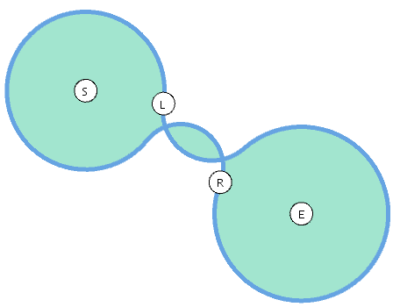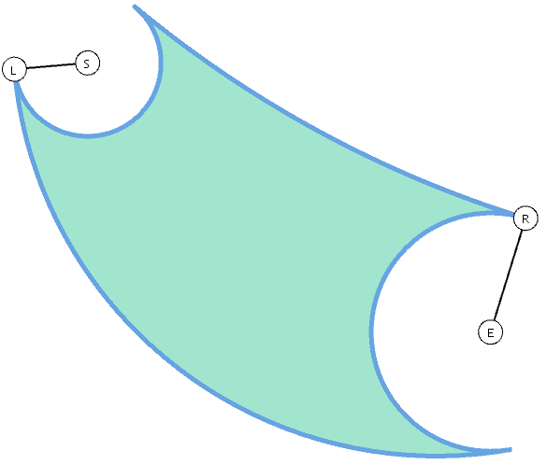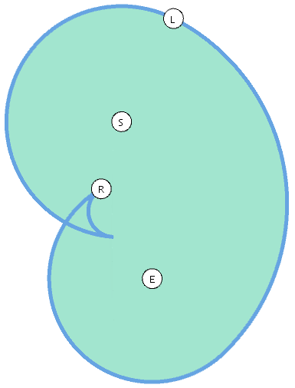

    Figure 1: Success          Figure 2: Intersecting arcs        Figure 3: L and R placement            Figure 4: Circles Intersect

## Details

*Math formulae for constructions (using point vector notation introduced in class, not coordinates!) Pseudocode of the algorithms. List of configurations that need to be distinguished, test for distinguishing them and brief overview of how each is handled.*

The mathematical formula for finding the radius, r, of the tangential circle is as follows, assuming points E, S, and L, radius |ER|=e, and tangent vector T = SL°:

r= (e2 - |EL|2) / (2 (EL · T))

Then, point Q is defined as:

Q = L + rT

And point M on circle E is:

M = E + eEQ°(tan-1(r/e))

The same equation is used to find the radius, r2, of the tangential circle from point R to circle S, assuming points E, S, and R, radius |SL|=s, and tangent vector T = ER°:

r2= (s2 - |SR|2) / (2 (SR · T))

Then, point Q2 is defined as:

Q2 = R + r2T

And point M2 on circle S is:

M2 = S + sSQ2°(tan-1(r2/s))

We then draw the arc by using points L, Q, M and R, Q2, M2 respectively to define the hats around them.

No special configurations needed to be distinguished that weren’t called out in our assumptions above.

## References

*Titles, Authors, and links to web sites or papers that have helped you. Add a short sentence explaining the merit of each.*

1. Rossignac, J. Blend between circles. 6491 2017 Slides Geometry, slide 79.
2. Fry, B. & Reas, C. Examples. <https://processing.org/examples/>

# Problem 2: Six-Arc Caplet

## Input

We started with four points that represent two circles as well as two points, A and B, to determine where the two tangent arcs will meet. S is the center of one circle, with L being a point on the circumference, and E is the center of the second circle with R being on the circumference. The assumptions for points S, E, L and R are the same as above: point L will be above the line going through the centers of the two circles, point R will be below that same line, the two circles do not intersect, and circle S will be on the left side of the screen, and E on the right. Other assumptions for this problem are that point A will be located above the line SE, and point B below it. Both points are also assumed to not be contained within either circle. Our solution can be performed by switching boolean b1 to false, and boolean b2 to true in the global variables section

## Objectives

From these two circles and exterior points, we want to compute the six-arc caplet that encompasses the two circles such that they are connected with arcs tangential to the circles and pass through points A, B, L and R.

## Output

The result will be a six-arc caplet outline, filled in with a different color. The points can be moved around after initial calculation and the new caplet will be created with each new frame.

## Validation

The result should be a smooth curve all the way around, and contain all six points, E, S, R, L, A and B within a continuous shape. The caplet should completely cover the two original circles, and the edge of the caplet should not intersect with itself at any point.

## Outline of your approach

To accomplish this, we will follow the same logic as for the four-arc caplet, but for each calculation, one of the two circles will be centered at point A or B, with a radius of zero. We will start by calculating the arc, as above, between point L and zero-radius circle A. Then we will calculate the arc between point A and circle E, such that the arc is tangent to the previous solution. We will repeat the same vector logic for points R and B and circle S.

## Results

Our algorithm works in most cases if all our assumptions listed above are held true (Figure 1). Similar to the four-arc caplet, our solution fails when any of the arcs intersect each other due to A and B being too close together (Figure 2). Should this happen, the caplet will no longer be one continuous shape, and will instead be divided into three separate sections.  It also fails when the second arc (e.g. from point B to circle S in Figure 3) needs to go all the way around the circle. This is due to the sign of the T vector not being respected. The new arc is tangent to the previously calculated arc (from circle E to point B), but since it starts in the opposite direction, it leaves us with a pointed shape instead of a smooth curve at point B and where that arc meets circle S in the example in Figure 3.

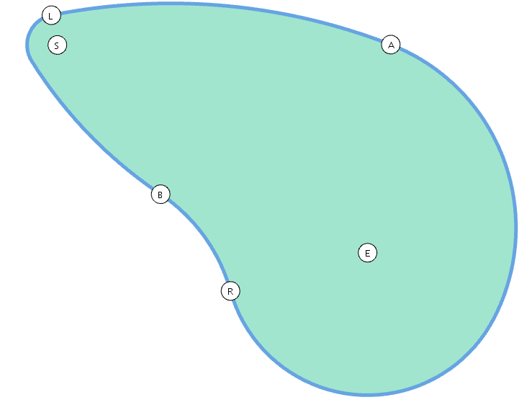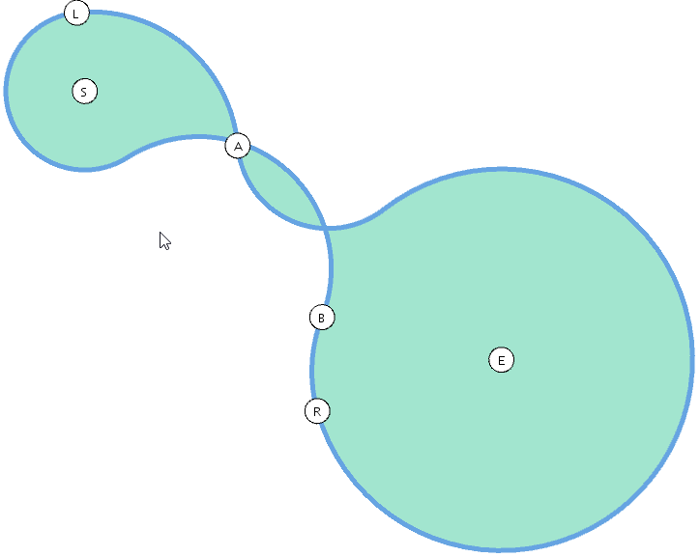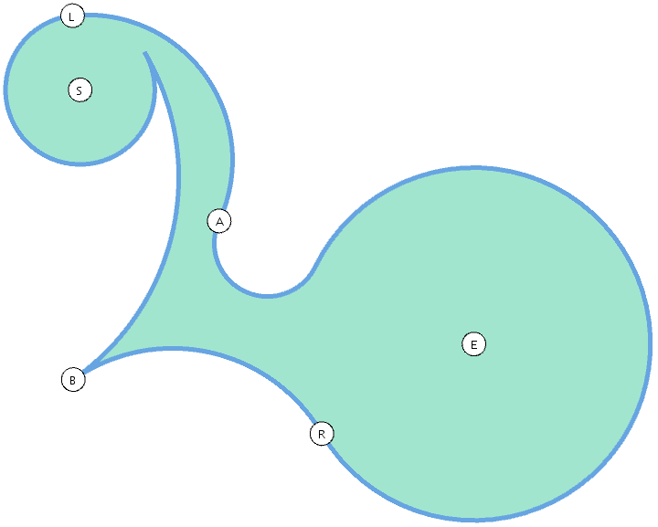

    Figure 1: Success       Figure 2: Intersecting arcs Figure 3: Tangent sign not respected

## Details

The mathematical formula for finding the radius, r, of the tangential circle that goes through point A is as follows, assuming points E, S, R, L, and A, radii |SL|=s and |ER|=e, and tangent vector T = SL°:

r= ( - |AL|2) / (2 (AL · T))

Then, point Q is defined as:

Q = L + rT

The formula for finding the radius, r2, of the circle tangent to circle E, that goes through point A, assuming a new tangent vector of T2 = QA:

r2= ( e2 - |EA|2) / (2 (EA · T2))

Point Q2 is calculated to be:

Q2 = A + r2T2

And then point M on circle E is defined as:

M = E + eEQ2°(tan-1(r2/e))

We then draw the two arcs by using points L, Q, A and A, Q2, M respectively to define the hats around them.

We then repeated the same vector formulas to calculate the arcs from point R, through point B, and on to be tangential to circle S simply by replacing points L, A, and E with R, B, and S, respectively.

No special configurations needed to be distinguished that weren’t called out in our assumptions above.

## References

1. Rossignac, J. Blend between circles. 6491 2017 Slides Geometry, slide 79.
2. Fry, B. & Reas, C. Examples. <https://processing.org/examples/>

# References & resources

*List papers, books, courses, software that may be useful.*

1. Rossignac, J. Blend between circles. 6491 2017 Slides Geometry, slide 79.
2. Fry, B. & Reas, C. Examples. <https://processing.org/examples/>