**LITM: Layer-Interpolating Tet Mesh**

## Project 5 for CS6491 – Fall 2017

## C:\Users\annag\AppData\Local\Microsoft\Windows\INetCache\Content.Word\Anna.jpg

**Anna Greene Dibyendu Mondal**

**ABSTRACT**

*The goal of this project is to invent, justify, implement, debug, and learn advanced algorithms that construct, display, process, and encode triangle (tri) meshes and tetrahedron (tet) meshes. Here, we review the goals achieved, an outline of our solution, an overview of prior art, and followed by a step-by-step description of our approach.*

# Problem Statement

Given two clouds of balls located on two horizontal planes, we first aim to compute the Delaunay Tetrahedralization of the union of the balls. Each ball has a center (called ‘sites’) on one of the two planes (called the **floor** and the **ceiling**, respectively), and the edges between the balls will be represented as tubes with the same radius.

Then, we will compute a high-resolution water-tight triangle mesh that approximates the boundary of the union of all balls and tubes and render this mesh using smooth shading with both visible and hidden silhouettes drawn.

# Goals Achieved

So far, we have successfully calculated the Delaunay Tetrahedralization of the given clouds of balls. The rendering of the mesh using smooth shading will take place in the next stage of the project.

To find the Delaunay Tetrahedralization, we first find the Delaunay Triangulation of the clouds of points on the floor and on the ceiling, displayed in orange and green, respectively, in Figure 1. Then, we loop once over the points on the opposite plane in order to determine the edges that connect the two planes, displayed in cyan in Figure 2. Figure 2 shows the tubes at their appropriate radius, which is the desired result.

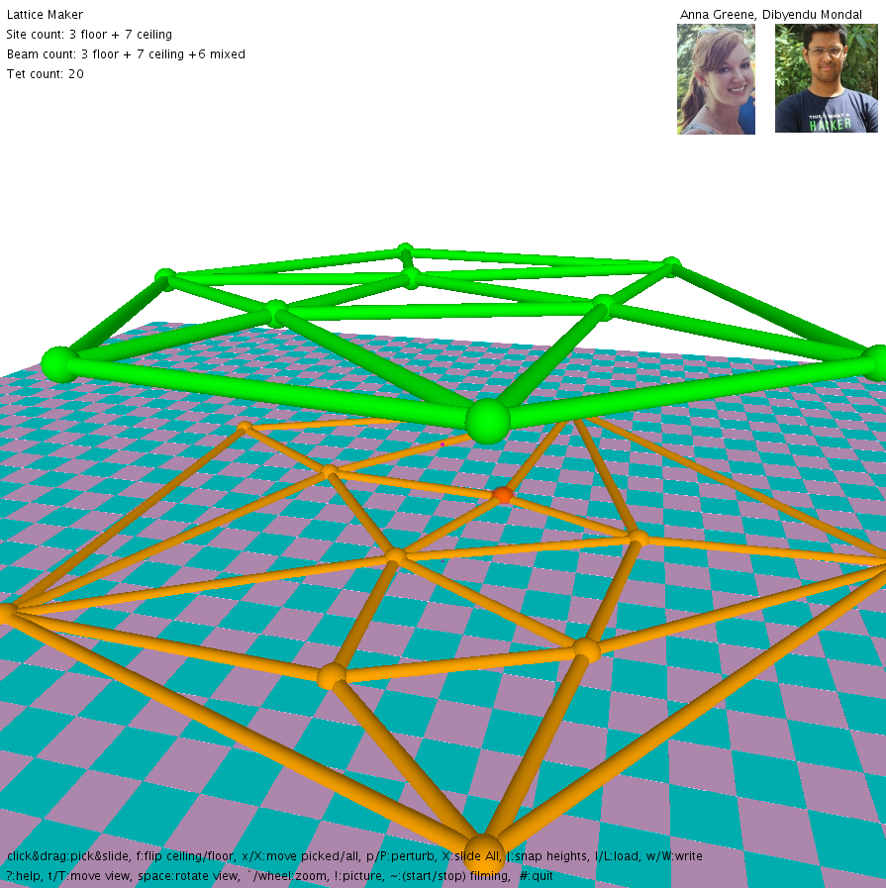 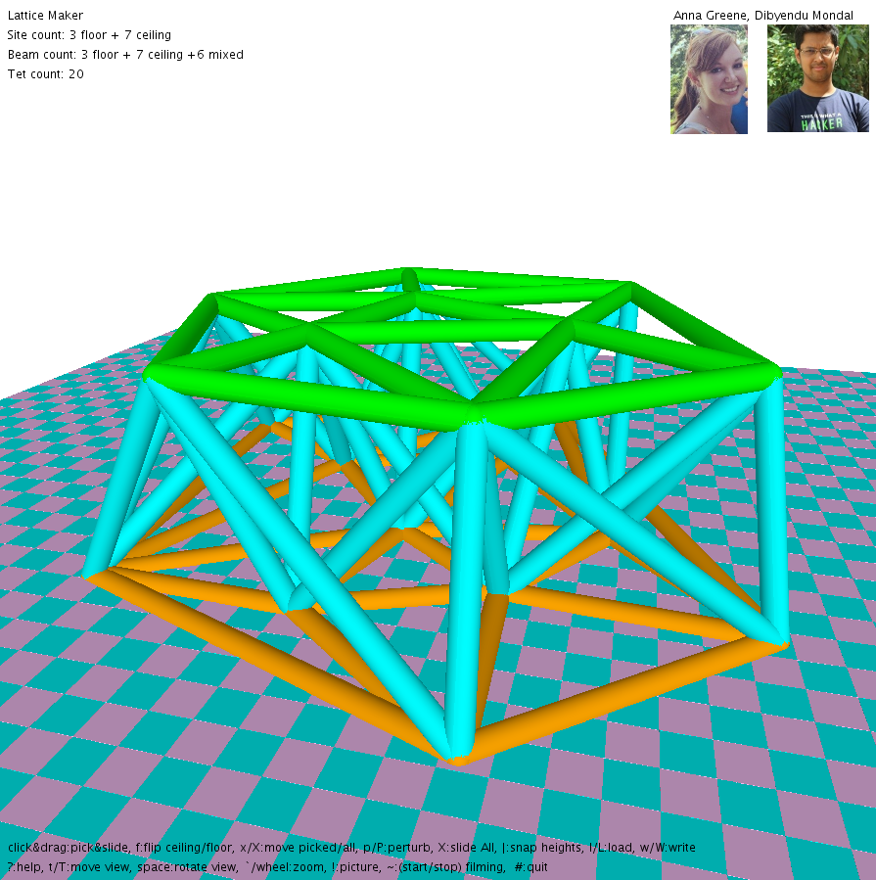

Fig 1. Delaunay Triangulation of the clouds of points on the floor (orange) and the ceiling (green).

Fig 2. Delaunay Tetrahedralization of the union of the clouds of points on the floor and the ceiling.

Given the following loop structure to determine points A, B, and C that define a triangle on one of the planes and a fourth point M on the other plane, our solution has a complexity of n4:

for (int i = 0; i < P.nv; i++) {

for (int j = i+1; j < P.nv; j++) {

for (int k = j+1; k < P.nv; k++) {

pt A = P.G[i];

pt B = P.G[j];

pt C = P.G[k];

...

for (int m = 0; m < P.nv; m++) {

pt M = P.G[m];

...

}

}

}

}

Since we store each triangle as we find it, our code to determine the tetrahedralization between the two planes loops over those existing triangles and all points on the other plane once, which has a complexity of n2. Since n2 < n4, our overall complexity remains n4.

Our solution, however, assumes the following restrictions on the input. First, we need at least three balls on each plane, and the balls must be pairwise disjoint. We also assume a general configuration, where no four balls in a plane can lie on the same circle.

Given these restrictions, our solution is reliable. Given the n4 complexity, there is a limit to the number of balls that can be provided as input in the two clouds, as our program will slow drastically as more balls are added.

# Outline of Solution

To find the Delaunay Tetrahedralization of union of all the sites on the two planes, we first find the triangle mesh of each of the two clouds of balls, and then continue on to find the tubes that connect the floor to the ceiling. To find the Delaunay Triangulation, we first calculate the circumcenter between any three balls (A, B, C) on the plane (first on the floor, then on the ceiling). Then we use a simple distance equation to determine if there is any fourth ball within that circle. If there is no fourth ball closer to the circumcenter that the three balls used to define it in the first place, then we store that triangle in either array Ptriangles or array Qtriangles, and store the tubes AB, BC, and AC in Ptubes or Qtubes to be drawn in a later routine.

Then to calculate the tetrahedral mesh, we calculate the circumcenter for a sphere between three points defined by one of our stored triangles (A, B, and C) and a fourth point (D) on the other plane. Once we have the circumcenter, we calculate the **bulge**, which we define as the vertical distance between the plane the triangle lives on and the “top” of the circle, which will be beyond the other plane. For example, while looping over Ptriangles, the bulge will be the distance between the floor, and the top of the circle, which lies above the ceiling. This bulge distance will always be larger than the distance between the floor and ceiling. When we find the smallest bulge for a given triangle, we store the edges DA, DB, and DC in array QPtubes to be drawn in a later routine.

# Prior Art

In the paper by Li and Teng [12], they provide a refinement-based algorithm to generate well-shaped Delaunay meshes. The algorithm majorly has 4 components:

Enforce Empty Encroachment: For any encroached boundary segment, add its midpoint and update the Delaunay triangulation. For any encroached boundary triangle, add its circumcenter c and update the Delaunay triangulation. If c encroaches any boundary segment, they split the encroached boundary segment instead of adding c.

Clean Bad Elements: For any bad tetrahedron T, find a point p in its picking region whose insertion avoids creating small slivers. If such p does not exist, then add the circumcenter CT of T. Here, tetrahedra with a large radius-edge ratio have priority over slivers to be split. If the circumcenter CT encroaches boundary, they either Encroach Equatorial Sphere or Encroach Diametric Sphere.

In the paper by Lee and Schachter [9], they provide two algorithms for constructing a triangulation over a planar set of N points. The first algorithm is a divide and conquer algorithm which runs in *O(NlogN)* time and the second algorithm is an iterative algorithm which runs in *O(N2)* time.

The first algorithm stores an ordered adjacency list of points vi1, vi2, vi3, … where (vi,vij) j = 1,…,k is a Delaunay edge. First, they sort the set of N points in lexicographically ascending order. Next, they divide the set into two equal subsets such that the first sorted half is in the first set and the second sorted half is in the second set. Next, they recursively construct the Delaunay triangulations. To merge the two triangulations, they use the convex hull of the union of those two sets.

The second algorithm iteratively triangulates a set of points within a rectangular region. If the point set does not include all four vertices of the rectangle, the missing vertices are implicitly added. The algorithm uses the swapping approach developed by Lawson.

# Step-by-Step Approach

Here, we will give an in-depth description of the methods that we created.

pt circumCenter(pt A, pt B, pt C)

{

  pt M = P(A, 0.5, V(A, B));

  vec N = cross(V(A, B), V(A, C));

  vec V0 = U(cross(N, V(A, B)));

  pt H = P(A, 0.5, V(A, C));

  vec AM = V(A, M);

  vec AH = V(A, H);

  float s = (dot(AH,AH) - dot(AM, AH))/(dot(V0, AH));

  pt center = P(M, s, V0);

  return center;

}

We represent the center of the circumcircle as P = M + s*V, where M is the midpoint of the edge AB, V is the vector perpendicular to edge AB and in the direction of the center, s is the distance from M to the center.

M = (A+B)/2 since it’s the midpoint of the edge AB.

V = (ABxAC)xAB which is perpendicular to the normal of the triangle and the edge AB.

Let H = (A+C)/2 be the midpoint of AC.

AP = P-A

= M + s*V – A

= AM + s*V

Also, AP.AH = AH.AH (since projection of AP on AH is AH)

* (AM+s*V).AH = AH.AH
* s = (AH.AH-AM.AH)/V.AH

Now we have the values of M, s and V, so we can find P which is M+s*V

pt circumCenter(pt A, pt B, pt C, pt D)

{

  pt center;

  pt P = circumCenter(B,C,D);

  pt P0 = circumCenter(A,B,C);

  float s = dot(V(P,P0),V(C,A))/(dot(U(cross(V(C,D),V(C,B))),V(C,A)));

  center = P(P,s,U(cross(V(C,D),V(C,B))));

  return center;

}

First, we find the circumcenter of 2 triangles.

P = circumCenter(B, C, D) and

P0 = circumCenter(A, B, C)

The circumcenter of the sphere Q = P + s*V

where V = CDxCB/|CDxCB| i.e. normal to the triangle BCD

P + s*V = P0 + s’*V’

where V’ = CAxCB/|CAxCB|

Now, do a dot product with CA on both the sides, we get,

P.CA + s*V.CA = P0.CA + 0 (since V’ is perpendicular to CA)

=> s = PP0.CA/V.CA

boolean isInCircle(pt A, pt center, pt point)

{

  if(d(point,center) <= d(A,center))

    return true;

  else

    return false;

}

Here, we check if the distance between the point to the center is <= the distance from one of the points on the circle to the center, then we return true else we return false.

pt findBulge(pt A, pt B, pt C, int num)

{

  pt minPt = P(0,0);

  if(num == 1)

  {

    pt D = Q.G[0];

    pt quadCenter = circumCenter(D,A,B,C);

    pt triCenter = circumCenter(A,B,C);

    float bulge = d(triCenter,quadCenter) + d(D,quadCenter);

    float min = bulge;

    minPt = D;

    for(int n = 1; n < Q.nv; n++)

    {

      D = Q.G[n];

      quadCenter = circumCenter(D,A,B,C);

      triCenter = circumCenter(A,B,C);

      bulge = d(triCenter,quadCenter) + d(D,quadCenter);

      if(min > bulge)

      {

        min = bulge;

        minPt = D;

      }

    }

  }

  else

  {

   ……

  }

  return minPt;

}

To find the bulge, we first find the circumcenter of the quad ABCD and the circumcenter of the triangle ABC.

bulge = distance from point on ceiling to circumcenter of ABCD + distance from circumcenter of ABCD to circumcenter of ABC

We iterate through all the points on the ceiling to find the point with minimum bulge

void addTube(pt A, pt B, int num)

{

  boolean flag = false;

  if(num == 0)

  {

    for(int i = 0; i < Ptubes.nv; i+=2)

    {

      if((A.x == Ptubes.G[i].x) && (A.y == Ptubes.G[i].y) && (A.z == Ptubes.G[i].z) && (B.x == Ptubes.G[i+1].x) && (B.y == Ptubes.G[i+1].y) && (B.z == Ptubes.G[i+1].z))

      {

        flag = true;

        break;

      }

    }

    if(!flag)

    {

      Ptubes.addPt(A);

      Ptubes.addPt(B);

    }

  }

  else if(num == 1)

  {

    ……

  }

  else if(num == 2)

  {

    ……

  }

}

To add a tube from A to B, we check if a tube already exists from A to B, if not then we add it.

Now, since we are done with the details of the helper functions, we will give an in-depth detail of our main code.

  for(int i = 0;i < P.nv; i++)

  {

    for(int j = i+1; j < P.nv; j++)

    {

      for(int k = j+1; k < P.nv; k++)

      {

        pt A = P.G[i];

        pt B = P.G[j];

        pt C = P.G[k];

        pt center = circumCenter(A,B,C);

        boolean flag = false;

        for(int m = 0; m < P.nv; m++)

        {

          pt M = P.G[m];

          if(M == A || M == B || M == C)

            continue;

          else

          {

            if(isInCircle(A,center,M))

            {

              flag = true;

              break;

            }

          }

        }

        if(!flag)

        {

          addTube(A,B,0);

          addTube(B,C,0);

          addTube(A,C,0);

          Ptriangles.addPt(A);

          Ptriangles.addPt(B);

          Ptriangles.addPt(C);

        }

      }

    }

  }

  for(int i = 0; i < Ptriangles.nv; i+=3)

  {

    pt A = Ptriangles.G[i];

    pt B = Ptriangles.G[i+1];

    pt C = Ptriangles.G[i+2];

    pt minPt = findBulge(A,B,C,1);

    addTube(minPt,A,2);

    addTube(minPt,B,2);

    addTube(minPt,C,2);

  }

Here, first we iterate through the points thrice and find the circumcenter of those three points. Next, we check if any point on the same plane lies inside the circumcircle of those three points. If not, then we add a tube/beam between those points. We also store those three points as a new triangle.

Next, we iterate through the triangles and find the minimum bulge point on the other plane and add a tube/beam from the minimum bulge point to the other three points.

# Resources

Circumspheres:

[1] <http://mathworld.wolfram.com/Circumsphere.html>

[2] <http://www2.washjeff.edu/users/mwoltermann/Dorrie/70.pdf>

[3] [https://www.jstor.org/stable/2973351?seq=1#page_scan_tab_contents](https://www.jstor.org/stable/2973351?seq=1&amp;page_scan_tab_contents)

Tetrahedralization:

[4] <http://wias-berlin.de/software/tetgen/examples.dragon.html>

Parallelization:

[5] [https://www.cs.cmu.edu/~glmiller/Publications/TalmorMiTeng93.pdf](https://www.cs.cmu.edu/%7Eglmiller/Publications/TalmorMiTeng93.pdf)

Slivers:

[6] <http://www.iue.tuwien.ac.at/phd/fleischmann/node55.html>

Ball pivoting triangulation:

[7] [http://web.cs.ucdavis.edu/~amenta/w11/DTapp.pdf](http://web.cs.ucdavis.edu/%7Eamenta/w11/DTapp.pdf)

Triangulation of 3D surfaces from points:

[8] <https://www.cs.purdue.edu/homes/aliaga/cs334-15fall/lectures/lec-voronoi-and-triangulation.pdf>

[9] <https://link.springer.com/article/10.1007/BF00977785>

[10] <https://dl.acm.org/citation.cfm?id=276894>

[11] <https://math.stackexchange.com/questions/1858388/tetrahedron-signed-distance-between-circumcenter-and-face>

[12] <https://dl.acm.org/citation.cfm?id=365416>

[13] https://arc.aiaa.org/doi/pdfplus/10.2514/6.1987-1124

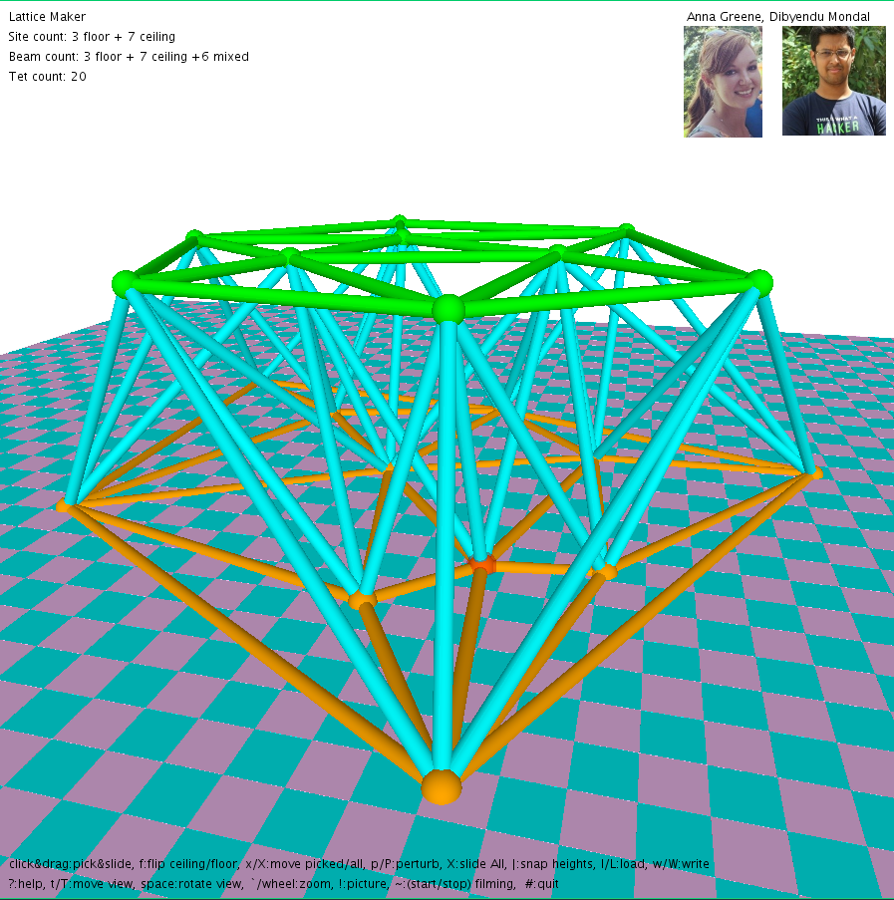 

# Due date and deliverables

The **final version of the project is due on November 28** before class (Early draft due Nov. 14. See below). It must be submitted online onto T-Square. One submission per team of one or two members.

The submission must include the following:

* + A zip of the **sketch**, including data and image files needed to run the sketch. Please, do not include in the zipped folder images or videos that are not necessary to run it. Make sure that the code of the sketch has a clear structure and enough comments to understand where the specific parts/modules are and what they compute.
  + A brief **report** in PDF
  + A short **video** (<5mns) stating the problem, showing your solution and the animation of its construction, and explaining the nature of your approach (using graphics and animation as appropriate).

About the report:

* Give your project an original title, such as “SpaceBallRoller”
* Include a proper header with that title, names of the authors, reference to “CS6491 Fall 2017, Project 5”, and the date
* Include the headshots of the team members above their names
* A clear, concise, complete, and concrete **problem statement** formulated in your own words using mathematical concepts learned in class and assisted by images produced by your program
* A precise statement of your contributions and the level of completion of your solution: Have you solved the problem? If not, what is missing and why? If yes, characterize your results (asymptotic complexity, measured time average per ball, assumed restrictions on the input (such as for example that balls must be pairwise disjoint or that you need at least 3 balls on each plane, or that you assume a ‘general configuration’ where specific spatial alignments are forbidden), and comments on how reliable your solution is (does it crash and if so how often).
* A clear, but high level **outline** of the nature of your solution/approach. This should target a senior researcher in this field.
* A brief review of the most relevant prior art that you have found. Do not merely cite the work or include a section of their abstract. Instead, show that you have read the paper and that you were able to extract the parts that are relevant to this project. Discuss whether you have followed any of the ideas suggested in prior art or how your solution relates to them.
* A step-by-step guideline for a junior developer charged to implement this from scratch.

I encourage you to also create a personal web page where you will post this report and the video and to email the TA and me the link to these with the names of the team members and cc’ing them… in case we have comments. In fact, if you do it in advance of the deadline, we may try to give you early feedback.

NOTE: Each team must submit on T-Square an early **draft of your report** by **November 14**. This should include the most of the above, including the problem statement, the outline of your approach, the discussion of prior art, and at least some of the implementation details and results.

# Code provided

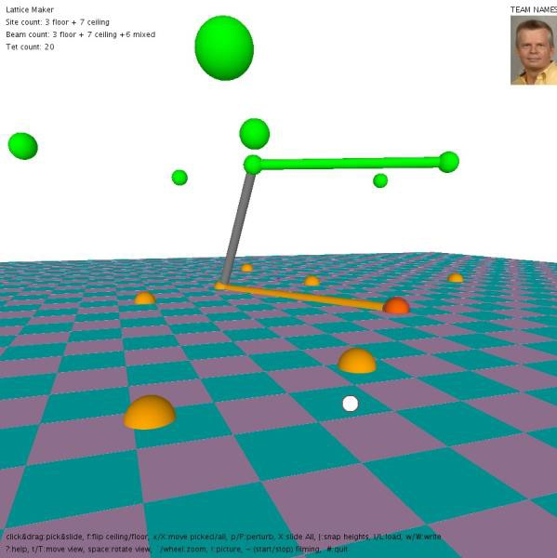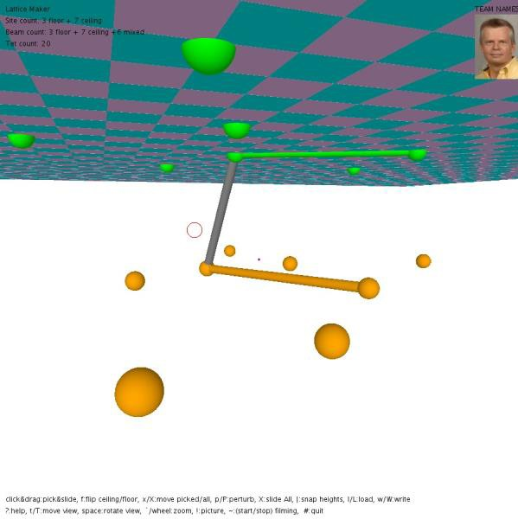The code provided lets you switch which plane is active by pressing ‘f’.

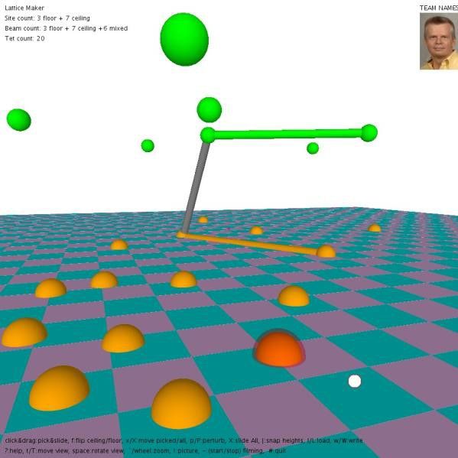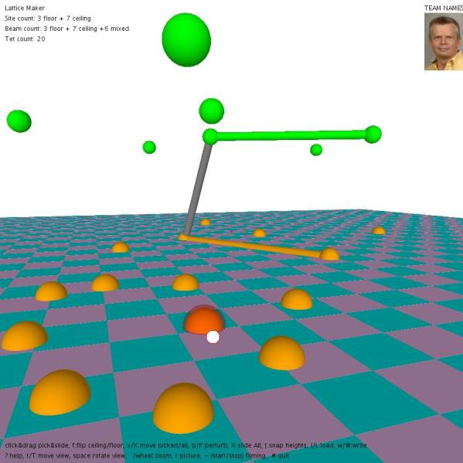You can click any of the balls in the active plane, slide it by dragging the mouse, add new balls (keep ‘a’ pressed and click where you want the new ball) or delete a ball (point and press ‘d’).

Add an action and two key presses: ‘p’ that perturbs the location of each ball on the active plane by a very small random amount and ‘P’ that perturbs it by a large random amount in x and y (cap the permutation to 100 or so, but avoid sites that fall outside of the drawn rectangle). These keys will be used to (1) avoid singular configurations and (2) keep you honest and make it easier to test your algorithms for a variety of input configurations.

You can switch between showing tubes with half-radius (‘h’), for clarity, and full radius (‘H’) when computing the bounding triangle mesh.

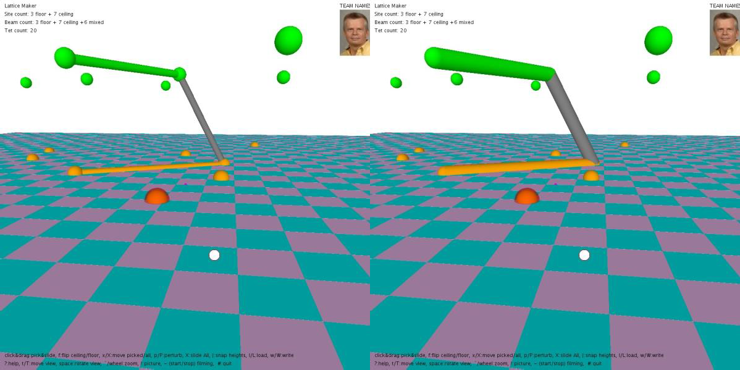

You can manipulate the view by sliding the red focus point (‘t’ + mouse drag) or dragging it up/down (‘T’), by zooming in/out (‘`’ + mouse move, not drag), and by rotating around the focus point (SAPCE + mouse move, not drag)