-By
Aman Goel
Anmol Arora
Dibyendu Mondal
Karan Vaidya
Pranjal Khare

Goal :

Design and simulate universal asynchronous receiver / transmitter circuit (UART) in Xilinx ISE. Implement the simulated design on ATLYS board.

System Specification :

System Clock- 100Mhz

Baud Rate- 19.2 KHz

Packet Format- Start bit, 8-bit Data, Stop bit

Functional Specification :

Data is transferred or received in serial fashion. Transmitter will get 8-bit data in parallel which should be transmitted 1-bit at a time using the format shown in figure. The transmission character is composed of an 8-bit data byte, sent LSB first, proceeded by a start bit (LOW) and followed by a stop bit (HIGH). Receiver will follow same format only difference is that it receive data in serial and convert it into 8-bit parallel data. When no character is being transmitted, the line remains idle (HIGH).

Functionality :

TX_UART :

- Initially the transmitter is in the idle state.
- The user sets the data bits appropriately and presses the switch to transmit.
- The data is then transmitted to the receiver after appending appropriate start and stop bits.

RX_UART :

- The clock of the receiver is a multiple of the bit rate, in PIC 16f877A,it’s x16 or x64. So, each bit is transmitted/received in 16 clock cycle.
- If the receiver detects a start bit for a period = bit period (16 clock cycles), then it waits for the period of half bit, and then sample the value on the RX pin and shift it in the receiving shift register.
- Every received bit is sampled at the middle of the bit’s time period. After the detection of a START bit, nine bits of serial data are shifted from the RX pin into the Receive Shift Register, one bit at a time.
- After the last bit has been shifted in, the STOP bit is checked and the data is moved into the FIFO buffer.

CLOCK_GEN :

- Used to create an enable signal at the rate equal to Baud Rate.
- It uses the system clock and a counter to do so.

State Transition Diagrams :

Transmitter :
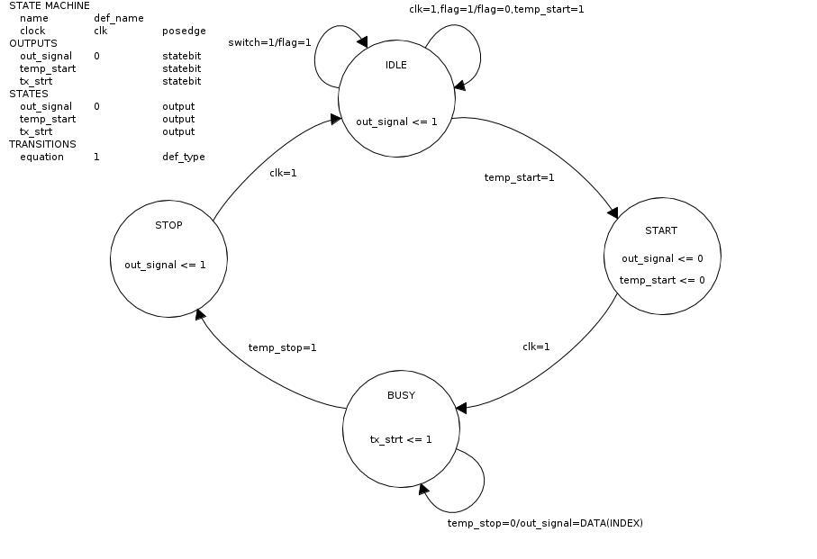
Receiver :

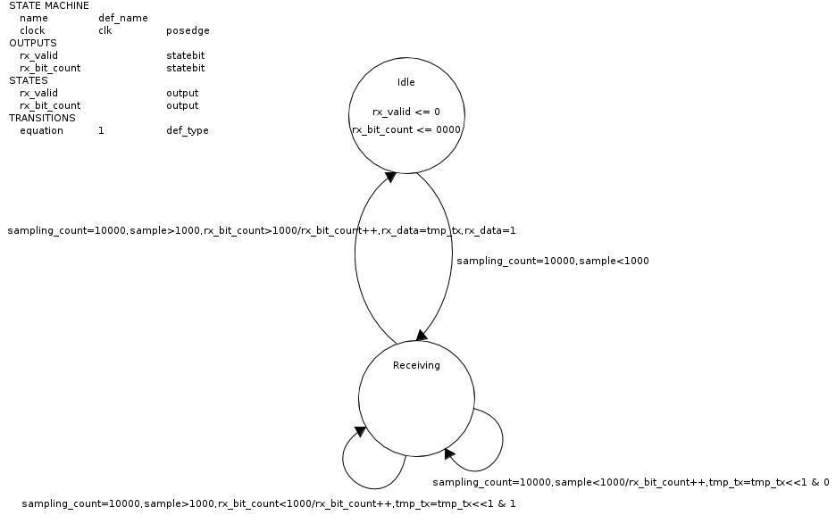

Clock Generator :

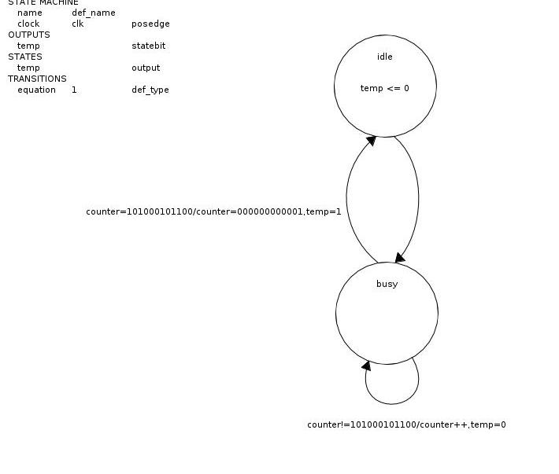
Inferences :

- Data cannot be transmitted at very high clock cycles. It is because of delay introduced by capacitors.
- Possible extensions could be parity checking.
- Interface that has been built can be used to control modules on FPGA using PC.

