**SRS**

Dan Beck

January 26, 2021

CMIS-330 6380

Prof. Abdulnasir Shash

SRS

# Introduction

## Purpose

The purpose of this system is for the client, or workers of the John and Jane B&B to be able to manage the reservations and to monitor expenses and profits. The system design will allow for the client to:

* check the calendar for vacancies and reservations
* store the customer’s name, address, phone number and credit card number
* Add and delete reservations for customers
* Assign reservations to each room number
* Store dates of reservations
* Agreed upon price per reservation
* Reservation option of 1 day’s payment
* Reservation option of reservation hold time before dropping

## Product Scope

The software products that are being used for this system will be a proprietary application called John and Jane’s B&B, that will be installed on an iPad, attached to a Square Stand allowing client to accept credit card payments. The application will be designed to accommodate for all items defined in the Purpose section of the document.

## References

* IEEE Recommended Practice for Software Requirements Specifications
* Square Stand: https://squareup.com/shop/hardware/us/en/products/ipad-pos-stand-credit-card-reader

## Overview

This document contains:

* Level 0 Data Flow Diagram (DFD)
* Level 1 Data Flow Diagram
* Entity Relationship Diagram
* Use Case Diagram
* State Diagram

# Overall Description

## Product Perspective

John and Jane’s B&B will be a mostly independent software that integrates with a Square Register and iPad, so that they can easily complete transactions without separate hardware. Because of this, the client will need to be sure that there is power and network connectivity at the location that they will be using this software.

## Product Functions

Product functionality will be broken down into:  
1. Calendar-Based Reservation Lookups  
2. Reservation Entry  
3. Reservation Removal  
4. Non-paid Reservation Guarantee Checks  
5. Guest Information Entry  
6. Payment Processing

Additional information regarding the functional decomposition or requirements can be seen in Appendix A/B (Level0/1 Data flow Diagrams), Appendix C (Entity Relationship Diagram), or in Appendix E (State Diagram).

## User Characteristics

The primary users of the John and Jane’s B&B are managers and front desk associates of the establishment. These users provide a level of service to customers based on four rooms, and reservations of those rooms. In addition, basic financial information must also be accounted for to ensure efficient monitoring of both profits and expenses within the establishment. More specific information regarding user characteristics can be seen in Appendix D (Use Case / Scenario Diagrams).

## Assumptions and Dependencies

For this application to operate, the assumptions made are:

1. The business provides an iPad onto which the software can be installed.
2. The business provides a telephone services to communicate with guests and provide the entry point for data into the system.
3. The business provides adequate infrastructure (power, Wi-Fi, etc.) for the iPad.

# Specific Requirements

## User Interfaces

The software should have the following user interface options:

1. Main menu – Displays choices to see guests, room status, calendar, reservations, checkouts, and finances.
2. Calendar – Shows a monthly calendar of reservations and vacancies, allowing users to change these as they are with or on the phone with a client.
3. Reservations – Shows a list of reservations, and the ability to add, change, or remove a reservation.
4. Finances – Tracks all the payments and expenses
5. Room Status – Shows the user the status of the room. Set to be cleaned after checkout. Set to be ready after cleaning.
6. Checkout – Shows the status of the client checkout. If the client needs to pay more for food, movies, etc.

## Hardware Interfaces

The hardware interfaces will be an iPad that can have the app installed on it and a square stand. No other hardware interface will be needed.

## Communications Interfaces

There needs to be an internet connection so that the app can be downloaded and so that payments can be processed with the square stand. It is assumed that the client will provide phone service.

## Classes/Objects

Below is an explanation of the features of each part of the program. An Entity Relationship Diagram can be found in Appendix C.

### Calendar

#### CalendarDateID

This is an integer ID that represents a unique record for a calendar date.

#### RoomID

A Reference to a unique Date ID. One-to-one relationship between Room and Calendar.

#### RoomAvailability

A SMALLINT that represents the if the room is available.

#### Date

A DATE that represents the date on the calendar.

### Date Range

#### DateRangeID

This is an integer ID that represents a unique record for a new date range that is requested by the guest.

#### DateID

Reference to a unique Date ID. One-to-multiple relationship between Calendar and Date Range

#### DaysRented

An INTEGER that represents the number of days that the guest will be renting the room.

### Guests

#### GuestID

This is an integer ID that represents a unique record for a new guest.

#### FirstName

A VARCHAR that represents the first name of the guest.

#### LastName

A VARCHAR that represents the last name of the guest.

#### Address

A TEXT that represents the address of the guest.

#### Telephone

A VARCHAR that represents the telephone of the guest.

#### CreditCard

An INTEGER that represents the credit card number of the guest.

### Room Info

#### RoomID

This is an integer ID that represents a unique record for each room.

#### RoomReady

A SMALLINT that represents if the room is clean and restocked.

### Reservation

#### ReservationID

This is an integer ID that represents a unique record for a new reservation.

#### DateRangeID

Reference to a unique DateRangeID. One-to-one relationship between Date Range and Reservations

#### GuestID

Reference to a unique GuestID. One-to-one relationship between GuestID and Reservations

#### RoomID

Reference to a unique RoomID. One-to-one relationship between RoomID and Reservations

#### ProcessedPayment

A SMALLINT that represents if the guest paid for the reservation in full.

#### PriceCharged

A DOUBLE that represents the charge of the reservation in total.

#### AmountLeft

A DOUBLE that represents total left for the guest to pay.

#### Taxes

A DOUBLE that represents the taxes charged for the reservation.

### Payments

#### PaymentID

This is an integer ID that represents a unique record for each payment.

#### ReservationID

Reference to a unique ReservationID. One-to-many relationship between Reservation and Payments.

#### TransactionAmount

A DOUBLE that represents the amount that was charged for that transaction.

### Guest Checkout

#### CheckoutID

This is an integer ID that represents a unique record for each checkout.

#### ReservationID

Reference to a unique ReservationID. One-to-one relationship between Reservation and Guest Checkout.

#### ExtraCharges

A DOUBLE that represents the amount that was charged in case the room was damaged or guests ordered movies, food, etc.

### Expenses

#### ExpenseID

This is an integer ID that represents a unique record for expenses.

#### CheckoutID

Reference to a unique CheckoutID. One-to-one relationship between Guest Checkout and Expenses.

#### ExtraCharges

A DOUBLE that represents the amount that was charged in case the room was damaged or guests ordered movies, food, etc.

## Functions

Below is an explanation of the functions of each part of the program. An Entity Relationship Diagram can be found in Appendix C.

### Calendar

#### requestDates()

Function that pulls requested dates that guest is asking for.

#### availabilityCheck()

Function that checks the requested dates against the availability of the calendar.

### Date Range

#### setDates()

Function that sends the requested dates to the calendar if they are available

### Guests

#### recallGuest()

Function that pulls up info from a returning guest.

#### newGuest()

Accepts parameters to enter new guest information.

#### newGuestAdd()

Adds new guest information to system.

### Room Info

#### roomReady

A function that checks if the room was cleaned and restocked.

### Reservation

#### setReservation()

Function that sends the reservation to the calendar after a payment has been made.

#### holdUntil()

Function that places a hold on a room before payment before a certain amount of time passes.

#### guestPayment()

Function that stores the payment details of whole reservation

#### downPayment()

Function that allows a hold to be placed on a room with partial payment.

### Payments

#### amountRemaining()

Function that calculates the remaining amount for the reservation after a payment has been made.

#### profitEarned()

Function that calculates and logs the profit after expenses.

### Guest Checkout

#### chargesToBill()

Function that adds charges to bill for extra expenditures.

### Expenses

#### roomExpense()

Function that stores expenses for room after checkout.

# Appendixes

## Appendix A: Level 0 Data Flow Diagram

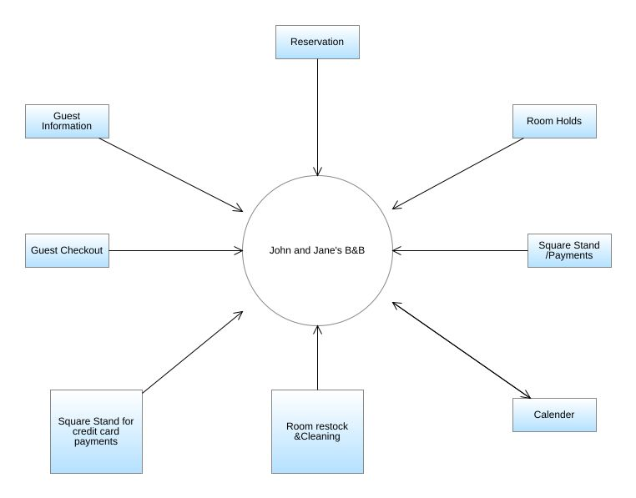

*Figure 1, Level0 Data Flow Diagram for John & Jane’s B&B*

## Appendix B: Level 1 Data Flow Diagram

*Figure 2, Level1 Data Flow Diagram for John & Jane’s B&B*

## Appendix C: ERD (Entity Relationship Diagram)

*Figure 3, Entity Relationship Diagram for John & Jane’s B&B*

## Appendix D: Use Case Diagram

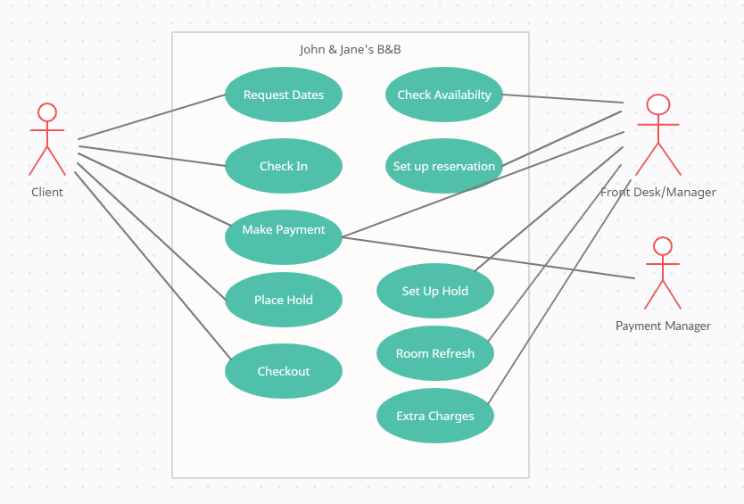

*Figure 4, Use Case Diagram for John & Jane’s B&B*

## Appendix E: State Diagram

*Figure 5, State Diagram for John & Jane’s B&B*

# References

Writing Software Requirements Specifications (SRS). (2019, July 10). Retrieved January 25, 2021, from https://techwhirl.com/writing-software-requirements-specifications/