**SDD**

Dan Beck

February 9th, 2021

CMIS-330 6380

Prof. Abdulnasir Shash

**SDD**

# Table of Contents

**1. Introduction ............................................................................................................................................** **4**  
 1.1 Purpose ............................................................................................................................................... 4  
 1.2 Scope................................................................................................................................................... 4  
 1.3 Definitions & Acronyms..................................................................................................................... 4 **2. References................................................................................................................................................ 5**  
**3. Data Model............................................................................................................................................... 6**  
 3.1 Calendar ............................................................................................................................................ 6  
 3.1.1 requestDates............................................................................................................................... 6  
 3.1.2 availabilityCheck....................................................................................................................... 6  
 3.2 Date Range………………………..................................................................................................... 7  
 3.2.1 setDates...................................................................................................................................... 7  
 3.3 Guests ................................................................................................................................................ 7  
 3.3.1 recallGuest................................................................................................................................. 7  
 3.3.2 newGuest................................................................................................................................... 7

3.3.2 updateGuest............................................................................................................................... 7

3.4 Room Info …………......................................................................................................................... 7  
 3.4.1 roomReady................................................................................................................................. 7

3.5 Reservation........................................................................................................................................ 8  
 3.5.1 setReservation............................................................................................................................ 8  
 3.5.2 holdUntil.................................................................................................................................... 8

3.5.3 guestPayment............................................................................................................................. 8

3.5.4 downPayment…………............................................................................................................. 8

3.6 Payments............................................................................................................................................ 8  
 3.6.1 amountRemaining...................................................................................................................... 8  
 3.6.2 profitEarned............................................................................................................................... 8

3.7 Guest Checkout ................................................................................................................................. 8  
 3.7.1 chargesToBill............................................................................................................................. 8

3.8 Expenses............................................................................................................................................. 9  
 3.8.1 roomExpense.............................................................................................................................. 9  
**4. Architectural Context Diagram..............................................................................................................9**  
 4.1 User Interface (iPad) ........................................................................................................................10

4.1.1 Calendar Lookup...................................................................................................................... 11  
 4.1.2 Guest Information.................................................................................................................... 11

4.1.3 Make Reservations................................................................................................................... 11

4.1.4 Payments.................................................................................................................................. 11

4.1.5 Checkout.................................................................................................................................. 11  
 4.1.6 Room Information.................................................................................................................... 11  
 4.2 Services.............................................................................................................................................11

4.2.1 Make Payment.......................................................................................................................... 12  
 4.2.2 Check Availability................................................................................................................... 12

4.2.3 Make Reservation.................................................................................................................... 12

4.2.4 Room Cleaning/Refresh........................................................................................................... 12

4.2.5 Extra Charges........................................................................................................................... 12  
 4.2.6 Hold Set-Up............................................................................................................................. 12  
 4.3 Database............................................................................................................................................12

4.3.1 Reservation............................................................................................................................... 12  
 4.3.2 Rooms...................................................................................................................................... 13

4.3.3 Guests....................................................................................................................................... 13

4.3.4 Finances................................................................................................................................... 13

4.3.5 Calendar................................................................................................................................... 13  
 4.3.6 Payments.................................................................................................................................. 13  
**5. Software Interface..................................................................................................................................14**  
 5.1 Calendar Lookup ..............................................................................................................................15

5.2 Guest Lookup ...................................................................................................................................16

5.3 Make Resrvation...............................................................................................................................17

5.4 Payments ..........................................................................................................................................18

5.5 Checkout ..........................................................................................................................................19

5.6 Room Information ............................................................................................................................20

# Introduction

## 1.1 Purpose

The purpose of this system is for the client, or workers of the John and Jane B&B to be able to manage the reservations and to monitor expenses and profits. The system design will allow for the client to:

* check the calendar for vacancies and reservations
* store the customer’s name, address, phone number and credit card number
* Add and delete reservations for customers
* Assign reservations to each room number
* Store dates of reservations
* Agreed upon price per reservation
* Reservation option of 1 day’s payment
* Reservation option of reservation hold time before dropping

## 1.2 Product Scope

The software products that are being used for this system will be a proprietary application called John and Jane’s B&B, that will be installed on an iPad, attached to a Square Stand allowing client to accept credit card payments. The application will be designed to accommodate for all items defined in the Purpose section of the document.

## 1.3 Definitions

This document contains for the scope of this document, the following definitions and lexicon should be noted:

*Design Entity:* An element (component) of a design that is structurally and functionally distinct from other elements and that is separately named and referenced.

*Design View:* A subset of design entity attribute information that is specifically suited to the needs of a software project activity.

*Entity Attribute:* A named characteristic or property of a design entity. It provides a statement of fact about the entity.

*Software Design Description (SDD):* A representation of a software system created to facilitate analysis, planning, implementation, and decision making. A blueprint or model of the software system. The SDD is used as the primary medium for communicating software design information.  
*Reservation:* A room that has been guaranteed to a guest for a specific date range.  
*Service:* Something that performs business logic.  
*User interface:* The graphical element that lets users interface with the system.  
*Domain Object:* Something that holds information for a specific function.

# References

* IEEE Std 1016-1998 Recommended Practice for Software Design Descriptions
* Square Stand: <https://squareup.com/shop/hardware/us/en/products/ipad-pos-stand-credit-card-reader>

# Data Model

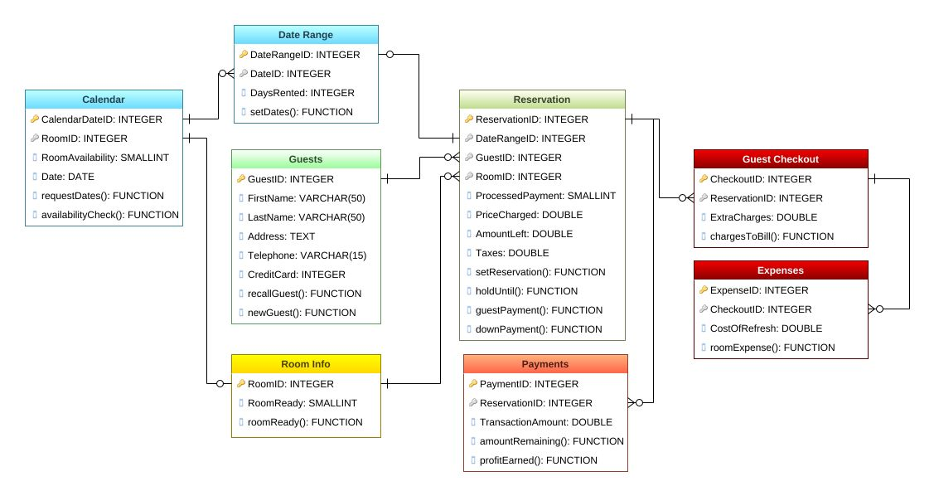Figure 1 gives the complete entity relationship diagram (ERD) in context for John and Jane’s B&B. This section describes the entities and their relationships.

*Figure 1, Entity Relationship Diagram for John & Jane’s B&B*

## 3.1 Calender

### 3.1.1 requestDates()

Module that pulls requested dates that the guest is requesting. The module sets the dates that are requested if they are checked to be available.

### 3.1.2 availabilityCheck()

Module that checks the requested dates against the availability of the calendar. The module reads the CalendarDateID with the RoomID and compares if there is availability on that specific date. If there is a range, the module uses setDates() to check multiple day’s availability.

## 3.2 Date Range

### 3.2.1 setDates()

Module that sends the requested dates to the calendar if they are available date. If setDates are available, the setDates are sent to the requestDates for scheduling.

## 3.3 Guests

### 3.3.1 recallGuest()

This entity holds all information related to a guest that previously made a reservation. This information includes metadata such as first and last name, address, and credit card number. Guest information found from this entity will be used to make their new reservation.

### 3.3.2 newGuest()

This entity accepts all new information of a guest that has not previously made a reservation.

### 3.3.2 updateGuest()

This method recalls the guest information but allows the adjusting of any new information that out of date.

## Room Info

### 3.4.1 roomReady()

This function accepts if the room has been cleaned, restocked and is ready for a new guest. Until this function is executed for a specific room, the room can not be reserved during that day.

## 3.5 Reservation

### 3.5.1 setReservation()

This function holds all the reservation information of the reservation such as information of the guests, current reservation dates and payments.

### 3.5.2 holdUntil()

This entity holds the days that the reservation will be held before the reservation is cancel or paid in full.

### 3.5.3 guestPayment()

This entity holds all information the payment made and whether it was a full or hold payment.

### 3.5.4 downPayment()

This function initiates the reservation Payments, whether partial or in full, and scans a new credit card or pulls credit card on file.

## 3.6 Payment

### 3.6.1 amountRemaining()

This entity holds what payment is still needed to finalize the room reservation.

### 3.6.2 profitEarned()

This entity calculates and stores the profit earned from the reservation equating for information stored in Expenses and ExtraCharges.

## 3.7 Guest Checkout

### 3.7.1 chargesToBill()

This function work with the Payments entity to add extra charges to the room for items such as food, movies, room service, etc.

## 3.8 Expenses

### 3.8.1 roomExpense()

This entity holds all information about the room’s cost to refresh such as shampoo, soap, washing, replacement of items, etc.

# Architectural Context Diagram

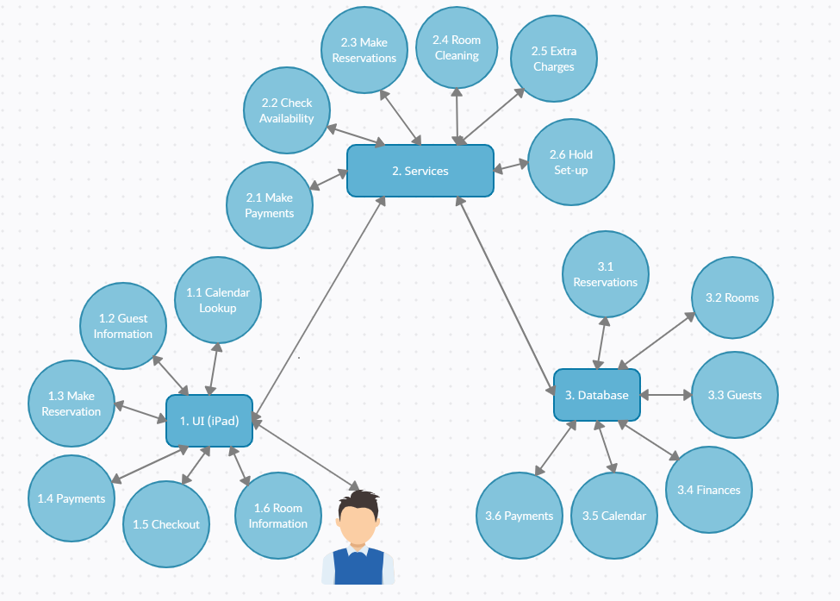John and Jane’s B&B software is built on three components. The database that will store all the information, the user interface that either someone at the front desk of the manager will be using, and the services that John and Jane’s B&B offer. The architectural context diagram in figure 2 builds on the level 1 data flow diagram in figure 3. In this section, each of the three components will be in explained.

*Figure 2, Architectural Context Diagram for John & Jane’s B&B*

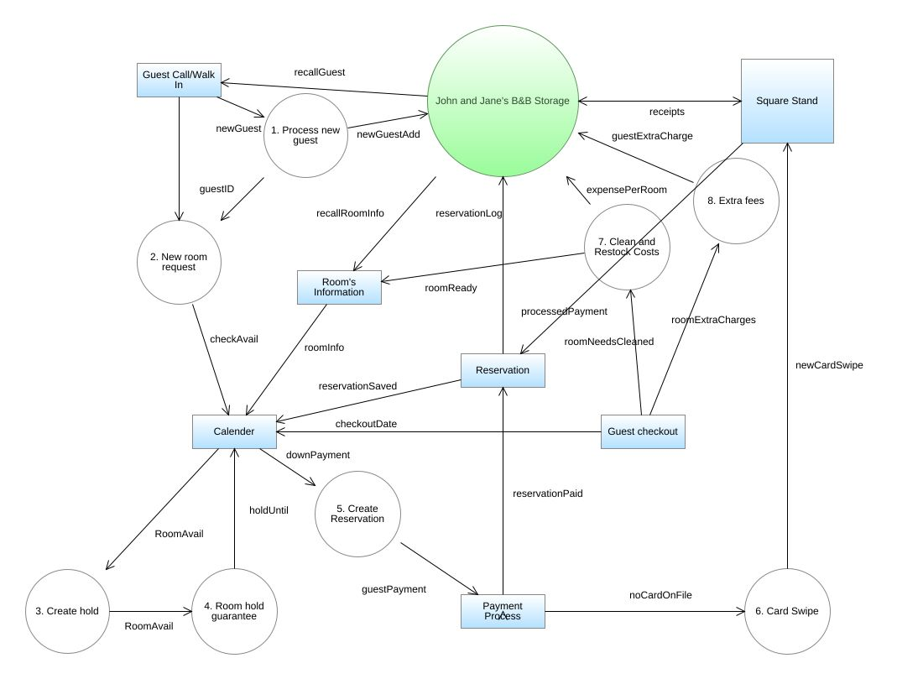

*Figure 3, Level1 Data Flow Diagram for John & Jane’s B&B*

## 4.1 User Interface (iPad)

These are the components of the user interface. A visual depiction of what the users will see is in section 5 of this document.

### 4.1.1 Calendar Lookup

Shows the user a calendar layout and information about room vacancies and room reservations. Calendar also allows for the cancelling of The visual design for the calendar lookup can be seen in section 5.1.

### 4.1.2 Guest Information

Adds, updates, or retrieves information about a guest. The visual design for the guest information can be seen in section 5.2.

### 4.1.3 Make Reservations

After selecting the days, sets up the reservation for the rooms, along with the hold time (for partial payments), and sets reservation costs to be processed at payment component. The visual design for the make reservations can be seen in section 5.3.

### 4.1.4 Payments

Allows the user to make payments based on the reservation, pulling the card information from the guest information or a new credit card swipe. The visual design for the payments can be seen in section 5.4.

### 4.1.5 Checkout

Upon checking out, this component shows if there are new charges that need to be added and sets the rooms to be cleaned. The visual design for the checkout can be seen in section 5.5.

### 4.1.6 Room Information

Shows information about each room and if the room is cleaned and restocked. The visual design for the room reservation can be seen in section 5.6.

## 4.2 Services

These are the services provided by John and Jane’s B&B.

### 4.2.1 Make Payment

This component allows for payments to be processed so that reservations, or holds, can be set or finalized.

### 4.2.2 Check Availability

This component retrieves information from the calendar that allows the user to see the availability of the selected date range.

### 4.2.3 Make Reservation

This component handles the reservation of rooms, blocks out the date range on the calendar, and sends info to the payment component for finalizing. Also stores the remaining balance on the reservation if it was not paid in full.

### 4.2.4 Room Cleaning/Refresh

This component gets set to needs cleaning when the checkout of a room occurs and gets reset when the rooms has been cleaned.

### 4.2.5 Extra Charges

This component handles the calculation of new charges outside of the initial reservation to be added up.

### 4.2.6 Hold Set-up

This component stores the hold time of the reservation. If the hold time expires, then the reservation is cancelled.

## 4.3 Database

These items are stored in a database so that they can be access at any time.

### 4.3.1 Reservations

Stores all the previous reservations.

### 4.3.2 Rooms

Stores all the information about the room such as if it has extra amenities, maintenance done, etc.

### 4.3.3 Guests

Stores all information of the guests including name, contact info, credit card info, etc.

### 4.3.4 Finances

Stores all information pertaining to costs and income of John and Jane’s B&B.

### 4.3.5 Calendar

Stores all information for each date of the calendar.

### 4.3.6 Payments

Stores all previous payments made and payment that still need to be made.

# Software Interface

The software interface description provides everything designers, programmers, and testers need to know to correctly use the functions provided by an entity. This design view consists of a set of interface specifications for each entity. Figure 4 shows the main menu when the user first uses the software. Each page will have a home button that returns to this menu.

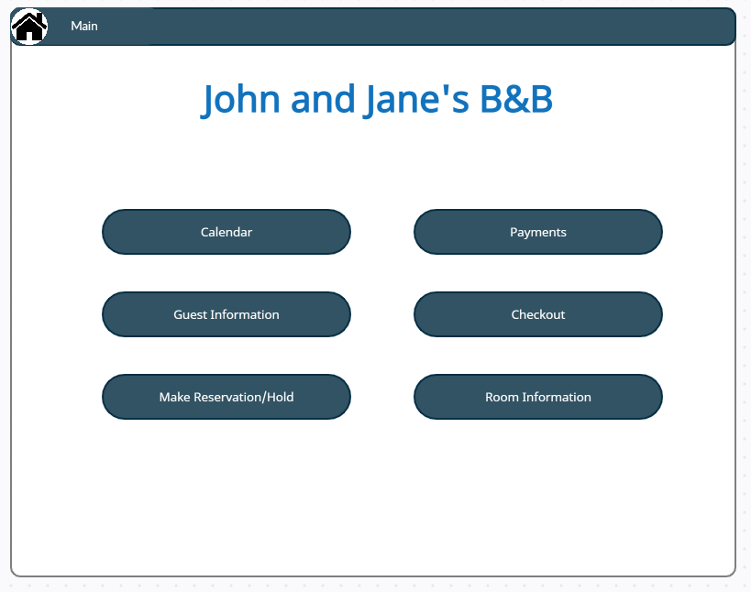

*Figure 4, UI Main*

## 5.1 Calendar Lookup

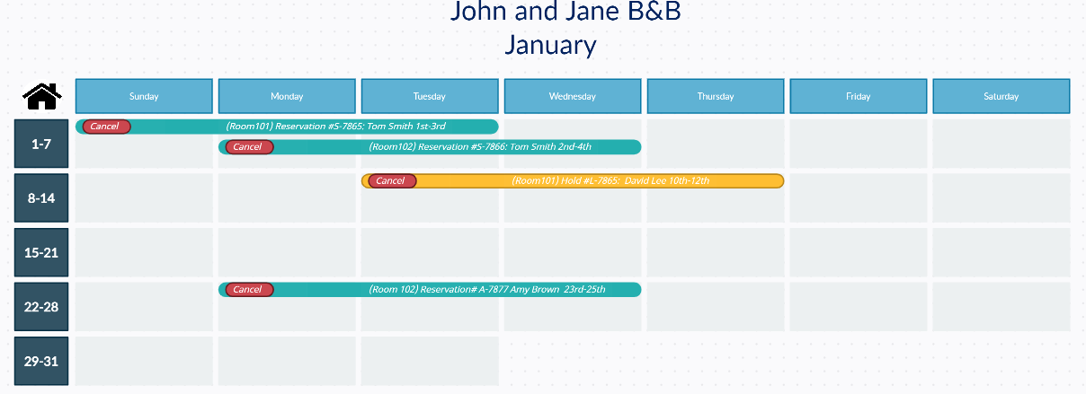Figure 5 shows the calendar lookup is where the user can see what room reservations (green) and holds (yellow)are currently active. Users can cancel reservations from the calendar by selecting the cancel button on the reservation. A home button is proved to go back to the main screen.

*Figure 5, UI Calendar*

## 5.2 Guest Information

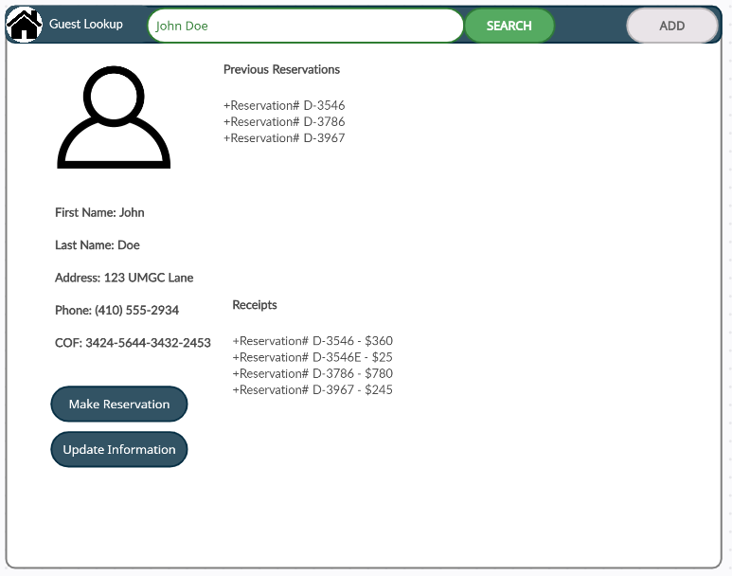Figure 6 shows the guest information form is designed to locate, update, and add guest information. Receipts and previous reservations can be seen from this page. Two buttons are provided to update the user’s information and to make a reservation based on the user, allow the charge from the card on file. A home button is proved to go back to the main screen.

*Figure 6, UI Guest Info*

## Graphical user interface, text, application, chat or text message Description automatically generated5.3 Make Reservation

*Figure 7, UI Reservation*

Figure 7 shows the room reservation form is designed to create a reservation based on the date range provided, and room availability. If there is vacancy for items provided, then the Vacancy Available item will illuminate. If there is not a vacancy for the items provided, the No Vacancy item will illuminate. The cost to reserve and cost to hold are shown to give client a price before making the reservation. Adjustment to cost adds or subtracts from total cost. Days to hold set how long the client must pay in full before the hold is cancelled. Items outlined in green are editable. Items outlined in red are not editable. Two buttons are provided to make a hold or reservation. One button is provided to show calendar for better view of availability. Two buttons are provided to search for a guest or to create a guest. A home button is proved to go back to the main screen.

## 5.4 Payments

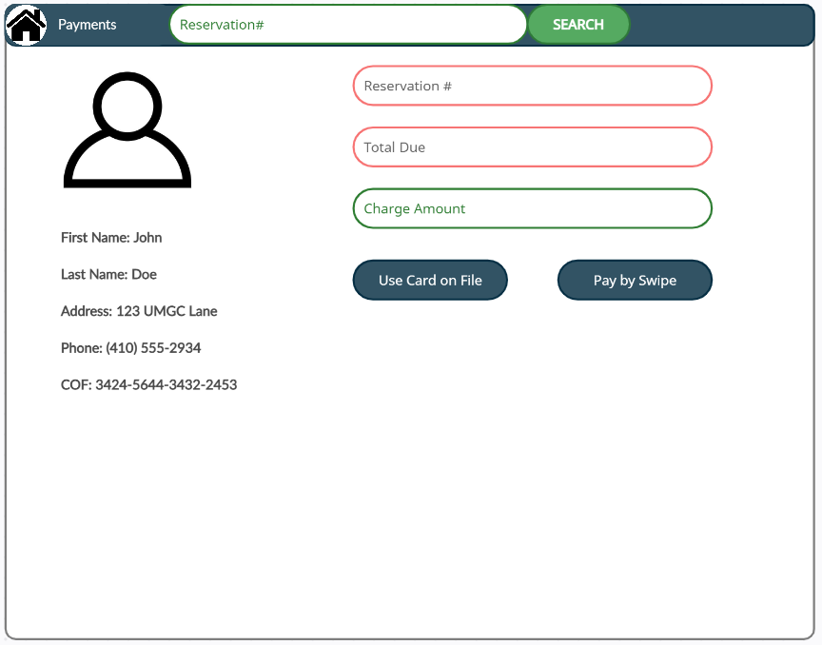Figure 8 shows the payment interface uses a search for the reservation number to make payments. The reservation number and total due are shown. The charge amount is how much the amount is to be charged. If the amount is not the full amount, the reservation number will point to the rest of the amount due. Items outlined in green are editable. Items outlined in red are not editable. Two buttons are provided to use the card that is on file or to select to pay by swipe. A home button is proved to go back to the main screen.

*Figure 8, UI Payments*

## 5.5 Checkout

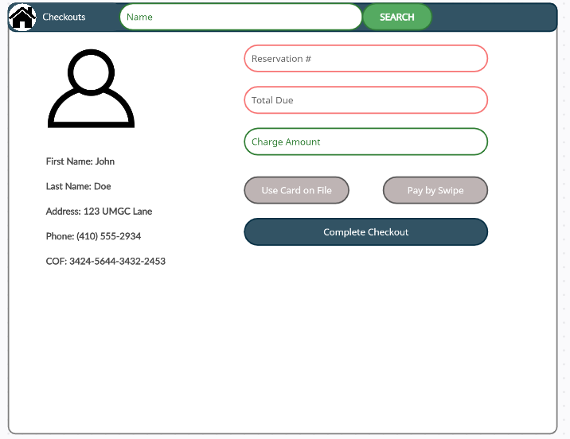Figure 9 shows the checkout interface which allows the user to charge for an extra service. If the amount is zero, the card option buttons are greyed out. If the payment is made for extra services, then after extra payment has been made, the user will be returned this screen so that the checkout can be completed.

*Figure 9, UI Checkouts*

## 5.6 Room Information

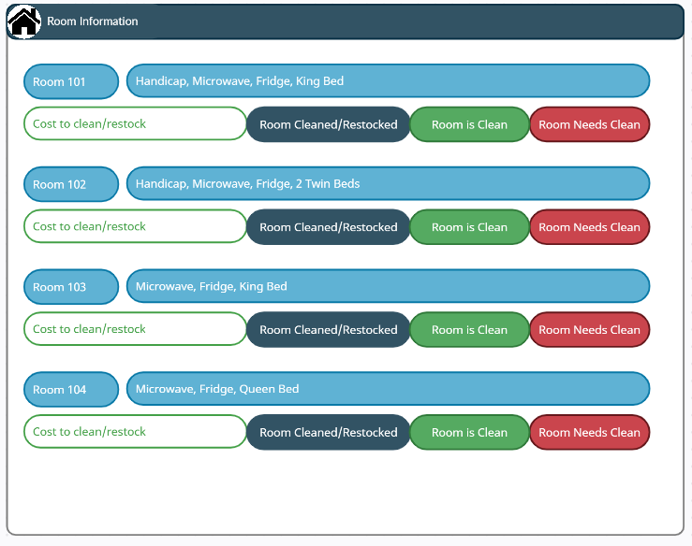Figure 10 shows the room information for each room including the amenities and if the room needs to be cleaned. There is an option to enter how much it cost to clean and restock the room after checkout. If the room needs to be cleaned, the red “Room Needs Clean” will be illuminated while the “Room is Clean” will be invisible. If the room is cleaned, the “Room is Clean” will be visible while the “Room Needs Clean” is invisible. When the Room Cleaned/Restocked button is pressed, it sets the room to cleaned ad adds the cost to clean/restock to the finances database.

*Figure 10, UI Room Infor*