Software Development

Plan (SDP)

John and Jane’s B&B

Dan Beck

CMIS330

University of Maryland Global Campus

Professor Shash

3/9/2021

### **Table of Contents**

Contents

**Table of Contents** 1

1. Overview 2

1.1 Project Summary 2

1.1.1 Purpose, Scope, and Objectives 2

1.1.2 Assumptions and Constraints 2

1.1.3 Project Deliverables 3

2. References 3

2.1 Standards and Documents 3

3. Definitions 4

4. Project Organization 5

4.1 External Interfaces 5

4.2 Internal Structure 6

4.3 Project Roles and Responsibilities 7

5. Management Process 7

5.1 Work Planning 7

5.1.1 Work Activities 8

5.1.2 Schedule Allocation 9

5.1.3 Resource Allocation 10

5.2 Risk Management 11

5.3 Project Closeout 12

6. Technical Process 12

6.1 Process Model 12

6.2 Methods, Tools and Techniques 12

# Overview

This software development plan (SDP) provides an overview of the schedule, tasks, and resources required to build and deliver the John and Jane’s B&B. This document will list, in detail, the Project schedule (Timeline), Project tasks, and Software Configuration Management.

## 1.1 Project Summary

### Purpose, Scope, and Objectives

The objective of the John and Jane’s B&B is to provide software to increase the efficiency of the business allowing for company growth and maximizing profits. By providing a software to manage the calendar, available reservations/holds, date ranges, guest information, room information and financial transactions associated with reservations, the managers of the bed and breakfast can easily schedule reservations amongst a large set of customers, while easily managing reservations across a broad timeframe.

The purpose of this system is for the client, or workers of the John and Jane’s B&B to be

able to manage the reservations and to monitor expenses and profits. The system design will

allow for the client to:

* check the calendar for vacancies and reservations
* store the customer’s name, address, phone number and credit card number
* Add and delete reservations for customers
* Assign reservations to each room number
* Store dates of reservations
* Agreed upon price per reservation
* Reservation option of 1 day’s payment
* Reservation option of reservation hold time before dropping

The software products that are being used for this system will be a proprietary application

called John and Jane’s B&B, that will be installed on an iPad, attached to a Square Stand

allowing client to accept credit card payments. The application will be designed to accommodate

for all items defined in the within this document.

### 1.1.2 Assumptions and Constraints

#### 1.1.2.1 Product interfaces

The software product interfaces with the database the client uses to store all the data of their clients will be integrated into the software. The software will also integrate with the Square Stand so that the client may accept credit cards.

#### 1.1.2.2 Technology to be employed

The technology being employed will be the Square Stand that allows the client to accept credit card swipes.

#### 1.1.2.3 Components to be reused

This software is brand new to the system so no existing code modules will be used.

### 1.1.3 Project Deliverables

Project deliverables for the John and Jane’s B&B are focused on the following:

# References

The John and Jane’s B&B project management plan references the following sources

* Cloud deployment manager. (n.d.). Retrieved March 08, 2021, from <https://cloud.google.com/deployment-manager/>
* EECS811: IT Project Management. (2013). Retrieved March 08, 2021, from <https://people.eecs.ku.edu/~hossein/Teaching/Sp18/811/Papers/fpa-cocomo.pdf>
* Find the bugs that Matter. (n.d.). Retrieved March 08, 2021, from <https://ontestpad.com/>
* Function point calculator. (n.d.). Retrieved March 08, 2021, from <https://w3.cs.jmu.edu/bernstdh/web/common/webapps/oop/fpcalculator/FunctionPointCalculator.html>
* Google java style guide. (n.d.). Retrieved March 08, 2021, from <https://google.github.io/styleguide/javaguide.html>
* Risk management in software development and software engineering projects. (n.d.). Retrieved March 08, 2021, from https://www.castsoftware.com/research-labs/risk-management-in-software-development-and-software-engineering-projects
* Square Stand: <https://squareup.com/shop/hardware/us/en/products/ipad-pos-stand-creditcard-reader>

## 2.1 Standards and Documents

The John and Jane’s B&B software development plan references the following documents:

* Software Requirements Specification (January 26th, 2021) – Dan Beck
* Software Design Document (February 9th, 2021) – Dan Beck
* Software Test Specification (February 23rd, 2021) – Kevin Gole, Dan Beck, Christopher Mair
* IEEE Std 1058-1998 Standard for Software Project Management Plans

# 3. Definitions

The This document contains for the scope of this document, the following definitions

should be noted:

*Database:* a structured set of data held in a computer, especially one that is accessible in various ways.

*GUI (Graphic Interface Design):* user interface that includes graphical elements.

*Product Interfaces:* Interfaces form the link between your product and its user, so they should make the product understandable and easy to use

*Project schedule:* Timeline of tasks to completed for the entire project.

*Project task set:* A collection of software engineering work tasks, milestones, and deliverables that must be accomplished to complete a particular project.

*Risk Management:* Includes the identification and classification of technical, programmatic and process risks, which become part of a plan that links each to a mitigation strategy.

*Software Configuration Management:* The task of tracking and controlling changes in the software, part of the larger cross-disciplinary field of configuration management

*Software Development Plan (SDP):* Describes a developer’s plans for conducting a software development effort. The SDP provides the acquirer insight and a tool for monitoring the processes to be followed for software development. It also details methods to be used and approach to be followed for each activity, organization, and resources.

# 4. Project Organization

This section outlines how the project team is organized for John and Jane’s B&B for both internal and external interfaces.

## 4.1 External Interfaces

The only external interface being used for the software will be the Square Stand that will allow user to accept credit cards.

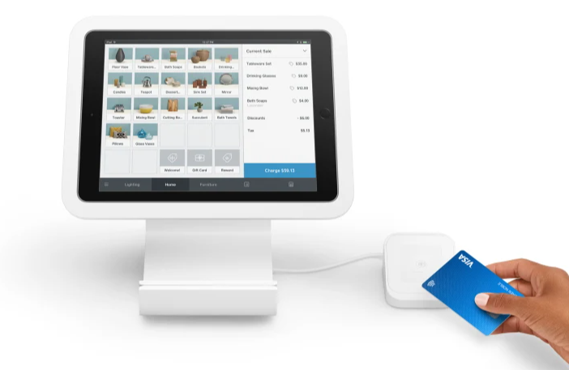

*Figure 1, Square Stand*

## 4.2 Internal Structure

The John and Jane’s B&B development will consist of two Software Engineers, a UX/UI Designer, a Quality Assurance Engineer, and a Project Manager. This development team will create a structure allowing for efficient development of the required software and user interface elements as defined in the documentation and other client requests. The project manager will handle the collaboration of the team, clients request, and costs.

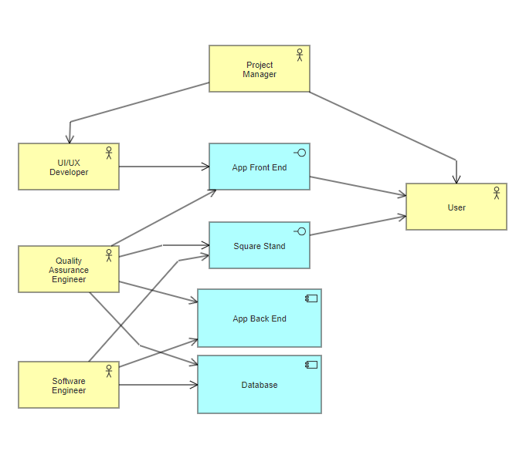

*Figure 2, Development Team*

## 4.3 Project Roles and Responsibilities

*Project Manager:* The project manager will coordinate everyone else on the team making sure that everyone stays on target. They will coordinate testing as the software engineers and UI/UX developers complete their task. They will work with the client to ensure that the software is being built to the client specification and address any issues that the client may have.

*Software Engineer:* The software engineers will be responsible for all the back-end programming that is required including the generation of methods for the code to call upon needed tasks, integration of services, and integration of database/domain objects.

*UI/UX Developer:* The UI/UX developer will work with the software engineers to test the functions and modules they create with the GUI that they develop. They will also develop mockups based on client specification to the development for the project manager to go over with the client for approval.

*Quality Assurance Engineer:* The QA engineer will work with the UI/UX designers to ensure that the GUI has no errors and integrates with the code that the software engineers have developed.

# 5. Management Process

This section goes of the work schedule and task structure required to meet the customer needs, requirements, and schedule as agreed upon by both parties.

## 5.1 Work Planning

The section goes over the work breakdown schedule and project schedule for the John and Jane’s B&B development team. The schedule is broken down into # sections of the software development life cycle including:

1. Analysis
   1. Business
   2. Software
2. Design
   1. Code
   2. Documentation
   3. User Interface
3. Code
   1. Back-End
   2. Front-End
   3. Integration
4. Test
   1. Software
   2. Documentation

### 5.1.1 Work Activities

Work Schedule

|  |  |  |
| --- | --- | --- |
| Task | SDLC | SDLC Sub-Task |
| Customer Requests | Analysis | Business |
| Discuss & Deliver Software Requirements  Specification | Analysis | Software |
| Develop Requirements | Design | Software |
| Form Development Team | Analysis | Business |
| Create Software Design Document | Design | Code |
| Develop Software Testing Specs | Test | Documentation |
| Design Wire Frame GUI | Design | User Interface |
| Wire Frame Approval from Client | Analysis | Business |
| Integrate Database | Code | Integration |
| Build Main Menu GUI | Code | Front-End |
| Build Guest info functions | Code | Back-End |
| Build Guest info GUI | Code | Front-End |
| Test Guest info GUI/functions | Test | Software |
| Build Calendar functions | Code | Back-End |
| Build Calendar GUI | Code | Front-End |
| Test Calendar GUI/functions | Test | Software |
| Integrate Square Stand | Code | Integration |
| Build Card Swipe functions | Code | Back-End |
| Test Card Swipe functions | Test | Software |
| Build Payment functions | Code | Back-End |
| Build Payment GUI | Code | Front-End |
| Test Payment GUI/functions | Test | Software |
| Build Reservation functions | Code | Back-End |
| Build Reservation GUI | Code | Front-End |
| Test Reservation GUI/functions | Test | Software |
| Build Room Information functions | Code | Back-End |
| Build Room Information GUI | Code | Front-End |
| Test Room Information GUI/functions | Test | Software |
| Build Checkouts functions | Code | Back-End |
| Build Checkouts GUI | Code | Front-End |
| Test Checkouts GUI/functions | Test | Software |
| Deployment | Analysis | Software |
| Final Acceptance from Client | Analysis | Business |

### 5.1.2 Schedule Allocation

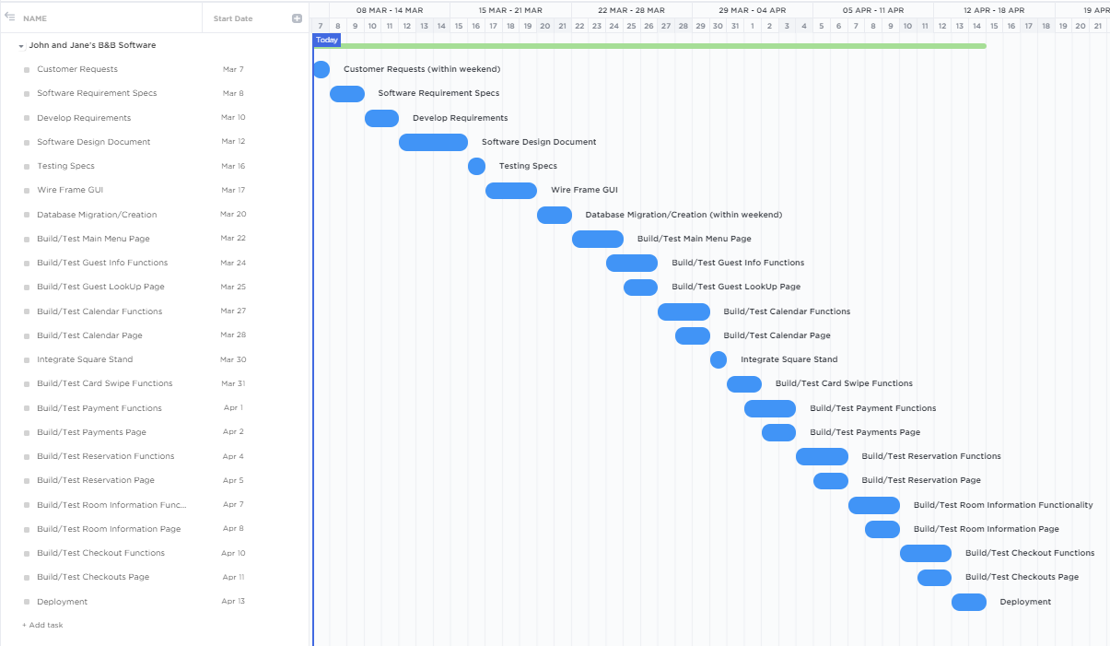

*Figure 3, Gantt chart*

### 5.1.3 Resource Allocation

Using the function point calculator from figures 4 & 5, John and Jane’s B&B software is projected to need (Function point calculator). Typical project measurements reveal that it takes an average of 3 person-days to implement a function point. At a total of 102 function points the total efforts for the new project will be three developers (two Software Engineers, one UX/UI Designer) for 34 days (EECS811: IT Project Management, 2013).

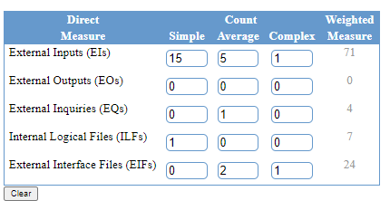

*Figure 4, Direct Measure*

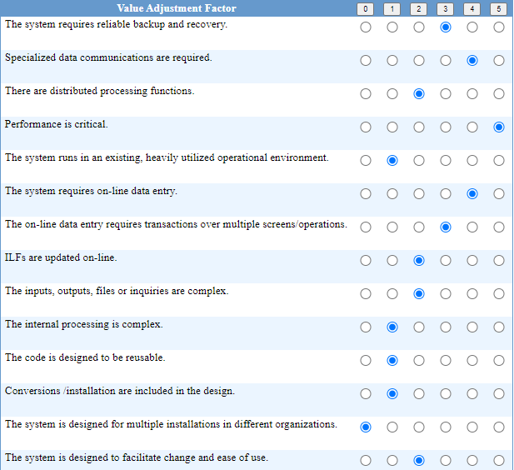

*Figure 5, Value Adjustment Factor*

## 5.2 Risk Management

Risk management for the John and Jane’s B&B focuses on the proper software configuration of databases, integration of the Square Stand, and that the customer is satisfied with all the requirements that were laid out. Other risks that are involved with the include:

|  |  |  |  |
| --- | --- | --- | --- |
| Priority | Risk | Probability | Impact |
| 1 | Performance | .1 | $20,000 |
| 2 | Application and system architecture | .1 | $5,000 |
| 3 | Organizational | .2 | $18,000 |
| 4 | User and functional requirements | .4 | $10,000 |
| 5 | New technologies, feature requests | .3 | $1,000 |

*Performance:* It is important to ensure that any risk management plan addresses end-user expectations on performance. The Project Manager must work closely with the development team and the end-user as the development progresses to make sure that the software is what the end-user expects

*Application and system architecture:* Taking the wrong direction with a platform, component, or architecture can have disastrous consequences (Risk Management, n.d.). It is important to have the UI/UX wireframe and the software design documents thoroughly read, and approved, by the end-user before moving forward with the development.

*Organizational*: Organizational problems can have serious effects on project outcomes. The Project Manager must plan to utilize the most efficient team. Whether that be experience or culture fit, the wrong people can make an enormous impact on a successful project.

*User and functional requirements*: Software design requirements capture all user needs with respect to the software system features, functions, and quality of service. Oftentimes requirements can change with discovery, prototyping, and integration activities. Changes can also occur if the end user decides on another feature to add. Unless covered in the contract, the Project Manager may work to add cost for the end- user to the project.

*New technologies, feature requests*: As technology changes and adds new feature every day, it increases the probability that the database changes may render a function useless, not allowing the database to correctly recall the information stored. Training and knowledge are of critical importance, and the improper use of new technology most often leads directly to project failure.

Risk Management Plan for Performance

* Develop project status reports consistently with daily stand ups
* Revise design according to any major changes in project schedule
* Brainstorm on potentially new risks after changes to project schedule or scope

## 5.3 Project Closeout

This section observes the processes in which the John and Jane’s B&B will be closed out. As the project gets turned over to the end-user, the development team will be assigned to the next job while the Project Manager will be in contact with the end-user periodically to make sure that the software is running smoothly. All of the code will be stored in a GitHub repository that can be access by the development team if changes need to made in the future.

# 6. Technical Process

This section observes the processes in which the John and Jane’s B&B development team will plan, analyze, design, develop and test the source code based on software design document. The methodology to be used by development team will be the waterfall software development lifecycle.

## 6.1 Process Model

*Figure 6, Waterfall SDLC*

## 6.2 Methods, Tools and Techniques

The John and Jane’s B&B development team, following the waterfall methodology for program management in section 6.1, will follow the process by which development, testing, integration, and documentation is performed. The following standards will be used during the lifecycle of the software development.

1. Analysis
   1. Project Manager works with client for needs analysis
2. Required Specification
   1. Software Design Document
3. Design
   1. Language – Java
   2. Documentation – Microsoft Word 2020 and Adobe Acrobat
   3. Google Java Style Guide
4. Development
   1. Database Implementations – MySQL
   2. Square Stand Integration
   3. Collaboration – Microsoft Teams
5. Testing
   1. Testpad
6. Build and Deploy
   1. Google Cloud Deployment Manager