Using the string ABxyBCyzABCxyz , the following parse tree is created by the given grammar:

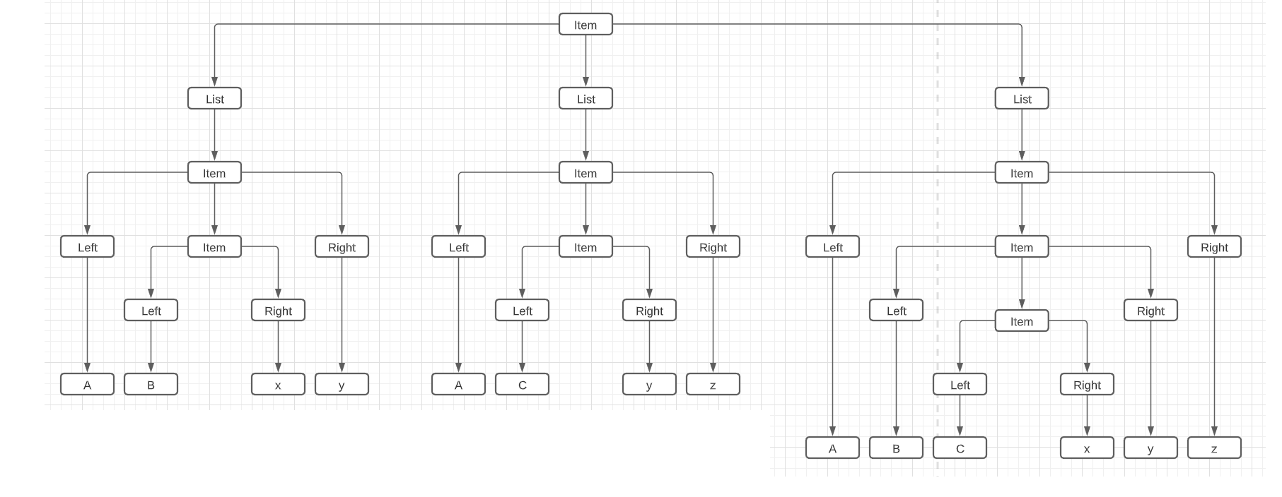

Adding a "z" to the beginning of the string (making zABxyBCyzABCxyz) would be an example of a string that is not in the same language because with "z" being the first character, there is no character left of it to make it part of the given grammar.