**Project 1**

Dan Beck

November 17, 2020

CMSC-330 7380

Prof. Francoise Keefe

Project 1

# Lessons Learned

This project was a real test of knowledge for everything I have learned in previous courses and lessons leading up to this project. I have written small programs that read text from a file but never did anything more than reprint the text in the compiler output or do some calculations with the data extracted. I remember learning a little about recursion in previous course but never got to implement it in a project. While still being a new skill, implementing a program that uses parsing with recursion has given me a much stronger base to my programming knowledge.

A skill that I was unable to use was how to read grammar given and making a program from that grammar. In previous courses, I only read and wrote the grammar but was never able to implement what was written down into a working program. While this is still a developing skill, I feel much more comfortable with reading the grammar.

# Test Plan

* Figure 1 shows the successful running of the program with given example.
* Figure 2 shows running the program with a different size frame.
* Figure 3 shows error that occurs when “Window” is missing from text file.
* Figure 4 shows running the program with a different size text field
* Figure 5 shows running the program with the numbers inverted.
* Figure 6 shows errors that occur when “End.” text is removed.
* Figure 7 shows the program running with different grid layout parameters

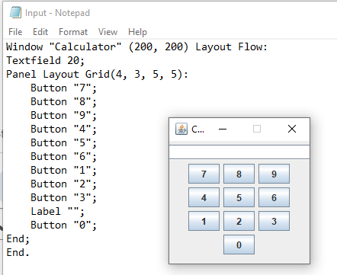

*Figure 1, Successful running of program with given example file*

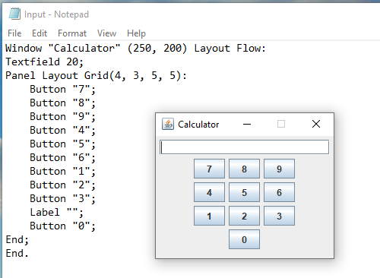

*Figure 2, Different size frame*

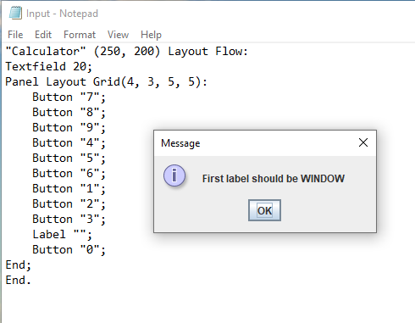

*Figure 3, Missing window text*

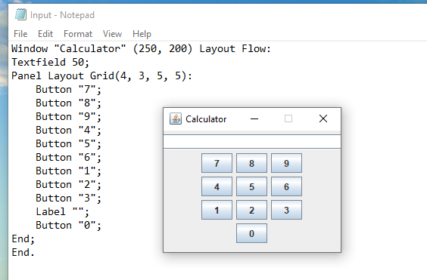

*Figure 4, Different size text field*

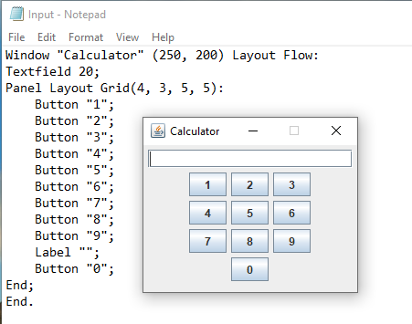

*Figure 5, Inverted numbers*

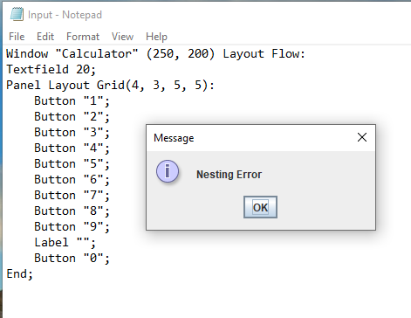

*Figure 6, Missing “End.” text*

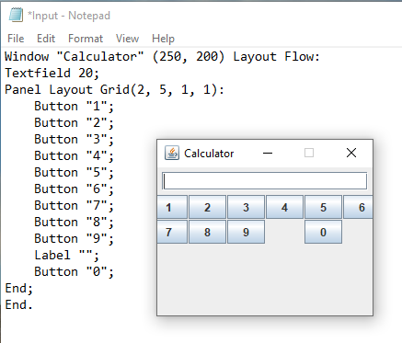

*Figure 7, Changing layout parameters*