I have an example retrieved from <http://www.se.rit.edu/~se331/votd/index.html>

This example shows a program that is asking for three characters. If four characters are entered, then the secret gets overridden with the excess characters.

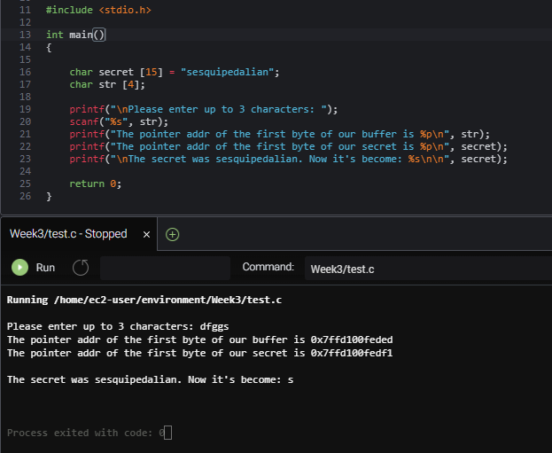

To mitigate the vulnerability in this instance, an if/else statement checks the string length entered by the user. If it is more than 3 characters, it does not let the code run.

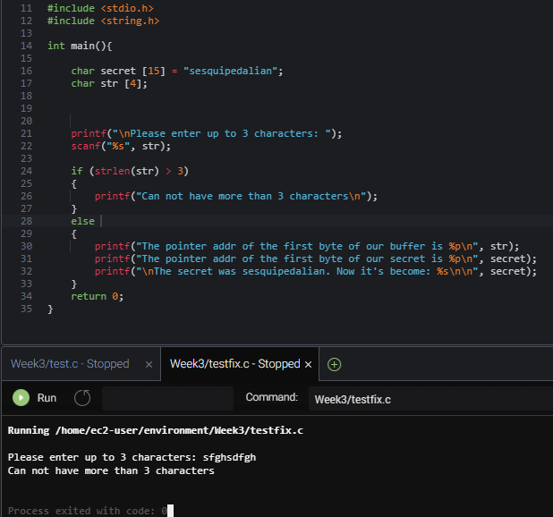

A great explanation from David Malan on Buffer Overflow:

<https://www.youtube.com/watch?v=TsQufuT80uc&feature=emb_rel_end>

References:

Vulnerability of the Day. (n.d.). Retrieved September 06, 2020, from http://www.se.rit.edu/~se331/votd/index.html