Since I have heard of multiple cases where Playstation was hacked, I was curious if they had their own bug bounty program. It turns out that they use HackerOne to accept reports and payout based of the rating of the report.

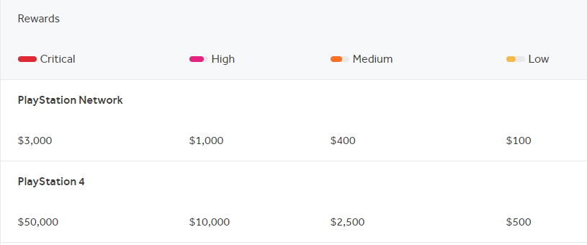

In my opinion, $3000 seems low for someone being able to spot a critical error. Especially when they have been hacked before, and lost millions. <https://www.wired.com/2011/05/sony-psn-hack-losses/>

A tool that can be used

Legal risks can occur when ethically hacking including “lawsuits due to disclosure of personal or confidential information. Such disclosure can lead to a legal battle involving the organization and the ethical hacker. It is very easy for ethical hacking to result in a legal battle if it is not performed properly. (panmore.com)”

There are a variety of tools that can be used for bug bounty including <https://www.vulnerability-lab.com/>

Since I do not know the first thing about ethical hacking, I would start using one of these programs to gain some knowledge

<https://www.udemy.com/course/hands-on-complete-penetration-testing-and-ethical-hacking/>

<https://www.cybrary.it/course/ethical-hacking/>

Other Resources:

http://panmore.com/ethical-hacking-code-of-ethics-security-risk-issues#:~:text=The%20legal%20risks%20of%20ethical,it%20is%20not%20performed%20properly.

<https://hackerone.com/playstation?type=team>