https://levelup.gitconnected.com/top-python-tools-for-developing-secure-quality-code-4b3f5ec1e2de
If I had to recommend one tool to improve the security of your python project, it would be Bandit. Bandit is originally from OpenStack, though is now maintained by PyCQA. Bandit is an open-source SAST tool, which also in some ways behaves like a security-focused linter as well. It’s great for catching issues like insecure configurations, known insecure module usage, hard-codes credentials, asserts, and much more.
Bandit is free, configurable, and fast. There’s no compelling reason I can think of not to add it to your project.

https://www.geeksforgeeks.org/software-testing-security-testing/
Software Testing | Security Testing
Security Testing is a type of Software Testing that uncovers vulnerabilities of the system and determines that the data and resources of the system are protected from possible intruders. It ensures that the software system and application are free from any threats or risks that can cause a loss. Security testing of any system is focuses on finding all possible loopholes and weaknesses of the system which might result into the loss of information or repute of the organization.

Goal of Security Testing:
The goal of security testing is to:

To identify the threats in the system.
To measure the potential vulnerabilities of the system.
To help in detecting every possible security risks in the system.
To help developers in fixing the security problems through coding.
Principle of Security Testing:
Below are the six basic principles of security testing:

Confidentiality
Integrity
Authentication
Authorization
Availability
Non-repudiation
Major Focus Areas in Security Testing:

Network Security
System Software Security
Client-side Application Security
Server-side Application Security
Types of Security Testing:

Vulnerability Scanning:
Vulnerability scanning is performed with the help of automated software to scan a system to detect the known vulnerability patterns.
Security Scanning:
Security scanning is the identification of network and system weaknesses. Later on it provides solutions for reducing these defects or risks. Security scanning can be carried out in both manual and automated way.
Penetration Testing:
Penetration testing is the simulation of the attack from a malicious hacker. It includes analysis of a system to examine for potential vulnerabilities from a malicious hacker that attempts to hack the system.
Risk Assessment:
In risk assessment testing security risks observed in the organization are analyzed. Risks are classified into three categories i.e. low, medium, and high. This testing endorses controls and measures to minimize the risk.
Security Auditing:
Security auditing is an internal inspection of applications and operating systems for security defects. An audit can also be carried out via line by line checking of code.
Ethical Hacking:
Ethical hacking is different from malicious hacking. The purpose of ethical hacking is to expose security flaws in the organization system.
Posture Assessment:
It combines security scanning, ethical hacking and risk assessments to provide an overall security posture of an organization.

https://wiki.sei.cmu.edu/confluence/display/seccode/Top+10+Secure+Coding+Practices
Top 10 Secure Coding Practices
Validate input. Validate input from all untrusted data sources. Proper input validation can eliminate the vast majority of software vulnerabilities. Be suspicious of most external data sources, including command line arguments, network interfaces, environmental variables, and user controlled files [Seacord 05].
Heed compiler warnings. Compile code using the highest warning level available for your compiler and eliminate warnings by modifying the code [C MSC00-A, C++ MSC00-A]. Use static and dynamic analysis tools to detect and eliminate additional security flaws.
Architect and design for security policies. Create a software architecture and design your software to implement and enforce security policies. For example, if your system requires different privileges at different times, consider dividing the system into distinct intercommunicating subsystems, each with an appropriate privilege set.
Keep it simple. Keep the design as simple and small as possible [Saltzer 74, Saltzer 75]. Complex designs increase the likelihood that errors will be made in their implementation, configuration, and use. Additionally, the effort required to achieve an appropriate level of assurance increases dramatically as security mechanisms become more complex.
Default deny. Base access decisions on permission rather than exclusion. This means that, by default, access is denied and the protection scheme identifies conditions under which access is permitted [Saltzer 74, Saltzer 75].
Adhere to the principle of least privilege. Every process should execute with the the least set of privileges necessary to complete the job. Any elevated permission should only be accessed for the least amount of time required to complete the privileged task. This approach reduces the opportunities an attacker has to execute arbitrary code with elevated privileges [Saltzer 74, Saltzer 75].
Sanitize data sent to other systems. Sanitize all data passed to complex subsystems [C STR02-A] such as command shells, relational databases, and commercial off-the-shelf (COTS) components. Attackers may be able to invoke unused functionality in these components through the use of SQL, command, or other injection attacks. This is not necessarily an input validation problem because the complex subsystem being invoked does not understand the context in which the call is made. Because the calling process understands the context, it is responsible for sanitizing the data before invoking the subsystem.
Practice defense in depth. Manage risk with multiple defensive strategies, so that if one layer of defense turns out to be inadequate, another layer of defense can prevent a security flaw from becoming an exploitable vulnerability and/or limit the consequences of a successful exploit. For example, combining secure programming techniques with secure runtime environments should reduce the likelihood that vulnerabilities remaining in the code at deployment time can be exploited in the operational environment [Seacord 05].
Use effective quality assurance techniques. Good quality assurance techniques can be effective in identifying and eliminating vulnerabilities. Fuzz testing, penetration testing, and source code audits should all be incorporated as part of an effective quality assurance program. Independent security reviews can lead to more secure systems. External reviewers bring an independent perspective; for example, in identifying and correcting invalid assumptions [Seacord 05].
Adopt a secure coding standard. Develop and/or apply a secure coding standard for your target development language and platform.
Bonus Secure Coding Practices
Define security requirements. Identify and document security requirements early in the development life cycle and make sure that subsequent development artifacts are evaluated for compliance with those requirements. When security requirements are not defined, the security of the resulting system cannot be effectively evaluated.
Model threats. Use threat modeling to anticipate the threats to which the software will be subjected. Threat modeling involves identifying key assets, decomposing the application, identifying and categorizing the threats to each asset or component, rating the threats based on a risk ranking, and then developing threat mitigation strategies that are implemented in designs, code, and test cases [Swiderski 04].

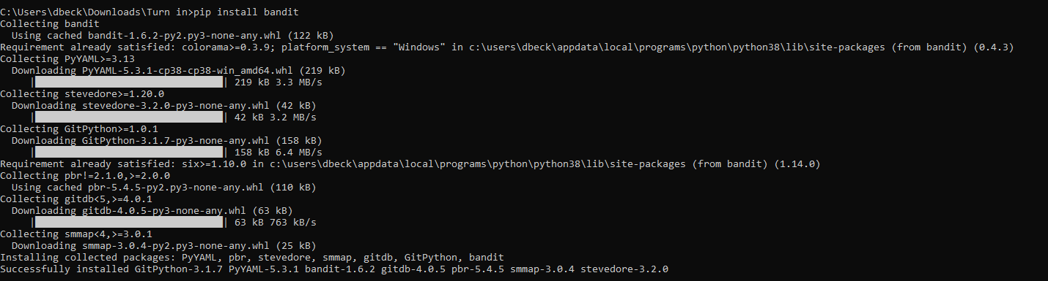
Installation of Bandit
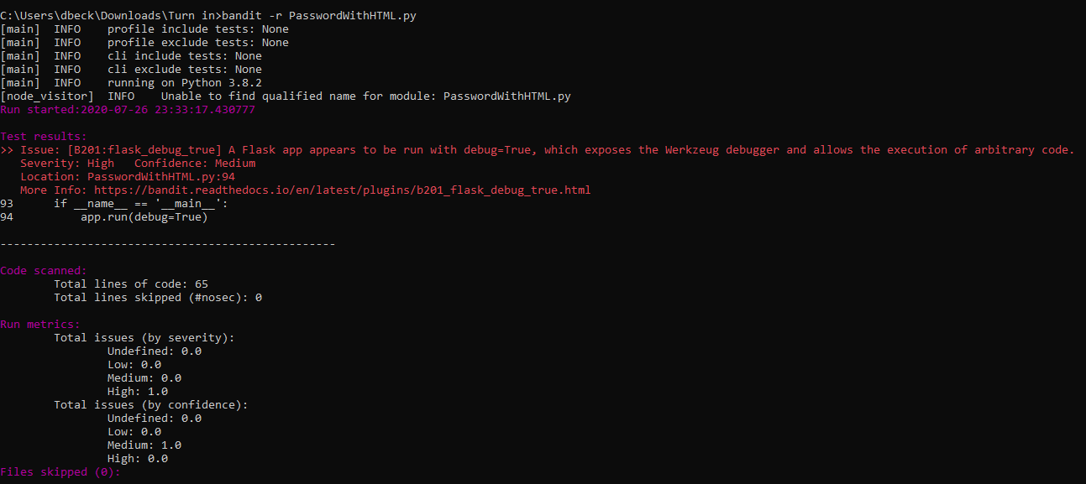
Bandit run on previously done code that checks password complexity
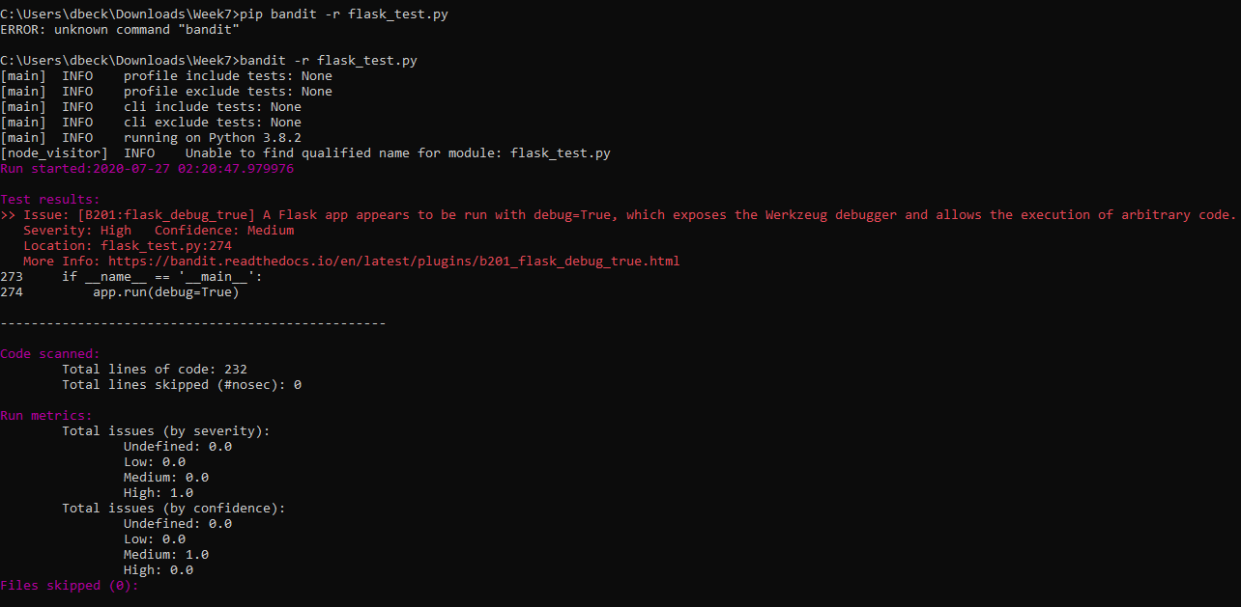
Bandit run on previously done python code that runs a simple website using flask

