Testing early and often strategy improves the entire SDLC. When a security bug is detected early, it can be mitigated faster and at a lower cost. If it is not tested earlier in the process, there is a better chance that it can missed as development progresses. If a large number of the critical bugs are found during the end of a given release, there is a higher probability of the testing cycle being extended, high probability of release deadline being missed, a particular feature having a large number of defects may all together need to be pulled out from that particular release, or customer commitments being missed.
The example below from the OWASP Testing Guide explains what a security threat might look like. During the design of this application an administrative backdoor was created “during testing, but obfuscated it to prevent the casual observer from discovering it. By submitting the value sf8g7sfjdsurtsdieerwqredsgnfg8d (30 characters), the user will then be logged in and presented with an administrative screen with total control of the application. The HTTP request is now: http://www.host/application?magic= sf8g7sfjdsurtsdieerwqredsgnfg8d” (Meucci & Muller).
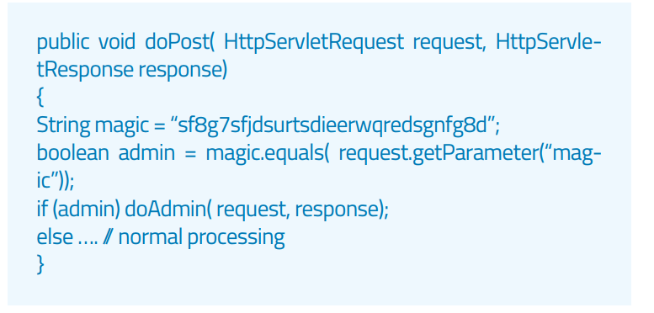
If this app were in the early stages of testing, a security bug such as this could be mitigated long before its release. If testing was not done early, and this was released for use, the ramifications could be devastating for the business that the application was being released to.

Meucci, M., & Muller, A. (n.d.). OWASP Testing Guide 4.0 [PDF]. OWASP.
What is Early Testing and Why to Start Testing Early in SDLC (Practical). (2020, June 30). Retrieved July 30, 2020, from https://www.softwaretestinghelp.com/early-testing/

Ahmad,
Thank you for your post! I appreciated how you pointed out from the testing guide mentions "patch-and-penetrate" not being as effective because it only solves issues on the front end and does not get to the root of the problem. Patches have their place in updating software, but fixing issues as we are developing the program allows us to understand the bugs and create a solid foundation, so the program is more stable.

Ahmad,
To add on to what Zechariah said, I agree that the patch-and-penetrate technique because it only solves the obvious problems. I believe that using the Agile or DevOps development methods can prevent the patch-and-penetrate process. The company I work for uses the “finish as fast as possible” method to install Audio/Video systems throughout an entire campus. This not only has caused problems throughout the years with service calls because of inconsistent performance, but now is proving to be even more problematic with the campus wanting to add distance learning to many of their rooms. Since most room’s code is all patch, its proving to be difficult to add this functionality.

