**Lab 1**

Dan Beck

October 27, 2020

SDEV-350 7380

Prof. Carl Eyler

Lab 1

# A

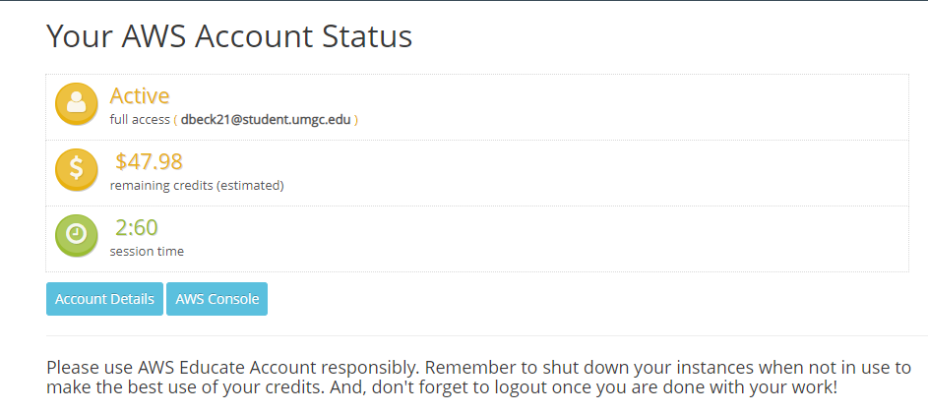 Below is a screenshot after logging into AWS Educate Account. The Active section shows my student email as having full access.

*Figure 1, Beck AWS Educate Classroom Account Status*

# B

After selecting “Account Details”, a screen shot shows the session start and end, remaining session time and term of the account access.

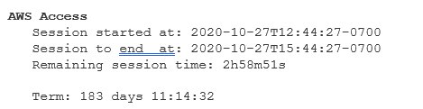

*Figure 2, Beck AWS Educate Account Status*

# C

Figure C show the connectivity and security status of the created database. It also shows the Oracle RDS endpoint and port for the RDS instance.

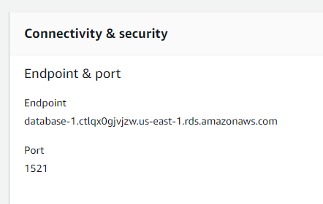

*Figure 3, Beck AWS Educate RDS Endpoint & Port*

## D

Figure 4 shows the successful connection to my RDS instance. Figure 5 shows the creation of a table called INVOICES that has the InvoiceID as an integer and the primary key of the table. It also accepts ClientFirstName and ClientLastName as variable characters with a limit of 50 characters each. It also accepts and InvoiceAmount that is a decimal that cam be 13 numbers long with 2 trailing numbers after the decimal point. The InvoiceAmount can not be left empty.

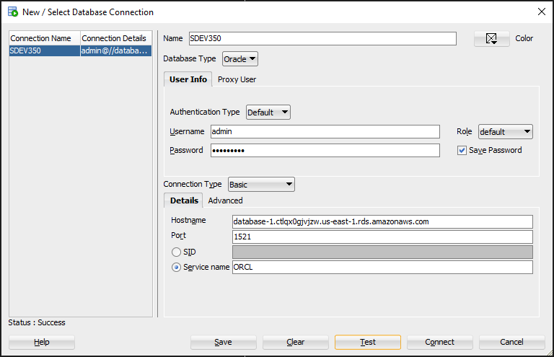

*Figure 4 Beck SQL*Developer RDS Connection Properties*

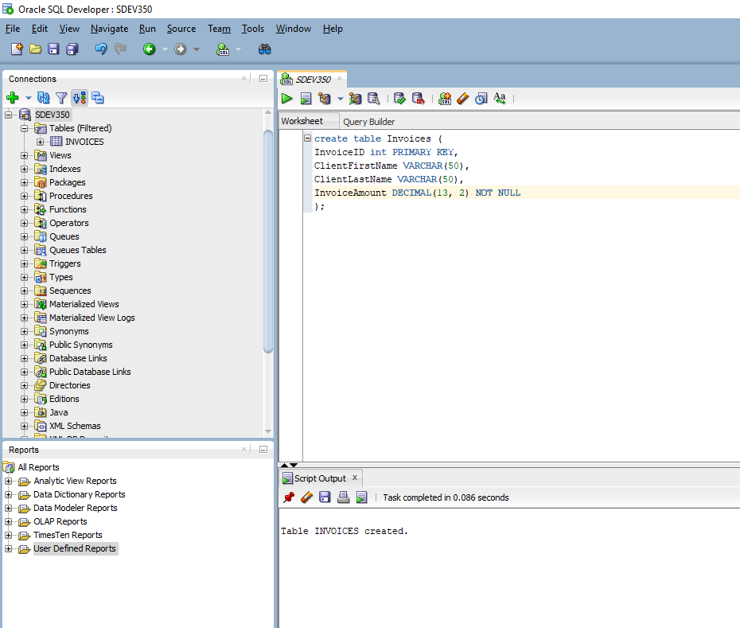

*Figure 5, Beck Successfully creating a Table*