**Lab 3**

Dan Beck

November 17, 2020

SDEV-350 7380

Prof. Carl Eyler

Lab 3

# Create a Unique Profile

Figure 1 shows the successful creation of a unique profile named PDANBECK.

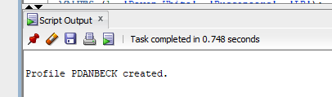

*Figure 1, Successful profile creation*

# Verify Profile Creation

Figure 2 shows the verification the profile PDANBECK was created. It shows password complexity meets requirements for Ora12 Verify function, that the user may have up to 3 concurrent sessions, up to 4 consecutive failed attempts to log in before the account is locked, up till 120 days before their password must be changed, and account will be locked for 1 hour after 4 consecutive failed login attempts.

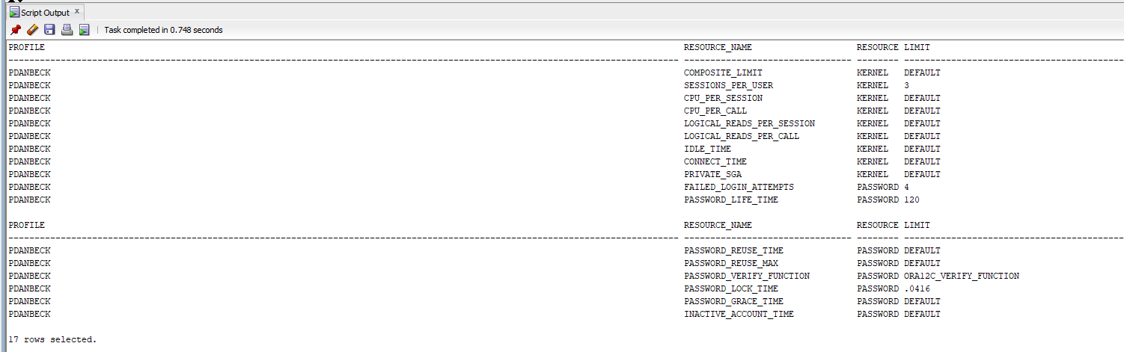

*Figure 2, Verification of profile creation*

# Creation of Users

Figure 3 shows the creation of two users assigned to the Permanent Tablespace of Users with a Quota of 30M. The new users are assigned to the PDANBECK profile.

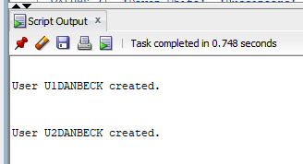

*Figure 3, Successful creation of users*

# Creation of Roles

Figure 4 shows the creation of role R1DANBECK allowing users assigned to be able to connect to the database and create tables.

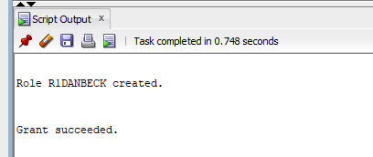

*Figure 4, Successful creation of role*

# Creation of Two Tables

Figure 5 shows the successful creation of two tables named User1Data and User2Data. The tables contain a primary key and 3 additional columns. In User1Data, the columns are PlayerName, Team, and Position for Offense. In User2Data, the columns are PlayerName, Team, and Position for Defense. 3 records were inserted into each table.

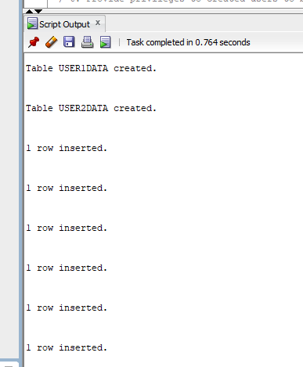

*Figure 5, Successful tables, and entry insertions*

# Privileges for Users

Figure 6 shows the successful granting of privileges to created users to be able to connect to the database and create tables.

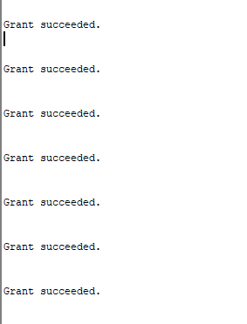

*Figure 6, Successful privileges granted*

# Test Plan Showing User’s Privileges

## 7A. User 1 Test Plan

Figure 7 shows the U1DANBECK logging in.

Figure 8 shows that the password for U1DANBECK needs to be reset.

Figure 9 shows the password for U1DANBECK being reset.

Figure 10 shows U1DANBECK selecting all data from the ADMIN.User1Data table.

Figure 11 shows U1DANBECK creating a table.

Figure 12 shows U1DANBECK adding an entry to the newly created table.

Figure 13 shows that the entry was successful.

Figure 14 shows U1DANBECK adding an entry to the User1Data table.

Figure 15 show U1DANBECK trying to drop table without necessary privileges.

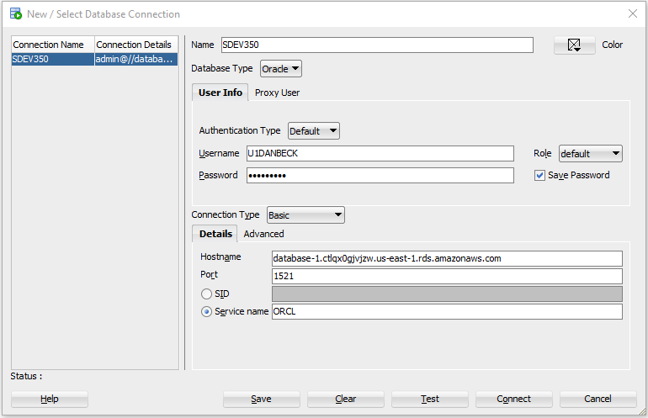

*Figure 7, User 1 log in*

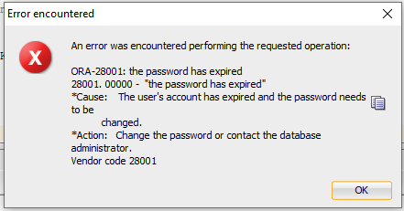

*Figure 8, User 1 password reset error*

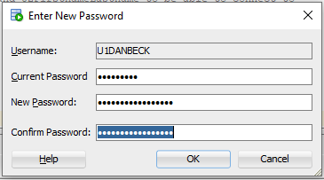

*Figure 9, User 1 password reset*

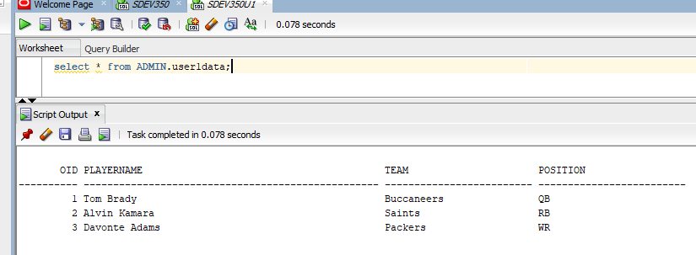

*Figure 10, User 1 select data from admin database*

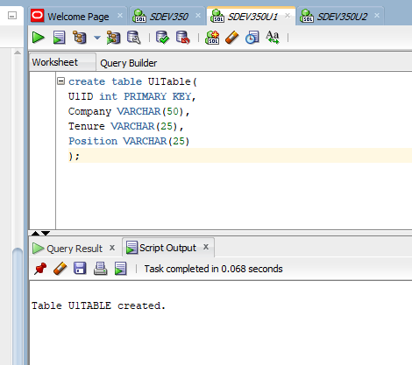

*Figure 11, User 1 table creation*

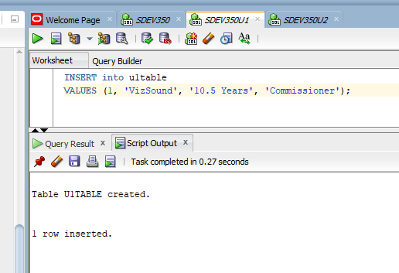

*Figure 12, User 1 entry into newly created table*

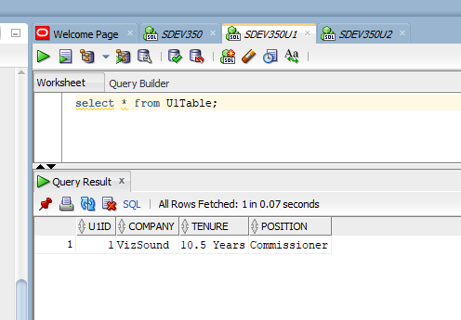

*Figure 13, User 1 entry into newly created table*

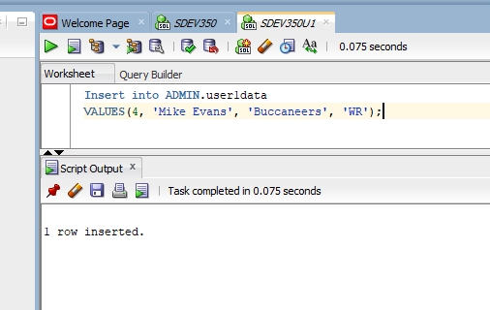

*Figure 14, User 1 entry into Admin table*

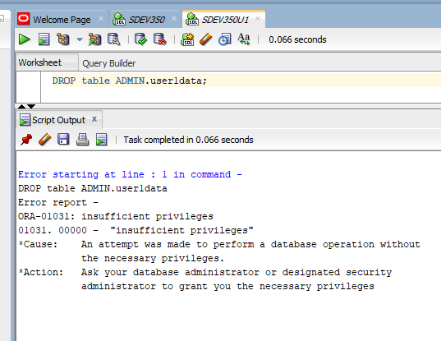

*Figure 15, User 1 try to drop table in admin database*

## 7B. User 2 Test Plan

Figure 16 shows the U2DANBECK logging in.

Figure 17 shows that the password for U2DANBECK needs to be reset.

Figure 18 shows the password for U2DANBECK being reset.

Figure 19 shows U2DANBECK selecting all data from the ADMIN.User2Data table.

Figure 20 shows U2DANBECK creating a table.

Figure 21 shows U2DANBECK adding an entry to the newly created table.

Figure 22 shows U2DANBECK selecting all data from the newly created table.

Figure 23shows U2DANBECK trying to add an entry to ADMIN.User2Data table without the proper privileges.

Figure 25 show U2DANBECK trying to drop table without necessary privileges.

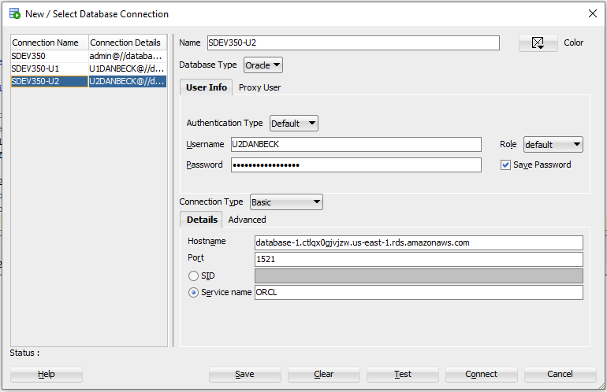

*Figure 16, User 2 log in*



*Figure 17, User 2 password expire error*

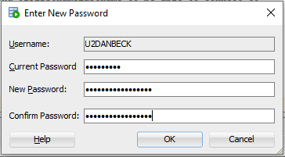

*Figure 18, User 2 password reset*

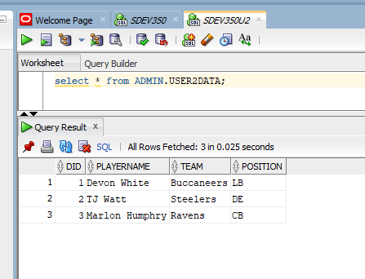

*Figure 19, User 2 select all from Admin table*

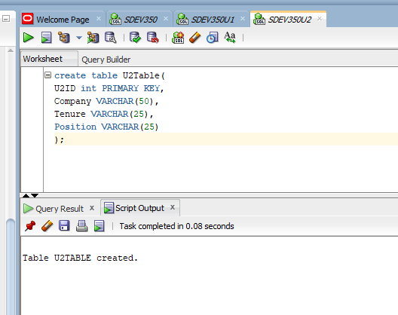

*Figure 20, User 2 creating table*

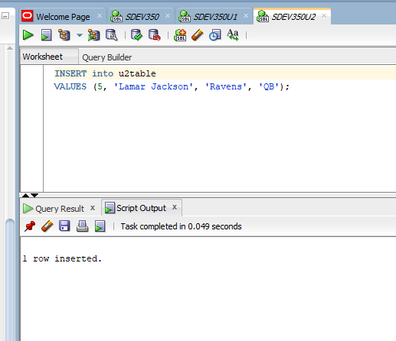

*Figure 21, User 2 add entry to newly created table*

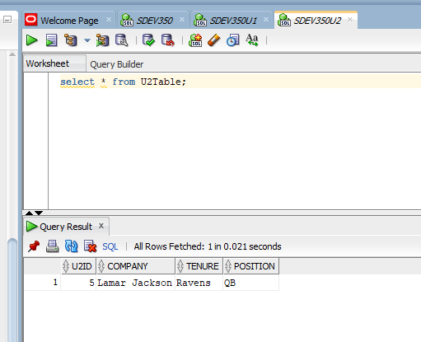

*Figure 22, User 2 select all from newly created table*

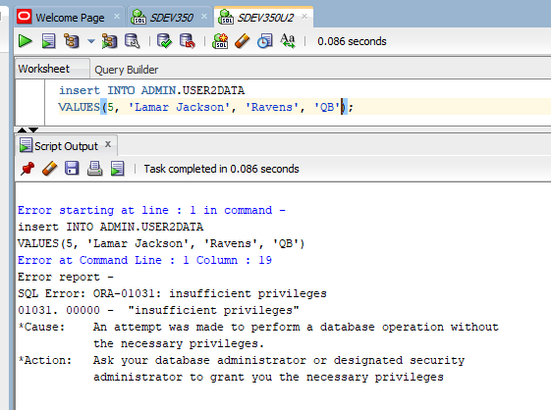

*Figure 23, User 2 inserting into admin table without proper privileges*

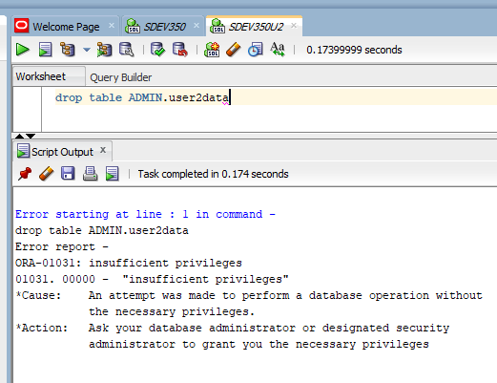

*Figure 24, User 2 trying to drop an admin table without proper privileges*