**Homework0**

Dan Beck

January 16, 2021

SDEV-400 6380

Prof. Errol Waithe

Homework0

# Classroom Account Status

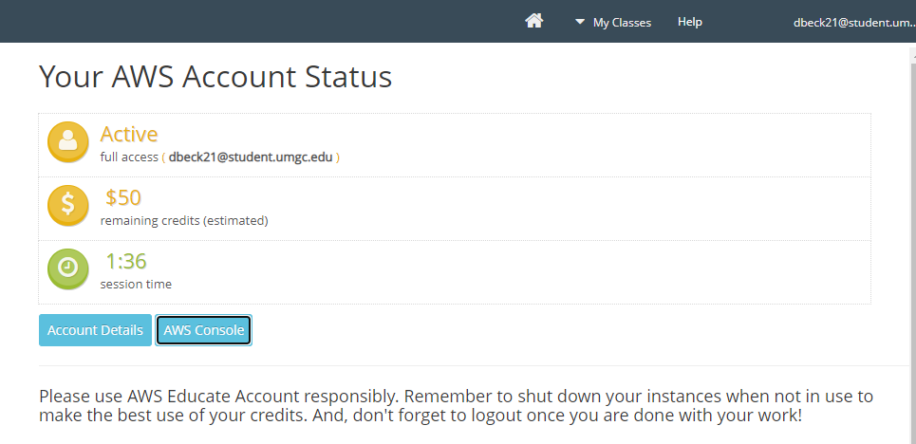

*Figure 1, Classroom Account*

# AWS Console

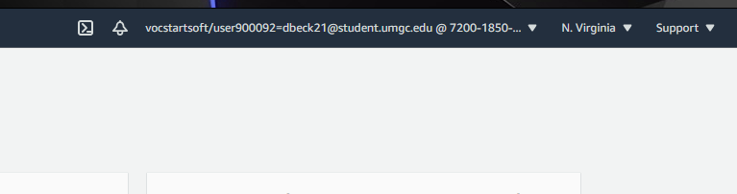

*Figure 2, AWS Console Username*