**Homework1**

Dan Beck

January 26, 2021

SDEV-400 6380

Prof. Errol Waithe

Homework1

# Table of Contents for Test Cases

1. Two created buckets with two folders in each bucket
2. Adding two pictures to each folder created
3. Menu after first running program
4. Create an S3 bucket
5. Put an object in a previously created bucket
6. Delete an object in a bucket
7. Delete a bucket
8. Copies an object from one bucket to another
9. Downloads an existing object from a bucket
10. Exiting the program

# Two created buckets with two folders in each bucket

Figure 1 shows the creation of two buckets and two folders named Jobs and Support in each bucket.

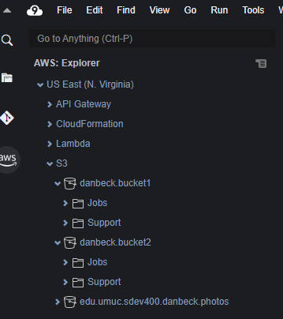

*Figure 1, Two created buckets with two folders in each bucket*

# Adding two folders to each bucket created

Figure 2 shows the insertion of two objects in each of the created folders.

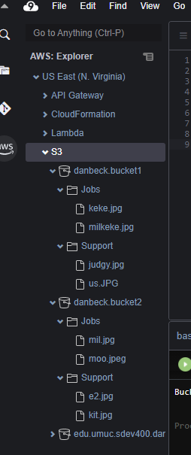

*Figure 2, insertion of two objects in each folder*

# Menu after first running program

Figure 3 shows the menu when successful running the program occurs.

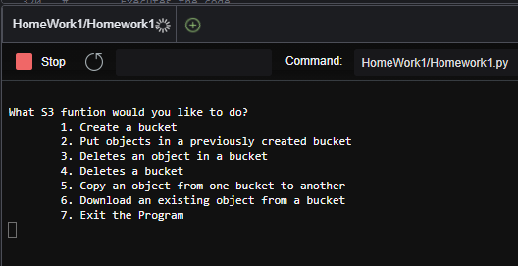

*Figure 3, Menu after first running program*

# Create an S3 bucket

Figure 3 shows what occurs when item three is selected. An AccessDenied error occurs every time this is run. After researching the error, I am supposed to be able to change permissions in the IAM but I do not have access to that (create_bucket.py)..

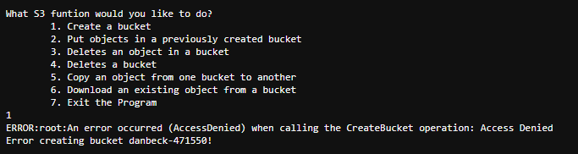

*Figure 4, creating an S3 bucket*

# Put an object in a previously created bucket

Figure 3 shows what occurs when item two is selected, then the second bucket being selected to be deleted. No matter what file location that was entered, the code continued to come across errors (put_object.py).

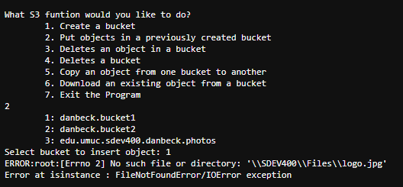

*Figure 3, Put an object in a previously created bucket*

# Delete an object in a bucket

Figure 4 shows what happens when item three is selected, then the first bucket is selected to delete from. After the name of the file is inserted to be deleted, the program shows a success prompt. Figure 5 shows that the file has been deleted from the bucket (delete_object.py).

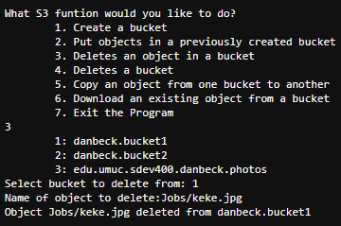

*Figure 4, Delete an object in a bucket*

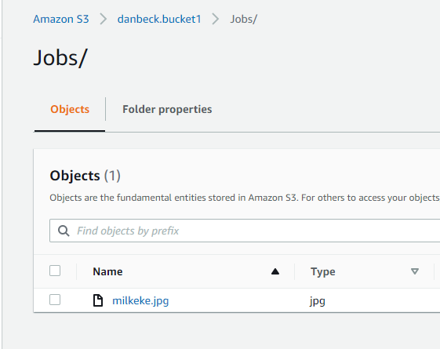

*Figure 5, bucket after file has been deleted*

# Delete a bucket

Figure 6 shows the bucket in the S3 before the code is executed. Figure 7 shows what happens when item four is selected, then the third bucket is selected to be deleted. Figure 8 shows the bucket in the S3 after the code has been executed (delete_bucket.py).

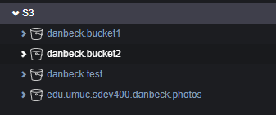

*Figure 6, S3 before bucket deletion*

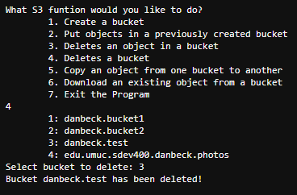

*Figure 7, adding of username and password to access database*

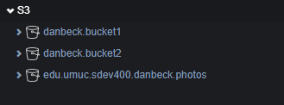

*Figure 8, S3 after bucket deletion*

# Copies an object from one bucket to another

Figure 9 shows what happens when item five is selected, then the first bucket is selected to be move the object from. After typing the name of the object to be moved, the new bucket to be inserted, and naming the new object, a prompt will indicate successful copying. Figure 10 shows the bucket in the S3 after the code has been executed with the new copied file (copy_object.py).

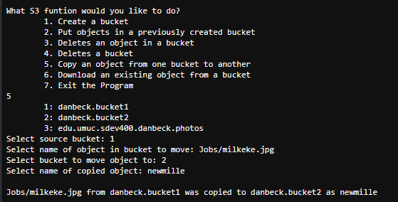

*Figure 9, Copying an object from one bucket to another*

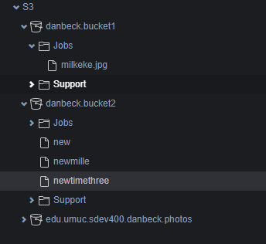

*Figure 10, bucket after item was copied to it*

# Downloads an existing object from a bucket

Figure 11 shows what happens when item six is selected, then the first bucket is selected to be downloaded from. After typing in the name of file to be downloaded, a prompt indicates successful downloading. Figure 12 shows the file being downloaded to the SDEV400 folder (s3-python-example-download-file.py).

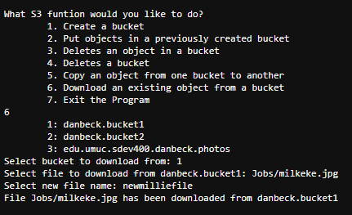

*Figure 11, S3 after bucket deletion*

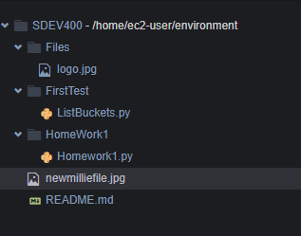

*Figure 12, S3 after bucket deletion*

# Exiting the program

Figure 13 shows what happens when item seven is selected, and the program exits.

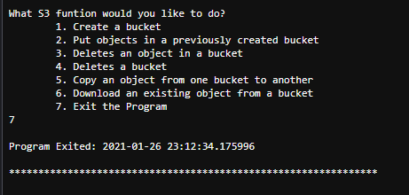

*Figure 11, Exiting the program*

# References

create_bucket.py[Source Code].http://aws.amazon.com/apache2.0/

copy_object.py[Source Code].http://aws.amazon.com/apache2.0/

delete_bucket.py[Source Code].http://aws.amazon.com/apache2.0/

delete_object.py[Source Code].http://aws.amazon.com/apache2.0/

put_object.py[Source Code].http://aws.amazon.com/apache2.0/

s3-python-example-download-file.py[Source Code].http://aws.amazon.com/apache2.0/