Hi Everyone,

I worked with Monica Wilson for this week's discussion. She made this a very easy experience 😊 Below are screenshots of the commands sent to allow access to my bucket and to receive a file from her bucket.

**Screenshot command granting permission:**



**Screenshot command retrieving object:**

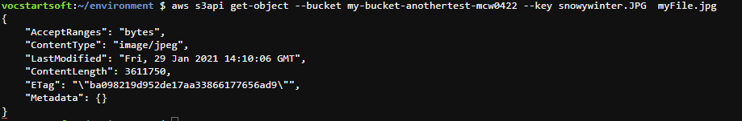

**Screenshot of retrieved file in my folder:**

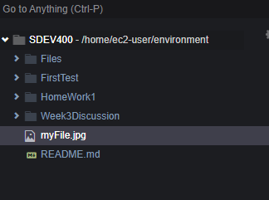

**Screenshot of the future she saw for Baltimore today!**

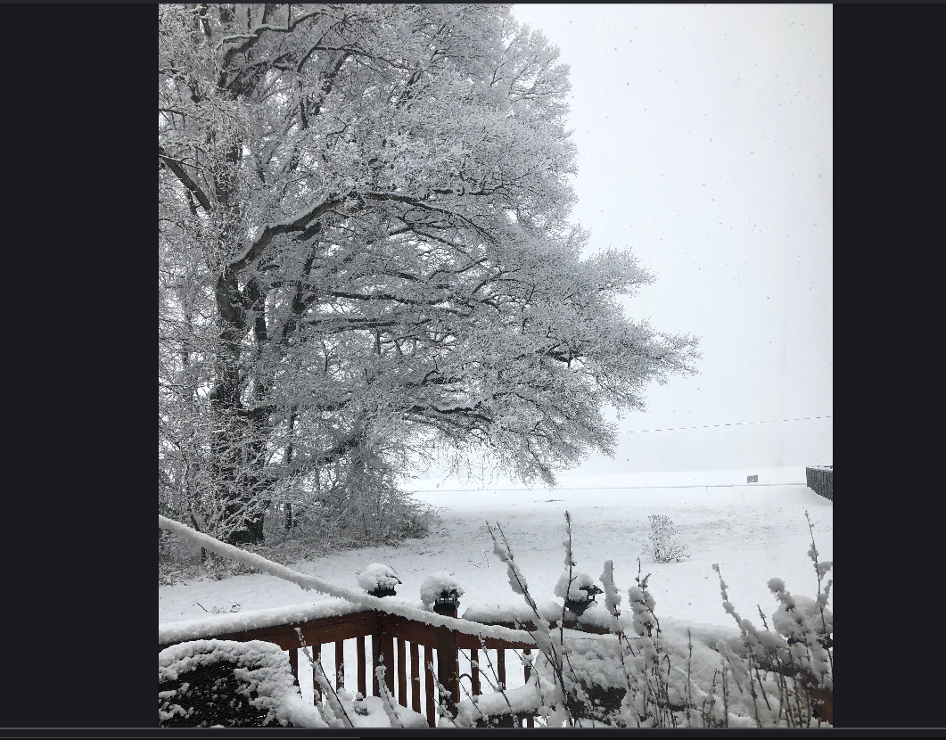

**Thank you Monica!**