**Homework2**

Dan Beck

February 9, 2021

SDEV-400 6380

Prof. Errol Waithe

Homework2

# Table of Contents for Test Cases

1. Creating the Sensor table
2. JSON file loading 20 sensor items
3. List sensors in Sensor table
4. Create a table named Classes
5. Executing the program
6. Delete tables from DynamoDB

# Creating the Sensor table

Figure 1 shows the successful creation of the Sensor table using the create-table, with a Hash Key named Sensor and a read/write capacity of 25 items.

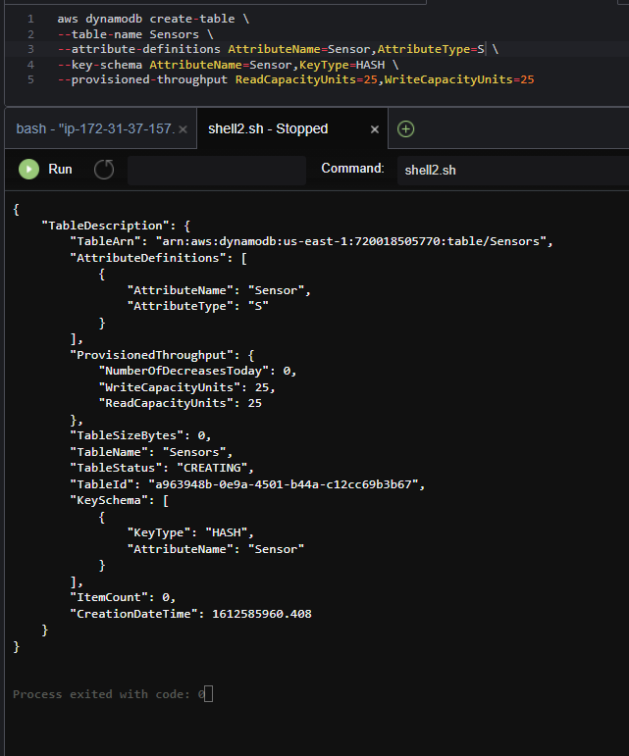

*Figure 1, Creating the Sensor table*

# JSON file loading 20 sensor items

Figure 2 shows the successful insertion of 20 different sensor items from a created JSON file.

*Figure 2, successful execution of JSON file*

# List sensors in Sensor table

Figure 3 shows the successful scanning of the Sensor table when scan –table-name Sensors was executed.

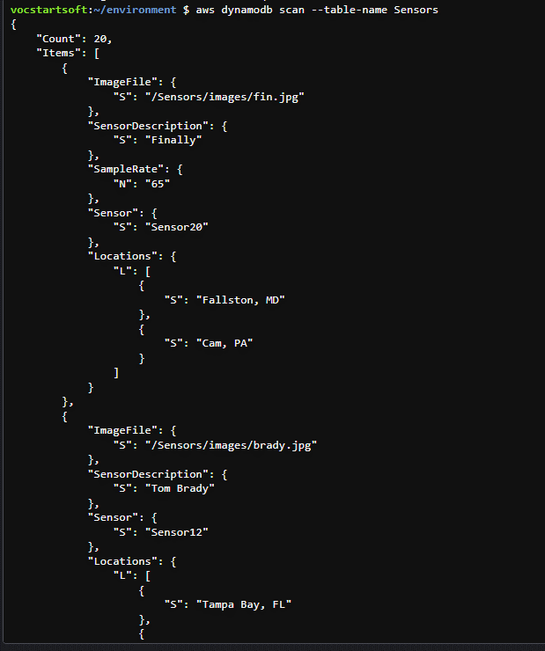

*Figure 3, Successful scanning of 20 items to sensor table*

# Create a table named Classes

Figure 4 shows the function that creates a table named Classes (MoviesCreateTable.py).

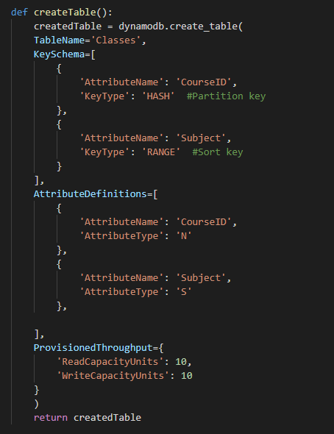

*Figure 4, creating a table in python*

# Executing the program

Figure 5 shows the command line interface with various sample cases. If the user enters the information for a course in the catalog, the program will show the title of the course. If the user does not enter a subject or catalog number, the program will ask to enter one. If the user enters a class that does not exist, then the program will start back at the beginning. If the user selects that they would like to look for another course, then the program starts back at the beginning. If the user selects that they do not want to search for another title, then the program exits.

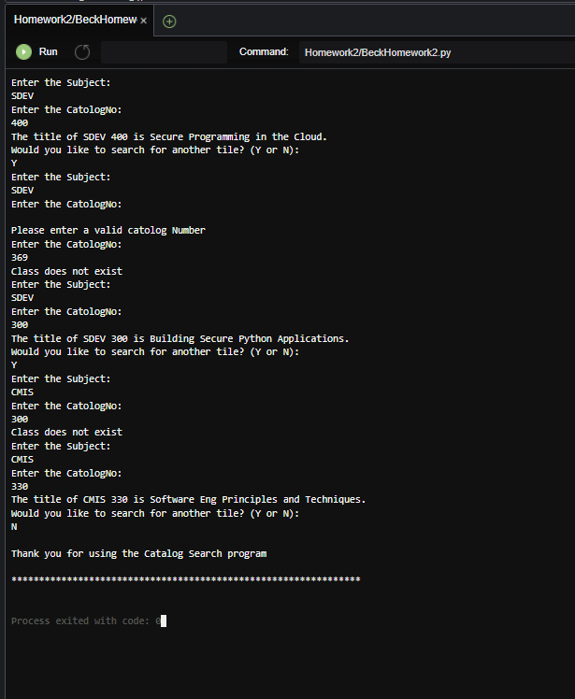

*Figure 5, command line for code*

# Delete tables from DynamoDB

Figure 6 shows the tables, Sensors and Classes, before deletion. Figure 7 shows the delete-table command being used for both tables. Figure 8 shows the table that is left in DynamoDB after deletion.

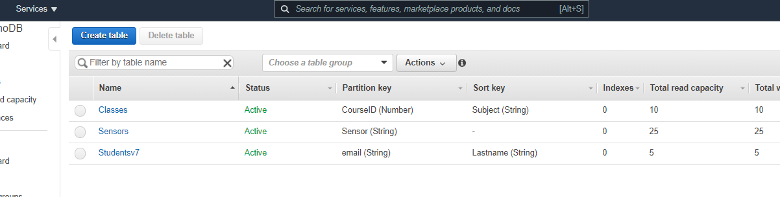

*Figure 6, Tables in DynamoDB before deletion*

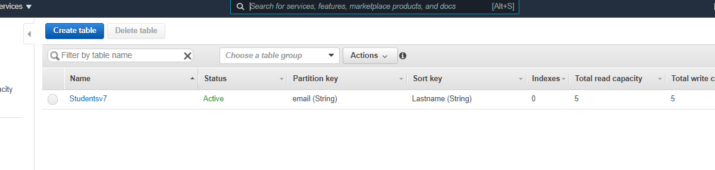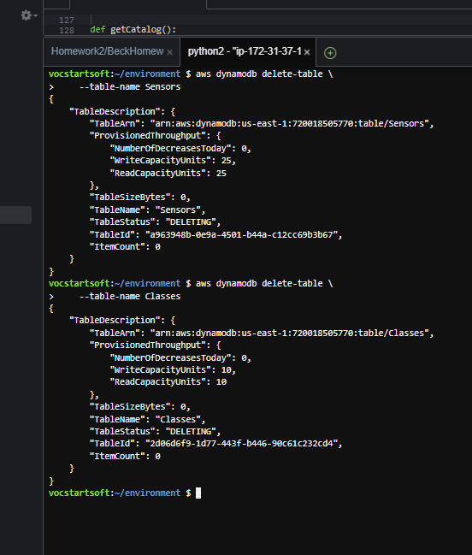

*Figure 7, bucket after file has been deleted*

\

*Figure 8, Tables in DynamoDB after deletion*

# References

MoviesCreateTable.py[Source Code].http://aws.amazon.com/apache2.0/

MoviesItemsOps1.py[Source Code].http://aws.amazon.com/apache2.0/