**Homework3**

Dan Beck

February 23, 2021

SDEV-400 6380

Prof. Errol Waithe

Homework3

# Table of Contents for Test Cases

1. Creating the SportsSearch Lambda and API
2. insertedSport=Baseball&insertedTeam=Rays
3. insertedSport=Baseball&insertedTeam=Orioles
4. insertedSport=Baseball&insertedTeam=Nationals
5. insertedSport=Football&insertedTeam=Ravens
6. insertedSport= Football&insertedTeam=Bills
7. insertedSport= Football&insertedTeam=Buccaneers
8. insertedSport=Hockey&insertedTeam=Capitals
9. insertedSport= Hockey&insertedTeam=Golden Knights
10. insertedSport= Hockey&insertedTeam=Lightning
11. Tests for failure

# Creating the SportsSearch Lambda and API

Figure 1 shows the deploying of the created API con. Figure 2 shows the lambda connecting the DynamoDB database and the SportsSearch API with the link:

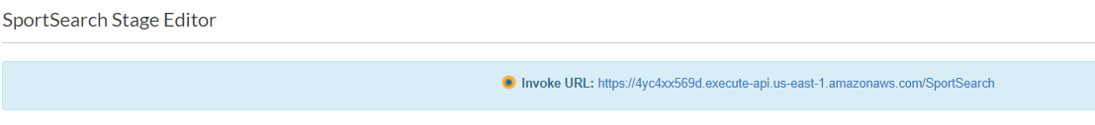<https://4yc4xx569d.execute-api.us-east-1.amazonaws.com/SportSearch>.

*Figure 1, Deploy API*

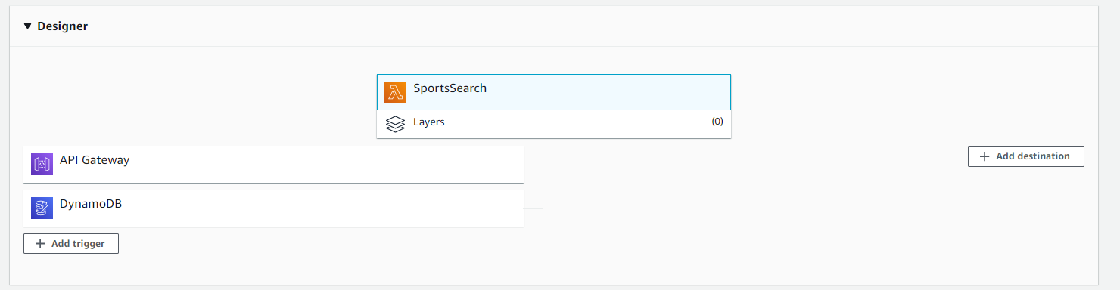

*Figure 2, Creating Lambda*

# insertedSport=Baseball&insertedTeam=Rays

Figure 3 shows the successful retrieving of the last four scores for the Rays baseball team with Baseball being used in the insertedSport query and Rays being used in the insertertedTeam query.

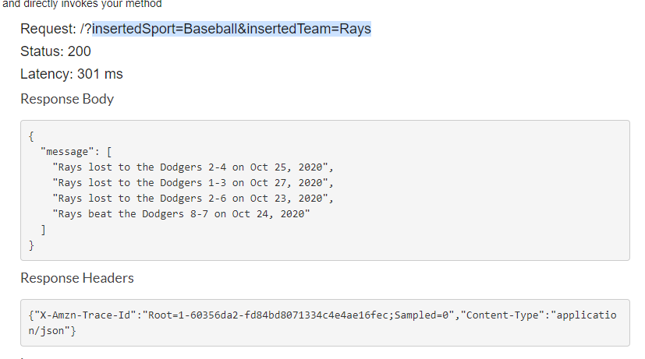

*Figure 3, Rays*

# insertedSport=Baseball&insertedTeam=Orioles

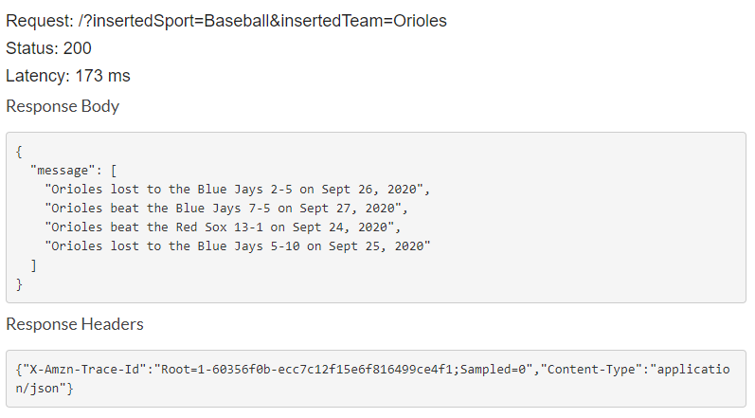Figure 4 shows the successful retrieving of the last four scores for the Orioles baseball team with Baseball being used in the insertedSport query and Orioles being used in the insertertedTeam query.

*Figure 4, Orioles*

# insertedSport=Baseball&insertedTeam=Nationals

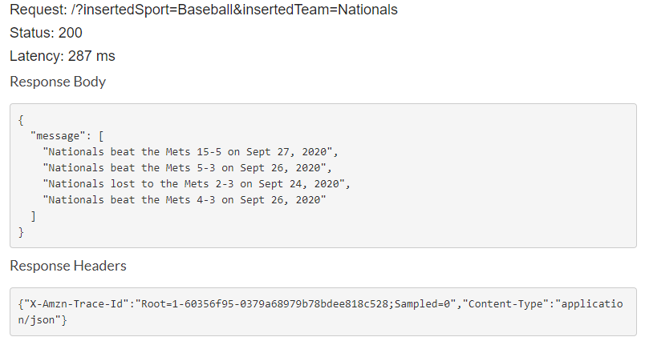Figure 5 shows the successful retrieving of the last four scores for the Nationals baseball team with Baseball being used in the insertedSport query and Nationals being used in the insertertedTeam query.

*Figure 5, Nationals*

# insertedSport=Football&insertedTeam=Ravens

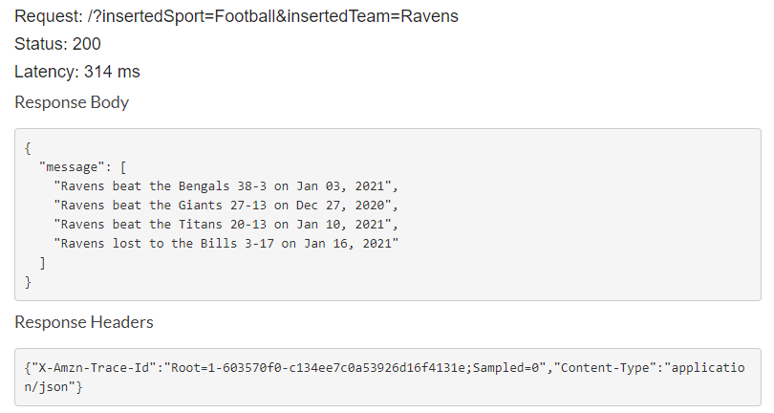Figure 6 shows the successful retrieving of the last four scores for the Ravens football team with Football being used in the insertedSport query and Ravens being used in the insertertedTeam query.

*Figure 6, Ravens*

# insertedSport=Football&insertedTeam=Bills

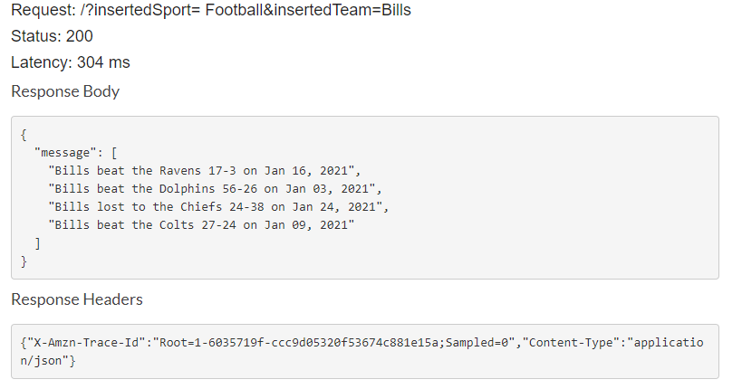Figure 7 shows the successful retrieving of the last four scores for the Bills football team with Football being used in the insertedSport query and Bills being used in the insertertedTeam query.

*Figure 7, Bills*

# insertedSport=Football&insertedTeam=Buccaneers

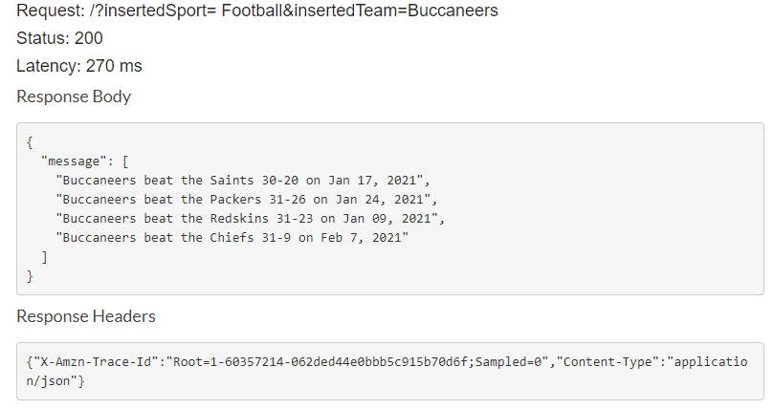Figure 8 shows the successful retrieving of the last four scores for the Buccaneers football team with Football being used in the insertedSport query and Buccaneers being used in the insertertedTeam query.

*Figure 8, Buccaneers*

# insertedSport=Hockey&insertedTeam=Capitals

Figure 9 shows the successful retrieving of the last four scores for the Capitals hockey team with Hockey being used in the insertedSport query and Capitals being used in the insertertedTeam query.

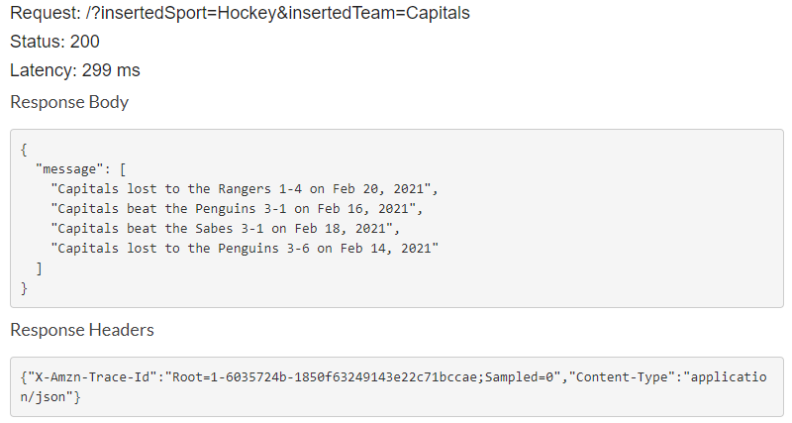

*Figure 9, Capitals*

# insertedSport=Hockey&insertedTeam=Golden Knights

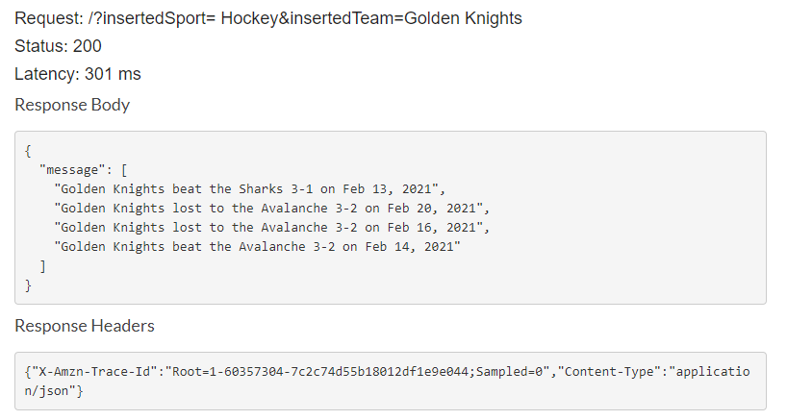Figure 10 shows the successful retrieving of the last four scores for the Golden Knights hockey team with Hockey being used in the insertedSport query and Golden Knights being used in the insertertedTeam query.

*Figure 10, Golden Knights*

# insertedSport=Hockey&insertedTeam=Lightning

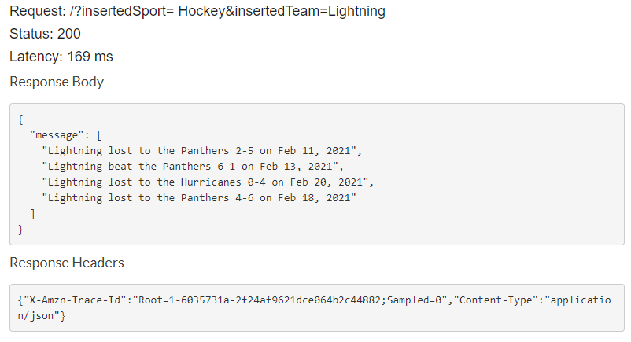Figure 11 shows the successful retrieving of the last four scores for the Lightning hockey team with Hockey being used in the insertedSport query and Lightning being used in the insertertedTeam query.

*Figure 11, Lightning*

# Tests for failure

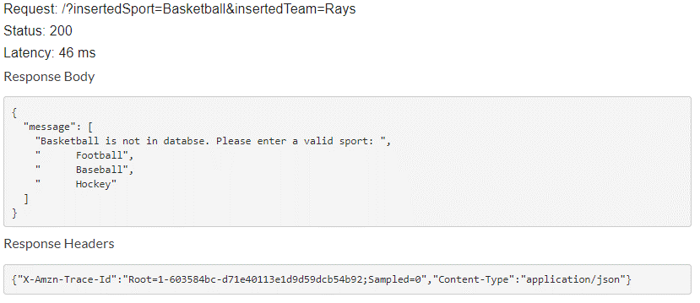Figure 11 shows the prompt from the lambda function, when using Basketball as the insertedSport, telling the user that Basketball is not stored in the database. Figure 12 shows the prompt when a baseball team that is not stored in the database is entered. Figure 13 shows the prompt when a football team that is not stored in the database is entered. Figure 14 shows the prompt when a hockey team that is not stored in the database is entered.

*Figure 11, invalid sport*

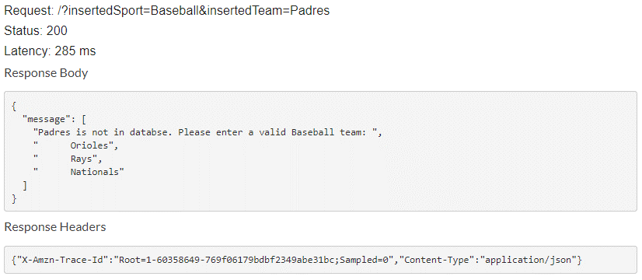

*Figure 12, invalid baseball team*

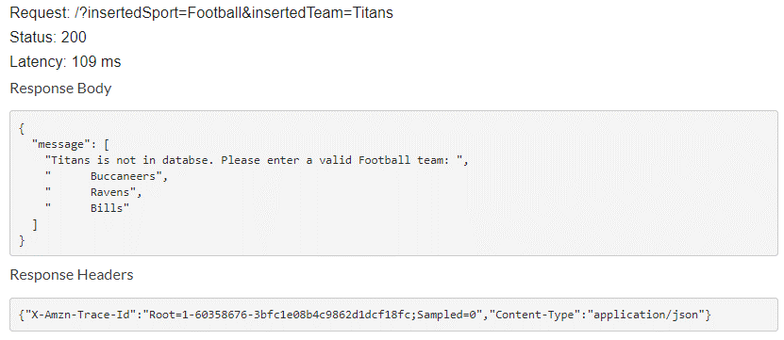

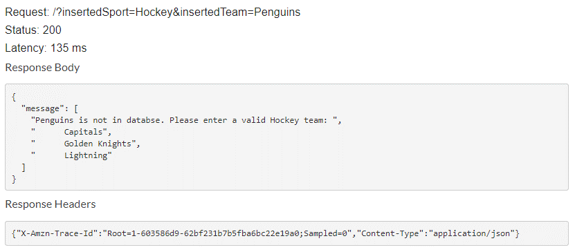

*Figure 13, invalid football team*

*Figure 14, invalid hockey team*

# References

MoviesCreateTable.py[Source Code].http://aws.amazon.com/apache2.0/

MoviesItemsOps1.py[Source Code].http://aws.amazon.com/apache2.0/

Serving sports fans. anytime. anywhere. (n.d.). Retrieved February 23, 2021, from https://www.espn.com/