**Homework4**

Dan Beck

March 9, 2021

SDEV-400 6380

Prof. Errol Waithe

Contents

1. User Guide 2

2. Welcome Page/Enter Player Name 3

3. Enter a new user 4

4. Play Blackjack (Draw Blackjack) 5

5. Play Blackjack (Hit or Stand/Lose) 6

6. BlackJack (Hit or Stand/Draw) 7

7. BlackJack (Hit or Stand/Win) 8

8. BlackJack (Hit or Stand/Bust) 9

9. Return to Main Menu 10

10. Change Player 11

11. See Chip Amount 12

12. See Win/Loss Record 13

13. Reset Record 15

14. Exit the program 16

References 17

# User Guide

Figure 1 shows the main screen of the game with a user guide after selecting 1 to play Blackjack.

The user enters their name. If the name exists, the chip total and record are loaded

|  |  |
| --- | --- |
| Menu |  |
| 1 | Allows the player to start playing Blackjack with the selected user |
| 2 | Allows the user to change players |
| 3 | Allows user to see the chips of the current user |
| 4 | Allows the user to see their win/loss record |
| 5 | Allows the user to reset the record of the current player |
| 6 | Terminates the program |

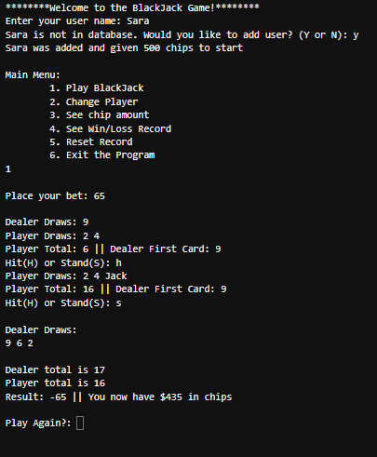

After the hand has been played, the user han an option to play another hand. Y will continure play, while N will take the user back to the main menu

After the dealers’ cards are drawn a winner is calculated and the winnings are calculated, showing the new chip total.

The user enters H to draw another card or S to have the dealer draw their cards. If the user goes over 21, they lose and the game moves to the next step

The user places their bet

*Figure 1, Game Guide*

# Welcome Page/Enter Player Name

Figure 2 shows the initial running of the program welcoming the user to the game and asking for their name.

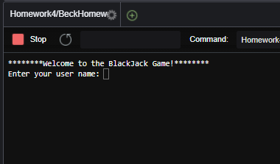

*Figure 2, Game start*

# Enter a new user

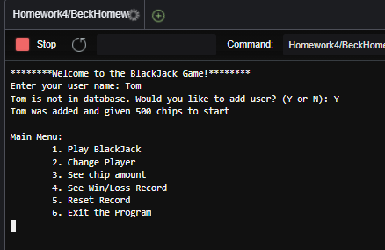Figure 3 shows the player entering a name that is not in the database. After entering the user in the database, the game creates their profile and starts them out with 500 chips.

*Figure 3, Name enter*

# Blackjack (Draw Blackjack)

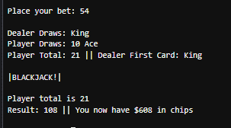Figure 4 shows the user placing a bet, then hitting Blackjack, winning two times what their bet was. Figure 5 shows the image that is retrieved from the S3 bucket that when the player gets Blackjack.

*Figure 5, S3 retrieved when play gets blackjack*

*Figure 4, Player getting Blackjack*



# Blackjack (Hit or Stand/Lose)

Figure 6 shows the user placing a bet, then drawing and standing, then losing to the dealer. Figure 7 shows the image that is retrieved from the S3 bucket that when the player gets loses to the dealer.

*Figure 7, S3 retrieval when loss to the dealer*

*Figure 6, lose to the dealer*

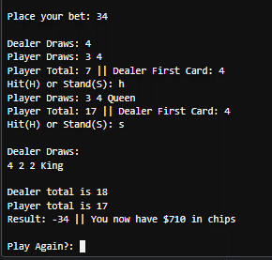

# Blackjack (Hit or Stand/Draw)

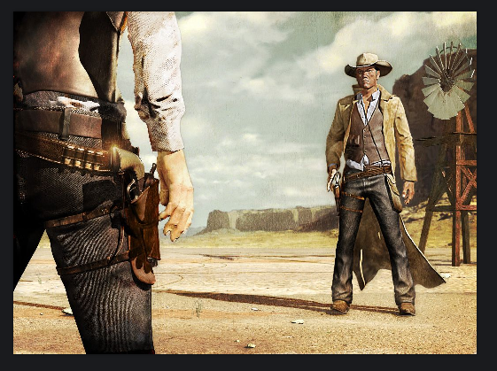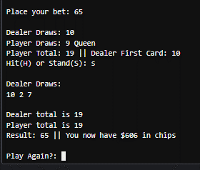 Figure 8 shows the user placing a bet, then drawing and standing, then tying with the dealer receiving their bet back. Figure 9 shows the image that is retrieved from the S3 bucket that when the player beats the dealer.

*Figure 9, S3 draw with the dealer*

*Figure 8, Draw with the dealer*

# Blackjack (Hit or Stand/Win)

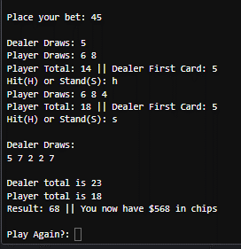Figure 10 shows the user placing a bet, then drawing and standing, then winning 1.5 times their bet. Figure 11 shows the image that is retrieved from the S3 bucket that when the player beats the dealer.

*Figure 11, S3 retrieval for when the user wins*

*Figure 10, User beats the dealer*



# Blackjack (Hit or Stand/Bust)

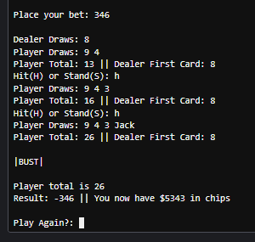Figure 12 shows the user placing a bet, then drawing until a bust occurred and they lost their bet. Figure 13 shows the image that is retrieved from the S3 bucket that when the player busts.



*Figure 13, S3 retrieval when player busts*

*Figure 12, player drawing until bust*

# Return to Main Menu

Figure 14 shows what occurs when after the plays hand is over, If they enter “n” to not play again, taking them back to the main menu.

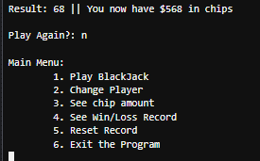

*Figure 14, Player selects not to play again*

# Change Player

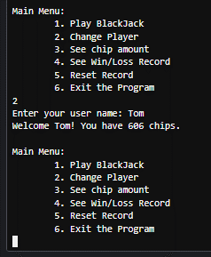Figure 15 shows the user changing to the user Tom, then showing how many chips Tom possesses.

*Figure 15, Changing Player*

# See Chip Amount

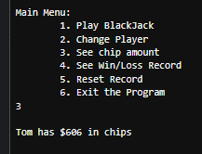Figure 16 shows when the user selects 3 from the menu, showing the current users chip count.

*Figure 16, Chip amount*

# See Win/Loss Record

Figure 17 shows when the user selects 4 from the menu, showing the current users win/loss record.

*Figure 17, win/loss record*

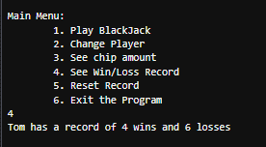

# Reset Record

Figure 18 shows when the user selects 5 from the menu, resetting the user’s win/loss record.

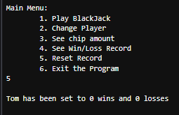

*Figure 18, reset record*

# Exit the program

Figure 19 shows when the user selects 6 from the menu, exiting the program.

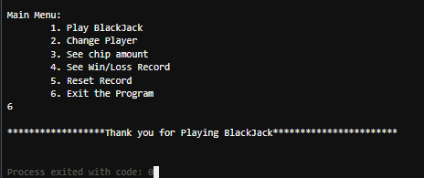

*Figure 19, exiting the program*

# References

MoviesCreateTable.py[Source Code].http://aws.amazon.com/apache2.0/

MoviesItemsOps1.py[Source Code].http://aws.amazon.com/apache2.0/

s3-python-example-download-file.py[Source Code].http://aws.amazon.com/apache2.0/