PS3 SYSCON UART CONNECTION GUIDE

Disclaimer:

I can not be held responsible for any damage made to you ps3 motherboard or issues that occur when following this guide! - At owners own risk!

Why do this?
- Diagnose YLOD issues commonly found on these old PS3 boards
- Adjust default fan speed policies
- Understand the workings of this machine
- Many other good reasons..

PS3 Motherboards
The guide is for the FAT PS3 motherboards, other type of PS3 boards can use this guide but will require knowledge of where to interface the serial connections!
Also note that not all revisions of syscon can be accessed or have all of the commands required!

COK-001
COK-002
DIA-001
DIA-002 (untested, ref pic only)
DYN-001 (
SEM-001

Required equipment

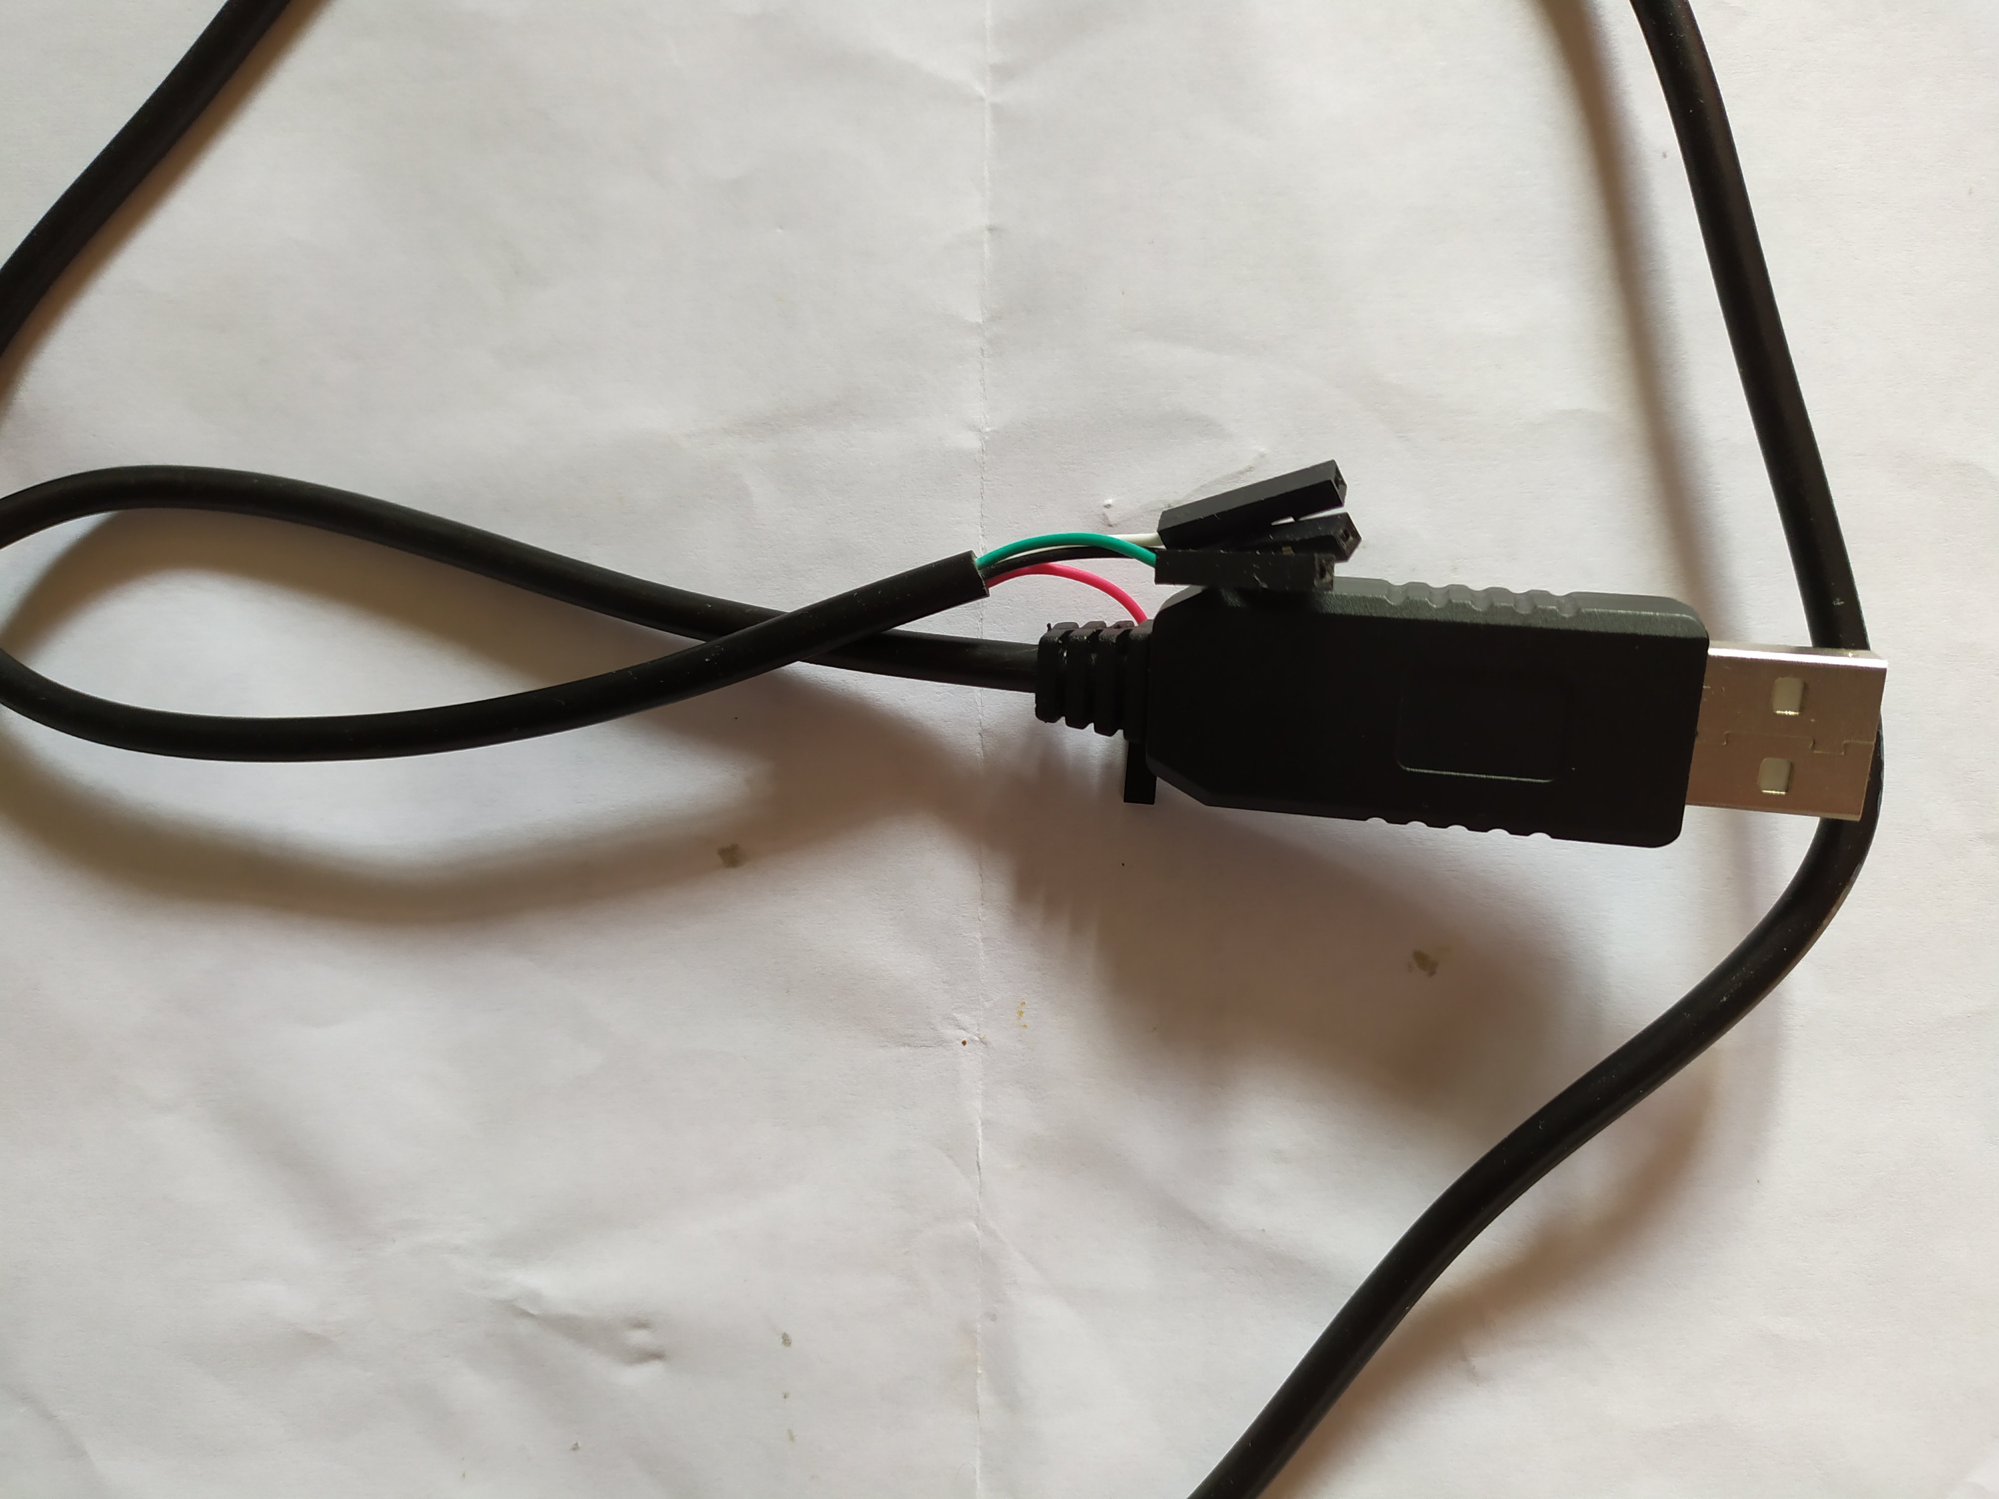

- 1x USB to TTL v3.3 Serial Converter Cable
- 4x AWG 30 single core wire (keep length short)
- Soldering iron and solder
- Wire cutters
- Electrical tape (for insulation afterwards)

Required software (tested on Linux OS only)

- Python 2 +3 (python-serial, python-crypto and pycryptodome modules needed)
- Serial communication program to check output is happening – putty, minicom, screen etc
- Syscon python communication script (used to action syscon commands) – ps3_syscon_uart_script.py (python 2 only) Support CXR and CXRF syscons
- ps3_syscon_uart_script23.py (python 2,3) Supports SW syscons

Identify the serial connections
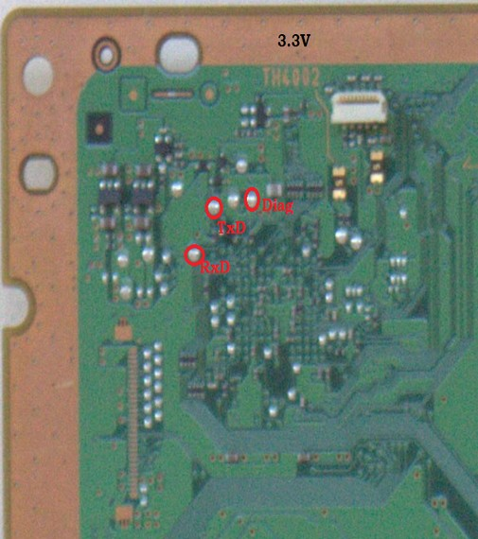
COK-001 and COK-002:

DIA-001 and DIA-002:

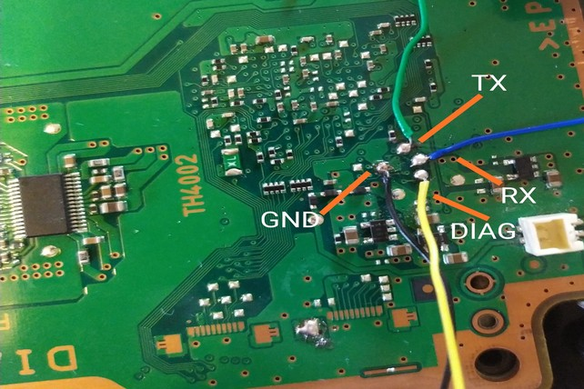

DYN-001:

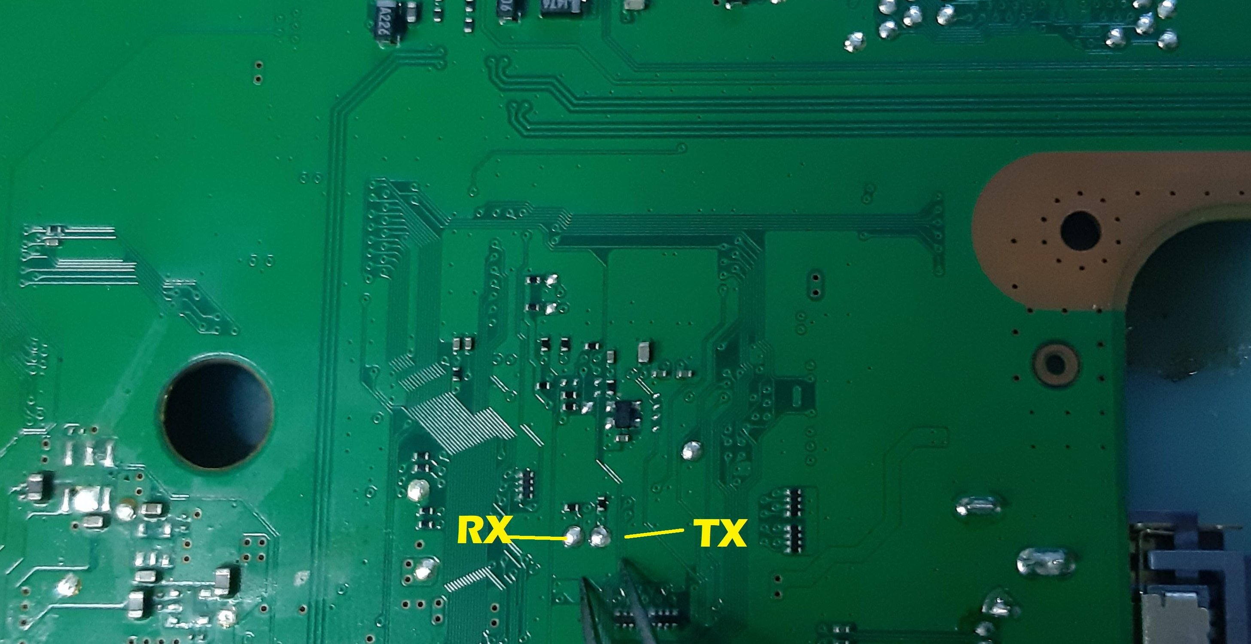

SEM-001:

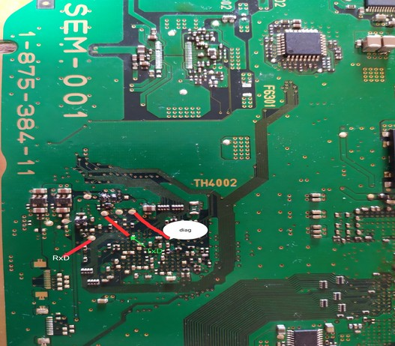

Connecting the serial connection

4x Jumper wires will be needed – 1x Rxd, 1x TxD, 1x Diag and 1x GND

These jumper leads will need to be cut and stripped on one end to solder onto the motherboards points.

Motherboard pin | USB TTL Cable pin | Pin type
RxD | RX | Receive transmission
TxD | TX | Transmit transmission
GND | Ground | Ground connection
Diag | Connect to GND to activate | Diagnose mode – connects to a Ground point to set low
 | 3.3v | 3.3v – DO NOT CONNECT!

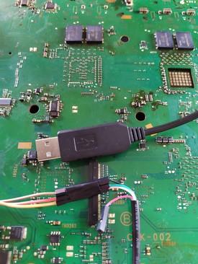

Setup software and usage

This guide will be using an Ubuntu OS to action the commands – Any OS can be used as it just requires Python 2 or 3 and the supplied ‘ps3_syscon_uart_script.py’ and serial terminal program to work.

Copy the supplied python script and open up a terminal:
(make sure your user has permissions to use “/dev/ttyUSB0” - add user to the dialout group)
Plug in your USB TTL cable and make sure its connected as described in the above table!
Do a dmesg command to verify what port its on
$# dmesg
Usually it will be the first ttyUSB0

$# python ps3_syscon_uart_script.py
ps3_syscon_uart_script.py <serial port> <sc type ["CXR", "CXRF"]>

This help will show you the options. So to explain each option:
<serial port> = “/dev/ttyUSB0” - serial device to use to connect to
<sc type> = The SYSCON mode to use:
CXR (57600 baud rate) will be External command mode
CXRF (15200 baud rate) will be Internal command mode – activated by shorting the DIAG jumper cable to the GND pin and clearing offset 0x3961 01 to 00 from FF

The following tables will show you what commands are available for each mode:
If the commands dont work they most likely need a patch to make them work!

External commands

Address | Command | Subcommand | Permission
0x32959 | BOOT | MODE | 0x000080D6
0x329D5 | BOOT | CONT | 0x000080D5
0x342D7 | SHUTDOWN | - | 0x0000C0D5
0x32A51 | HALT | - | 0x0000C0D5
0x32A85 | BOOTENABLE | - | 0x0000809A
0x33491 | AUTH1 | - | 0x0000C0EF
0x33525 | AUTH2 | - | 0x0000C0EF
0x33619 | AUTHVER | SET | 0x0000C0DF
0x335BF | AUTHVER | GET | 0x0000C0FF
0x32AC3 | EEP | INIT | 0x000080DA
0x32C51 | EEP | SET | 0x0000C0DF
0x32D3D | EEP | GET | 0x0000C0DF
0x32EA7 | PDAREA | SET | 0x0000C0DF
0x32E3B | PDAREA | GET | 0x0000C0DF
0x330C5 | CSAREA | SET | 0x0000C0DF
0x33057 | CSAREA | GET | 0x0000C0DF
0x33169 | VID | GET | 0x0000C0D5
0x331D7 | CID | GET | 0x0000C0D5
0x3321D | ECID | GET | 0x0000C0D5
0x3325D | REV | SB | 0x0000C0D5
0x3328D | SPU | INFO | 0x0000C0D5
0x332E1 | KSV | - | 0x0000C0D5
0x33685 | FAN | SETPOLICY | 0x0000C0D7
0x33717 | FAN | GETPOLICY | 0x0000C0D7
0x33781 | FAN | START | 0x0000C0D7
0x33781 | FAN | STOP | 0x0000C0D7
0x33951 | FAN | SETDUTY | 0x0000C0D7
0x339C3 | FAN | GETDUTY | 0x0000C0D7
0x33A27 | R8 | - | 0x0000C0DF
0x33AD1 | W8 | - | 0x0000C0DF
0x33B71 | R16 | - | 0x0000C0DF
0x33C19 | W16 | - | 0x0000C0DF
0x33CBB | R32 | - | 0x0000C0DF
0x33E49 | W32 | - | 0x0000C0DF
0x33EE9 | RBE | - | 0x0000C0D5
0x33F91 | WBE | - | 0x0000C0D5
0x34049 | PORTSTAT | - | 0x0000C0DF
0x332BF | VER | - | 0x0000C0FF
0x341C5 | BUZ | - | 0x00008096
0x342D7 | SERVFAN | - | 0x0000C0D7
0x341F9 | ERRLOG | START | 0x0000C0DF
0x34221 | ERRLOG | STOP | 0x0000C0DF
0x34249 | ERRLOG | GET | 0x0000C0FF
0x342B3 | ERRLOG | CLEAR | 0x0000C0DF

Internal commands

Command | Address | Perms | SubCommands | Description
becount | 0xCA7D | 0xDD0C0000 | - | Display bringup/shutdown count + Power-on time
bepgoff | 0xA4E7 | 0xD00C0000 | - | BE power grid off
bepkt | 0x2435D | 0xDC0C0000 | show/set/unset/mode/debug/help | Packet permissions
bestat | 0xD413 | 0xFD0F0000 | - | Get status of BE
boardconfig | 0x99C7 | 0xDC0C0000 | - | Displays board configuration
bootbeep | 0x1EA67 | 0xF0000000 | stat/on/off | Boot beep
bringup | 0xD597 | 0xFD0F0000 | - | Turn PS3 on
bsn | 0xD805 | 0xF00F0000 | - | Get board serial number
bstatus | 0x24269 | 0xDD0C0000 | - | HDMI related status
buzz | 0xA4FF | 0xDC0C0000 | [freq] | Activate buzzer
buzzpattern | 0xA8B7 | 0xDC0C0000 | [freq] [pattern] [count] | Buzzer pattern
clear_err | 0x2595B | 0xDD0C0000 | last/eeprom/all | Clear errors
clearerrlog | 0xB8CB | 0xDD0C0000 | - | Clears error log
comm | 0x9919 | 0xDC0C0000 | - | Communication mode
commt | 0x24907 | 0xDC0C0000 | help/start/stop/send | Manual BE communication
cp | 0x1E077 | 0xF0000000 | ready/busy/reset/beepremote/beep2kn1n3/beep2kn2n3 | CP control commands
csum | 0xD687 | 0xFF0F0000 | - | Firmware checksum
devpm | 0xD053 | 0xDD0C0000 | ata/pci/pciex/rsx | Device power management
diag | 0x9AAD | 0xD00C0000 | ... | Diag (execute without param to show help)
disp_err | 0x25911 | 0xDD0C0000 | - | Displays errors
duty | 0x9B23 | 0xDD0C0000 | get/set/getmin/setmin/getmax/setmax/getinmin/setinmin/getinmax/setinmax | Fan policy
dve | 0x2995D | 0xDC0C0000 | help/set/save/show | DVE chip parameters
eepcsum | 0xAA65 | 0xDD0C0000 | - | Shows eeprom checksum
eepromcheck | 0x9A1D | 0x000C0000 | [id] | Check eeprom
eeprominit | 0x9A65 | 0x000C0000 | [id] | Init eeprom
ejectsw | 0xD611 | 0xFD0F0000 | - | Eject switch
errlog | 0xB7ED | 0xFF0C0000 | - | Gets the error log
fancon | 0xD26D | 0x0D000000 | - | Does nothing
fanconautotype | 0xC075 | 0xDD0C0000 | - | Does nothing
fanconmode | 0xBF35 | 0xDD0C0000 | get | Fan control mode
fanconpolicy | 0xBBC9 | 0xDD0C0000 | get/set/getini/setini | Fan control policy
fandiag | 0x1E91B | 0xF0000000 | - | Fan test
faninictrl | 0xD3D9 | 0x0D000000 | - | Does nothing
fanpol | 0xCA31 | 0xDD0C0000 | - | Does nothing
fanservo | 0xBF29 | 0xDD0C0000 | - | Does nothing
fantbl | 0xC087 | 0xDD0C0000 | get/set/getini/setini/gettable/settable | Fan table
firmud | 0xD61D | 0xFDFF0000 | - | Firmware update
geterrlog | 0xB84F | 0xDD0C0000 | [id] | Gets error log
getrtc | 0xA6F3 | 0xDD0C0000 | - | Gets rtc
halt | 0x1E107 | 0xF0000000 | - | Halts syscon
hdmi | 0x29F39 | 0xDD0C0000 | ... | HDMI (various commands, use help)
hdmiid | 0x29D1D | 0xDC0F0000 | - | Get HDMI id's
hdmiid2 | 0x29D81 | 0xDC0F0000 | - | Get HDMI id's
hversion | 0x2422F | 0xDD0C0000 | - | Platform ID
hyst | 0xAEF5 | 0xDD0C0000 | get/set/getini/setini | Temperature zones
lasterrlog | 0xB7FF | 0xDD0C0000 | - | Last error from log
ledmode | 0xA80B | 0xDC0C0000 | [id] [id] | Get led mode
LS | 0x2421B | 0xDD0C0000 | - | LabStation Mode
ltstest | 0xCB97 | 0xDD0C0000 | get/set be/rsx | ?Temp related? values
osbo | 0x1EA3F | 0xF0000000 | - | Sets 0x2000F60
patchcsum | 0xD9F7 | 0xDD0C0000 | - | Patch checksum
patchvereep | 0xD9B1 | 0xDD0C0000 | - | Patch version eeprom
patchverram | 0xD965 | 0xDD0C0000 | - | Patch version ram
poll | 0x240E3 | 0xDD0C0000 | - | Poll log
portscan | 0xDA0D | 0xDD0C0000 | [port] | Scan port
powbtnmode | 0xB911 | 0xDC0C0000 | [mode (0/1)] | Power button mode
powerstate | 0xCE6F | 0xDD0C0000 | - | Get power state
powersw | 0xD5F9 | 0xFD0F0000 | - | Power switch
powupcause | 0xB621 | 0xDD0C0000 | - | Power up cause
printmode | 0x99D9 | 0xDC0C0000 | [mode (0/1/2/3)] | Set printmode
printpatch | 0xD94F | 0xDD0C0000 | - | Prints patch
r | 0x8CA5 | 0xDD0C0000 | [offset] [length] | Read byte from SC
r16 | 0x8ED5 | 0xDD0C0000 | [offset] [length] | Read word from SC
r32 | 0x9191 | 0xDD0C0000 | [offset] [length] | Read dword from SC
r64 | 0x935D | 0xDD0C0000 | [offset] [length] | Read qword from SC
r64d | 0x948F | 0xDD0C0000 | [offset] [length] | Read ?qword data? from SC
rbe | 0x96F9 | 0xDD0C0000 | [offset] | Read from BE
recv | 0x24135 | 0xDD0C0000 | - | Receive something
resetsw | 0xD605 | 0xFC0F0000 | - | Reset switch
restartlogerrtoeep | 0xB903 | 0xDD0C0000 | - | Reenable error logging to eeprom
revision | 0xD7E1 | 0xFFFF0000 | - | Get softid
rrsxc | 0xD313 | 0xDD0C0000 | [offset] [length] | Read from RSX
rtcreset | 0xA7BB | 0x000C0000 | - | Reset RTC
scagv2 | 0xE24F | 0xFF000000 | - | Auth related?
scasv2 | 0xE207 | 0xDD000000 | - | Auth related?
scclose | 0xE1EF | 0xFF000000 | - | Auth related?
scopen | 0xE121 | 0xFF000000 | - | Auth related?
send | 0x2416F | 0xDD0C0000 | [variable] | Send something
shutdown | 0xD5C5 | 0xFD0F0000 | - | PS3 shutdown
startlogerrtsk | 0xB8E7 | 0xDD0C0000 | - | Start error log task
stoplogerrtoeep | 0xB8F5 | 0xDD0C0000 | - | Stop error logging to eeprom
stoplogerrtsk | 0xB8D9 | 0xDD0C0000 | - | Stop error log task
syspowdown | 0xB6E9 | 0xDD0C0000 | 3 params 0 0 0 | System power down
task | 0x15005 | 0xDD0C0000 | - | Print tasks
thalttest | 0xD813 | 0x000F0000 | - | Does nothing
thermfatalmode | 0xCA3B | 0xDD0C0000 | canboot/cannotboot | Set thermal boot mode
therrclr | 0xD3E5 | 0xDD0C0000 | - | Thermal register clear
thrm | 0xBF1D | 0xDD0C0000 | - | Does nothing
tmp | 0xAA69 | 0xDD0C0000 | [zone] | Get temperature
trace | 0xB951 | 0xDD0C0000 | ... | Trace tasks (use help)
trp | 0xAB2F | 0xDD0C0000 | get/set/getini/setini | Temperature zones
tsensor | 0xA279 | 0xDD0C0000 | [sensor] | Get raw temperature
tshutdown | 0xB2A1 | 0xDD0C0000 | get/set/getini/setini | Thermal shutdown
tshutdowntime | 0xC95D | 0xDD0C0000 | [time] | Thermal shutdown time
tzone | 0xB5E1 | 0xDD0C0000 | - | Show thermal zones
version | 0xD65F | 0xFFFF0000 | - | SC firmware version
w | 0x8BF9 | 0xDD0C0000 | [offset] [value] | Write byte to SC
w16 | 0x8E2D | 0xDD0C0000 | [offset] [value] | Write word to SC
w32 | 0x8FED | 0xDD0C0000 | [offset] [value] | Write dword to SC
w64 | 0x92A9 | 0xDD0C0000 | [offset] [value] | Write qword to SC
wbe | 0x9665 | 0xDD0C0000 | [offset] [value] | Write to BE
wmmto | 0xCB3B | 0xDC0C0000 | get | Get watch dog timeout
wrsxc | 0xD279 | 0xDD0C0000 | [offset] [value] | Write to RSX
xdrdiag | 0x1E711 | 0xF0000000 | start/info/result | XDR diag
xiodiag | 0x1E875 | 0xF0000000 | - | XIO diag
xrcv | 0x25313 | 0xDC0C0000 | - | Xmodem receive

Now that the commands are established lets start getting the PS3 into the correct mode:

External Command mode usage:

Note: Not all boards have external mode, the default mode is internal mode but patched to prevent access from sony.

Without grounding the DIAG lead the default mode is ‘external mode’

- Before switching on the PS3, make sure the USB TTL lead is connected – Rxd, Txd and GND
- Turn on the PS3, and open up a terminal shell
- Execute the python script - ‘python ps3_syscon_uart_script.py /dev/ttyUSB0 CXR’
- Some commands can be used with requiring the higher privilage mode (auth) and a patched syscon based on your model of board!
An error on the terminal ‘F000005’ will show saying that you have not authenticated (decrypted master key and signed in).
- To sign in you need to ‘auth’, then run those higher privilege commands, for example:
> AUTH
> Auth successful
If you get ‘Auth1 response invalid’, swap the RX and TX wires!, if same check wiring and connection.
Make sure to exit script, switch off PS3 and back on again, then load the script again!
- Now you can run high level commands – EEP SET

To gain access to the internal commands you need to set offset 0x3961 01 value to 00 (originally FF – not set)

External commands are limited in use and will be using a couple of limited commands to allow internal command mode to be activated.

Before attempting this please be aware that setting the offset will temporarily prevent the PS3 from booting when turned off then on again – as this invalidates the eeprom checksum for the syscon
This will be fixed in the later steps!

So to allow internal command we will need to set the offset:

- On the terminal already loaded the python script and run ‘auth’
- Check current offset value for 0x3961 01 – this should be value ‘FF’
EEP GET 3961 01
00000000 FF
- We need now change this value – EEP SET 3961 01 00

- Verify that it is changed before switching to internal mode –
EEP GET 3961 01
00000000 00

Now you can switch off the PS3.
Now we ground the DIAG pin cable to a GND or the GND pin on the usb cable

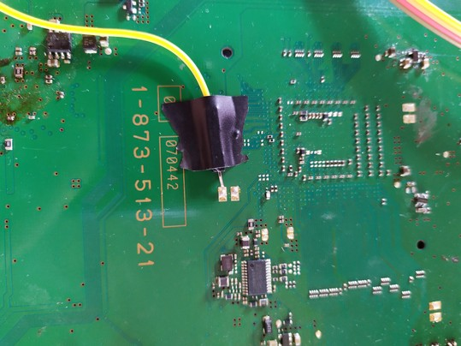

Internal Command mode usage:
(Not all revisions of boards have all of the commands)

Now that the diag pin is grounded we can turn the PS3 on.

PLEASE NOTE: The standby led will flash red repeatly and will not turn on – This is normal as now we need to check the eeprom checksum and fix it

- Run the python command script -
‘python ps3_syscon_uart_script.py /dev/ttyUSB0 CXRF’
- Authenticate to syscon (decrypt and gain high privilege)
> auth
Auth successful

Now check the eeprom checksum and what needs correction

> eepcsum
Addr:0x000032fe should be 0x528c
Addr:0x000034fe should be 0x7115
sum:0x0100
Addr:0x000039fe should be 0x0038
Addr:0x00003dfe should be 0x00ff
Addr:0x00003ffe should be 0x00ff

Highlighted in yellow is what needs to be fixed as its the correct value that needs to be set

PLEASE NOTE: This is an example, you need to use the value specified for your board that shows on the eepcsum result!

Another way to see the whole table is run:

> r 3900 FF
r 3900 FF
+0 +1 +2 +3 +4 +5 +6 +7 +8 +9 +A +B +C +D +E +F
-----------------------------------------------
FF BF FF FF FF FF FF FF FF FF FF FF FF FF FF FF
31 40 11 FF FF FF FF FF FF FF FF FF FF FF FF FF
FF FF FF FF FF FF FF FF FF FF FF FF FF FF FF FF
FF FF FF 00 FF FF FF FF FF FF FF FF FF FF FF FF
FF FF FF FF FF FF FF FF FF FF FF FF FF FF FF FF
FF FF FF FF FF FF FF FF FF FF FF FF FF FF FF FF
02 00 FF FF FF FF FF FF FF FF FF FF FF FF FF FF
FF FF FF FF FF FF FF FF FF FF FF FF FF FF FF FF
FF FF FF FF FF FF FF FF FF FF FF FF FF FF FF FF
FF FF FF FF FF FF FF FF FF FF FF FF FF FF FF FF
FF FF FF FF FF FF FF FF FF FF FF FF FF FF FF FF
FF FF FF FF FF FF FF FF FF FF FF FF FF FF FF FF
FF FF FF FF FF FF FF FF FF FF FF FF FF FF FF FF
FF FF FF FF FF FF FF FF FF FF FF FF FF FF FF FF
FF FF FF FF FF FF FF FF FF FF FF FF FF FF FF FF
FF FF FF FF FF FF FF FF FF FF FF FF FF FF 02
As you can see from this table F and E is misaligned (02) and needs to be corrected to fix the checksum.

So as it is an endian byte we need to swap them around when fixing this table.

Now we set the correct checksum using the write command (w) (byte):

> w 39FE 38 00
Remember we are doing the swap as its an endian byte swap.

To validate the change:

> r 39fe 02
+0 +1 +2 +3 +4 +5 +6 +7 +8 +9 +A +B +C +D +E +F
-----------------------------------------------
38 00

Run eepcsum and ‘r’ command to validate correct checksum:

> eepcsum
eepcsum
Addr:0x000032fe should be 0x528c
Addr:0x000034fe should be 0x7115
Addr:0x000039fe should be 0x0038
Addr:0x00003dfe should be 0x00ff
Addr:0x00003ffe should be 0x00ff

As you can see the sum value is missing meaning that the table is correct
sum:0x0100

r 3900 FF
+0 +1 +2 +3 +4 +5 +6 +7 +8 +9 +A +B +C +D +E +F
-----------------------------------------------
FF BF FF FF FF FF FF FF FF FF FF FF FF FF FF FF
31 40 11 FF FF FF FF FF FF FF FF FF FF FF FF FF
FF FF FF FF FF FF FF FF FF FF FF FF FF FF FF FF
FF FF FF 00 FF FF FF FF FF FF FF FF FF FF FF FF
FF FF FF FF FF FF FF FF FF FF FF FF FF FF FF FF
FF FF FF FF FF FF FF FF FF FF FF FF FF FF FF FF
02 00 FF FF FF FF FF FF FF FF FF FF FF FF FF FF
FF FF FF FF FF FF FF FF FF FF FF FF FF FF FF FF
FF FF FF FF FF FF FF FF FF FF FF FF FF FF FF FF
FF FF FF FF FF FF FF FF FF FF FF FF FF FF FF FF
FF FF FF FF FF FF FF FF FF FF FF FF FF FF FF FF
FF FF FF FF FF FF FF FF FF FF FF FF FF FF FF FF
FF FF FF FF FF FF FF FF FF FF FF FF FF FF FF FF
FF FF FF FF FF FF FF FF FF FF FF FF FF FF FF FF
FF FF FF FF FF FF FF FF FF FF FF FF FF FF FF FF
FF FF FF FF FF FF FF FF FF FF FF FF FF FF 38
The PS3 will now be able to boot normally.

Note: if the value has an extended ffff, then just ignore that and
use the last 4 digit values – remember to swap them as endian.

Example below of a fantbl change ignoring the extra ffff

eepcsum
Addr:0x000032fe should be 0x1596
sum:0xf812
Addr:0x000034fe should be 0xffff3aee
Addr:0x000039fe should be 0x7360
Addr:0x00003dfe should be 0x00ff
Addr:0x00003ffe should be 0x00ff

w 34FE ee 3a – to fix the checksum in internal mode

Examples of the internal commands as follows:
lasterrlog – Show last known errors since boot
Last Error Code:0xa0801001, Time:0x0bacd69b 2006/03/17 02:08:27

errlog – Show full error log (this example shows issues with the RSX chip)
ofst[ 48]:err_code:0xffffffff, clock:0x211a31c0 2017/08/06 20:00:00
ofst[ 52]:err_code:0xa0404412, clock:0x211ba360 2017/08/07 22:17:04
ofst[ 56]:err_code:0xa0403034, clock:0x211ba361 2017/08/07 22:17:05
ofst[ 60]:err_code:0xa0404412, clock:0x211f92e6 2017/08/10 21:55:50
ofst[ 64]:err_code:0xa0403034, clock:0x211f92e6 2017/08/10 21:55:50
ofst[ 68]:err_code:0xa0404412, clock:0x24da1cd0 2019/08/04 22:46:40
ofst[ 72]:err_code:0xa0403034, clock:0x24da1cd0 2019/08/04 22:46:40
ofst[ 76]:err_code:0xa0404412, clock:0x24da1cda 2019/08/04 22:46:50
ofst[ 80]:err_code:0xa0403034, clock:0x24da1cda 2019/08/04 22:46:50
ofst[ 84]:err_code:0xa0404412, clock:0x24f32fd9 2019/08/23 23:14:33
ofst[ 88]:err_code:0xa0403034, clock:0x24f32fd9 2019/08/23 23:14:33
ofst[ 92]:err_code:0xa0404412, clock:0x24f33013 2019/08/23 23:15:31
ofst[ 96]:err_code:0xa0403034, clock:0x24f33013 2019/08/23

eepcsum – Show current eeprom checksum state
Addr:0x000032fe should be 0x1596
Addr:0x000034fe should be 0x3aee
Addr:0x000039fe should be 0x7360
Addr:0x00003dfe should be 0x00ff
Addr:0x00003ffe should be 0x00ff
r 3900 ff – Read areas of the eeprom (390 hex area to end)
+0 +1 +2 +3 +4 +5 +6 +7 +8 +9 +A +B +C +D +E +F
-----------------------------------------------
FF BF FF FF FF FF FF FF FF FF FF FF FF FF FF FF
40 50 11 FF FF FF FF FF FF FF FF FF FF FF FF FF
FF FF FF FF FF FF FF FF FF FF FF FF FF FF FF FF
FF FF FF 00 FF FF FF FF FF FF FF FF FF FF FF FF
FF 03 C8 78 FF FF FF FF FF FF FF FF FF FF FF FF
FF FF FF FF FF FF FF FF FF FF FF FF FF FF FF FF
02 00 FF FF FF FF FF FF FF FF FF FF FF FF FF FF
FF FF FF FF FF FF FF FF FF FF FF FF FF FF FF FF
FF FF FF FF FF FF FF FF FF FF FF FF FF FF FF FF
FF FF FF FF FF FF FF FF FF FF FF FF FF FF FF FF
FF FF FF FF FF FF FF FF FF FF FF FF FF FF FF FF
FF FF FF FF FF FF FF FF FF FF FF FF FF FF FF FF
FF FF FF FF FF FF FF FF FF FF FF FF FF FF FF FF
FF FF FF FF FF FF FF FF FF FF FF FF FF FF FF FF
FF FF FF FF FF FF FF FF FF FF FF FF FF FF FF FF
FF FF FF FF FF FF FF FF FF FF FF FF FF FF 60
w – Write to eeprom
w 34fe d5 e5
w complete!
fanconpolicy get 0 – Show or set fan policy for CELL
fancon No:00
policy01: Auto

fanconpolicy get 1 – Show or set fan policy for RSX
fancon No:01
policy01: Auto

tmp 0 – Show current temp for the CELL chip
TZone No:00
1st BE Primary Temperature:43.70(0x2bb5)
tmp 1 – Show current temp for the RSX chip
TZone No:01
RSX Primary Temperature:36.75(0x24c0)

duty get 0 – Show current running fan mode for CELL
CrntDuty(0x0):27%(0x47)
duty get 1 – Show current running fan mode for RSX
CrntDuty(0x1):27%(0x47)
tsensor 0 – Show thermal monitor sensor temp for CELL
Raw:60.00(0x3c00), Offset:0.00(0x0000)
Temperature:60.70(0x3cb5)
tsensor 1 – Show thermal monitor sensor temp for RSX
Raw:56.25(0x3840), Offset:2.00(0x0200)
Temperature:56.25(0x3840)

tsensor 3 – Show thermal monitor sensor temp for Southbridge
Temperature:49.25(0x3140)

tzone – Show thermal zones available
00: 1st BE Primary
01: RSX Primary
14: SB
tshutdown get 0 – View or Set (set) Thermal shutdown mode CELL in hex or percentage value
TZone No:00
1st BE Primary Temperature:91.0(0x5b00)
tshutdown get 1 - View or Set (set) Thermal shutdown mode RSX in hex or percentage value
TZone No:01
RSX Primary Temperature:95.0(0x5f00)

trp get 0 – View or Set (set) Temperature zones CELL in hex or percentage value
TZone No:00
1st BE Primary Temperature:90.0(0x5a00)

trp get 1 - View or Set (set) Temperature zones RSX in hex or percentage value
TZone No:01
RSX Primary Temperature:94.0(0x5e00)
version – Show syscon firmware version
v1.2.3_k1
powerstate – Show current running power states (good for diagnose)
ATA Power : ON
PCI Power : OFF
RSX Power : ON
XDR Power : ON
Eurus Power : ON
SB Power : ON
RSX Thermal Sensor : AVAILABLE
BE Thermal Sensor : AVAILABLE
bringup – Power cycle the board to come on

syspowdown – System power down if running
> syspowdown 0 0 0

shutdown – Power off immediately
There are many more commands, but the examples are the most useful

