**Hydraulic Conductivity:**

1. Birds-eye map of K

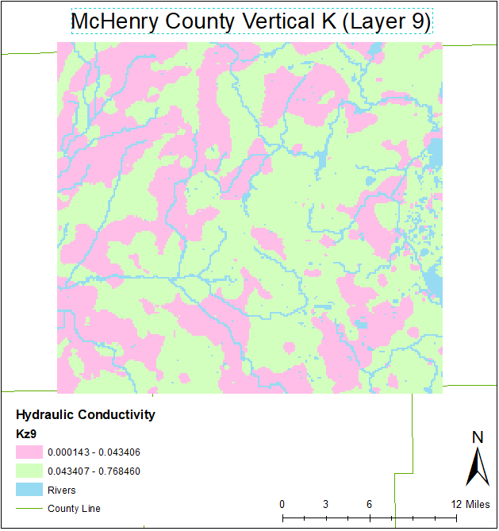

1. N-S cross sections of hydraulic conductivity
   1. Row 1; Column 10

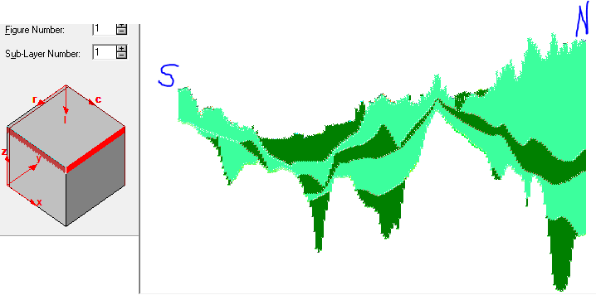

* 1. Row 1; Column 110

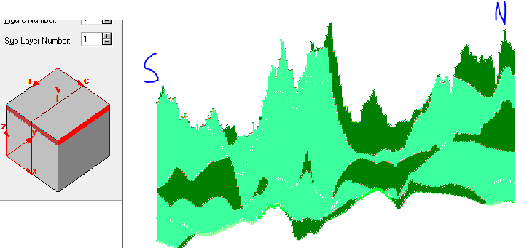

* 1. Row 1; Column 210

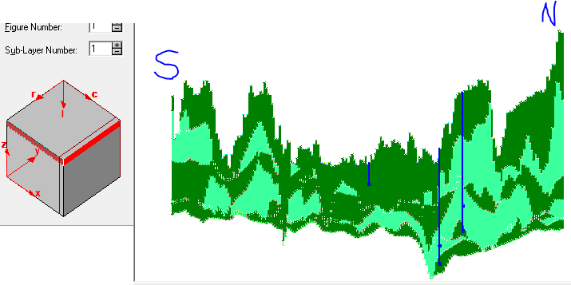

**Water Levels and Monitoring Sites:**

An extensive study on the monitoring wells and groundwater of McHenry County, Illinois was completed by the USGS and Amy Gahala in 2017. Data from a countywide network of 44 monitoring wells were analyzed using continuous water-level data from 2009-2014. Water levels in the sand and gravel aquifers of McHenry County are sensitive to natural influences like precipitation, seasonal and annual variations, barometric pressure, and pumping.

Figure 36 showed the potentiometric surface derived from the monitoring wells across McHenry County in 2010. There is a south-east trending high to low water level gradient across the county. The south-east corner of the county consists of municipalities with a higher population density relative to the rest of the county. The wells in this area are influenced by pumping, which negatively affects water levels (figure 15). Water levels in the aquifer are lower in this area because of the higher amounts of pumping to support agriculture and the population of peoples in the municipalities.

Recharge from precipitation replenishes the groundwater in McHenry County an estimated 2.4 inches per year. Recharge rates in the monitoring wells show that some areas in the eastern half of the county had higher than average recharge rates. Potentially, this is the case because many of these wells in the east are either unconfined or semi-confined (figure 14). Unconfined aquifers recharge more quickly because of the lack of a confining, impermeable layer. The high recharge areas to the east need to be protected and further monitored because wells there supply water to most of the population in the county.

Overall, the groundwater levels in McHenry county supply water to agriculture, waterbodies, and people. Natural processes like precipitation influence recharge to the aquifer. In the case of a drought – like in 2012 – the recharge rates that replenish the aquifer diminish creating vulnerabilities in the water supply. Extreme weather events will occur continuously as global warming increases. Therefore, it is imperative to keep groundwater levels as high in McHenry County to help keep people safe and agriculture yield consistent to help the local economy.

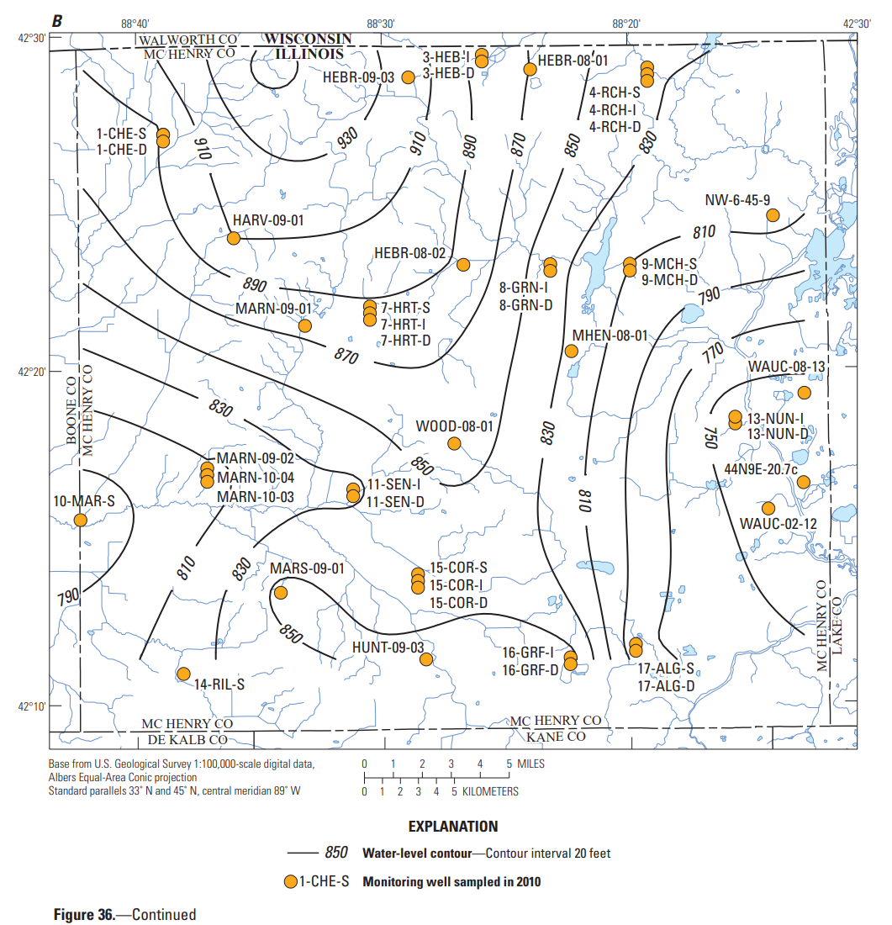

**References:**

Gahala, A.M., 2017, Hydrogeology and water quality of sand and gravel aquifers in McHenry County, Illinois, 2009–14, and comparison to conditions in 1979: U.S. Geological Survey Scientific Investigations Report 2017–5112, 91 p., <https://doi.org/10.3133/sir20175112.>