GRANT ACCESS TO ORACLE CLONE DATABASES
In order to ensure that the password expiration policy is maintained, we need to create the account in the source of the clone with only access to “create session” which allows the end user to connect to the database and nothing more.
- Make sure the end user put in a system access request for database access.
- Create account in jdpd (or the appropriate source database) with only “CREATE SESSION” permissions. This will allow the account to be able to connect to the database and manage their password.
CREATE USER "EmployeeSID" IDENTIFIED BY "NewPassword"
DEFAULT TABLESPACE USERS
TEMPORARY TABLESPACE TEMP
PROFILE PLEXUS_USER_PROFILE
ACCOUNT UNLOCK /*IncidentNumber*/;
GRANT CREATE SESSION TO "EmployeeSID" /*IncidentNumber*/;
ALTER USER "EmployeeSID" PASSWORD EXPIRE /*IncidentNumber*/;

- Create account in the destination database (clone). In this environment you can grant the additional access needed for the request (Access to specific objects and / or database roles). These permissions will persist until the clone is refreshed which we will address with additional steps to follow.
CREATE USER "EmployeeSID" IDENTIFIED BY "NewPassword"
DEFAULT TABLESPACE USERS
TEMPORARY TABLESPACE TEMP
PROFILE PLEXUS_USER_PROFILE
ACCOUNT UNLOCK /*IncidentNumber*/;
GRANT CREATE SESSION TO "EmployeeSID" /*IncidentNumber*/;
ALTER USER "EmployeeSID" PASSWORD EXPIRE /*IncidentNumber*/;

-- actual database permissions applied only in the clone
GRANT PLXDEV TO "EmployeeSID" /*IncidentNumber*/;
ALTER USER "EmployeeSID" DEFAULT ROLE ALL /*IncidentNumber*/;

- The end user’s PC should be configured with the Oracle client tools (including sqlplus) which will provide them the ability to manage their passwords. The appropriate TNS entries will need to exist in their tnsnames.ora file as well unless different connection strings are utilized.
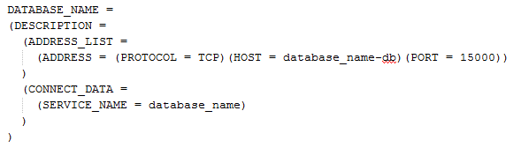
- Because the clones are destroyed and recreated on a scheduled basis we need to edit a “Post Clone” script to include the account permissions going forward. The file should exist on each cloned database server in a specific location.

- Log into the clone database server and choose the appropriate SID (database)
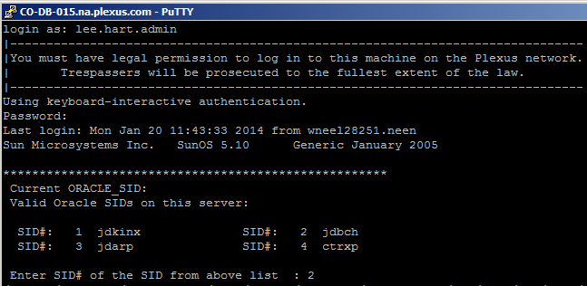

- Once your environment has been set by the login script and your database choice, you need to navigate to the pfile directory and look for a file called flexpost.sql. For 11g databases the location of this directory is /oracle/admin/<database>/pfile. This file is executed from UC4 during the clone process. This file may or may not call other .sql scripts.
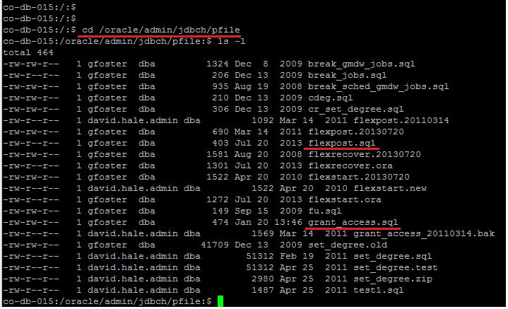

- The flexpost.sql script may or may not call additional scripts. For instance additional commands can be broken out and maintained independently. In the example above, permissions are maintained through a script called grant_access.sql. If we were to open the file with the vi editor you would see the path to that script (listed below).

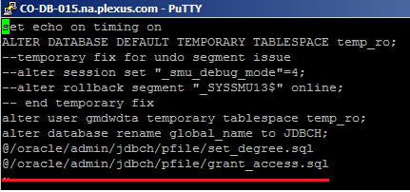
- In this case we would need to edit the grant_access.sql script to add / append the account permissions so they persisted during the clone process.

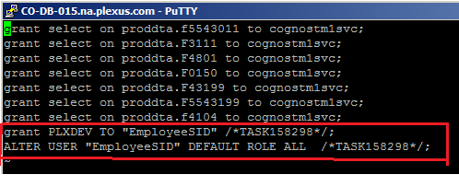
- Since we created the end users account with an expired password they will need to log into both the source and destination databases and change their passwords. To do this they should utilize the sqlplus tool.

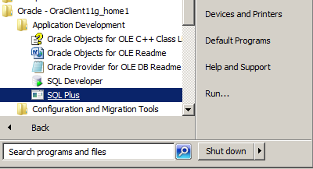

- Open SQLplus, once prompted for Enter user-name: have the end user enter accountname@databasename. For (example AA12@JDRO), this should then prompt them to change their expired password.

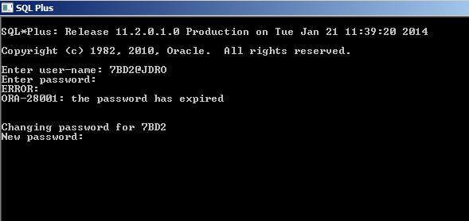
- Once their password is changed in the source they can repeat the process in the clone environment or simply wait until the clone environment is refreshed (schedules vary).
- At this point the account creation process for clones should be complete. When the employee needs to change their password they should be using the SQLplus tool to change their password in the appropriate source environment.

