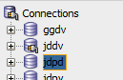
Connect to the database using your current password

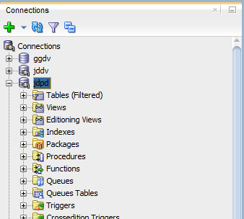
Right Click on the database connection > select “Reset Password..."

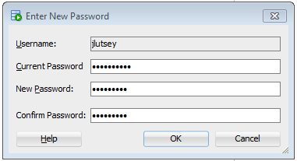
Enter your current password and a new password.

