Changing Expired Oracle Database Password with SQL Plus

- Open the SQL Plus tool
Start > Oracle – OraClient… > Application Development > SQL Plus

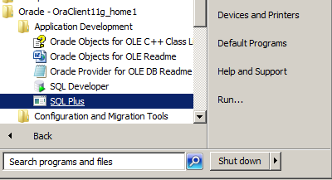

- Once prompted for “Enter user-name: “, enter accountname@databasename. (example AF38@JDPD.WORLD)
- At the prompt for “Enter password: “, enter the temporary password you were given.
- You will get a message stating “the password has expired”, and you will be prompted to enter a “New password: ”. Enter a new password; press Enter. (note: the characters will not be displayed as you type)
- You will be prompted to “Retype new password: “. Enter the same new password, press Enter (note: the characters will not be displayed as you type)
- You will get a message stating “Password changed”
- Type “exit” and press Enter to exit SQL Plus.

