Request SSL Certificate
Service Now
Service Catalog
IT – Use Only
SSL Certificate Request

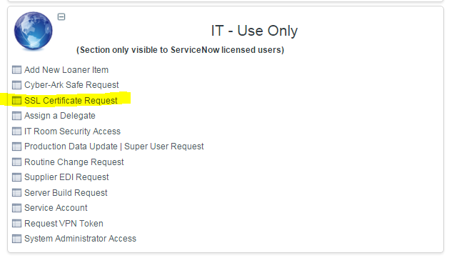

Fill Out the Mandatory Fields
- Common name for this certificate: FQDN (co-db-041.na.plexus.com)
- Certificate Type: Plexus PKI
- Certificate Term: 3 Years
- Primary host: server name (CO-DB-041)
- DSL Entry: application name (PSOM-SMS/KMS)

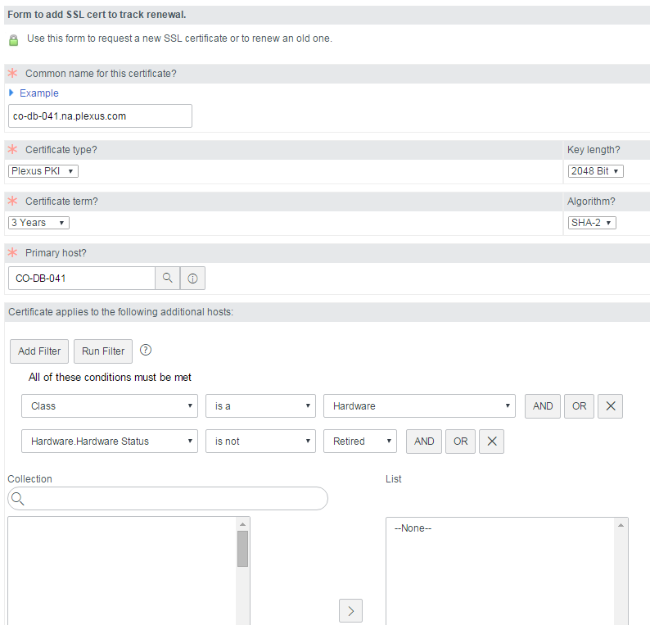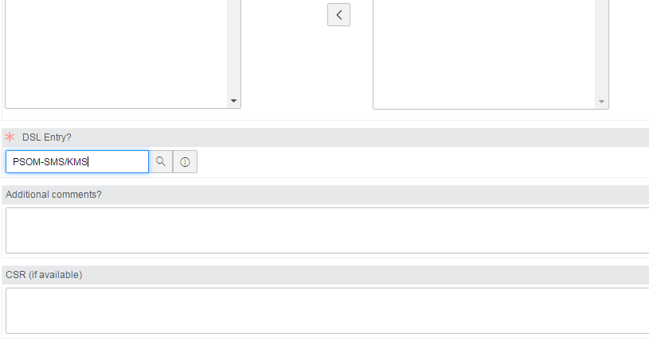
You will receive an email from the security team with a link to download the certificate. There will be 2 files: the certificate, and a text file with a password needed when provisioning the cert on the server.

Provision SSL Certificate on the Server
Log onto the machine as the service account running SQL Server Engine

Copy the certificate file to the server.

Open MMC Console
Start > Run > MMC
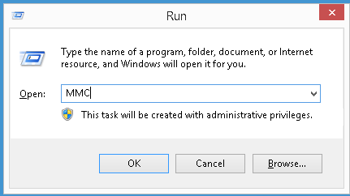

File > Add/Remove Snap-in
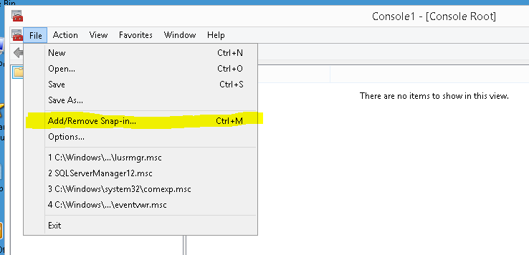

Select ‘Certificates’ under ‘Available snap-ins:’
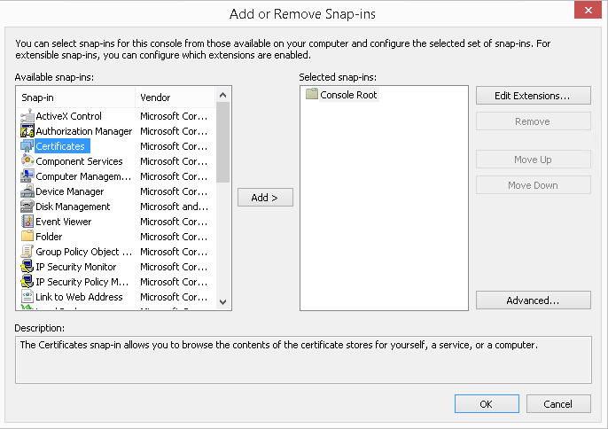

Click Add >
Select ‘Computer account’
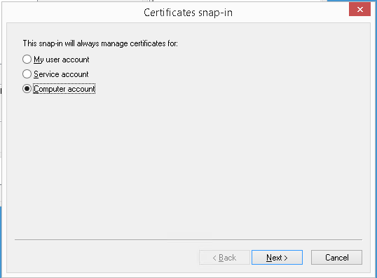

Click Next >
Leave ‘Local computer’ selected
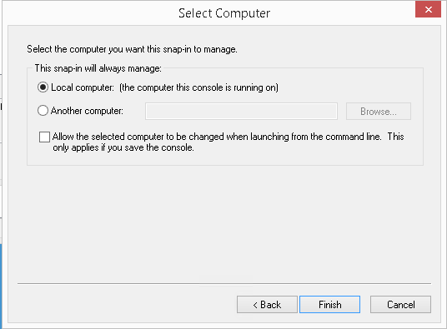

Click Finish
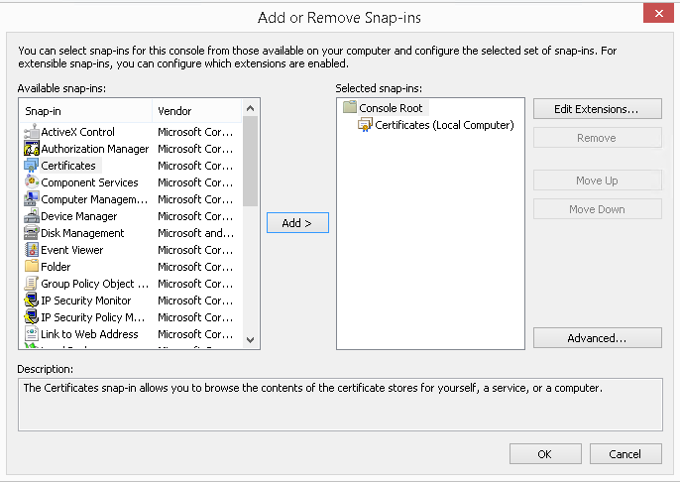

Click OK

Expand ‘Certificates’, ‘Personal’
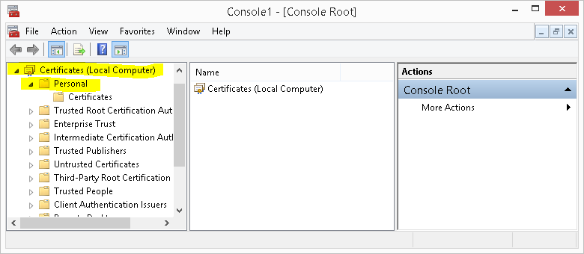

Right-click ‘Certificates’
Select ‘All Tasks’ > ‘Import…’
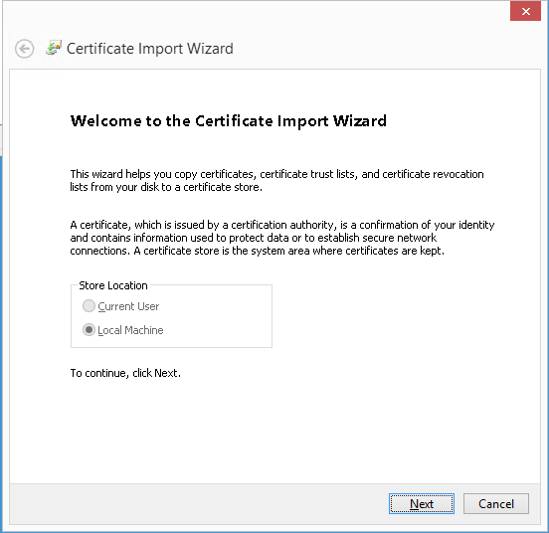

Click Next
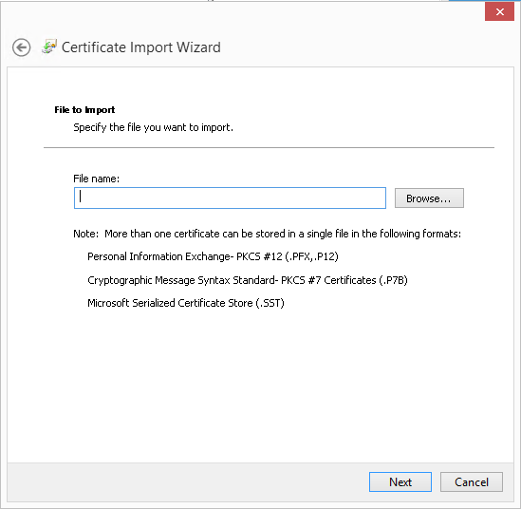

Click Browse…
Locate and select your certificate.
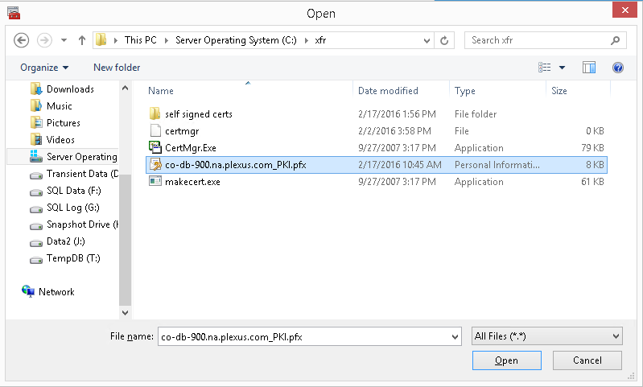

Click Open
Click Next
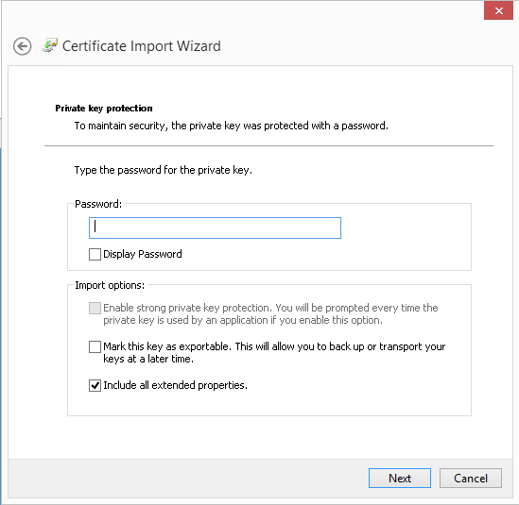

Enter the password you received (it is in a text file that came with the certificate from the security team)
Click Next

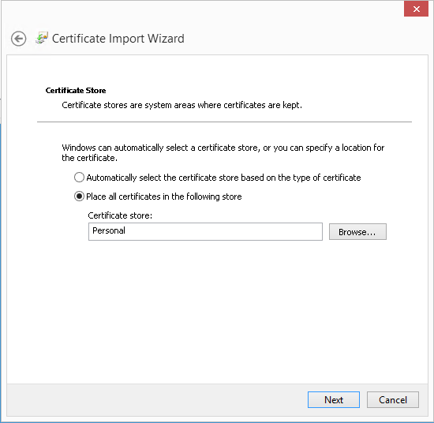

Leave Certificate store: Personal
Click Next
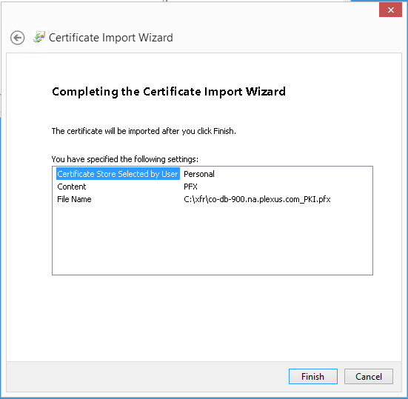

Click Finish

You should now be able to see the certificate if you select ‘Certificates’ in the MMC Console
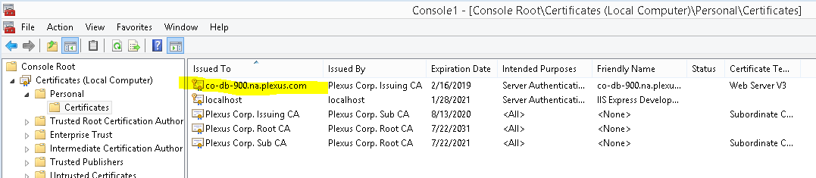

Close the MMC Console
Save console settings? Click No

Configure SQL Server to Accept Encrypted Connections
Open SQL Server Configuration Manager
Expand 'SQL Server Network Configuration'
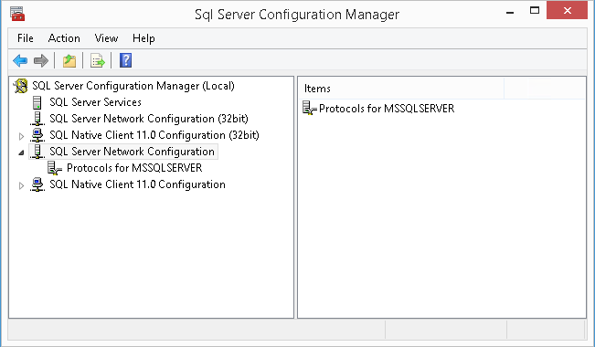

Right-click ‘'Protocols for MSSQLSERVER'
Select 'Properties'

Select tab ‘Certificate’
Select your certificate from the dropdown menu
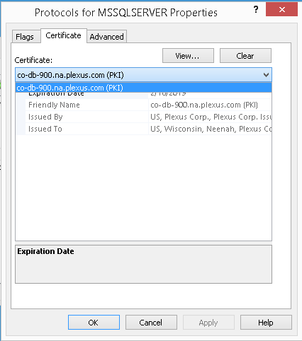

OPTION: Force Encryption - this will force all connections to use SSL encryption
Select tab ‘Flags’
Select ‘Yes’ for ‘Force Encryption’
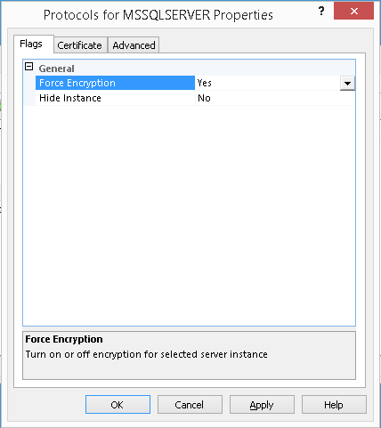

Click ‘OK’ for the warning about restarting the service

Restart SQL Server service

NOTES: If you did NOT select ‘Force Encryption’
- If you did not select ‘Force Encyption’, the client must request encryption in the connection string. If you did set ‘Force Encyption’ to ‘Yes’, then the client does not need to request encryption, it will automatically be encrypted.
- If ‘Force Encyption’ is set to ‘No’, you must use the FQDN when entering the server in the connection string.
- Using SSMS to connect with SSL encryption if ‘Force Encryption’ is set to ‘No’
  - Enter the FQDN in Server Name:
  - Click ‘Options >>’
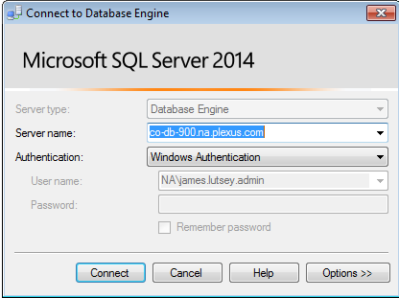
  - Under tab ‘Connection Properties’, select ‘Encrypt connection’
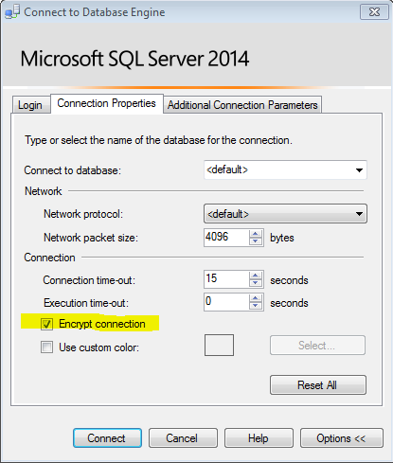
  - Click ‘Connect’

Verifying the connection(s) are encrypted
SELECT session_id, encrypt_option
FROM sys.dm_exec_connections;

