RESTORING SYSTEM DATABASES

- Restoring MSDB and MODEL Databases are no different from restoring a simple User Database.
  - Note: restoring MSDB, make sure that your Agent Service is stopped for Exclusive access. Stop SQL Agent service with Configuration Manager and set to manual startup.
- Restoring MASTER
  - Start SQL Server in Single User Mode
    - From Configuraiton Manager, add -m in startup parameters
    - Screen shot - SQL Server 2008 R2
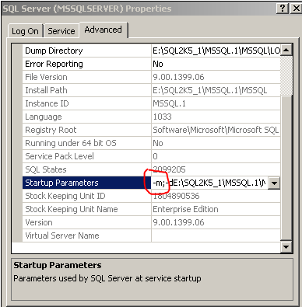
    - Screen shot - SQL Server 2012
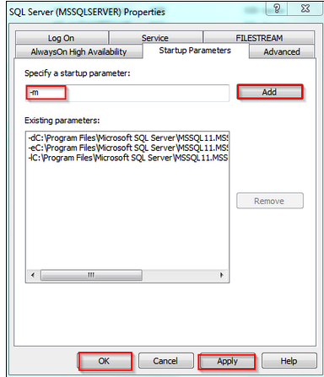
  - Configuration Manager – Change SQL Server Agent Startup to Manual
  - Restart SQL Server service
  - From SQLCMD
  - RESTORE DATABASE master FROM <backup_device> WITH REPLACE
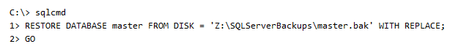
  - After master is restored, the instance of SQL Server shuts down and terminates the sqlcmd process. Before you restart the server instance, remove the single-user startup parameter from Configuration Manager.

