SQL Server – CNAMEs
Contents
Request CNAME(s) for a SQL Server database server 1
Naming Convention 3
Looking Up Existing CNAMEs 3

Request CNAME(s) for a SQL Server database server

ServiceNow
- Service Catalog > DNS Request

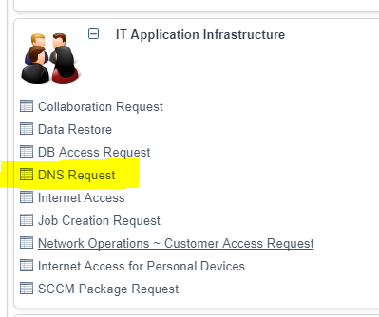

- Describe the Action Required:
Add a New Record
- Please Provide the Reason for this Action:
New Equipment
- Please provide the Full Qualified Domain Name:
Enter the server’s fqdn
- Requested IP Address or Alias Target
Enter the server’s ip address
- Additional Comments:
Please create an alias [<CNAME>] that points to [<Server FQDN>]

<example on the next page>
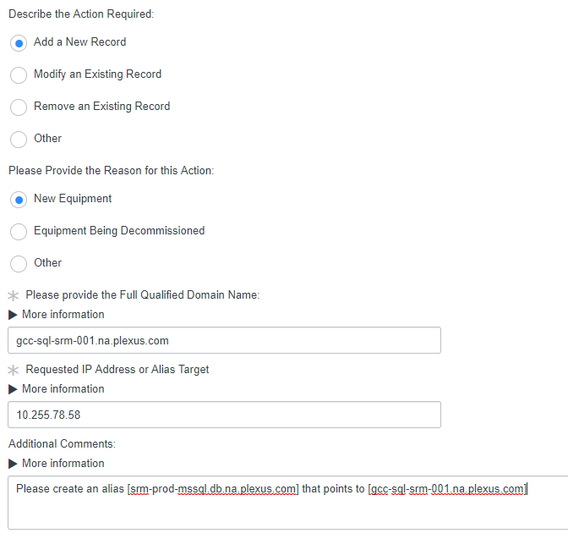

Naming Convention

<application>-<region>-<environment>-mssql.db.na.plexus.com
- <region> is optional
- <environment> prod, qa, tst, trn, dev

Examples
- wms-appl-prod-mssql.db.na.plexus.com
- wms-buff-prod-mssql.db.na.plexus.com
- wms-kels-prod-mssql.db.na.plexus.com
- gRCE-dev-mssql.db.na.plexus.com
- SupplierPortal-test-mssql.db.na.plexus.com

Looking Up Existing CNAMEs

- Log onto the “Desktop – IT Admin” through Citrix (https://appstogo.plexus.com)
- Start > Administrative Tools > DNS
- If no DNS server is listed
  - Right Click “DNS”
  - Click “Conneto to DNS Server…”
  - Enter IP Address of a DNS server (you can find one by running ipconfig /all in a command prompt)
  - Click “OK”
- Forward Lookup Zones > na.plexus.com > db

