SQL Server – Managed Service Accounts

Contents
Request Managed Service Accounts 2
Configure SQL Server to Use Managed Service Accounts 3
Naming Convention 5

Request Managed Service Accounts

ServiceNow
- Service Catalog > Service Account
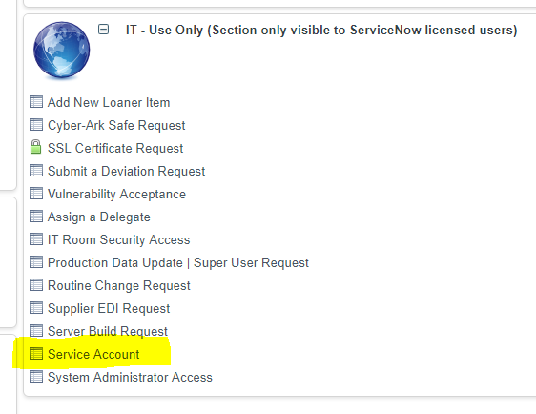
- Service Account Name: (entered by IT)
Managed Service Accounts | <server name>
- (The sys admins have the msa naming convention built into their PowerShell scripts, so you do NOT need to list the actual account names here)
- What application / system and environment is this being requested for?
SQL Server – Production/QA/Test/Dev
- Does Service Account require access to ITAR data?
No/Yes
- How will the account login and password be secured within the application?
Login entered in SQL Server Configuration Manager.
Password is not entered.
- What function is this Service Account performing?
Running the services for SQL Server
- Does this Service Account need elevated priviliges? If so give details.
Please add the managed service accounts for SQL Server and SQL Server Agent to group [NA\Neenah-US Neen SQL Backups Edit Users in NA]. This group allows permissions to folders used for SQL Server maintenance activities.
- Additional Comments:
Please create managed service accounts for the following services on <server name>
SQL Server service
SQL Server Agent service
<List any additional services that need an MSA: SQL Server Analysis Services, SQL Server Integration Services, SQL Server Reporting Services>

Configure SQL Server to Use Managed Service Accounts

SQL Server Configuration Manager > SQL Server Services
- Right Click on the service you want to change the account of
- Click “Properties”
- Select tab “Log On”
- Click “Browse” next to account name
- Click “Locations…”
- Select “Entire Directory” (or you can select the specific domain if you prefer)
- Click “OK”
- Click ”Object Types…”
- Select “Service Accounts”
- Click “OK”
- Type the account name in the text box
- Click “Check Names”
- If multiple names are presented, select the correct one and click “OK”

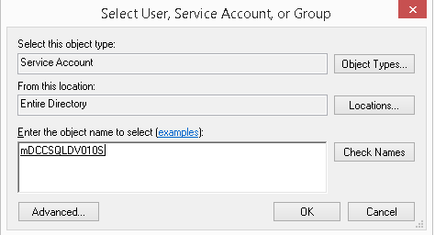

- Click “OK”

< Continued on the next page >

- The account name will be shown in with a “$” at the end
- Leave the Password boxes blank

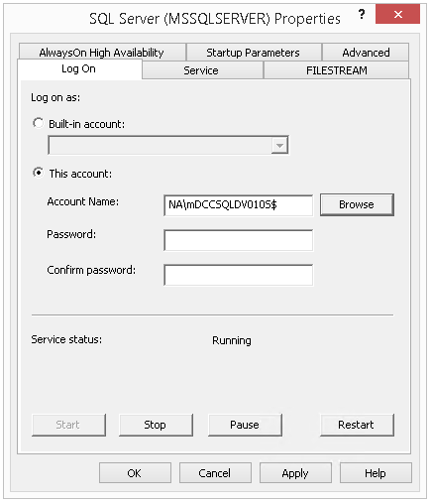

- Click “Apply”
- Restart the service
- Repeat for all services that will use a managed service account
  - SQL Server
  - SQL Server Agent
  - SSAS
  - SSIS
  - SSRS

Naming Convention

m + <ServerName> + <ServiceIdentifier>

<ServerName>
- Name of the server with no dashes

<ServiceIdentifier>
- S = SQL Server
- G = SQL Server Agent
- I = SQL Server Integration Services (SSIS)
- A = SQL Server Analysis Services (SSAS)
- R = SQL Server Reporting Services (SSRS)

Examples
- mDCCSQLDV010S
- mDCCSQLDV010G

Note: The sys admins have the msa naming convention built into their PowerShell scripts, so you do NOT need to list the actual account names in the request

