"Why is this SQL Server so slow?"
Hi - Brent Ozar here. In the old days, I used to monitor all kinds of Perfmon counters to try to figure out why SQL Server was slow.
Today, there's a much easier way: wait stats will tell you what the SQL Server has been waiting on. For example, if SQL Server isn't waiting on your storage, then it doesn't really matter if disk queue length is 1 or 1,000 - that's not the bottleneck.
In the First Responder Kit zip, open sp_BlitzFirst.sql and run that. It'll install the stored proc sp_BlitzFirst - you can put it in master, or any database you want.
Then, run sp_BlitzFirst with these options:
EXEC sp_BlitzFirst @SinceStartup = 1;
And the first result set will look like this:
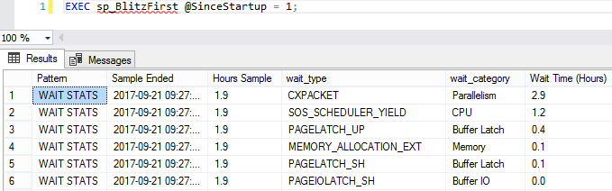
This is a prioritized list of what your SQL Server queries have been waiting on - but it is indeed all queries since startup, which includes jobs like backups, index rebuilds, CHECKDB, etc. In a perfect world, you'd want to log it to a table, and trend it over time. There's more info on how to do that on the documentation page, but for a quick performance check, we're just going to start here.
Start with your top wait type.That's the bottleneck SQL Server is waiting on. Here's some common wait types and how to get more information about 'em:
- CXPACKET - parallelism, which isn't necessarily bad
- PAGEIOLATCH% - waiting to read data pages from data files on disk (we didn't have enough memory to cache them, or we have bad indexes, or bad queries, or slow storage, or all of the above)
- SOS_SCHEDULER_YIELD - queries need more CPU time (but doesn't necessarily mean that the entire server is running 100% CPU, which makes things kinda tricky)
- WRITELOG - which is, uh, exactly what it sounds like
There are hundreds of wait types - way beyond what I can do justice to here - but usually you can Google your way through a lot of pages explaining what each wait type means. (We also have a lot of performance tuning training classes to teach you how to fix 'em.)
Heads up, though: when you're reading about a wait type, be aware that the page's author may have an agenda. For example, if you read a page about PAGEIOLATCH written by a storage vendor, their primary goal may be telling you your storage is too slow, and you should invest in faster storage. They might be right - but try to find the queries causing the wait first, and see if you can tune those for free. (Your time, after all, is free. At least that's what your boss told me.)
Then, find the queries causing that wait type.Open sp_BlitzCache.sql in the First Responder Kit, and run that to create that stored proc. Then you can run it like this:
EXEC sp_BlitzCache @SortOrder = 'cpu';
In that example, I'm sorting the plan cache to find the most CPU-intensive queries. You'll want to use a sort order that matches up with your primary wait type - for example, if you're waiting on PAGEIOLATCH (reading data pages from the data file), you'll want to use @SortOrder = 'reads'.
You get:
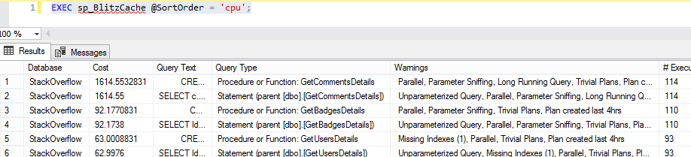
It's a list of your most resource-intensive queries, statistics about how often they run and how bad they are, plus a list of warnings about ways to tune them to make 'em faster.
To get the full list of sort order options, plus all kinds of other stuff like explanations for what each column means, run:
EXEC sp_BlitzCache @Help = 1;

