Snapshot of VMs

Connect to MSSQL server in question via SSMS if you like.

Open a new query window and type the following command to initiate a shutdown of the MSSQL service

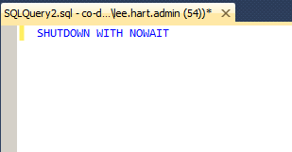

I have as a test, always tried to run the command twice…once to initiate and a second to verify it is not running…

Once the MSSQL service is down you are free to power off the server in prep for a VM snapshot

Log into PowerShell with you .admin account

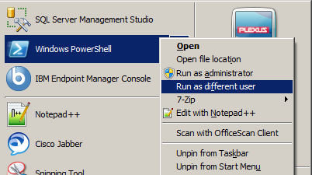

Run the following commands based on what you want to do:
-- obviously restart the given server (use if you want to simply reboot the server)
restart-computer -computername CO-DB-956 -FORCE

-- power off the server (used when you want to run a vm snapshot while powered off)
stop-computer -computername CO-DB-956 -FORCE

In Chrome, go to vsphere.plexus.na.com (https://vsphere.na.plexus.com:9443/vsphere-client/)

Log in with .Admin account (include prefix ‘na\’ with username)

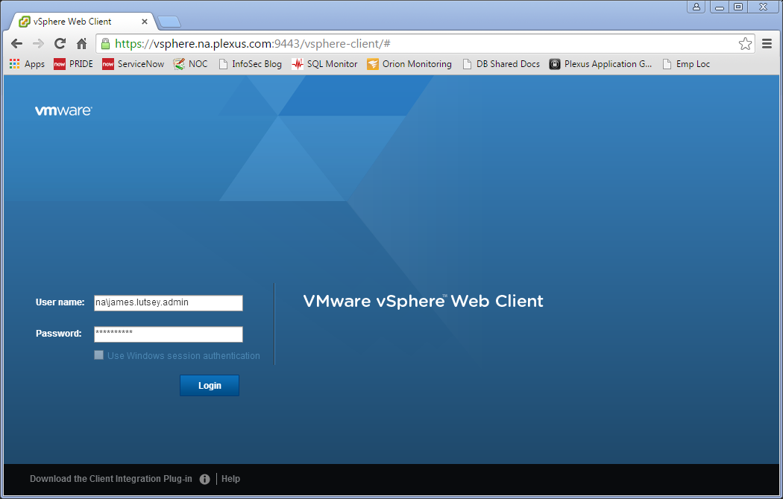

Click on the Home icon or tab, then
Click on ‘VMs and Templates’
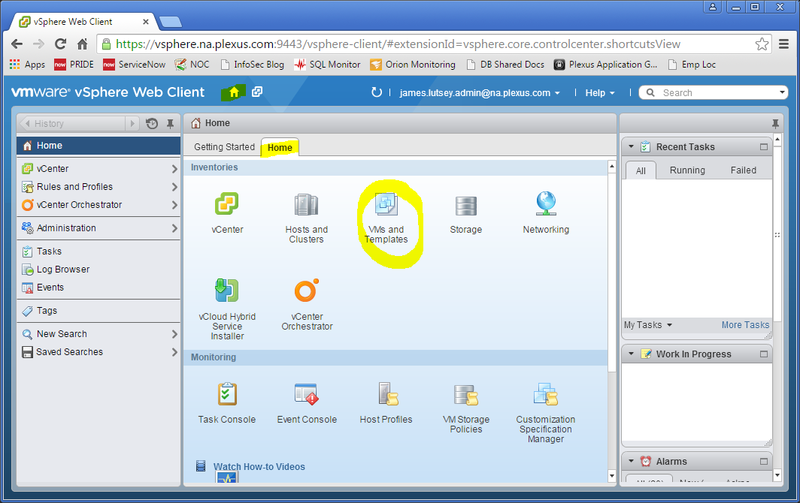

In the left pane, find and click on, the list of virtual machines.
(most of the database ones are in Prod > Corporate > Database Servers > Virtual Machines)
The list will populate in the center pane.
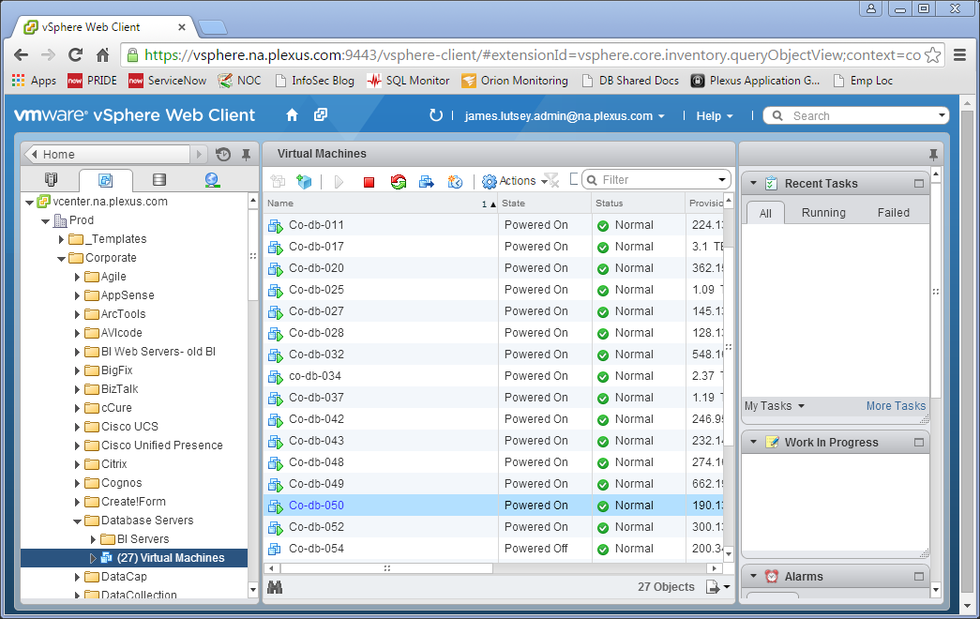

Double click on the VM you want.
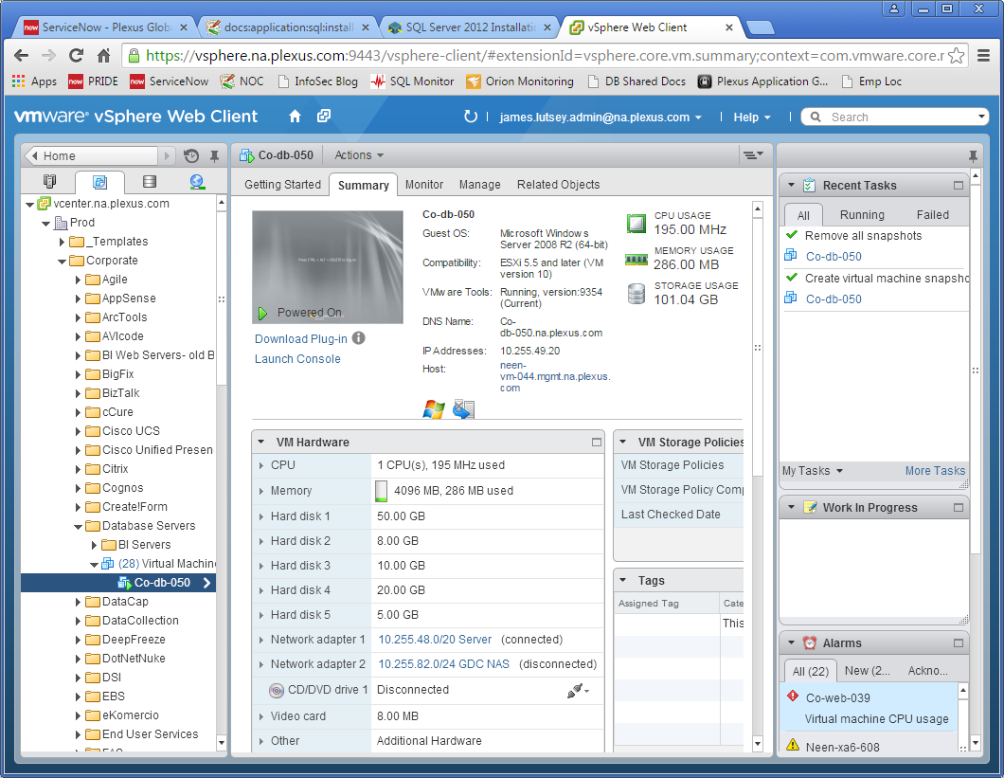

To Take a Snaphot

- Click the ‘Actions’ dropdown menu.
- Select ‘Take Snapshot…’
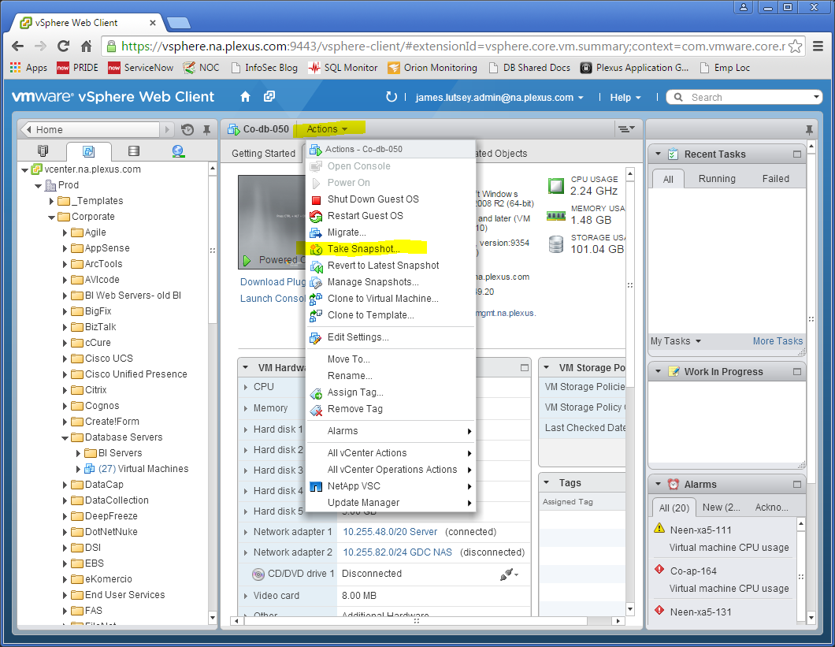

Enter Name and Description.
Uncheck “Snapshot the virtual machine’s memory” (a couple of transactions may be missed if they are currently running, but the impact to the server’s performance will be much less)
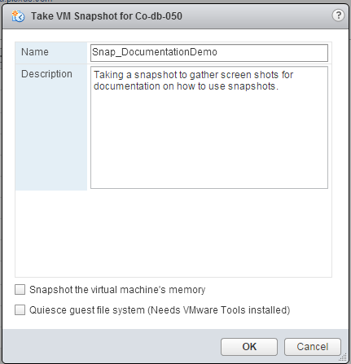

Status of the snapshot can be seen in the upper right pane, ‘Recent Tasks’

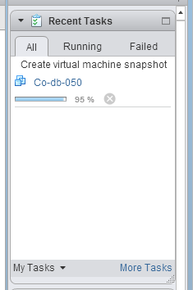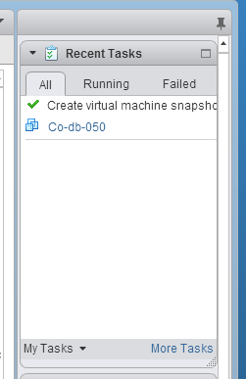

To Delete a Snapshot

- Click the ‘Actions’ dropdown menu.
- Select ‘Manage Snapshots…
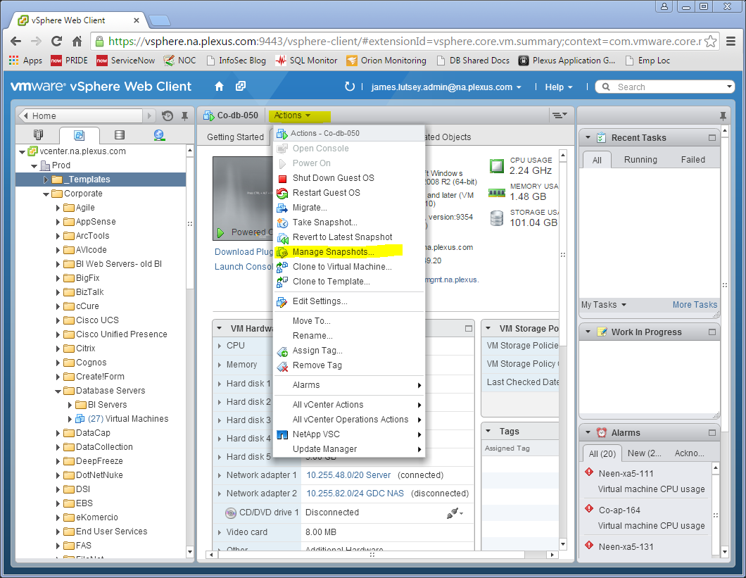’
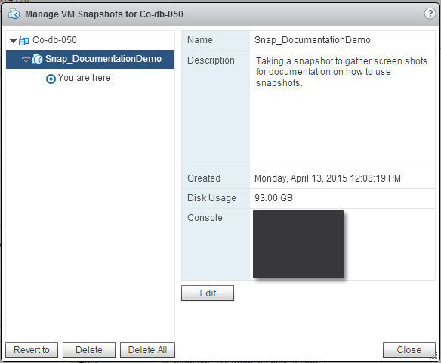

Select your named snapshot.
Click ‘Delete All’

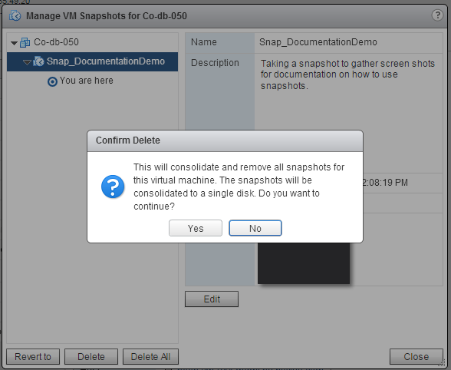

Click ‘Yes’
Click ‘Close’

The status of the delete action can be seen in the upper right pane, ‘Recent Tasks’

