**Setup/Installation Instructions for Windows** (do this once):

1. Install anaconda: <https://www.anaconda.com/products/individual>
2. Install git: <https://git-scm.com/download/win>
3. Install Cuda toolkit: <https://developer.nvidia.com/cuda-10.1-download-archive-base>
4. Install C++ build tools: <https://visualstudio.microsoft.com/visual-cpp-build-tools/>
   * Run this program and install C++ build tools

Double click setup.bat; this will create a new conda environment named ‘ml’ with python 3.7, will activate that environment, and will install necessary packages

**To run the program**:

Double click ‘RunProgram.bat’.

Notes on the following opening screen:

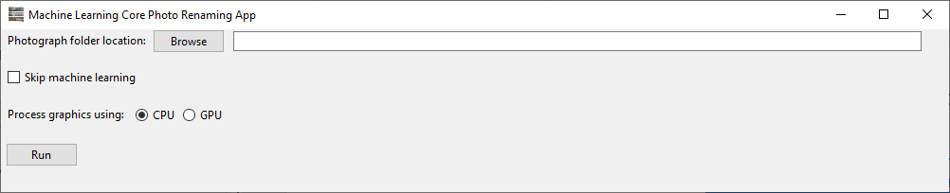

* Select “Skip machine learning” if you do not want the program to attempt to name photographs for you, you just wish to quickly step through the photos and name them yourself using the program interface. Selecting this option will save you the time of waiting for the machine learning algorithms to compute.
* Process graphics using ‘GPU’ is recommended if you have an NVIDIA graphics card as computation times will be reduced. However selecting ‘GPU’ may cause your computer to crash if you do not have an NVIDIA graphics card and drivers installed. ‘CPU’ is therefore the default

The main program interface looks like the following:

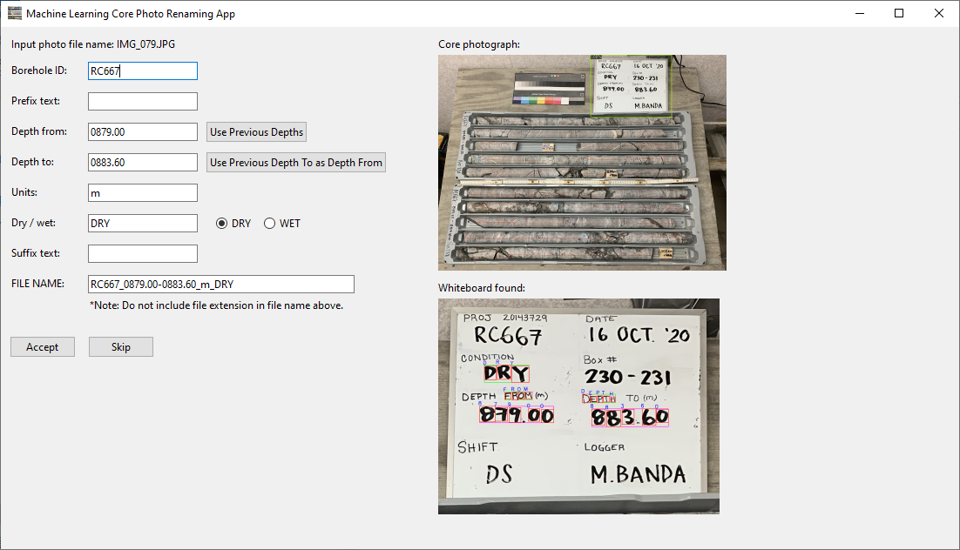

Guidance for core photographs for best machine learning algorithm results:

* Best to make sure the white board is totally contained within the photograph
* Clean "white" whiteboards without black smudges, except for where the text is written
* Neat writing
* Write in capitals
* Use black marker, or if not, the darker the better
* Do not let characters touch each other at all
* Leave sufficient space between words such that individual words can be distinguished
  + Conversely do not leave too large of a gap between number characters, especially across the decimal place
* Do not include 'm' suffix on the actual depth values (i.e. have it in brackets on the line above instead)
* Must have keywords ‘DEPTH’ and/or 'FROM', and also 'WET' vs 'DRY', as the program searches for these

Note: Examples of good photographs are included in the ‘ExamplePhotos’ directory.