Mapping the data landscape for developing and parameterizing Antarctic krill models

Co-lead: Bahl, A. A.* (1,2) and Bahlburg, D.* (3,4)
Co-authors : Green, D. (5), Halfter, S. (5), Liszka, C. (6), O’Sullivan, D. (7), Rombolá, E. F. (8), Ryabov, A. (9), Thorpe, S. E. (6), Pakhomov, E. A. (1,2,11), Kawaguchi, S., Hofmann, E. E. (10), Johnston, N. (6), Veytia, D., Sylvester, Z. (12), Young, E. (6), Conroy, J. A. (14), Bernard, K. (13), Murphy, E. J. (6)

Affiliations:
- Department of Earth, Ocean and Atmospheric Sciences, University of British Columbia, 2207 Main Mall, Vancouver, B.C., V6T1Z4, Canada
- Institute for the Oceans and Fisheries, University of British Columbia, 2202 Main Mall, Vancouver, B.C., V6T1Z4, Canada
- Technical University Dresden, Forest Biometrics and Forest Systems Analysis, Pienner Straße 8, D-01737 Tharandt
- Helmholtz Centre for Environmental Research Leipzig/Halle, Department of Ecological Modelling, Permoserstraße 15, D-04318 Leipzig
- Institute for Marine and Antarctic Studies, University of Tasmania, Hobart, Australia
- British Antarctic Survey, High Cross, Madingley Road, Cambridge, CB3 0ET, UK
- Marine Institute, Rinville West, Rinville, Co. Galway, H91 R673, Ireland
- Instituto Antártico Argentino: Buenos Aires, Buenos Aires, Argentina
- Institute for Chemistry and Biology of Marine Environments, Carl-von-Ossietzky University Oldenburg, Oldenburg, Germany
(10) Center for Coastal Physical Oceanography, Old Dominion University, Norfolk, VA, United States
- Hakai Institute, P.O. Box 309, Heriot Bay, BC, V0P 1H0, Canada
- Environmental Studies Program, University of Colorado Boulder, Boulder, CO, United States
- College of Earth, Ocean and Atmospheric Sciences, Oregon State University, Corvallis, OR 97330, United States
- Virginia Institute of Marine Science, William & Mary, Gloucester Point, VA, United States

Abstract

1. Introduction
As a key prey item for higher trophic levels (Mori and Butterworth 2006; Warwick-Evans et al. 2022), a major grazer on lower trophic levels (Perissinotto et al. 1997; Pakhomov, Froneman, and Perissinotto 2002; Whitehouse et al. 2009), and a major contributor to nutrient cycling and carbon export (Lehette et al. 2012; Ratnarajah and Bowie 2016; Cavan et al. 2019), Antarctic krill (Euphausia superba, Dana 1850, hereafter krill) is an extraordinarily important species in the Southern Ocean ecosystem. However, the this region of the world and its krill populations are facing increasing pressures due to regional impacts of climate change (Meredith and King 2005; Turner et al. 2015), a growing commercial krill fishery (Kawaguchi et al. 2022), and the recovery of major krill consumers such as humpback and fin whales (Viquerat and Herr 2017; Pallin et al. 2018; Herr et al. 2022). As a result, it is crucial for both policymakers and the scientific community to gain a comprehensive understanding on how krill populations function, especially as it pertains to growth and life history in order to develop effective strategies that mitigate potential threats (Johnston et al., 2021; McBride et al., 2021).

Population estimates are defined by recruitment. The definition of recruitment itself can vary depending on the reference, but generally refers to the number of one-year-old krill juveniles that have survived their first winter and are part of the population in their second summer (Meyer et al. 2020). Krill population yield estimates are utilized by the Commission for the Conservation of Antarctic Marine Living Resources (CCAMLR) to formulate, adopt, and revise conservation measures for the krill fishery (Article VII of CAMLR). Thus, understanding the drivers of variability in krill abundance and population spatial connectivity is necessary for effective management of the krill fishery and other human interventions in the Southern Ocean ecosystem (Flores et al., 2012).

Numerical models are a widely used tool in krill research to derive insights into the growth and development of these organisms under varying environmental conditions. Researchers have developed differentmodel design principles, each with specific purposes. For example, early models focused onpredicting the descent, ascent and development of embryos (Hofmann et al. 1992), while more recent models set out to understand individual krill growth and its life cycle (Hofmann and Lascara 2000; Atkinson et al. 2006; Jager and Ravagnan 2015; Constable and Kawaguchi 2018), as well as its population and implication on biomass dynamics (Wiedenmann et al. 2008; Ryabov et al. 2017). ther models have incorporated behavioural aspects of krill (Cresswell et al. 2009; Richerson et al. 2015), included more detailed physiological information (Fach et al. 2008; Groeneveld et al. 2015; Bahlburg et al. 2021) or explicitly simulated the interaction of krill with other species (Willis 2014; Pietzsch et al. 2022). These models are critical for predicting krill growth and habitat quality on regional (Wiedenmann et al. 2008; Ryabov et al. 2017) and circumpolar scales (Green et al. 2021) in present (Murphy et al. 2017) and future climates (Hill et al. 2013; Veytia et al. 2020; Sylvester et al. 2021) and thus serve an integral role in developing management strategies.

It is clear that krill models are versatile, widespread and established as a means of advancing our understanding of krill and its ecology.
However, one single model concept is unlikely to answer all questions related to krill recruitment, and thus, we must rely on different models with different characteristics and focus areas. With that said, consensus amongst different model types requires a commonality: to consider the size of the spawning population, fecundity and spawning output, and larval and juvenile survival during the first year of life. Furthermore, conceptualization and calibration of model components are restricted to the empirical data available. Directing the research community’s current and future efforts to collectively support improved management strategies, however, is lacking.

Therefore, from May 17-20, 2021, the Integrating Climate and Ecosystem Dynamics of the Southern Ocean (ICED) program convened 81 participants from the international krill modelling community to discuss current and future approaches and define high-priority knowledge gaps necessary for improving our understanding of krill and its ecological role in the Southern Ocean (Murphy et al. 2022). During the workshop, discussions and surveys followed presentations of current and planned research, as well as tutorials on current modelling methodologies, by a diverse set of researchers from all career stages. The following three topics were identified through consensus to be most pressing: 1) improving model development requires, first, an evaluation on the current state of parameters and identification of those most sensitive,lacking in observation and/or validation, and thus require prioritization; 2) extending experiments on krill physiological responses under different environmental conditions is needed to gain a mechanistic understanding of krill recruitment and their behaviour in a dynamic setting ; and 3) predicting krill population dynamics and distribution requires identifying their ideal habitats and the coinciding environmental conditions responsible for its suitability. Certainly, additional requirements for addressing uncertainties in krill population connectivity with the food webs and the impacts of climate change on krill ecosystems, also emerged, and we encourage readers to review the full workshop report (Murphy et al. 2022).

Every modeler is familiar with the challenges associated with finding appropriate data for model development. Ideally, these data should be reliable, closely related to actual model parameters, and representative of the spatial and temporal scales being considered. For example, when the metabolism of krill needs to be parameterized in a model, measurements of metabolic rates are required in comparable units, derived using comparable methodological approaches across krill individuals of different body sizes at different temperatures, seasons and potentially regions (CITE). It can be very difficult for modelers to find this data, and for processes that are less commonly investigated than metabolic rates, the data may not even exist.

The aims of this study were to develop a theoretical framework for conceptualizing the processes most responsible for krill recruitment, extract and catalogue all relevant studies pertaining to these processes through a systematic literature review, and asses the collected information’s useability and relevancy for krill modelling efforts. Krill recruitment was therefore defined through expert consensus as being a process accounted for by three mechanisms: spawning, egg and larval development, and overwintering. These mechanisms and their associated parameters were further illustrated in individual conceptual models, and used as the basis for our literature review. Through a systematic literature review on related keywords included in krill recruitment-related studies published from 1974 to 2021, a data catalogue was produced. . Comprised ofnearly 3,000 data entries, the resultant catalogue serves as a resource for researchers seeking: 1) identification of pertinent data; 2) extraction and application of meaningful information for the purposes of conceptualizing and parameterizing model mechanisms; 3) visualization of variability within available data sets; and 4) identification of mechanistic uncertainties that require further investigation. To the best of our knowledge, this compilation of all existing krill recruitment data is the first of its form. As a first effort in addressing the priority topics discussed during the ICED workshop, the information synthesized within this study sheds light on where inadequate data exist and thus require enhanced sampling and measurement efforts.

2. Materials and Methods
The following three mechanisms were defined as the most critical processes that formalize recruitment: spawning, Egg and larval development, and overwintering, and therefore guided the methods described hereafter.

2.1 Conceptual model creation
Numerical models for simulating krill population dynamics are highly diverse in structure, level of included detail, and are subject to ongoing innovation and development. Providing suites of parameters tailored to specific types of models is, therefore, not only beyond the scope of this study but likely not useful given the different data requirements of different models. Instead, we present a suite of idealized models, which are further referred to as conceptual models, that incorporate the fundamental mechanistic processes relevant to describing krill growth and life history within a bioenergetic framework. Each mechanism (spawning, egg and larval development, and overwintering) was defined based on expert opinion as being key for simulating krill population dynamics and therefore, highly relevant for the general development of krill population models. A definition of each process and the logic behind each mechanism and its relevancy to recruitment is as follows:
- Spawning refers to the process by which adult Antarctic krill release their eggs into the water column. A mechanistic understanding of spawning and the size of the spawning stock provides baseline information on the number of embryos produced by a krill population;
- egg and larval development refers to the subsequent stages of growth and maturation, including periods of moult, experienced by nauplii, metanauplii, calyptosis, and furcilia, before reaching adulthood. Development also includes the build-up of body reserves (i.e., lipids, carbohydrates, and proteins). Ultimately, this mechanism etermines the survival, and thus abundance, of larval krillbefore the onset of winter;
- overwintering refers to the winter period when individuals either seek refuge from the seasonal harsh conditions by descending to deeper depths or occupying areas under the sea ice. The surviving individuals that emerge as part of the summer cohort determines the number of recruits.

Next, sub-units supporting each main mechanism were included in each individual conceptual model (Table S2). Sub-units can be thought of as components of a box model that need to be accounted for to properly simulate the respective mechanism. They also represent important causal relationships between parameters and processes (e.g., sea ice and productivity).

2.2 Systematic Literature review
Extraction of all information related to krill recruitment was conducted with a systematic literature review. Following the standardized PRISMA (Preferred Reporting Items for Systematic Reviews and Meta-Analyses) protocol (O’Dea et al. 2021), studies wereselected by querying the literature databases, “Web of Knowledge” and “Scopus” (accessed on November 5th, 2021) using the following keywords:

- Spawning: “euphausia superba” OR “antarctic krill” AND “spawning”
- Overwintering: "euphausia superba" OR "antarctic krill" AND "winter"
- Larval development:
  - "euphausia superba" OR "antarctic krill" AND "larva"
  - "euphausia superba" OR "antarctic krill" AND "embryo”
- Build-up of body reserves in autumn:
  - "euphausia superba" OR "antarctic krill" AND "fall"
  - "euphausia superba" OR "antarctic krill" AND "autumn"
  - "euphausia superba" OR "antarctic krill" AND "lipid"

Keywords were chosen to identify studies using derivatives or slightly different terminology on a similar topic (e.g. “larva” matches papers containing the words “larva”, “larvae” or “larval development”, “winter” matches papers mentioning “winter” and “overwinter” or “overwintering”). From this process, a total of 16,739 publications were collected, including duplicates within (due to different databases/search terms) and between topics (the reader is referred to a full scheme of the paper selection process in figure 1). This initial selection was exported to csv-files and further processed using R statistical software (R Core Team 2021). The full process and its results can be found at
https://github.com/dbahlburg/Paper1UncertaintiesRecruitment.

To refine the literature selection from the initial database query, papers were filtered with the following topic-specific keywords, which required inclusion in either the paper title or abstract:
- Spawning: spawning OR vitellogenesis OR egg OR fecundity
- Overwintering: winter OR sea ice
- Build-up of body reserves in autumn: fall OR autumn OR lipid
- Egg and larval development: larva OR egg OR embryo OR ontogen

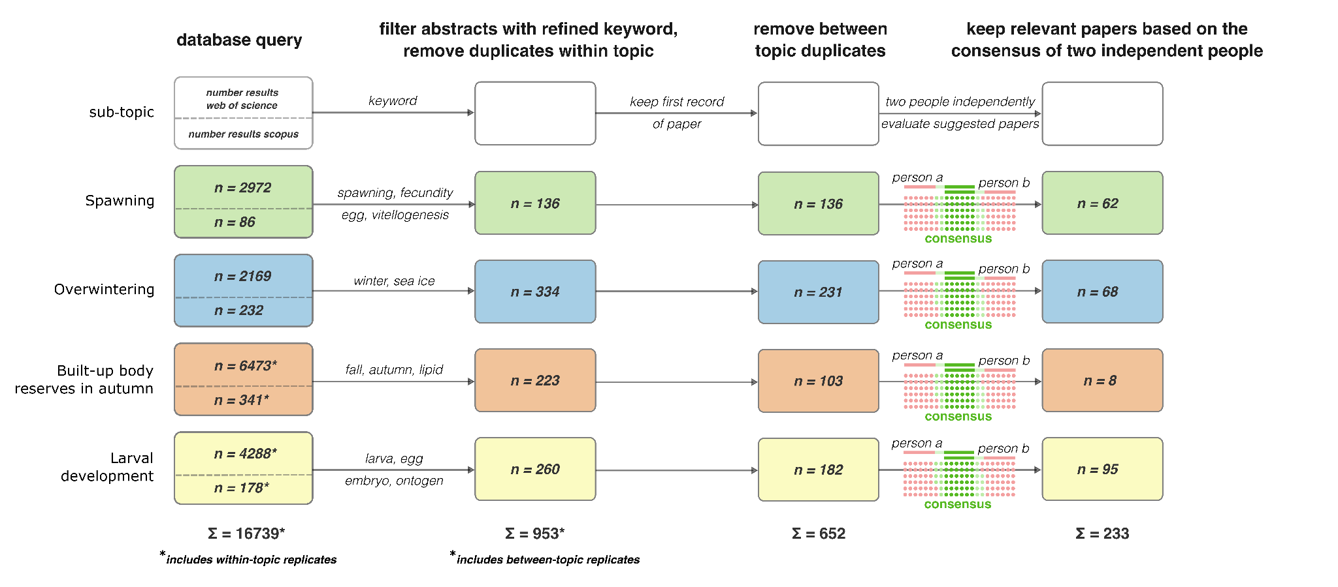
Figure 1. Schematic illustrating the systematic literature review of krill recruitment mechanisms: egg and larval development (defined by the yellow boxes), spawning (defined by the green boxes), and overwintering (defined by the blue boxes). The steps taken (from left to right in the schematic) included an initial database query of Web of Science and Scopus, including use of the keywords documented in section 2.1. The number of studies identified in Web of Science are documented in the upper portion of each box, while the number of studies identified in Scopus are included in the lower portion of each box. The total number of studies from all combined subtopics can be found at the bottom of the far-left column. . Filtering of titles and abstracts, as well as duplicates, is illustrated in the middle two columns. The last step of the literature review is documented in the last column and included relevancy to the study, as determined by person a and b (i.e., both lead authors).

Furthermore, in the event that a paper was listed under multiple topics, it was assigned to the first topic (topics were sorted alphabetically) and removed from the others to avoid duplicationSince all papers were later reviewed in the light of all sub-topics (more information in next paragraph), no relevant information was lost this way. After removing all duplicates, the literature list was reduced to 652 entries. Next, both lead authors independently went through the literature list and classified each paper as “relevant” or “not relevant” according to the information included in the title and abstract. This step was deemed necessary given the initial query pulled studies that were irrelevant to Antarctic krill modelling because they included the keywords(e.g. krill aquaculture or pharmaceutical research). The final selection of papers was determined as the consensus of both reviewers,meaninga paper had to have been independently classified as “relevant” twice. This resulted in a total of 233 papers (Fig. 1). A record of the final selection process can be found in the GitHub repository mentionedpreviously.

The 233 papers were then divided into groups of 20-30 and reviewed by 16 of the authors. Authors were encouraged to review the studies most aligned with their expertise and were therefore not assigned at random. Each review required documenting the following information in a shared spreadsheet: relevant mechanism (e.g., egg and larval development, spawning, overwintering), type of study, study author(s), year published, title, study duration, season(s), year(s) of study investigation, study region, individual data point name, data point value origin, data point unit, sample size, krill life stage, data point value, significance (if available and/or relevant), R-squared, standard deviation, and data point applicability to other mechanisms. The ‘type of study’ was created to categorize the many methodologies and approaches we encountered. The three categories created were: observational (i.e., provides a measure of a parameter without manipulating the values themselves), model (i.e., simulation model methods only), and hybrid (i.e., a combination of observational and experimental, and thus includes statistical methods and models). ‘Study duration’ was defined as hours, days, months, or years, where years is any study duration greater than 12 months; ‘season’ was defined as spring (the months between August and October) summer (the months between November and January), fall (the months between February and March), and winter (the months between May and July), and the ‘study region’ required documenting the region where the data originated. Study datapoint documentation required defining ‘the datapoint value origin’, or how the data point was attained (i.e., from measurement, statistical tests, field collection, etc.). The ‘sample size’ includes the number of observations of replicates used to define the ‘data point value’ indicated. Krill ‘life stage’ was categorized as egg, larvae, juvenile, and adult. The ‘significance’ the data point was defined as true (e.g., p ≤ 0.05) or false. Finally, if the documented data point was found to be of relevance to any of the other two mechanisms, reviewers were told to document this. If a data point value was not discussed in the study, it was left blank in the spreadsheet.

A total of 2,883 unique data points, and their associated information, were extracted and documented as part of this process. Many of the data points, however, were applicable to more than one mechanism, resulting in a total number of 3,515 entries.

2.3 Mapping the data landscape

The next step included assigning the data point gathered from the literature review to the sub-units captured in the conceptual models. A list of each sub-unit included in each model was consolidated into a list and assigned a unique ID. Within the list, each sub-unit was further defined as either a state variable or a function, given parameters such as tissue reserves, for example, define a property rather than a dynamical process such as ingestion. Further, functional processes inherently depend on conditions that force manipulation. Thus, the following conditions were established within and across each functional type: temperature, chlorophyll-a, particulate organic carbon (POC), fatty acid composition of food, photoperiod, distance to shelf, bottom depth, water density, heterotrophic carbon, ice algae, sea ice thickness, detritus, and time (Table S2). Because the three conceptual models were created to focus on the mechanistic processes responsible for maintaining krill physiological activity, growth, and reproduction, they explicitly did not consider mortality. However, some assessment of mortality was necessary given its impact on population growth and was therefore taken into account when assigning the data points. Mortality types included starvation, fisheries, predation, parasitism, temperature, natural, and other, for embryo, larvae, and adult life stages (Table S2). The IDs created for all mortality types were extended from the original list of IDs created for the sub-units, resulting in a total of 120 IDs.

Both lead authors then consolidated all 3,515 parameter entries and independently assigned each data point with its appropriate ID(s). Some datapoints entries did not relate to any of the IDs, such as density or abundance,and were therefore left blank, while others could relate to more than one ID. In addition, we developed five information categories to further characterize the data point type./. These information categories were: "parameter", "correlation","validation", “parameter, validation”, and “not assigned”. The category "parameter" means that the data point represents a value that could be used directly as a model parameter; "correlation" refers to the result of a correlation test that suggests a relationship between two variables, but could not be used directly as a model parameter; "validation" refers to data points that could not be used directly as model parameters, but might still be useful to validate model predictions (such as krill abundance data); and “parameter, validation” refers to information that could be used either as a model parameter or as validation data of a model sub-mechanism The fifth information category, “not assigned” refers to entries that were not applicable to any. The boundaries between these information scores can sometimes be blurred and context-dependent, and we elaborate on this in the discussion.

With this approach, we outlined a “map of the data landscape” available to inform krill model development. By characterizing the amount and type of information available for the three different models, mortality and their respective sub-units, we identified existing data and information gaps that should be addressed by future research.

3. Results
3.1. Systematic literature review dataset overview
The 2,883 unique entries generated from the systematic review of 233 studies related to Antarctic krill recruitment provided a broad overview of the information available. A recording of where each study had either collected data, or reused previously collected data, demonstrated a spatial bias. Such that, 72%, or 167 of the 233 studies, came from the East Pacific and Atlantic sectors of the Southern Ocean (Figure 2). Of which, 87 studies were focused on the Antarctic Peninsula, thereby accounting for the top location that krill data, and thus our understanding, is derived. The Central (16 studies) and Eastern Indian sectors (7 studies) made up 9% of the total studies, and the Western Pacific was accounted for by a single study. Despite 10 of the 233 studies encompassing a circumpolar focus, the results of the literature review illustrate the defining geographic boundaries that make up our current knowledge of Antarctic krill. A temporal bias also emerged from the review. Most of the studies (110) presented data from the summer season (), followed by fall (60 studies), winter (51 studies), and spring (33 studies).

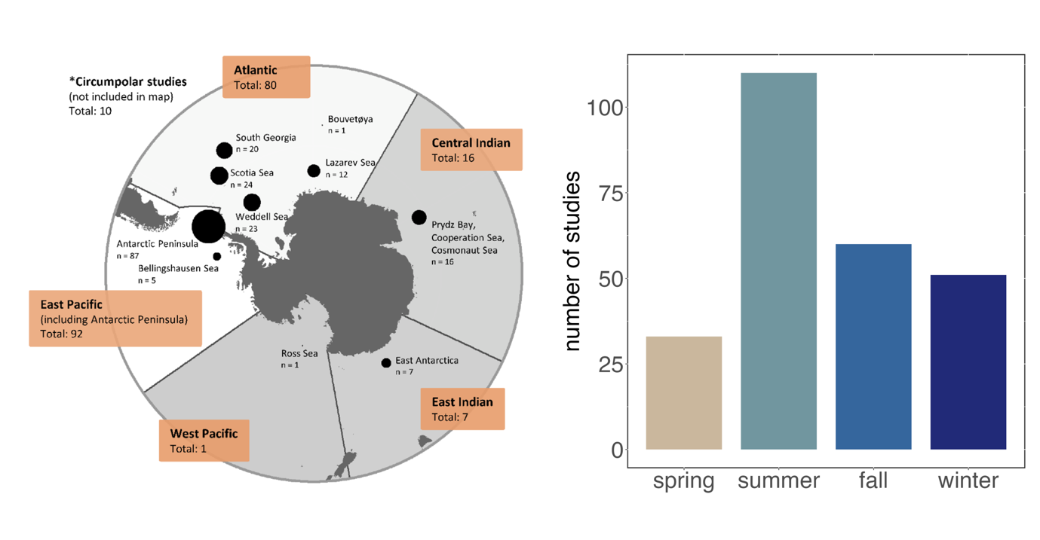
Figure 2 Left panel: Spatial distribution by ocean sector of the 233 studies that were assessed in the systematic literature review. White shading indicates sectors with the highest number of studies and grey shading indicates sectors with a lower number of studies. Right panel: Seasonal distribution of the 233 studies. The spring season was defined as the months between August and October, summer as the months between November and January, fall as the months between February and March, and winter was defined as the months between May and July.

About 48% of the almost 3,500 assignments were not related to any of the conceptual models (Figure 3). Of these 1,669 data points, about two-thirds were classified as being relevant for "validation" =, meaning the data pointmay be useful for validating model predictions, but does not directly contribute to model development. The majority of these data were krill abundance data from different habitats or regions.

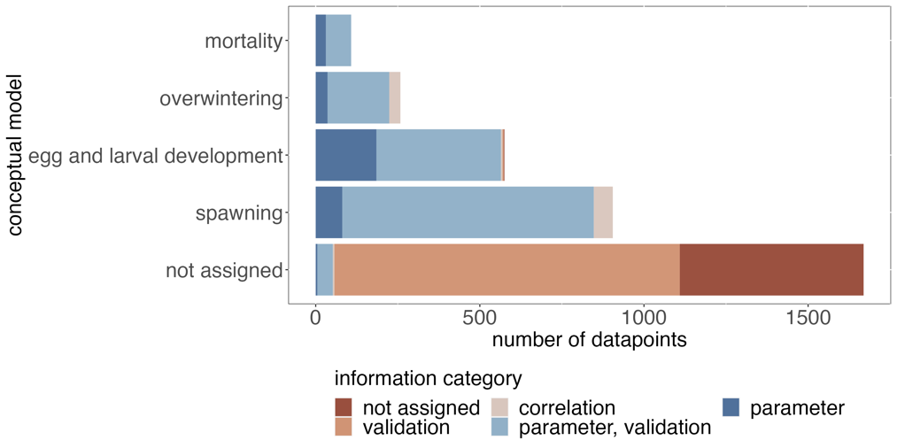
Of the conceptual models and mortality information, most assignments were made to the "spawning" mechanism, followed by "egg and larval development", "overwintering", and "mortality" (Figure 3). Across the information categories groups, the majority of data points were classified as "parameter, validation” Such data points typically provided information such as observations of growth rates that were reported in no functional relationship to other factors such as food availability or temperature. In theory, growth rates can be related not only to environmental conditions, but to the net outcome of an individual’s energy budget, however this information was rarely found among the studies reviewed. In summary, less than half of the data points were directly related to the sub-units of the three conceptual models and mortality. Thus, the majority of information included in the literature comprised a level of information that was not specific enough to act as stand-alone model parameters.
Figure 3 Number of datapoints that were assigned to each of the three conceptual models or to mortality.

3.2 Analyzing the data points assigned to each conceptual model
3.2.1 Spawning
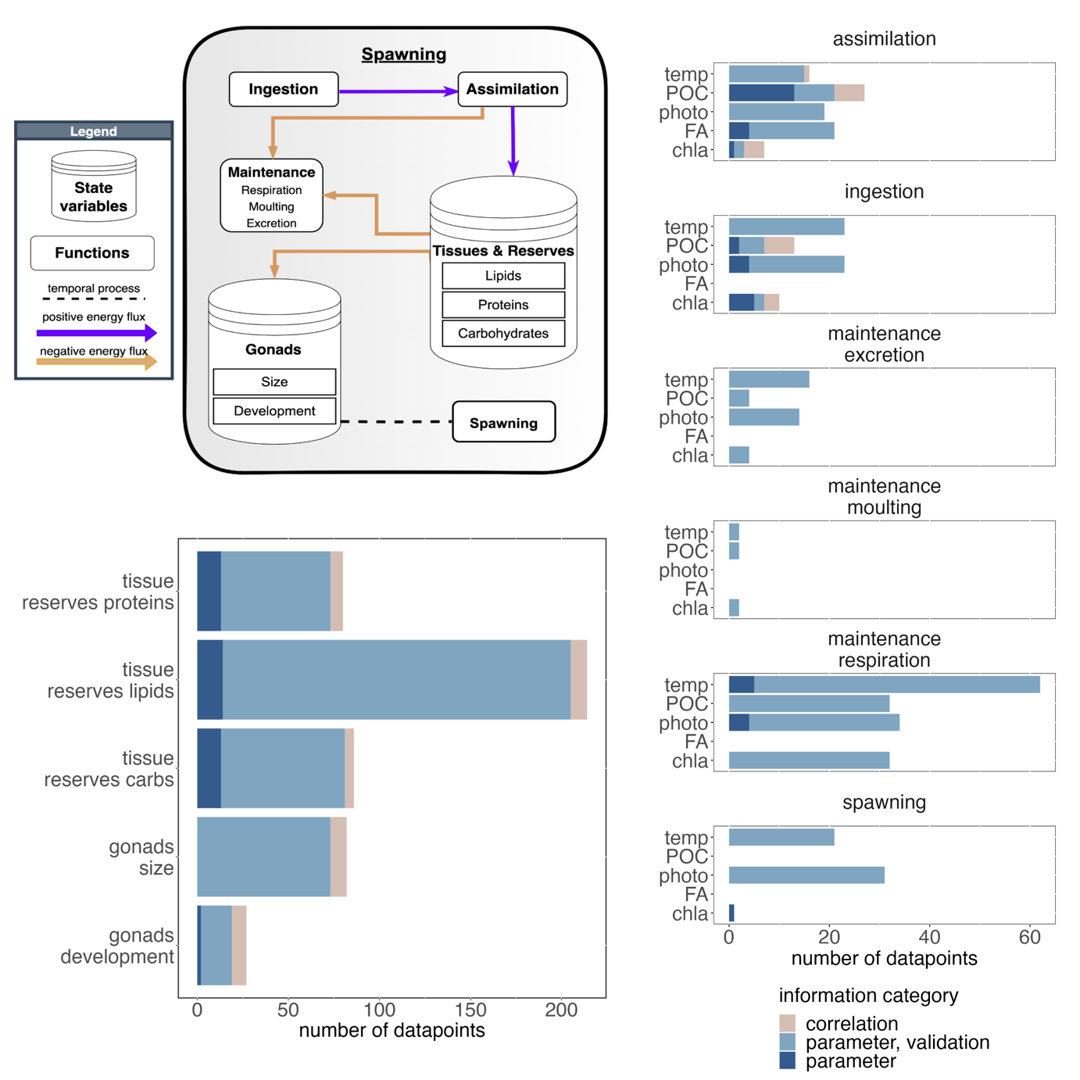
The spawning conceptual model provides an overview of the key mechanisms that drive egg production and release (Figure 4). The box represents an individual krill, but could be scaled up to a population of adult female krill. In this conceptual model, the female krill is represented by its reserves, which are partitioned into lipids, proteins, and carbohydrates, and its gonads, which are characterised by their size (or mass) and developmental stage. If one were to utilize this conceptual model as a starting point but required other morphological information, such as body length, it could be approximated with some of the many regression functions we catalogued that related body length to carbon weight or total body weight. The partitioning of body reserves into lipids, proteins and carbohydrates recognises the importance of these components for gonadal and ovarian development. Essential fatty acids, often found in large diatoms, are essential for female krill to develop their gonads in spring and deficiencies can limit successful spawning. Female krill gonads follow an ovarian cycle, which was conceptualized by Kawaguchi et al. (2007). Depending on the stage of maturity within this cycle, there may be specific energetic requirements for gonad development that deplete krill reserves in different ways. The total number of released embryos is ultimately determined by the size/mass of the gonads at spawning and the number of spawnings the female can complete during the reproductive season.
Figure 4 Top left panel: Conceptual model for spawning. Bottom left panel: information categories of data points assigned to model sub-units that did not relate to environmental conditions. Right panel: information categories of data points assigned to model sub-units that related to environmental conditions. Abbreviations: temp – temperature, POC – particulate organic carbon, photo – photoperiod, FA – fatty acid composition food, chla – chlorophyll a

The reserves (lipids, proteins, carbohydrates) available to meet the energetic costs of spawning and maintenance are replenished by ingestion and assimilation of food and depleted by the amount allocated to gonad development, maintenance (respiration, moulting) and excretion. Metabolic rates such as ingestion, respiration or moulting often interact directly with environmental factors such as temperature.
A total of 905 data points were assigned to the spawning conceptual model. Of those assigned to model sub-units that were not related to environmental factors, the majority related to lipid reserves of adult female krill during the spawning season. Eight times fewer data points were assigned to gonad development (27 data points for gonad development vs. 214 for lipid reserves) and slightly less than 100 data points related to protein and carbon reserves as well as gonad size (Figure 4). The minority of these data points provided correlational information and most were classified as “parameter, validation”, meaning that they typically did not provide information that could be used directly as parameters in functional relationships, but rather as reference values against which, for example, model predictions of krill lipid content could be validated.
Of the model sub-units that directly related to environmental conditions, the highest number of data points were assigned to respiration, ingestion, and assimilation. In these three sub-units, there was a comparatively high coverage of the different environmental factors such as temperature, POC, photoperiod, fatty acid composition of the food and chlorophyll a (Figure 4), with >20 datapoints assigned to each, respectively. Fewer data points were of relevance to spawning, excretion, and especially moulting in dependence of environmental conditions. Similar to the model sub-units that did not relate to environmental drivers, the majority of the assigned data points had the information category “parameter, validation”, meaning that they typically could not be used as stand-alone model parameters.

3.2.2 Egg and larval development
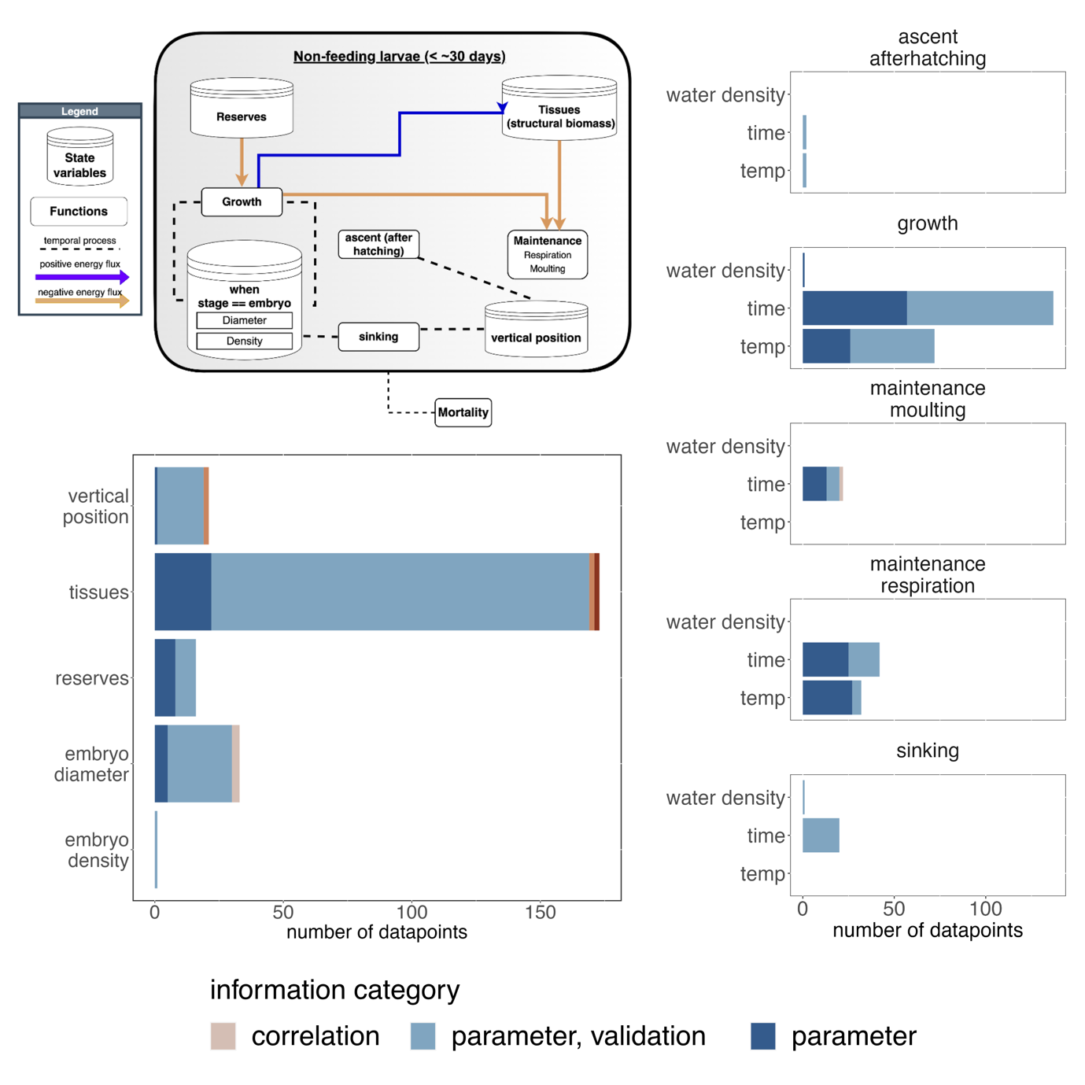
During spawning, mature female krill release embryos into the water column. These embryos do not yet feed, but instead metabolize internal reserves that were previously stored during the egg formation process (Figure 5). Immediately after spawning, the embryos begin to sink in the water column due to their negative buoyancy. The embryo diameter and density as well as the water density determine the rate of sinking, and therefore the range of environmental conditions experienced, which in turn drive developmental rate. Once the embryo is fully developed, it hatches and starts ascending the water column as a nauplius I larva. The nauplius I and its subsequent stages are non-feeding stages that still metabolize the energy reserves provided upon birth (Figure 5). While developing through the different nauplius stages, the larvae undergo an ascent in the water column. Mortality of non-feeding krill larvae is mainly determined by environmental conditions (e.g. unfavorable temperatures), local
Figure 5 Top left panel: conceptual model for egg and larval development. Bottom left panel: information categories of data points assigned to model sub-units that did not relate to environmental conditions. Right panel: information categories of data points assigned to model sub-units that related to environmental conditions. Abbreviations: temp – temperature

topography (increased mortality has been associated with shallow waters where the embryo reaches the sea floor before hatching), and predation. After reaching the metanauplius stage, the larvae begin to assimilate food from the environment. Although the time of reaching the metanauplius stage can be as early as summer, depending on the timing of spawning, the processes that drive growth and development of feeding krill larvae are covered in the conceptual model for overwintering (Figure 6).
In total, 575 data points were assigned to the conceptual model for egg and larval development. Similar to the other conceptual models, most of these data points were classified as “parameter, validation” although some sub-units such as time and temperature dependent growth or tissues had comparatively higher proportions of data points that had the highest information category “parameter” (up to 42% in case of time-dependent growth, Figure 5).
Less than 50 datapoints were assigned to vertical position of the embryo, its reserves as well as the embryo diameter. Only one data point was found that related to the density of embryos, which in combination with embryo diameter is important to determine sinking rates (Figure 5). Analogously, only 2 data points were assigned to the temperature, and time-dependent ascent of the nauplius I larva after hatching. 21 data points informing sinking rates could be found in the compiled dataset although 20 of them only reported sinking rates with no direct relation to embryo diameter, embryo density and water temperature. Whereas over 200 datapoints could be assigned to growth of the embryo, only 22 related to moulting, which is an important component in the growth of crustaceans. Time- and temperature dependent respiration rates wereextracted from 42 and 33 data points, respectively, with the majority of datapoints being closely related to actual model parameters (“parameter” information category).

3.2.3 Overwintering
In contrast to adult krill, larval and juveniles do not accumulate significant amount of lipids in fall and rely on the uptake of food to meet maintenance costs throughout the winter. Therefore, the overwintering model includes similar mechanisms required for maintenance as the adult female spawning model in spring/summer. Maintenance functions such as respiration, moulting, and excretion imply energetic costs that are covered by assimilated food and available body reserves. Similar to the spawning conceptual model, reserves are partitioned into lipids, proteins and carbohydrates. The conceptual model structure is relatively simple, and it hides the complex interactions of the >1 year krill and the physical environment during winter. These interactions are considered in the physiological rates such as assimilation, ingestion and respiration, which were related to different environmental drivers such as the availability of sea ice biota or heterotrophic carbon as food sources (Figure 6).
Of the 258 data points that were assigned to overwintering, most (around 60) related to the lipid reserves of subadult krill during winter (Figure 6). Of these, most were classified as “parameter, validation”, meaning that many of the data were primarily useful for model validation but could not directly be used for the parameterization of lipid reserve dynamics. Less than half as many data points could be assigned to protein and carbon reserves (Figure 6).
A relatively similar number of data points related to physiological rates such as assimilation, ingestion, and respiration (42-58 data points). No data points were found related to moulting and excretion, which are listed in the conceptual model. Data related to assimilation, ingestion, and respiration were relatively common in the context of food availability in the form of particulate organic carbon, ice algae, or heterotrophic carbon. Physiological rates in direct relation to photoperiod, a potentially important factor in the physiological activity of adult krill, were reported in increased numbers for respiration (n = 13, Figure 2), but less so for ingestion or assimilation (n = 5, n = 0, respectively).
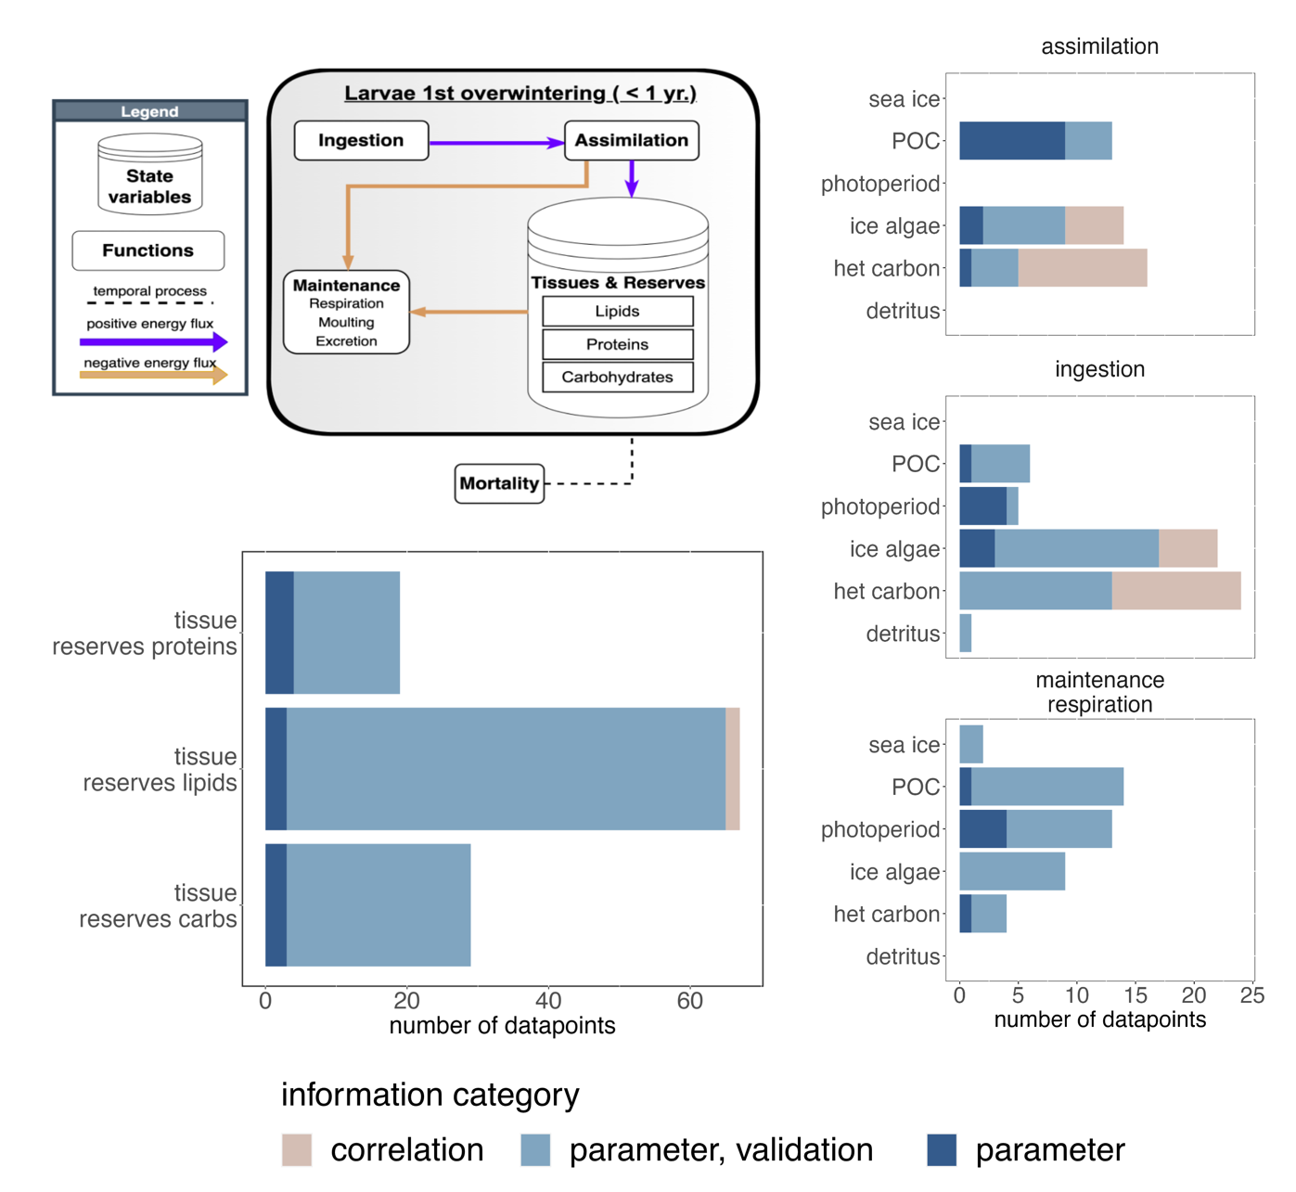
Figure 6 Top left panel: conceptual model for the overwintering of the <1 year age class. Bottom left panel: information categories of data points assigned to model sub-units that did not relate to environmental conditions. Right panel: information categories of data points assigned to model sub-units that related to environmental conditions. Abbreviations: POC – particulate organic carbon, het carbon – heterotrophic carbon

3.2.4 Mortality
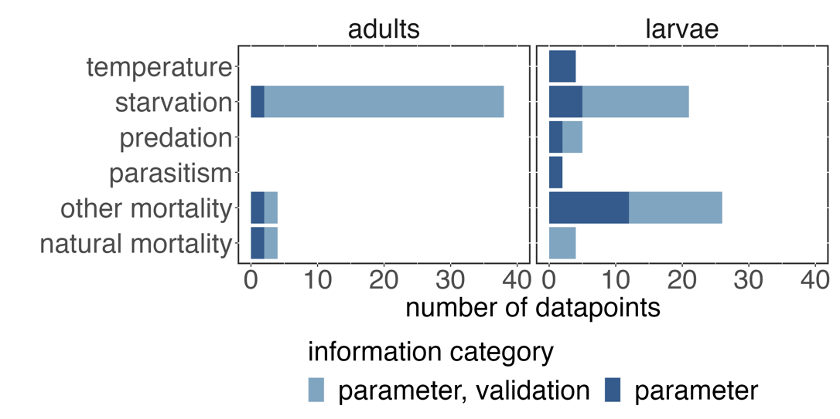
The conceptual models analyzed in the previous subsections included mechanisms responsible for maintenance and reproduction in different life-history stages of krill. However, population dynamics are a result of the balance between reproduction, survival and mortality, and therefore we also examined the compiled dataset for data points that could be related to
Figure 7 Data points assigned to different drivers of mortality for adult and larval krill

the drivers of mortality for adult and larval krill. parameterization of stage-specific drivers of krill mortality (Figure 7). Within the compiled dataset, no data points informed thermal tolerance, predation mortality, or parasitism mortality in adult krill. The dataset yielded four data points related to estimates of natural mortality rates in adults, and starvation mortality was the most studied mechanism with a total of 38 data points. For larvae, most data points could be assigned to starvation and other mortality, which included information on mortality risks from UV radiation or critical partial pressure. About 5 data points could be assigned to the thermal tolerance of larval krill as well as predation risk, parasitism and natural mortality.

4. Discussion
In our study, we developed three conceptual models that incorporate important mechanisms of stage-dependent maintenance, reproduction, and mortality of krill, which are key drivers of recruitment and population dynamics. In addition, we conducted a systematic literature review to extract nearly 2900 data points from 233 studies that could be used to inform the practical development of krill growth, recruitment, and population dynamics models. These data points were then mapped to the sub-units of the three conceptual models and to different sources of mortality to identify important mechanisms with sparse information.
Before discussing the results of our analysis, it is important to note some of the caveats associated with our approach. Most importantly, the number of data points that can be attributed to individual model mechanisms is certainly an imperfect measure of uncertainty or state of knowledge. Some data points may be more informative than others, and some may represent single observations while others represent summary statistics of many samples. Nevertheless, the number of available data points is indicative of the empirical effort that has been made to investigate specific model mechanisms, and we have attempted to address the information value problem by introducing additional criteria that give some indication of the information quality of different data points. In addition, having many observations to parameterize different model mechanisms helps to obtain uncertainty estimates, which are critical for robust model predictions (Bahlburg et al. 2023).
Another issue was the manual assignment of data points to model subunits. This process was done independently by the two corresponding authors to account for individual biases, and a comparison of the initial assignments revealed considerable differences in the interpretation of the data points. While thus might be an indication that there is often no direct link between empirical data and model mechanisms, it also means that the results are likely to contain some bias. We attempted to address this issue by iterating through the data point assignments after several consultations to reach consensus. Finally, agreeing on the three conceptual models and their structure was not straightforward. Depending on individual backgrounds, different mechanisms may be considered more relevant than others, and the models presented in this study represent one, arguably incomplete, option of how they might be structured. We acknowledge that different structures of the conceptual models are possible, but we have tried to include as many mechanisms as possible to still allow for meaningful analysis within the scope of this study.
The most striking feature of the dataset was that nearly half of the extracted data points were not related to any of the 120 model sub-units suitable for model development, and the majority of the data points would not be useful as stand-alone model parameters. Although krill recruitment and population dynamics have always been important topics in krill research (e.g. De La Mare 1994; Siegel and Loeb 1995; Murphy et al. 1998; Quetin and Ross 2003; Wiedenmann et al. 2009; Meyer et al. 2020; Conroy et al. 2020), and mechanistic krill models have existed for more than 20 years (Hofmann et al. 1992; Hofmann and Lascara 2000; Fach et al. 2002), the collection of empirical data is often not done with data requirements for model development in mind. This is certainly a two-way problem, with modelers not communicating their data needs clearly enough, or not participating in field research, and empirical researchers not taking model development into account when designing experiments and field campaigns. Organizing workshops that bring together modelers and empiricists, such as the ICED workshop on which this study is based (Murphy et al. 2022), is important to improve the coordination between the different disciplines and hopefully lead to more compatible future study designs.
The analysis of the data associated with the spawning conceptual model identified a "low data status" for mechanisms related to gonad development, excretion, moulting, and mechanisms leading to spawning. The functional relationships between body size, feeding history, and timing of spawning are critical for predicting the spawning output of the adult female population, which sets the baseline conditions for the development of recruits. Simplistic approaches, such as predicting egg production as a function of body size, as done in the mechanistic growth models of Jager and Ravagnan (2015) and Bahlburg et al. (2021), ignore known drivers of reproductive success, such as intake of critical fatty acids (Yoshida 2009; Schmidt et al. 2012; Steinke et al. 2022), and thus cannot reproduce the high variability observed in the body length-fecundity relationship (Kawaguchi 2016). Models that allow for flexible spawning output (e.g. the model of Constable and Kawaguchi (2018)), still do not consider the importance of lipids or fatty acids. Our analysis also shows that this is not only a problem of existing models, but that empirical data that would directly support the conceptualization and especially the parameterization of such processes are sparse.
Moulting was another process that had relatively few data points assigned to it. To date, two functions have been published that predict krill moulting frequency in dependence of environmental conditions (Tarling et al. 2006; Kawaguchi et al. 2006). However, a recent analysis showed that the two functions produce different results for a range of environmental conditions (Bahlburg et al. 2023), and more observations are needed to increase the robustness of our understanding of the drivers of moulting. This is important because moulting is not only a process that drives growth and implies energetic costs, but also plays an important role in the maturity cycle of krill (Kawaguchi et al. 2007; Constable and Kawaguchi 2018).
The development of non-feeding larvae was a conceptual model that had a relatively large number of data points assigned to it, although it captures only a relatively short period in the life history of krill. Much of the early development of embryos and non-feeding larvae is synthesized in the mechanistic model of Hofmann et al. (1992), which has been applied in later studies to explore larval krill development and advection at different scales and habitats (Hofmann and Hüsrevoğlu 2003; Piñones and Fedorov 2016; Thorpe et al. 2019). This model provides a relatively complete description of the development from embryo to feeding larval stages but its predictions are sensitive on the initial embryo size, which can vary by more than 50 μm between years (e.g. embryo diameters ranged from 576-627 μm in Quetin and Ross (2001)). Given the relatively large number of observations for this period in the life history of krill, a re-evaluation of the model of Hofmann et al. (1992) with updated data and uncertainty estimates may be a useful future step to address the sensitivities of the current model configuration.
The overwintering of krill recruits was the conceptual model that the fewest number of data points was assigned to. Lowe et al. (2012) developed the only existing mechanistic model that specifically simulated the development of larval krill during winter. However, this model is based on experimental work from the Western Antarctic Peninsula, which means that it might be region-specific and unfortunately, no source is available to apply this model in new contexts. The paucity of information during winter is a result of logistical challenges, but it is critical because winter is often considered a bottleneck for krill population dynamics due to the harsh environment and scarcity of food. Most other existing growth models that cover the entire seasonal range (Jager and Ravagnan 2015; Ryabov et al. 2017; Constable and Kawaguchi 2018; Bahlburg et al. 2021) do so by making relatively simple assumptions about the overwintering physiology of larval and adult krill although the model of Bahlburg et al. (2021) attempted to add more detail. Most of these models include seasonal switches that reduce winter metabolism to a fixed fraction of summer metabolism for a fixed period of time, which does not account for the diversity of overwintering strategies observed in different krill habitats, that can cover a wide range of latitudes and environmental conditions (Tarling 2020). Meyer et al. (2002) provided an important overview of overwintering strategies of larval krill, but many questions remain, particularly about feeding ecology and habitat requirements. For example, photoperiod was the environmental factor with the least number of data points assigned to in the context of physiological functions of krill during winter. However, photoperiod may be the key cue for the entrainment of endogenous clocks that synchronize physiological functions of krill with environmental conditions (Teschke et al. 2011; Biscontin et al. 2017; Piccolin et al. 2018), which would have great impact on model predictions (Groeneveld et al. 2015). Recent research has addressed knowledge gaps regarding the winter feeding ecology and development (Bernard et al. 2022; Steinke et al. 2022), but further studies, possibly in close coordination with modelers, could be of great value in developing better-informed models.
Finally, we also screened the compiled dataset for information relating to different drivers of krill mortality. Mortality contained the group of sub-units to which the least number of data points were assigned. Our analysis showed that there are comparatively many data points that address starvation mortality in larval and adult krill. Data points assigned to temperature-induced mortality were much less frequent, but may also be of minor importance for adult krill, except in their northern distribution range in the South Georgia regions, where krill might face water temperatures outside their thermal tolerance (Michael et al. 2021). The role of parasitism or diseases for krill mortality are largely unknown and almost no information relating to these factors could be found. On the other hand, predation mortality will play an important role for krill populations but not many data points could be found in our dataset that could be used to parameterize this process in mechanistic models. Past modelling studies have addressed krill consumption by predators (Mori and Butterworth 2006) but the results are rarely transferrable into more regional contexts and lack the detail, such as the roles of sea ice or swarming behaviour to reduce predation risk, that might be required in simulation studies. A final and increasingly important source of krill mortality is commercial fishing. However, since catch quotas are set by CCAMLR and vessel-specific landings and locations are known, this source of mortality is well quantified.

Modelling krill in the face of uncertainty
Our analysis identified mechanisms that are important for modelling krill population dynamics, but for which little data are available for model development and parameterization. These mechanisms would benefit most from new experiments and field studies that are more closely aligned with the data needs of the modelling community.
However, conducting such studies is expensive, time-consuming, and sometimes impossible, and it is also clear that not all studies can and should be tailored to the needs of modellers. It is the responsibility of modellers to explore approaches that can produce robust results despite the existing unknowns. One of these approaches can be qualitative models, which do not rely on specific parameter values, but rather assume relationships between different model entities and their direction (positive, negative, neutral). Qualitative models allow to explore the sensitivity of simulation results to competing hypotheses and Sylvester et al. (2023) demonstrate the use of such model to predict the future overwinter survival of krill larvae. The work of Sylvester et al. (2023) was developed as a complementary study to this one and represents the second output of the ICED modelling workshop.
When functional relationships are unknown or cannot be parameterized, statistical modelling approaches that fit observations to environmental drivers (using Bayesian or frequentist techniques) or hybrids of mechanistic and regression models can be useful for making predictions in the absence of mechanistic understanding of all relevant processes. However, special care should be taken when extrapolating such models outside the range of data with which they were parameterized.
Another approach could be to use model ensemble runs to reduce the specificity of simulation results to individual model design choices and to include the expected variance that is introduced by the spatial and temporal specificity of the individual models. In general, future modelling studies should make uncertainty estimates more explicit and investigate the robustness of their simulation results to these. A recent krill growth model comparison project analyzed the sensitivity of simulation results to different krill growth models of choice and found strong differences between models (Bahlburg et al. 2023). While the study only considered inter-model variance, intra-model variance due to uncertainties in parameter estimates will be equally important. Murphy et al. (2017) conducted a sensitivity analysis of their results to different parameter constellations in their model, and we argue that this should be more common in future modelling studies, potentially even as a core component of the analysis. While this will not close existing knowledge gaps, this study atleast allowed for explicitly acknowledging the uncertainties associated with existing krill models.

Data statement
The R code used for processing the krill literature data and data visualization can be accessed under https://github.com/dbahlburg/Paper1UncertaintiesRecruitment. We used the following packages for data processing and visualization: […]. The full dataset compiled from the reviewed literature is available under https://docs.google.com/spreadsheets/d/1IQIxcE-LpCL4RjPTmSA9AlcQQCC58IcnplSyOeRQoGs/edit?usp=sharing

Author Contributions
AB and DB led the conceptualization, coordination and data analysis of this project as well as the writing of the manuscript. In addition, SH, DG, DOS, CL, ER and AR contributed to the development of the conceptual models and data analysis. All authors participated in the development of the study concept, reviewed the selected krill literature, provided feedback on the study design and analysis at intermediate stages, and contributed to the writing.

Funding
DB received funding from the German Research Foundation (DFG, grant number 411096565). AB was supported by the University of British Columbia’s Graduate Four-Year Fellowship.

Conflict of Interest
The authors declare no conflict of interest.

Acknowledgments

References
Atkinson, Angus, Rachael S. Shreeve, Andrew G. Hirst, Peter Rothery, Geraint A. Tarling, David W. Pond, Rebecca E. Korb, Eugene J. Murphy, and Jonathon L. Watkins. 2006. “Natural Growth Rates in Antarctic Krill (Euphausia Superba): II. Predictive Models Based on Food, Temperature, Body Length, Sex, and Maturity Stage.” Limnology and Oceanography 51 (2): 973–87. https://doi.org/10.4319/lo.2006.51.2.0973.
Bahlburg, Dominik, Bettina Meyer, and Uta Berger. 2021. “The Impact of Seasonal Regulation of Metabolism on the Life History of Antarctic Krill.” Ecological Modelling 442 (January). https://doi.org/10.1016/j.ecolmodel.2021.109427.
Bahlburg, Dominik, Sally Thorpe, Bettina Meyer, Uta Berger, and Eugene Murphy. 2023. “Intercomparison of Growth Models for Antarctic Krill ( Euphausia Superba ): Towards a Generalised Understanding.” Preprint. Ecology. https://doi.org/10.1101/2023.05.09.540012.
Bernard, Kim S., Kirsten B. Steinke, and Julia M. Fontana. 2022. “Winter Condition, Physiology, and Growth Potential of Juvenile Antarctic Krill.” Frontiers in Marine Science 9. https://www.frontiersin.org/articles/10.3389/fmars.2022.990853.
Biscontin, Alberto, Thomas Wallach, Gabriele Sales, Astrid Grudziecki, Leonard Janke, Elena Sartori, Cristiano Bertolucci, et al. 2017. “Functional Characterization of the Circadian Clock in the Antarctic Krill, Euphausia Superba.” Scientific Reports 7 (1): 17742. https://doi.org/10.1038/s41598-017-18009-2.
Cavan, E. L., A. Belcher, A. Atkinson, S. L. Hill, S. Kawaguchi, S. McCormack, B. Meyer, et al. 2019. “The Importance of Antarctic Krill in Biogeochemical Cycles.” Nature Communications 10 (1): 4742. https://doi.org/10.1038/s41467-019-12668-7.

Conroy, John A, Christian S Reiss, Miram R Gleiber, and Deborah K Steinberg. 2020. “Linking Antarctic Krill Larval Supply and Recruitment along the Antarctic Peninsula.” Integrative and Comparative Biology 60 (6): 1386–1400. https://doi.org/10.1093/icb/icaa111.
Constable, Andrew John, and So Kawaguchi. 2018. “Modelling Growth and Reproduction of Antarctic Krill, Euphausia Superba, Based on Temperature, Food and Resource Allocation amongst Life History Functions.” Edited by Stéphane Plourde. ICES Journal of Marine Science 75 (2): 738–50. https://doi.org/10.1093/icesjms/fsx190.
Cresswell, Katherine A., Geraint A. Tarling, Sally E. Thorpe, Michael T. Burrows, John Wiedenmann, and Marc Mangel. 2009. “Diel Vertical Migration of Antarctic Krill (Euphausia Superba) Is Flexible during Advection across the Scotia Sea.” Journal of Plankton Research 31 (10): 1265–81. https://doi.org/10.1093/plankt/fbp062.
De La Mare, William K. 1994. “Modelling Krill Recruitment.” CCAMLR Science 1: 49–54.
Fach, Ba, Ee Hofmann, and Ej Murphy. 2002. “Modeling Studies of Antarctic Krill Euphausia Superba Survival during Transport across the Scotia Sea.” Marine Ecology Progress Series 231: 187–203. https://doi.org/10.3354/meps231187.
Fach, Bettina A., Bettina Meyer, Dieter Wolf-Gladrow, and Ulrich Bathmann. 2008. “Biochemically Based Modeling Study of Antarctic Krill Euphausia Superba Growth and Development.” Marine Ecology Progress Series 360 (May): 147–61. https://doi.org/10.3354/meps07366.
Flores, H. et al. (2012) ‘Impact of climate change on Antarctic krill’, Marine Ecology Progress Series, 458, pp. 1–19. doi: 10.3354/meps09831.
Green, David B., Sophie Bestley, Stuart P. Corney, Rowan Trebilco, Patrick Lehodey, and Mark A. Hindell. 2021. “Modeling Antarctic Krill Circumpolar Spawning Habitat Quality to Identify Regions With Potential to Support High Larval Production.” Geophysical Research Letters 48 (12): e2020GL091206. https://doi.org/10.1029/2020GL091206.
Groeneveld, Jürgen, Karin Johst, So Kawaguchi, Bettina Meyer, Mathias Teschke, and Volker Grimm. 2015. “How Biological Clocks and Changing Environmental Conditions Determine Local Population Growth and Species Distribution in Antarctic Krill (Euphausia Superba): A Conceptual Model.” Ecological Modelling 303 (May): 78–86. https://doi.org/10.1016/j.ecolmodel.2015.02.009.
Hill, Simeon L., Tony Phillips, and Angus Atkinson. 2013. “Potential Climate Change Effects on the Habitat of Antarctic Krill in the Weddell Quadrant of the Southern Ocean.” PLOS ONE 8 (8): e72246. https://doi.org/10.1371/journal.pone.0072246.
Hofmann, Ee, and Cm Lascara. 2000. “Modeling the Growth Dynamics of Antarctic Krill Euphausia Superba.” Marine Ecology Progress Series 194: 219–31. https://doi.org/10.3354/meps194219.
Hofmann, Eileen E., Jorge E. Capella, Robin M. Ross, and Langdon B. Quetin. 1992. “Models of the Early Life History of Euphausia Superba—Part I. Time and Temperature Dependence during the Descent-Ascent Cycle.” Deep Sea Research Part A. Oceanographic Research Papers 39 (7): 1177–1200. https://doi.org/10.1016/0198-0149(92)90063-Y.
Hofmann, Eileen E, and Yusuf Sinan Hüsrevoğlu. 2003. “A Circumpolar Modeling Study of Habitat Control of Antarctic Krill (Euphausia Superba) Reproductive Success.” Deep Sea Research Part II: Topical Studies in Oceanography, The US JGOFS Synthesis and Modeling Project: Phase II, 50 (22): 3121–42. https://doi.org/10.1016/j.dsr2.2003.07.012.
Jager, T, and E Ravagnan. 2015. “Parameterising a Generic Model for the Dynamic Energy Budget of Antarctic Krill Euphausia Superba.” Marine Ecology Progress Series 519 (January): 115–28. https://doi.org/10.3354/meps11098.
Johnston, N. M. et al. (2022) ‘Status, change and futures of zooplankton in the Southern Ocean’, Frontiers in Marine Science, 9(June). doi: 10.3389/fevo.2021.624692.
Kawaguchi, S, Sg Candy, R King, M Naganobu, and S Nicol. 2006. “Modelling Growth of Antarctic Krill. I. Growth Trends with Sex, Length, Season, and Region.” Marine Ecology Progress Series 306 (January): 1–15. https://doi.org/10.3354/meps306001.
Kawaguchi, So. 2016. “Reproduction and Larval Development in Antarctic Krill (Euphausia Superba).” In Biology and Ecology of Antarctic Krill, edited by Volker Siegel, 225–46. Advances in Polar Ecology. Cham: Springer International Publishing. https://doi.org/10.1007/978-3-319-29279-3_6.
Kawaguchi, So, Toshihiro Yoshida, Luke Finley, Paul Cramp, and Stephen Nicol. 2007. “The Krill Maturity Cycle: A Conceptual Model of the Seasonal Cycle in Antarctic Krill.” Polar Biology 30 (6): 689–98. https://doi.org/10.1007/s00300-006-0226-2.
Kawaguchi, So, Bettina Meyer, Jack Conroy, Haiting Zhang, and Emilce Florencia Rombolá. 2022. “Antarctic Krill and Its Fishery: Current Status and Challenges.” https://doi.org/10.48361/B1VP-MT19.
Lehette, Pascal, Antonio Tovar-Sánchez, Carlos M. Duarte, and Santiago Hernández-León. 2012. “Krill Excretion and Its Effect on Primary Production.” Marine Ecology Progress Series 459 (July): 29–38. https://doi.org/10.3354/meps09746.
Lowe, Alexander T., Robin M. Ross, Langdon B. Quetin, Maria Vernet, and Christian H. Fritsen. 2012. “Simulating Larval Antarctic Krill Growth and Condition Factor during Fall and Winter in Response to Environmental Variability.” Marine Ecology Progress Series 452 (April): 27–43. https://doi.org/10.3354/meps09409.
McBride, M. M. et al. (2021) ‘Antarctic krill Euphausia superba: spatial distribution, abundance, and management of fisheries in a changing climate’, Marine Ecology Progress Series, 668, pp. 185–214. doi: 10.3354/meps13705.
Meyer, B., A. Atkinson, D. Stöbing, B. Oettl, W. Hagen, and U. V. Bathmann. 2002. “Feeding and Energy Budgets of Antarctic Krill Euphausia Superba at the Onset of Winter—I. Furcilia III Larvae.” Limnology and Oceanography 47 (4): 943–52. https://doi.org/10.4319/lo.2002.47.4.0943.
Meyer, Bettina, Angus Atkinson, Kim S. Bernard, Andrew S. Brierley, Ryan Driscoll, Simeon L. Hill, Enrique Marschoff, et al. 2020. “Successful Ecosystem-Based Management of Antarctic Krill Should Address Uncertainties in Krill Recruitment, Behaviour and Ecological Adaptation.” Communications Earth & Environment 1 (1): 1–12. https://doi.org/10.1038/s43247-020-00026-1.
Michael, Katharina, Lavinia A. Suberg, Wiebke Wessels, So Kawaguchi, and Bettina Meyer. 2021. “Facing Southern Ocean Warming: Temperature Effects on Whole Animal Performance of Antarctic Krill (Euphausia Superba).” Zoology 146 (June): 125910. https://doi.org/10.1016/j.zool.2021.125910.
Mori, M, and D S Butterworth. 2006. “A First Step towards Modelling the Krill–Predator Dynamics of the Antarctic Ecosystem.” CCAMLR Sci 13: 217–77.
Murphy, E. J., J. L. Watkins, K. Reid, P. N. Trathan, I. Everson, J. P. Croxall, J. Priddle, M. A. Brandon, A. S. Brierley, and E. Hofmann. 1998. “Interannual Variability of the South Georgia Marine Ecosystem: Biological and Physical Sources of Variation in the Abundance of Krill.” Fisheries Oceanography 7 (3–4): 381–90. https://doi.org/10.1046/j.1365-2419.1998.00081.x.
Murphy, Eugene, Corney, Stuart, Hofmann, Eileen, Meyer, Bettina, Johnston, Nadine, Thorpe, Sally, Brooks, Cassandra, et al. 2022. “Using Models to Improve Our Understanding of Antarctic Krill and Their Ecological Role in the Southern Ocean.” Zenodo. https://doi.org/10.5281/ZENODO.6780069.
Murphy, Eugene J., Sally E. Thorpe, Geraint A. Tarling, Jonathan L. Watkins, Sophie Fielding, and Philip Underwood. 2017. “Restricted Regions of Enhanced Growth of Antarctic Krill in the Circumpolar Southern Ocean.” Scientific Reports 7 (July): 6963. https://doi.org/10.1038/s41598-017-07205-9.
Pakhomov, E. A., P. W. Froneman, and R. Perissinotto. 2002. “Salp/Krill Interactions in the Southern Ocean: Spatial Segregation and Implications for the Carbon Flux.” Deep Sea Research Part II: Topical Studies in Oceanography, The Southern Ocean I: Climatic Changes in the Cycle of Carbon in the Southern Ocean, 49 (9): 1881–1907. https://doi.org/10.1016/S0967-0645(02)00017-6.
Perissinotto, R., E. A. Pakhomov, C. D. McQuaid, and P. W. Froneman. 1997. “In Situ Grazing Rates and Daily Ration of Antarctic Krill Euphausia Superba Feeding on Phytoplankton at the Antarctic Polar Front and the Marginal Ice Zone.” Marine Ecology Progress Series 160 (December): 77–91. https://doi.org/10.3354/meps160077.
Piccolin, Fabio, Lavinia Suberg, Robert King, So Kawaguchi, Bettina Meyer, and Mathias Teschke. 2018. “The Seasonal Metabolic Activity Cycle of Antarctic Krill (Euphausia Superba): Evidence for a Role of Photoperiod in the Regulation of Endogenous Rhythmicity.” Frontiers in Physiology 9. https://www.frontiersin.org/articles/10.3389/fphys.2018.01715.
Pietzsch, Bruno Walter, Aaron Schmidt, Jürgen Gröneveld, Dominik Bahlburg, Bettina Meyer, and Uta Berger. 2022. “The Impact of Salps on the Antarctic Krill Population - An Individual-Based Modelling Study.” Preprint. In Review. https://doi.org/10.21203/rs.3.rs-2271484/v1.
Piñones, Andrea, and Alexey V. Fedorov. 2016. “Projected Changes of Antarctic Krill Habitat by the End of the 21st Century.” Geophysical Research Letters 43 (16): 8580–89. https://doi.org/10.1002/2016GL069656.
Quetin, Langdon B., and Robin M. Ross. 2001. “Environmental Variability and Its Impact on the Reproductive Cycle of Antarctic Krill1.” American Zoologist 41 (1): 74–89. https://doi.org/10.1093/icb/41.1.74.
———. 2003. “Episodic Recruitment in Antarctic Krill Euphausia Superba in the Palmer LTER Study Region.” Marine Ecology Progress Series 259 (September): 185–200. https://doi.org/10.3354/meps259185.
Ratnarajah, Lavenia, and Andrew R. Bowie. 2016. “Nutrient Cycling: Are Antarctic Krill a Previously Overlooked Source in the Marine Iron Cycle?” Current Biology 26 (19): R884–87. https://doi.org/10.1016/j.cub.2016.08.044.
Richerson, Kate, George M. Watters, Jarrod A. Santora, Isaac D. Schroeder, and Marc Mangel. 2015. “More than Passive Drifters: A Stochastic Dynamic Model for the Movement of Antarctic Krill.” Marine Ecology Progress Series 529 (June): 35–48. https://doi.org/10.3354/meps11324.
Ryabov, Alexey B., André M. de Roos, Bettina Meyer, So Kawaguchi, and Bernd Blasius. 2017. “Competition-Induced Starvation Drives Large-Scale Population Cycles in Antarctic Krill.” Nature Ecology & Evolution 1 (7): 1–8. https://doi.org/10.1038/s41559-017-0177.
Schmidt, Katrin, Angus Atkinson, Hugh J. Venables, and David W. Pond. 2012. “Early Spawning of Antarctic Krill in the Scotia Sea Is Fuelled by ‘Superfluous’ Feeding on Non-Ice Associated Phytoplankton Blooms.” Deep Sea Research Part II: Topical Studies in Oceanography, DISCOVERY 2010: Spatial and Temporal Variability in a Dynamic Polar Ecosystem, 59–60 (January): 159–72. https://doi.org/10.1016/j.dsr2.2011.05.002.
Siegel, V, and V Loeb. 1995. “Recruitment of Antarctic Krill Euphausia Superba and Possible Causes for Its Variability.” Marine Ecology Progress Series 123: 45–56. https://doi.org/10.3354/meps123045.
Steinke, Kirsten B., Kim S. Bernard, Julia M. Fontana, Louise A. Copeman, and Lani M. Garcia. 2022. “The Energetic Cost of Early Reproductive Development in Juvenile Antarctic Krill at the Western Antarctic Peninsula.” Frontiers in Marine Science 9 (December): 1009385. https://doi.org/10.3389/fmars.2022.1009385.
Sylvester, Zephyr T., Matthew C. Long, and Cassandra M. Brooks. 2021. “Detecting Climate Signals in Southern Ocean Krill Growth Habitat.” Frontiers in Marine Science 8. https://www.frontiersin.org/articles/10.3389/fmars.2021.669508.
Tarling, Geraint A. 2020. “Routine Metabolism of Antarctic Krill (Euphausia Superba) in South Georgia Waters: Absence of Metabolic Compensation at Its Range Edge.” Marine Biology 167 (8): 108. https://doi.org/10.1007/s00227-020-03714-w.
Tarling, Geraint A., Rachael S. Shreeve, Andrew G. Hirst, Angus Atkinson, Dave W. Pond, Eugene J. Murphy, and Jon L. Watkins. 2006. “Natural Growth Rates in Antarctic Krill (Euphausia Superba): I. Improving Methodology and Predicting Intermolt Period.” Limnology and Oceanography 51 (2): 959–72. https://doi.org/10.4319/lo.2006.51.2.0959.
Teschke, Mathias, Sabrina Wendt, So Kawaguchi, Achim Kramer, and Bettina Meyer. 2011. “A Circadian Clock in Antarctic Krill: An Endogenous Timing System Governs Metabolic Output Rhythms in the Euphausid Species Euphausia Superba.” PLOS ONE 6 (10): e26090. https://doi.org/10.1371/journal.pone.0026090.
Thorpe, Sally E., Geraint A. Tarling, and Eugene J. Murphy. 2019. “Circumpolar Patterns in Antarctic Krill Larval Recruitment: An Environmentally Driven Model.” Marine Ecology Progress Series 613 (March): 77–96. https://doi.org/10.3354/meps12887.
Veytia, Devi, Stuart Corney, Klaus M. Meiners, So Kawaguchi, Eugene J. Murphy, and Sophie Bestley. 2020. “Circumpolar Projections of Antarctic Krill Growth Potential.” Nature Climate Change 10 (6): 568–75. https://doi.org/10.1038/s41558-020-0758-4.Warwick-Evans, V., N. Kelly, L. Dalla Rosa, A. Friedlaender, J. T. Hinke, J. H. Kim, N. Kokubun, et al. 2022. “Using Seabird and Whale Distribution Models to Estimate Spatial Consumption of Krill to Inform Fishery Management.” Ecosphere 13 (6): e4083. https://doi.org/10.1002/ecs2.4083.
Whitehouse, M. J., A. Atkinson, P. Ward, R. E. Korb, P. Rothery, and S. Fielding. 2009. “Role of Krill versus Bottom-up Factors in Controlling Phytoplankton Biomass in the Northern Antarctic Waters of South Georgia.” Marine Ecology Progress Series 393 (October): 69–82. https://doi.org/10.3354/meps08288.

Wiedenmann, J, K Cresswell, and M Mangel. 2008. “Temperature-Dependent Growth of Antarctic Krill: Predictions for a Changing Climate from a Cohort Model.” Marine Ecology Progress Series 358 (April): 191–202. https://doi.org/10.3354/meps07350.
Wiedenmann, John, Katherine A. Cresswell, and Marc Mangel. 2009. “Connecting Recruitment of Antarctic Krill and Sea Ice.” Limnology and Oceanography 54 (3): 799–811. https://doi.org/10.4319/lo.2009.54.3.0799.
Willis, Jay. 2014. “Whales Maintained a High Abundance of Krill; Both Are Ecosystem Engineers in the Southern Ocean.” Marine Ecology Progress Series 513 (October): 51–69. https://doi.org/10.3354/meps10922.

Yoshida, T. 2009. “Environmental Influences on Reproduction in Antarctic Krill, Euphausia Superba.” PhD Thesis, University of Tasmania. https://eprints.utas.edu.au/11285/.

Supplementary

Sub-mechanism | Type | Process | Environmental conditions | ID
Spawning | State var | Tissue, reserves, carbs | NA | ID1
Spawning | State var | Tissue, reserves, proteins | NA | ID2
Spawning | State var | Tissue, reserves, lipids | NA | ID3
Spawning | function | Ingestion | Temperature | ID4
Spawning | function | Ingestion | Chlorophyll-a | ID5
Spawning | function | Ingestion | POC | ID6
Spawning | function | Ingestion | Fatty acid composition (prey) | ID7
Spawning | function | Ingestion | Photoperiod | ID8
Spawning | function | Ingestion | Distance to shelf | ID9
Spawning | function | Assimilation | Temperature | ID10
Spawning | function | Assimilation | Chlorophyll-a | ID11
Spawning | function | Assimilation | POC | ID12
Spawning | function | Assimilation | Fatty acid composition (prey) | ID13
Spawning | function | Assimilation | Photoperiod | ID14
Spawning | function | Assimilation | Distance to shelf | ID15
Spawning | function | Maintenance - respiration | Temperature | ID16
Spawning | function | Maintenance - respiration | Chlorophyll-a | ID17
Spawning | function | Maintenance - respiration | POC | ID18
Spawning | function | Maintenance - respiration | Fatty acid composition (prey) | ID19
Spawning | function | Maintenance - respiration | Photoperiod | ID20
Spawning | function | Maintenance - respiration | Distance to shelf | ID21
Spawning | function | Maintenance - moulting | Temperature | ID22
Spawning | function | Maintenance - moulting | Chlorophyll-a | ID23
Spawning | function | Maintenance - moulting | POC | ID24
Spawning | function | Maintenance - moulting | Fatty acid composition (prey) | ID25
Spawning | function | Maintenance - moulting | Photoperiod | ID26
Spawning | function | Maintenance - moulting | Distance to shelf | ID27
Spawning | function | Maintenance - excretion | Temperature | ID28
Spawning | function | Maintenance - excretion | Chlorophyll-a | ID29
Spawning | function | Maintenance - excretion | POC | ID30
Spawning | function | Maintenance - excretion | Fatty acid composition (prey) | ID31
Spawning | function | Maintenance - excretion | Photoperiod | ID32
Spawning | function | Maintenance - excretion | Distance to shelf | ID33
Spawning | State var | Gonads - size | NA | ID34
Spawning | State var | Gonads - development | NA | ID35
Spawning | function | Spawning | Temperature | ID36
Spawning | function | Spawning | Chlorophyll-a | ID37
Spawning | function | Spawning | POC | ID38
Spawning | function | Spawning | Fatty acid composition (prey) | ID39
Spawning | function | Spawning | Photoperiod | ID40
Spawning | function | Spawning | Distance to shelf | ID41
Egg and larval development | State var | Reserves | NA | ID42
Egg and larval development | function | Growth | time | ID43
Egg and larval development | function | Growth | Bottom depth | ID44
Egg and larval development | function | Growth | Temperature | ID45
Egg and larval development | function | Growth | Water density | ID46
Egg and larval development | State var | Embryo - diameter | NA | ID47
Egg and larval development | State var | Embryo - density | NA | ID48
Egg and larval development | function | Sinking | Time | ID49
Egg and larval development | function | Sinking | Bottom depth | ID50
Egg and larval development | function | Sinking | Temperature | ID51
Egg and larval development | function | Sinking | Water density | ID52
Egg and larval development | function | Ascent after hatching | Time | ID53
Egg and larval development | function | Ascent after hatching | Bottom depth | ID54
Egg and larval development | function | Ascent after hatching | Temperature | ID55
Egg and larval development | function | Ascent after hatching | Water density | ID56
Egg and larval development | State var | Vertical position | NA | ID57
Egg and larval development | function | Maintenance - respiration | time | ID58
Egg and larval development | function | Maintenance - respiration | Bottom depth | ID59
Egg and larval development | function | Maintenance - respiration | Temperature | ID60
Egg and larval development | function | Maintenance - respiration | Water density | ID61
Egg and larval development | function | Maintenance - moulting | Time | ID62
Egg and larval development | function | Maintenance - moulting | Bottom depth | ID63
Egg and larval development | function | Maintenance - moulting | Temperature | ID64
Egg and larval development | function | Maintenance - moulting | Water density | ID65
Egg and larval development | State var | tissues | NA | ID66
Overwintering | function | Ingestion | Heterotrophic carbon | ID67
Overwintering | function | Ingestion | Ice algae | ID68
Overwintering | function | Ingestion | POC | ID69
Overwintering | function | Ingestion | Photoperiod | ID70
Overwintering | function | Ingestion | Sea ice concentration | ID71
Overwintering | function | Ingestion | Detritus | ID72
Overwintering | function | Assimilation | Heterotrophic carbon | ID73
Overwintering | function | Assimilation | Ice algae | ID74
Overwintering | function | Assimilation | POC | ID75
Overwintering | function | Assimilation | Photoperiod | ID76
Overwintering | function | Assimilation | Sea ice concentration | ID77
Overwintering | function | Assimilation | Detritus | ID78
Overwintering | function | Maintenance - respiration | Heterotrophic carbon | ID79
Overwintering | function | Maintenance - respiration | Ice algae | ID80
Overwintering | function | Maintenance - respiration | POC | ID81
Overwintering | function | Maintenance - respiration | Photoperiod | ID82
Overwintering | function | Maintenance - respiration | Sea ice concentration | ID83
Overwintering | function | Maintenance - respiration | Detritus | ID84
Overwintering | function | Maintenance - moulting | Heterotrophic carbon | ID85
Overwintering | function | Maintenance - moulting | Ice algae | ID86
Overwintering | function | Maintenance - moulting | POC | ID87
Overwintering | function | Maintenance - moulting | Photoperiod | ID88
Overwintering | function | Maintenance - moulting | Sea ice concentration | ID89
Overwintering | function | Maintenance - moulting | Detritus | ID90
Overwintering | function | Maintenance - excretion | Heterotrophic carbon | ID91
Overwintering | function | Maintenance - excretion | Ice algae | ID92
Overwintering | function | Maintenance - excretion | POC | ID93
Overwintering | function | Maintenance - excretion | Photoperiod | ID94
Overwintering | function | Maintenance - excretion | Sea ice concentration | ID95
Overwintering | function | Maintenance - excretion | Heterotrophic carbon | ID96
Overwintering | State var | Tissue, reserves, carbs | NA | ID97
Overwintering | State var | Tissue, reserves, proteins | NA | ID98
Overwintering | State var | Tissue, reserves, lipids | NA | ID99
Table S1.

Life stage | Process | ID
Larvae | Starvation | ID100
Larvae | Fisheries | ID101
Larvae | Predation | ID102
Larvae | Parasitism | ID103
Larvae | Temperature | ID104
Larvae | Natural mortality | ID105
Larvae | Other mortality | ID106
Embryo | Starvation | ID107
Embryo | Fisheries | ID108
Embryo | Predation | ID109
Embryo | Parasitism | ID110
Embryo | Temperature | ID111
Embryo | Natural mortality | ID112
Embryo | Other mortality | ID113
Adult | Starvation | ID114
Adult | Fisheries | ID115
Adult | Predation | ID116
Adult | Parasitism | ID117
Adult | Temperature | ID118
Adult | Natural mortality | ID119
Adult | Other mortality | ID120
Table S2.

