Identifying and prioritising key data gaps for modelling Antarctic krill recruitment

Co-leads:
Alexis A. Bahl* (1,2) ORCID: 0000-0002-8575-2679 ; email: <abahl@eoas.ubc.ca>
Dominik Bahlburg (3,4) ORCID: 0000-0003-0210-0649

Co-authors:
Zephyr Sylvester (5), ORCID: 0000-0002-2057-3741
Devi Veytia (6), ORCID: 0000-0001-6268-1508
David B. Green (7,8), ORCID: 0000-0002-0346-3129
Svenja Halfter (9), ORCID: 0000-0002-0480-0350
Ceilia M. Liszka (10), ORCID: 0000-0003-1309-4045
Denise O’Sullivan (11), ORCID: 0009-0005-8137-5262
Emilce F. Rombolá (12), ORCID: 0000-0003-1863-1911
Alexey Ryabov (13, 14),
Sally E. Thorpe (10), ORCID: 0000-0002-5193-6955
Evgeny A. Pakhomov (1,2), ORCID: 0000-0002-6145-2129
So Kawaguchi (16),
Eileen E. Hofmann (17),
Nadine M. Johnston (10), ORCID 0000-0003-2211-1492
Emma F. Young (10), ORCID: 0000-0002-7069-6109
John A. Conroy (17), ORCID: 0000-0001-6559-8240
Kim S. Bernard (18), ORCID: 0000-0003-0509-2744
Eugene J. Murphy (10), 0000-0002-7369-9196

*Corresponding author

Affiliations:
- Department of Earth, Ocean and Atmospheric Sciences, University of British Columbia, 2207 Main Mall, Vancouver, B.C., V6T1Z4, Canada
- Institute for the Oceans and Fisheries, University of British Columbia, 2202 Main Mall, Vancouver, B.C., V6T1Z4, Canada
- Technical University Dresden, Forest Biometrics and Forest Systems Analysis, Pienner Straße 8, D-01737 Tharandt
- Helmholtz Centre for Environmental Research Leipzig/Halle, Department of Ecological Modelling, Permoserstraße 15, D-04318 Leipzig
- Environmental Studies Department, University of Colorado Boulder, Boulder, CO, United States
- Centre for the Synthesis and Analysis of Biodiversity, Bouisson Bertrand Institute, Montpellier, France
- Australian Centre for Excellence in Antarctic Science (ACEAS), University of Tasmania, Hobart, TAS, Australia
- Institute for Marine and Antarctic Studies, University of Tasmania, Hobart, TAS, Australia
- National Institute of Water and Atmospheric Research, 301 Evans Bay Parade, Hataitai, 6021 Wellington, New Zealand
- British Antarctic Survey, High Cross, Madingley Road, Cambridge, CB3 0ET, UK
- Marine Institute, Rinville West, Rinville, Co. Galway, H91 R673, Ireland
- Instituto Antártico Argentino: 25 de Mayo 1143, San Martin, Buenos Aires, Argentina
- Institute for Chemistry and Biology of Marine Environments, Carl-von-Ossietzky University Oldenburg, Oldenburg, Germany
- Polar Biological Oceanography, Alfred Wegener Institute Helmholtz Centre for Polar and Marine Research, Bremerhaven, Germany
- Australian Antarctic Division, Hobart, TAS, Australia
- Center for Coastal Physical Oceanography, Old Dominion University, Norfolk, VA, United States
- Ocean Sciences Department, University of California, Santa Cruz, Santa Cruz, CA, United States
- College of Earth, Ocean, and Atmospheric Sciences, Oregon State University, Corvallis, OR 97330, United States

Abstract
Antarctic krill (Euphausia superba) models are essential for predicting growth and life-history events of this key species under various future Southern Ocean conditions at individual and population scales. However, uncertainties in parameterising key processes influencing krill population dynamics, such as recruitment, pose a major impediment to model development and reliably predicting ecosystem changes. This study identifies data gaps that require prioritisation for improving the accuracy of krill recruitment models to inform effective management and conservation strategies for the krill fishery and the wider krill-based ecosystem. A suite of conceptual models were developed to address aspects of krill life history (i.e., embryo and larval development, spawning, and overwintering of larval and juvenile krill) and used to guide a systematic review of 254 studies published from 1974 to 2021, focusing on the development and parameterisation of krill recruitment models. Over 3,500 data points were catalogued according to the conceptual model components to identify important processes with sparse information. Our review revealed significant gaps in data compatibility with model development, particularly concerning drivers of moulting, the role of photoperiod in krill ecophysiology, and the quantification of different sources of mortality, which should be considered as priorities for future research.

Keywords: Ecosystem modelling, Euphausia superba, Conservation, Krill fisheries management, Recruitment, Southern Ocean

1. Introduction
Antarctic krill (Euphausia superba, Dana, 1850; hereafter ‘krill’) is an important species in the Southern Ocean ecosystem; it is a key prey item for higher trophic levels (Mori and Butterworth, 2006; Warwick-Evans et al., 2022, Johnston et al. 2022, Hill et al. 2024, Kawaguchi et al. 2024), a major grazer on lower trophic levels (Perissinotto et al., 1997; Pakhomov et al., 2002; Whitehouse et al., 2009; Bernard et al., 2012), and a vital contributor to nutrient cycling and carbon export (Lehette et al., 2012; Ratnarajah and Bowie, 2016; Cavan et al., 2019). However, the Southern Ocean and its krill populations are currently facing various pressures, including the regional impacts of climate change (Meredith and King, 2005; Turner et al., 2015; Morley et al., 2020; Grant et al., 2021; Kawaguchi et al., 2024), the recovery of major krill consumers such as humpback and fin whales (Viquerat and Herr, 2017; Pallin et al., 2018; Herr et al., 2022), and the growing demand from the commercial krill fishery (Kawaguchi et al., 2022). To sustain the integrity and resilience of the Southern Ocean ecosystem, adequate data are required to inform conservation and management decisions by the Commission for the Conservation of Antarctic Marine Living Resources (CCAMLR, Article II of the CCAMLR Convention). In its decision-making regarding the conservation and management of krill, CCAMLR relies on the best available scientific evidence related to krill population dynamics as well as the dynamics of the ecosystems of which it is part (i.e., its predators). One key measure for understanding krill population dynamics is that of recruitment (Constable, 2011). The definition of recruitment varies but generally denotes the number of spawned krill that survive their first winter and join the population as juveniles the following spring (Meyer et al., 2020). The CCAMLR Scientific Committee (SC-CAMLR) uses the generalised yield model (GYM, Constable and de la Mare, 1996), a stock assessment model, to estimate and set precautionary harvest rates for krill under a variety of assumed recruitment, mortality and harvesting. A recent re-implementation and improvement of this in the R environment (GRYM, Maschette et al, 2023) details the parameters and methods required to generate such krill stock assessments. A mechanistic understanding of krill recruitment is therefore not only essential for supporting decision-making and fisheries management by CCAMLR, but it is also key to understanding the krill-centred Southern Ocean ecosystems (Johnston et al., 2022; Kawaguchi et al., 2023). This prompts the need to examine current knowledge and evidence on krill recruitment and the biological pathways leading to it, and to explore the methods used to gather this critical information, ultimately reducing uncertainty in observed and modelled krill recruitment.

Numerical modelling is a widely used tool for understanding and predicting krill population dynamics. Numerical models have been developed for predicting krill growth and habitat quality on regional (Wiedenmann et al., 2008; Ryabov et al., 2017) and circumpolar scales (Green et al., 2021) in present (Murphy et al., 2017) and future climates (Hill et al., 2013; Veytia et al., 2020; Sylvester et al., 2021). Researchers have developed various model design principles, each serving specific purposes. For example, early models focused on predicting the descent, ascent, and development of embryos (Hofmann et al., 1992), while more recent models set out to understand individual krill growth and its life cycle (Hofmann and Lascara, 2000; Atkinson et al., 2006; Jager and Ravagnan, 2015; Constable and Kawaguchi, 2018), as well as population size and biomass dynamics (Wiedenmann et al., 2008; Ryabov et al., 2017). Other models have incorporated behavioural aspects of krill (Cresswell et al., 2009; Richerson et al., 2015), included more detailed physiological information (Fach et al., 2008; Groeneveld et al., 2015; Bahlburg et al., 2021), explicitly simulated the interaction of krill with other species (Willis, 2014; Pietzsch et al., 2022), or have been extended to include dynamic processes in the physical environment (Murphy et al., 2004; Thorpe et al., 2007). The versatility and diversity of krill models have undoubtedly advanced our understanding of krill and its ecology. However, modelling krill recruitment requires representing multiple life stages undergoing various metabolic, developmental, and reproductive processes that occur on variable spatial and temporal scales (Johnston et al., 2022; Kawaguchi et al., 2023). Acquiring data that aligns with model parameters, spatial and temporal scales, and methodological approaches remains a challenge for researchers (Johnston et al., 2022; Kawaguchi et al., 2023).

From 17-20 May 2021, the Integrating Climate and Ecosystem Dynamics in the Southern Ocean (ICED; Murphy et al., 2008) program convened an Antarctic Krill Modelling workshop, uniting 81 participants from the international krill research community to define high-priority knowledge gaps and discuss approaches to collectively support improved krill model development for conservation and management strategies (Murphy et al., 2022). Through consensus, three priorities were identified: 1) a thorough evaluation of the current state of common krill model parameters, identifying those most sensitive to climate change, or lacking in observation and validation; 2) extending experiments on krill physiological responses under different environmental conditions to gain a mechanistic understanding of krill recruitment and behaviour in dynamic settings; and 3) predicting krill population dynamics and distribution by identifying favourable habitats and environmental conditions. Importantly, models that project population dynamics and recruitment must consider the following processes: the size of the spawning population, fecundity and spawning output, and the survival of larval and juvenile krill during the first year of life.

As a first effort to address the priority topics identified during the ICED workshop, this study developed a theoretical framework encompassing critical processes of krill population dynamics that are fundamental to krill recruitment. These processes, namely spawning, embryo and larval development, and overwintering of sub-adult krill, guided the creation of a conceptual model suite. This then formed the basis for a systematic literature review aimed at summarising the quantity and nature of observational and modelling data available for krill recruitment modelling, and to inform the research community on where additional data, sampling, and measurement methods would be beneficial. All krill recruitment-related studies published from 1974 to 2021 were reviewed, catalogued, and inspected according to the defined krill processes (i.e., spawning, embryo and larval development, and overwintering of sub-adult krill) and conceptual model components (i.e., gonad development, maintenance, growth, etc). The resultant catalogue and analysis presented herein serve as a resource for researchers seeking: 1) identification of relevant data; 2) extraction and application of meaningful information to conceptualise and parameterise model processes related to krill recruitment; 3) assessing the variability within available data sets; and 4) identification of mechanistic uncertainties requiring further investigation.

2. Materials and Methods

2.1 Conceptual model creation with defined essential processes
Each of the three mechanistic processes defined by expert opinion as essential for simulating krill recruitment (i.e., spawning, embryo and larval development, and overwintering) has its own set of energy flows and physiological demands that influence krill growth, development, and survival. The suite of conceptual models was developed within a bioenergetic framework to comprehensively account for these processes by accounting for causal relationships between state variables (i.e., static properties or parameters) and functions (i.e., dynamic processes), both of which are further described as sub-units within each model. Each conceptual model was created to represent an individual krill but is adaptable for scaling up to the population scale.

Spawning is the first process in recruitment. The ‘Spawning Conceptual Model’ (Fig. 1) describes female krill sexual maturation and reproductive potential, or fecundity - defined by Ross and Quetin (1986) as the total number of eggs released by an individual during a spawning episode - during the spring and summer seasons. Egg production and release from mature female krill begin with nutrient intake and assimilation, both of which are defined in the model as dynamic processes that require functional dependencies (i.e., functions). Assimilated nutrients are initially routed into tissues and reserves and partitioned into lipids, proteins, and carbohydrates, which are defined as state variables in the model (Atkinson et al., 2006). The reserves are subsequently allocated to support metabolic maintenance (e.g., respiration, moulting, and excretion) and to gonad development, which requires essential fatty acids. Female krill progress through an ovarian cycle, as previously conceptualised by Kawaguchi et al. (2007), characterised by gonad size (or mass) and development state. Different maturity stages within this cycle incur varying energetic demands for gonad development, depleting krill reserves differently (Quetin and Ross, 1991). Finally, the spawning function sub-unit closes the model and represents the number of embryos released into the water column, contingent on the size and development of the female gonads at spawning and the number of spawning events completed within the reproductive season (Siegel, 2000).
.

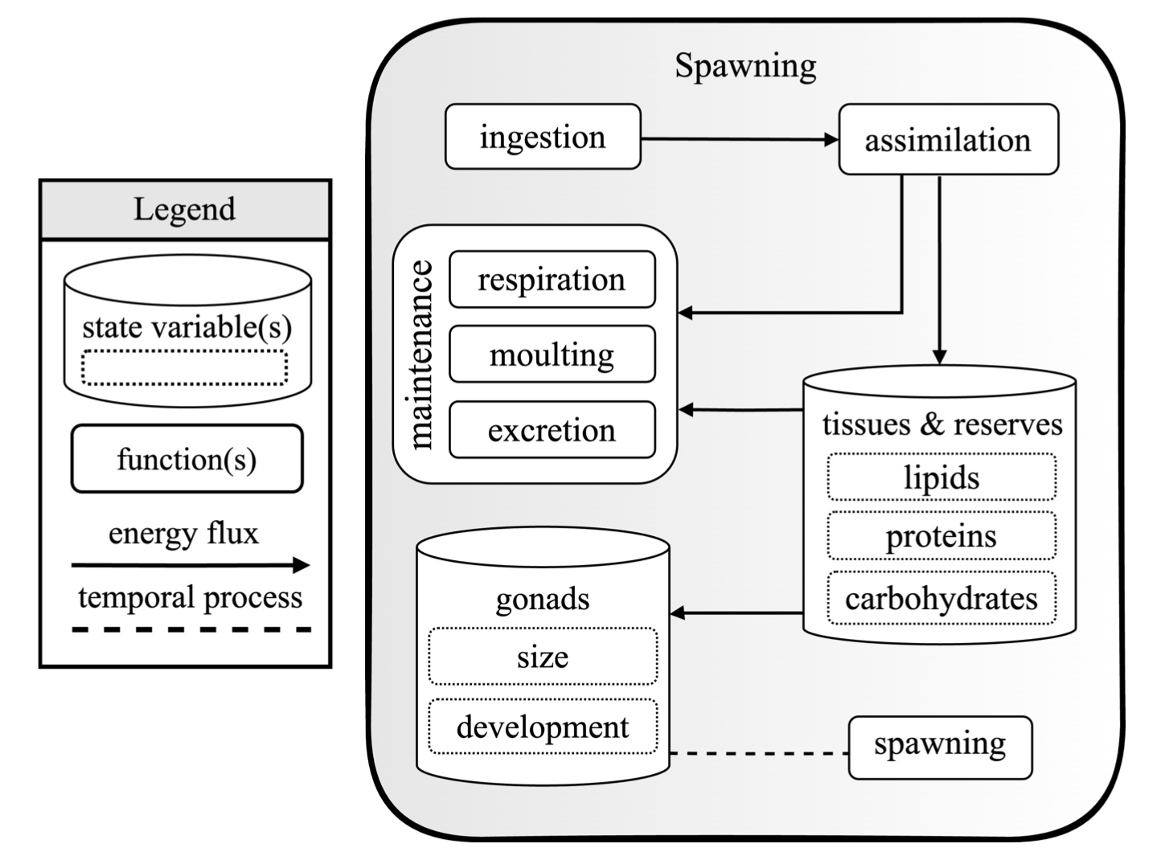

Figure 1. Conceptual model of the Antarctic krill (Euphausia superba) spawning process illustrating the flow of energy and resources (solid arrows, head noting direction) through various metabolic functions (rounded rectangles and squares) and state variables (dashed-line rectangles in cylinders) that define model sub-units. Ingestion leads to assimilation, where nutrients are allocated to tissues and reserves (e.g., lipids, proteins, and carbohydrates). Maintenance functions (e.g., respiration, moulting, and excretion) are supported by the assimilated material. Energy stored in tissues and reserves is also directed toward the development of gonads, which grow and advance in development, leading to spawning. These sub-units are described as temporal processes (dashed lines) or energy fluxes (arrows). This graphic was created with draw.io. and Adobe software.

The ‘Embryo and Larval Development Conceptual Model’ (Fig. 2) focuses on the growth and maturation of fertilised embryos, together with the growth, maturation, and moulting of non-feeding larvae (i.e., nauplius stages I-II and metanauplius stage), which altogether takes around 30 days in water temperatures of 0°C (Ikeda, 1984). After spawning, the released embryo begins to sink at a rate dependent on its density relative to the ambient water temperature, which is influenced by embryo diameter and developmental stage (Hofmann et al., 1992). Growth and respiration gradually deplete internal reserves developed during this phase. Once the embryo fully develops, it hatches as a nauplius I larva and progresses through the second nauplius and metanauplius stages as it ascends through the water column (George, 1984; Hempel, 1986). Larval development rates are temperature-dependent (Ross et al., 1988), and the energy consumed during this time is derived from maternally provided energy reserves (Quetin and Ross, 1989). Since the larvae in these stages are non-feeding, the energy reserves assimilated during these earlier stages become critical for survival as they begin their ascent into productive surface waters. However, larvae that do not arrive in phytoplankton-rich waters, or deplete their maternal energy reserves before reaching the feeding stage, may reach the point-of-no-return and die (Quetin and Ross, 1989). For this study, the embryo and larval development model does not extend beyond the non-feeding stages (nauplius and metanauplius).

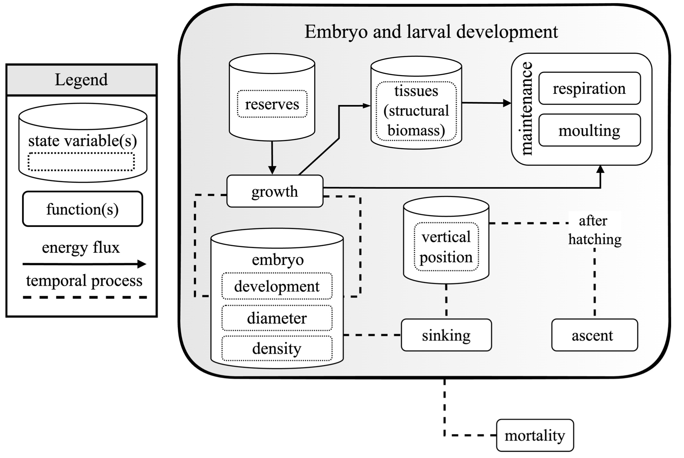

Figure 2. Conceptual model of embryo and larval development for non-feeding Antarctic krill (Euphausia superba). This model illustrates the flow of energy and resources (arrows) through various metabolic functions (rounded rectangles and squares) and state variables (dashed-line rectangles in cylinders) that define model sub-units, in the early stages of development from embryo to nauplius stage I to nauplius stage II to metanauplius. During embryogenesis, reserves are utilised for cell division and the development of tissues, organs, and limbs, as well as for metabolic maintenance demands (respiration). In addition, embryo diameter and density change during development and influence sinking rate and vertical position in the water column, which affects temperature-dependent development and metabolism. Upon hatching, the embryo develops through the non-feeding nauplius (I and II) and metanauplius larval stages, undergoing moulting as it ascends through the water column. All model sub-units are described as temporal processes (dashed lines) or energy fluxes (arrows). This graphic was created with draw.io. and Adobe software.

The ‘Overwintering Conceptual Model’ (Fig. 3) captures the final process influencing krill recruitment experienced by larval (feeding stages from calyptopis stages to furcilia) and juvenile krill in its first winter (Quetin and Ross, 1991). The conceptual model focuses on bioenergetics and, in a simplified way, considers interactions of subadult krill with the physical environment through their influence on metabolic processes (e.g., ingestion in relation to food availability, respiration rates in relation to temperature; see Figure 9). In contrast to adult krill, larvae and juveniles do not accumulate significant amounts of lipids in autumn and therefore rely on the uptake of food to meet maintenance costs required for overwintering (Quetin and Ross, 1991). Therefore, the overwintering model includes similar maintenance sub-units (respiration, moulting, and excretion) as the adult female spawning model (Fig. 1). Maintenance energetic costs are supported by the energy gained from ingestion and assimilation, which is also routed to body tissues and reserves (lipids, proteins, and carbohydrates). Ultimately, survival can require slowing metabolism, body shrinkage (Ikeda and Dixon, 1982), seeking alternative food sources (Price et al., 1988), or occupying areas under the sea ice (Daly, 1990). The surviving individuals emerge after the winter as part of the new cohort, thereby determining the number of recruits.
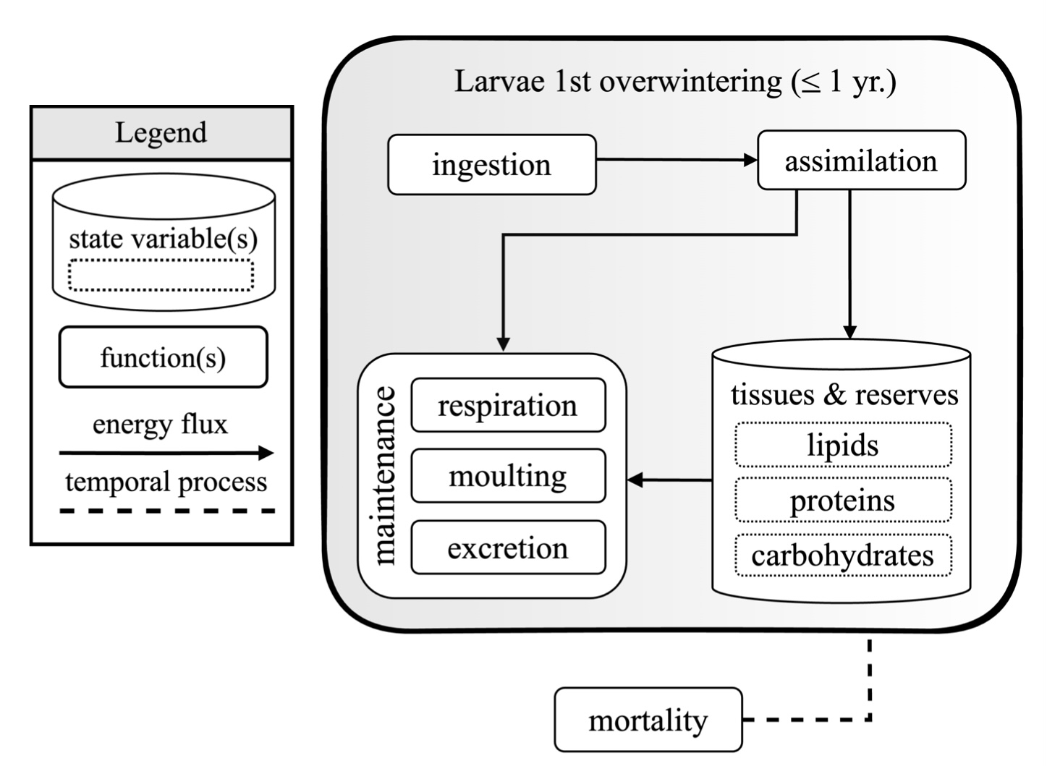

Figure 3. Conceptual model of the first overwintering for Antarctic krill (Euphausia superba) larvae and juveniles ≤1 year old. This model illustrates the flow of energy and resources (arrows) through various metabolic functions (rounded rectangles and squares) and state variables (dashed-line rectangles in cylinders) that define model sub-units. Maintenance functions (respiration, moulting, excretion) are supported by the ingestion and assimilation of nutrients stored as tissues and reserves (lipids, proteins, carbohydrates). The model does not explicitly include a mortality sub-unit, but it is represented to account for potential mortality across stages. All model sub-units are described as temporal processes (dashed lines) or energy fluxes (arrows). This graphic was created with draw.io. and Adobe software.

2.2 Functional dependencies on external factors and accounting for mortality

Spawning, embryo and larval development, and overwintering processes all include functions that inherently relate to external (abiotic) factors. The following factors were defined by the authors (unweighted) expert consensus based on current understanding and information detailed in the 254 studies examined in Section 2.3. as most influential to the processes: seawater temperature, chlorophyll-a concentration, particulate organic carbon (POC) concentration, fatty acid composition of prey, photoperiod, distance to continental shelf, seafloor depth, seawater density, heterotrophic prey availability, sea ice algal biomass, sea ice thickness, detritus concentration, and time (Table S2). Applicability to each model sub-unit was defined and utilised in further analysis (Table S2). Model state variables, however, were not assessed against external factors.

Mortality was not explicitly included in the three conceptual models as a function; however, some assessment of mortality was necessary for the embryo and larval stages (Figs. 2-3), during which mortality rates are elevated. Therefore, we examined data points related to mortality by life stage (i.e., embryo, larvae, and adult), cause of mortality, and applicable conceptual model sub-units (i.e., for the sub-units in the Embryo and Larval development and Overwintering Conceptual Models). Mortality was not included in the Spawning Conceptual Model because this process focuses on reproductive output and the physiological mechanisms underlying the embryo, rather than on the survival of female krill during this stage. Mortality drivers were defined by expert consensus (using the same method as defined above) as starvation, fishing, predation, parasitism, temperature, and other mortality, including ultraviolet radiation and exposure to critical partial pressure of oxygen (Table S3).

2.3 Systematic literature review
We conducted a systematic literature review of peer-reviewed and published papers to extract information on krill recruitment (Fig. 4). Our protocol was structured, where relevant, in accordance with the Guidelines and Standards for Evidence Synthesis in Environmental Management provided by the Collaboration for Environmental Evidence and following the standardised PRISMA (Preferred Reporting Items for Systematic Reviews and Meta-Analyses) protocol (O’Dea et al., 2021). Four separate searches were conducted by querying the citation-indexed databases “Web of Science Core Collection” and “Scopus” (accessed on November 5th, 2021) using the following keywords as search terms:

- Spawning: “euphausia superba” OR “antarctic krill” AND “spawning”
- Embryo and larval development:
    - "euphausia superba" OR "antarctic krill" AND "larva"
    - "euphausia superba" OR "antarctic krill" AND "embryo”
- Overwintering: "euphausia superba" OR "antarctic krill" AND "winter"
- Build-up of body reserves in autumn:
    - "euphausia superba" OR "antarctic krill" AND "fall"
    - "euphausia superba" OR "antarctic krill" AND "autumn"
    - "euphausia superba" OR "antarctic krill" AND "lipid"

Keywords were chosen to identify studies using varied terminology (e.g., “larva” includes mention of “larva”, “larvae”, or “larval development”; “winter” includes mention of “winter”, “overwinter”, or “overwintering”). The “build-up of body reserves” prevalent in autumn initially accounted for a fourth process; however, the corresponding data overlapped with those for overwintering, embryo, and larval development. Given this, we integrated the data and conceptual model sub-units (Figs. 2 and 3) and left the record of the keywords to document the formal process followed (Fig. 4). The reader is referred to the full scheme of the paper selection process in Figure 4.

The database query resulted in 16,726 published studies, including duplicates within (due to different databases/search terms) and between topics. This initial selection was exported to CSV files and de-duplicated using R statistical software (R Core Team 2021) with the help of the tidyverse (Wickham et al., 2019), vroom (Hester et al., 2023), and openxslx (Schauberger and Walker, 2024) packages. Studies listed under multiple topics were assigned to the first topic (topics were sorted alphabetically) and removed from others to avoid duplication. To refine the initial database query, studies were subsequently filtered for matches with the following topic-specific keywords included in either the paper title or abstract:
- Spawning: “spawning” OR “vitellogenesis” OR “egg” OR “fecundity”
- Embryo and larval development: “larva” OR “egg” OR “embryo” OR “ontogen” OR
“lipid” OR “autumn” OR “fall”
- Overwintering: “winter” OR “sea ice”

After deduplication, the literature list was reduced to 744 entries. The two lead authors double-screened these studies for relevance based on title and abstract, eliminating those irrelevant to krill modelling (e.g., aquaculture, pharmaceutical research). Any disagreements were resolved by discussion between the two reviewers. This screening resulted in 254 relevant studies. A full documentation of the study selection is provided in the Appendix.
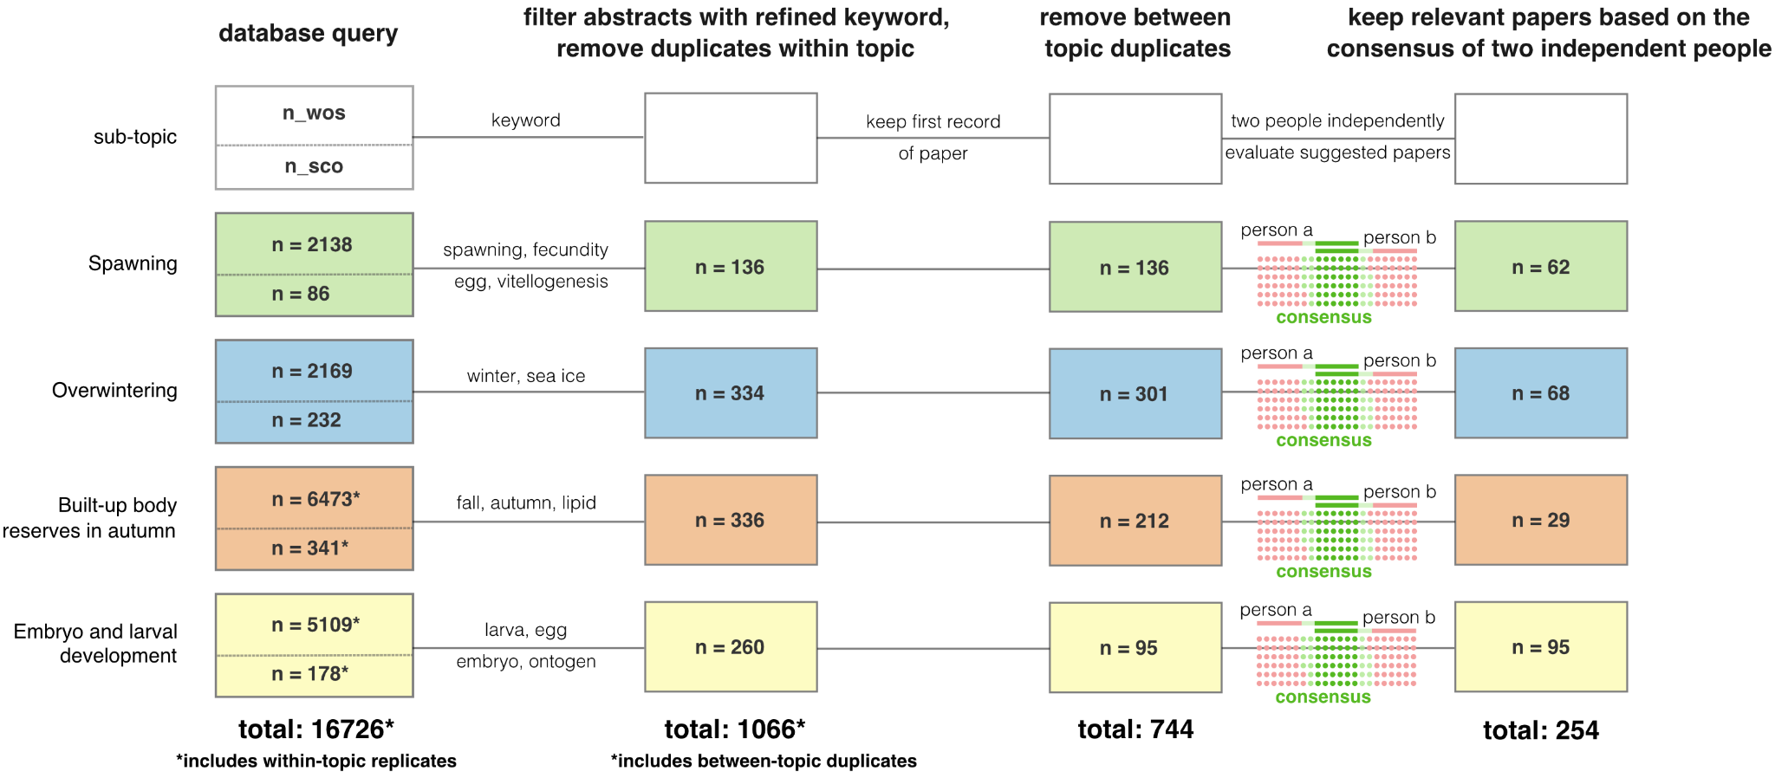

Figure 4. Schematic illustrating the systematic literature review of Antarctic krill (Euphausia superba) recruitment processes: spawning (green boxes), egg and larval development (yellow boxes), and overwintering (blue boxes). The steps taken (from left to right in the schematic) included an initial database query of Web of Science and Scopus, including the use of the keywords documented in Section 2.3. The number of studies identified in Web of Science (n_wos) is documented in the upper portion of each box, while the number of studies identified in Scopus (n_sco) is included in the lower portion of each box.

The 254 studies were then divided into groups of 20-30 and reviewed at the full-text level by the 17 co-authors of this study. Each co-author was encouraged to review studies most aligned with their expertise, and studies were therefore not randomly assigned. Metadata were coded, and data were extracted simultaneously using a common codebook. The variables coded described relevant process (e.g., spawning, embryo and larval development, overwintering), type of study (observational, model, or hybrid (model and observational)), study author(s), year published, title, study duration, time period (defined according to season) during which the study took place or data were utilised, year(s) of study investigation, study region, individual data point name, data point value origin (i.e., method for how the data point originated; for example, observational study type data points originate from measurement), data point unit, sample size, krill life stage, data point value, statistical significance (if available and/or relevant), R-squared value (if available and/or relevant), standard deviation (if available and/or relevant), and data point applicability to other processes (see Table S1). A total of 3,589 unique data points and their associated metadata were extracted and documented during this process. In the figure presented in the preceding section, this number may be exceeded, as many data points refer to more than one process.

2.4. Mapping the data landscape
Following data extraction from the literature, all data points were classified according to the specific Conceptual Model and the sub-units for which they contributed information, thereby generating a ‘data landscape’ of how comprehensively the different sub-units are covered in the current literature. To do this, a table was compiled to consolidate all unique combinations of sub-unit description, type (state variable or function), and each external factor influencing them. Each combination was assigned a distinct ID, yielding 99 IDs (Table S2). Additionally, we conducted a separate assessment of sub-unit relevance to mortality across life stages (embryo, larvae, and adult) and types (starvation, fisheries, predation, parasitism, temperature, and natural). This extended the unique IDs in Table S2 to 120 distinct IDs (Tables S2 and S3).

In addition to ID assignment, data point types were classified according to information categories to give some indication of data-point quality and applicability to study type: "correlation", "parameter", "validation", “parameter, validation”, and “not assigned” (See Table 1 for the definitions of the categories). The delineation between these information categories can occasionally be fluid and context dependent.

All 3,589 data points were independently assigned IDs and information categories by both lead co-authors using private spreadsheets to eliminate bias. Some entries were associated with more than one ID, while others, such as population density or abundance data, did not align with any IDs and were therefore left blank and excluded from further analysis. Consequently, the number of assigned IDs exceeds the total number of collected data points.

Table 1. Information categories and associated definitions used to categorise the data points extracted from the systematic review of literature relating to Antarctic krill (Euphausia superba) recruitment (specifically spawning, embryo and larval development, and overwintering).
Information category | Definition
Correlation | Value indicating the result of a correlation test, suggesting a relationship between two variables, but not directly usable as a model parameter
Parameter | Value that can be directly used as a model parameter
Validation | Value that cannot be directly used as a model parameter, but is useful for validating model predictions
Parameter, validation | Value that can serve either as a model parameter or for validating model predictions
Not assigned | Value that does not fit in any of the above categories

3. Results

3.1. Systematic literature review dataset overview
The systematic review of 254 studies on krill recruitment yielded 3,589 unique data points, offering a broad overview of the current literature. Our analysis revealed a noticeable spatial and temporal bias amongst the studies (Fig. 5). Despite 9 of the 254 studies encompassing a circumpolar focus, the geographic distribution of studies that had either collected data or reused previously collected data (Fig. 5A) was strongly concentrated in the Atlantic sector, accounting for 197 studies. Data from the Western Antarctic Peninsula were reported in 103 studies, and the data for the Central Indian and East Indian sectors were reported in 21 and 6 studies, respectively. Only 5 studies represented the Western Pacific sector. Most studies presented data from the austral summer season (n = 122 studies), followed by autumn (n = 66), winter (n = 57), and spring (n = 36) (Fig. 5B). Several studies presented comparisons across seasons and thus accounted for multiple seasons.

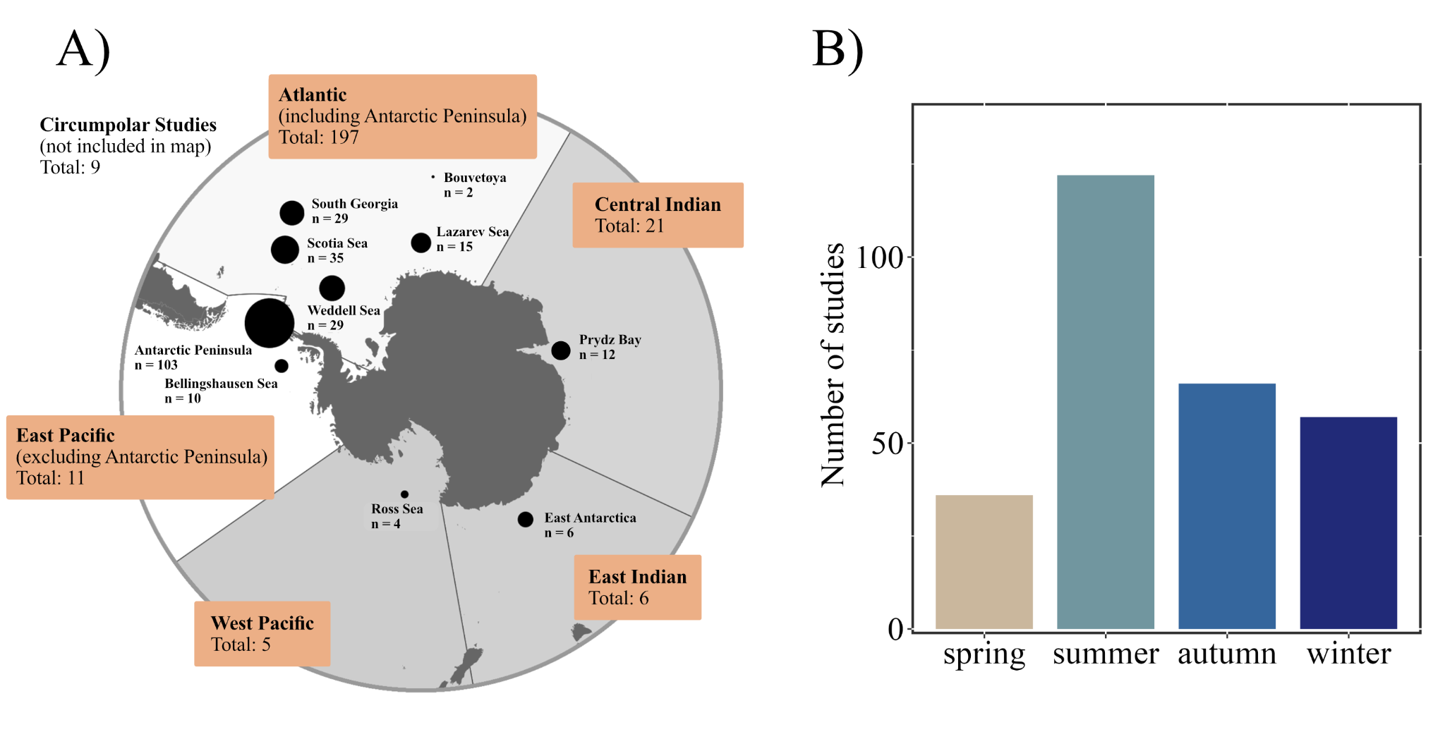

Figure 5. (A) Spatial and (B) seasonal distribution of reviewed literature relevant to Antarctic krill (Euphausia superba) recruitment, shown as the total number of studies that reported data for a specific location, sector, or season. Some studies reported data from more than one location or multiple seasons, and others did not specify specific locations (e.g., 5 studies reported data for the West Pacific sector but only 4 for the Ross Sea within that sector). (A) White shading indicates sectors with the highest number of studies, and grey shading indicates sectors with fewer studies. (B) Temporal period and corresponding number of studies grouped by season (spring: September - November, summer: December - February, autumn: March - May, and winter: June - August).

The largest proportion of relevant data points (1,535 or 43%) applied to the spawning process (Table 2). The number of data points decreased from embryo and larval development (n = 789) to overwintering (n = 431), and then to mortality (n = 113; Fig. 6), as elaborated on in Section 3.2.4.

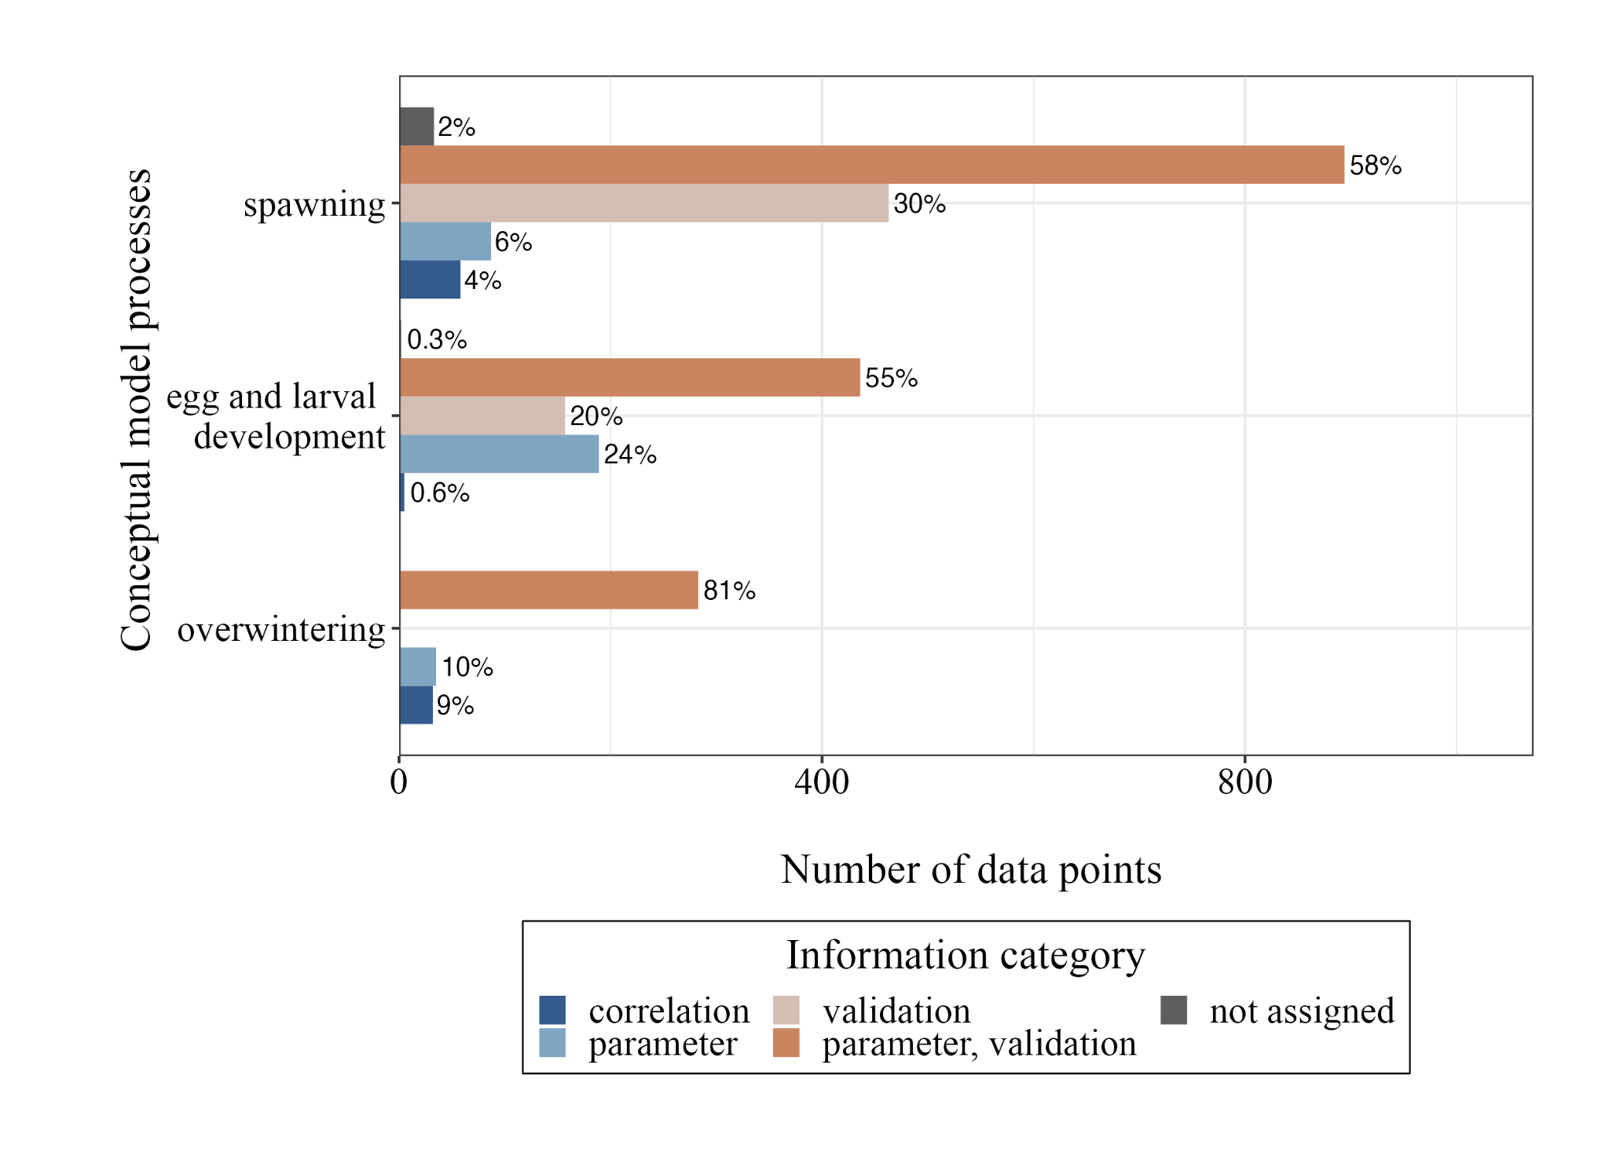

Figure 6. Total number of data points recorded for each information category (colour-coded - see legend below plot) and corresponding Antarctic krill (Euphausia superba) Conceptual Model process (detailed in Figs 1-3) relating to recruitment (spawning, embryo and larval development, and overwintering). The percentage (%) of each information category within each Conceptual Model process is positioned next to each bar. The definitions of each information category are in Table 1, and the total number of data points is in Table 2.

Across the information categories (“correlation”, “parameter”, “parameter, validation”, and “not assigned”), most data points were classified as "parameter, validation” (Table 2). This suggested that the catalogued data points could serve either as a model parameter or for validating model predictions. These data points typically provided observational information on reported growth rates with no functional relationship to other factors, such as food availability or temperature. For the spawning process, 894 (58%) of the data points were classified as “parameter, validation”, and “correlation” made up the smallest proportion (n = 58 or 4%) of the data (Fig. 6). Data points that could directly be used as model parameters (e.g., information category “parameter”) constituted 8% of the total data set (n = 353), meaning many of the data points were not specific enough to act as stand-alone model parameters.

Of the 3,589 data points catalogued, 1,540 assignments were unrelated to any Conceptual Model process nor their corresponding sub-units, and therefore classified as “not assigned” (Table 2). Within this “not assigned” category, the majority of the data points (n = 1,064) were classified as being relevant for "validation", meaning the data point may be useful for validating model predictions, but did not directly align with model sub-units within our conceptual framework. Most of these validation data consisted of krill abundance data collected from various habitats or regions. Data points not relevant to any of the information categories comprised 344, or 23%, of the “not assigned” category (Table 2).

Table 2. Total number of data points assigned to each Conceptual Model process and information category relating to Antarctic krill (Euphausia superba) recruitment (detailed in Fig 1-3), and the proportion of each relative to the total data set. Information category total number of data points (n) accounts for the sum of data points assigned to each category within each process, including mortality and those not assigned. Data points that were not applicable to any process nor information category are shown in the final row “not assigned”. The sum of all data points across information categories is included in the fourth column, and the proportion to the total data set is included in the last column.
Process | Information  category | Information category  total number of data points (n) | Process  total number of data points (n) | Process  proportion of the  total data set (%)
Spawning | Correlation | 58 | 1,535 | 35
Spawning | Parameter | 87 | 1,535 | 35
Spawning | Validation | 463 | 1,535 | 35
Spawning | Parameter, validation | 894 | 1,535 | 35
Spawning | Not assigned | 33 | 1,535 | 35
Embryo and larval  development | Correlation | 5 | 789 | 18
Embryo and larval  development | Parameter | 189 | 789 | 18
Embryo and larval  development | Validation | 157 | 789 | 18
Embryo and larval  development | Parameter, validation | 436 | 789 | 18
Embryo and larval  development | Not assigned | 2 | 789 | 18
Overwintering | Correlation | 32 | 350 | 8
Overwintering | Parameter | 35 | 350 | 8
Overwintering | Validation | 0 | 350 | 8
Overwintering | Parameter, validation | 283 | 350 | 8
Overwintering | Not assigned | 0 | 350 | 8
Mortality | Correlation | 0 | 113 | 3
Mortality | Parameter | 33 | 113 | 3
Mortality | Validation | 0 | 113 | 3
Mortality | Parameter, validation | 80 | 113 | 3
Mortality | Not assigned | 0 | 113 | 3
not assigned | Correlation | 5 | 1,540 | 36
not assigned | Parameter | 5 | 1,540 | 36
not assigned | Validation | 1,064 | 1,540 | 36
not assigned | Parameter, validation | 122 | 1,540 | 36
not assigned | Not assigned | 344 | 1,540 | 36

3.2 Analysis of the data points assigned to each conceptual model

3.2.1 Spawning
A total of 1,535 data points were assigned to the Spawning Conceptual Model sub-units (Figs. 1 and 7; Table 2). Among the state variable model sub-units, the majority directly pertained to the adult krill lipid reserves (n = 640) (Fig. 7). In contrast, fewer than 200 data points were related to protein reserves (n = 124) and carbohydrate reserves (n = 187) (Fig. 7). Gonad development (n = 34) and gonad size (n = 82) garnered substantially fewer data points compared to lipid, protein, or carbohydrate reserves. A minority of these model sub-unit data points provided correlational information with most classified as “parameter, validation” or “validation”, meaning that they typically did not provide information that could be used directly as parameters in functional relationships, but rather as reference values against which model predictions, for example, of krill lipid content, could be validated.

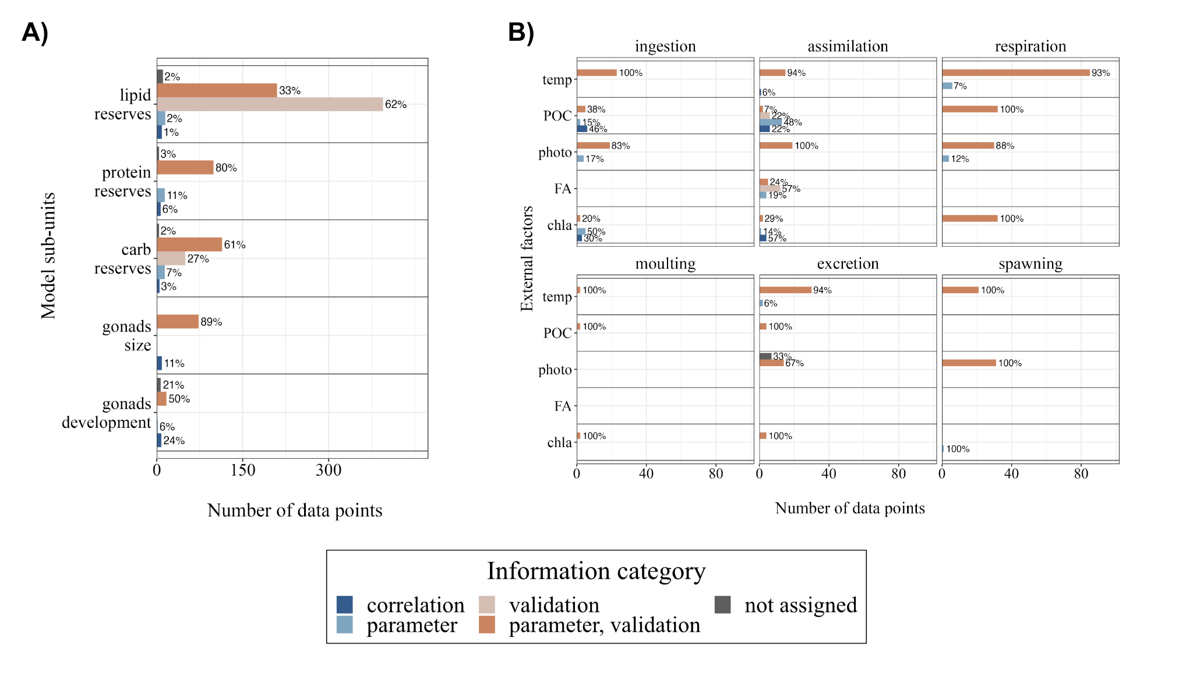

Figure 7. Categorisation of data points related to Antarctic krill (Euphausia superba) spawning (an aspect of recruitment). The number of data points assigned to each sub-unit (A) state variable (abbreviations: carb - carbohydrates) and (B) function related to environmental and ecological factors (abbreviations: temp - temperature, POC - particulate organic carbon, photo - photoperiod, FA - fatty acid composition, and chla - chlorophyll-a) included in the spawning conceptual model, colour-coded according to information category (see legend below plot).

Of the spawning sub-unit functions that were directly related to environmental conditions (Fig. 7B), the highest number of data points were assigned to respiration (n = 189), assimilation (n = 90), and ingestion (n = 69). These three were found to be related to an array of environmental factors such as temperature, POC, photoperiod, fatty acid composition of the food, and chlorophyll-a concentration (Fig. 7B). A total of 85 data points related to respiration and temperature accounted for the greatest number of data points amongst the environmental factors. Fewer data points were relevant to spawning itself (n = 53), excretion (n = 61), and especially moulting (n = 6). Like the model sub-unit state variables that did not relate to environmental drivers, most of the assigned data points had the information category “parameter, validation”.

3.2.2 Embryo and larval development
In total, 789 data points were assigned to the Embryo and Larval Development Conceptual Model (Figs. 2 and 8; Table 2). Nearly half of these data points (46%, n = 360) were related to the state variable 'tissues'. Comparatively, 27% (n = 216) of the data points were assigned to embryo growth, but only 36 were related to moulting, despite being an influential factor for larval growth (Fig. 8A). Like the other conceptual models, most of the embryo and larval development data points (n = 436) were classified as “parameter, validation”. However, some state variables, such as time- and temperature-dependent growth or tissues, had comparatively higher proportions of data points that could be used directly as parameters (41% for time-dependent growth; Fig. 8).
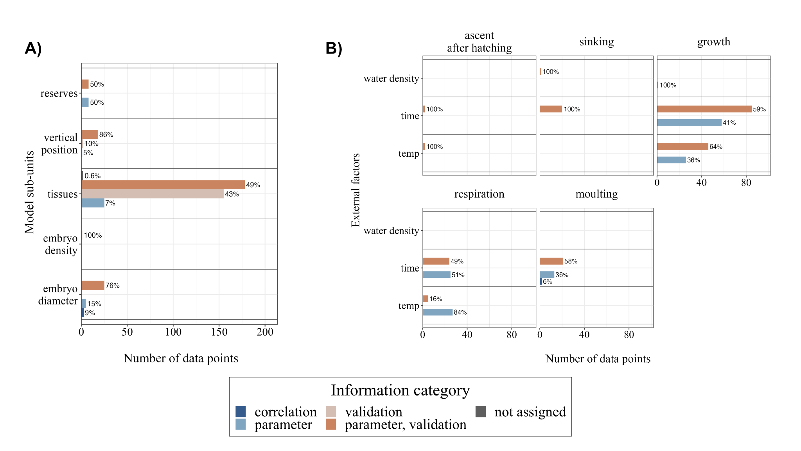

Figure 8. Antarctic krill (Euphausia superba) embryo and larval development (an aspect of recruitment). The number of data points assigned to each (A) state variable and (B) function related to environmental and ecological factors (abbreviations: temp - temperature) included in the embryo and larval development conceptual model, colour-coded according to information category (see legend below plot).

Small numbers of data points were assigned to the state variables: vertical position in the water column (n = 21) and reserves (n = 16). Only one data point was related to embryo density and 33 data points were related to embryo diameter, which in combination influence sinking rates (Fig. 8A). Twenty-one data points directly informing sinking rates were found in the compiled dataset, although 20 of these sinking rates included no associated information on embryo diameter, density, or water temperature (Fig. 8B). Four data points were assigned to the ascent of the nauplius I larva after hatching, of which two each related to temperature and time-dependence. Time- and temperature-dependent respiration rates were extracted from 49 and 32 data points, respectively, with most data points being relevant as model parameters (“parameter” information category).

3.2.3 Overwintering
A total of 350 data points were assigned to the overwintering conceptual model process (Figs. 3 and 9; Table 2), of which 81% pertained to the information category “parameter, validation”. Most of the model sub-unit state variables (19% or n = 65) related to the lipid reserves of krill during winter (Fig. 9A). Of these, 61 were classified as “parameter, validation”, meaning that much of the data were primarily useful for model validation but could not directly be used for parameterising lipid reserve dynamics. Comparatively, 34 data points related to carbohydrate reserves and 36 related to protein reserves (Fig. 9A).

A similar number of data points related to physiological functions such as assimilation (n = 60) and respiration (n = 37) (Fig. 9B). Ingestion comprised 30% (n = 105) of the data points assigned to the conceptual model, while very few data points were found to be related to moulting (n = 6) and excretion (n = 7). Data points on assimilation, ingestion, and respiration were relatively common in relation to food availability in the form of detritus, ice algae, or heterotrophic carbon. Photoperiod was primarily associated with physiological rates, including ingestion (n = 34), respiration (n = 8), and assimilation (n = 9).

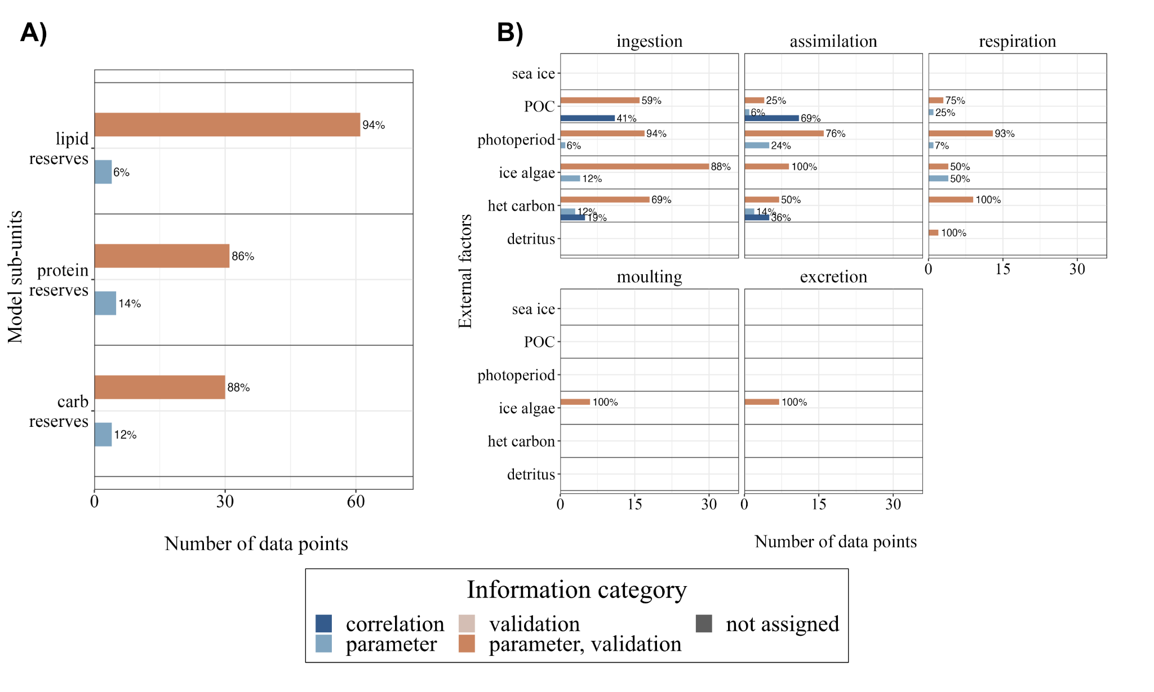

Figure 9. Antarctic krill (Euphausia superba) overwintering survival of larvae and juveniles during first year of life (an aspect of recruitment). The number of data points assigned to each (A) state variable (abbreviations: carb - carbohydrates) and (B) function related to environmental and ecological factors (abbreviations: POC - particulate organic carbon and het carbon - heterotrophic carbon) included in the overwintering conceptual model, colour-coded according to information category (see legend below plot).

3.3. Assessing mortality
Within the compiled dataset, 113 data points were assigned to mortality (Table 2). All data points were assigned to the information categories “parameter” (n = 33) or “parameter, validation” (n = 80). Most of the mortality data points pertained to larvae (n = 65), accounting for 58%, whilst adult krill (n = 48) accounted for 42%. Our dataset did not contain data points relevant to the embryonic life-history stage (Fig. 10). For larvae, 24 of the 65 points were assigned to starvation and 30 to other mortality, including mortality risks from UV radiation or a critical partial pressure of oxygen. The remaining data points were assigned to the thermal tolerance of larval krill (n = 4), predation risk (n = 5), and parasitism (n = 2). For adult krill, no data points informed thermal tolerance, predation mortality, parasitism mortality, nor fisheries mortality. In fact, no data points were applied to fisheries mortality across any stages. For adults, the dataset yielded eight data points related to estimates of other mortality rates, and the remaining data points (n = 40) were related to starvation.
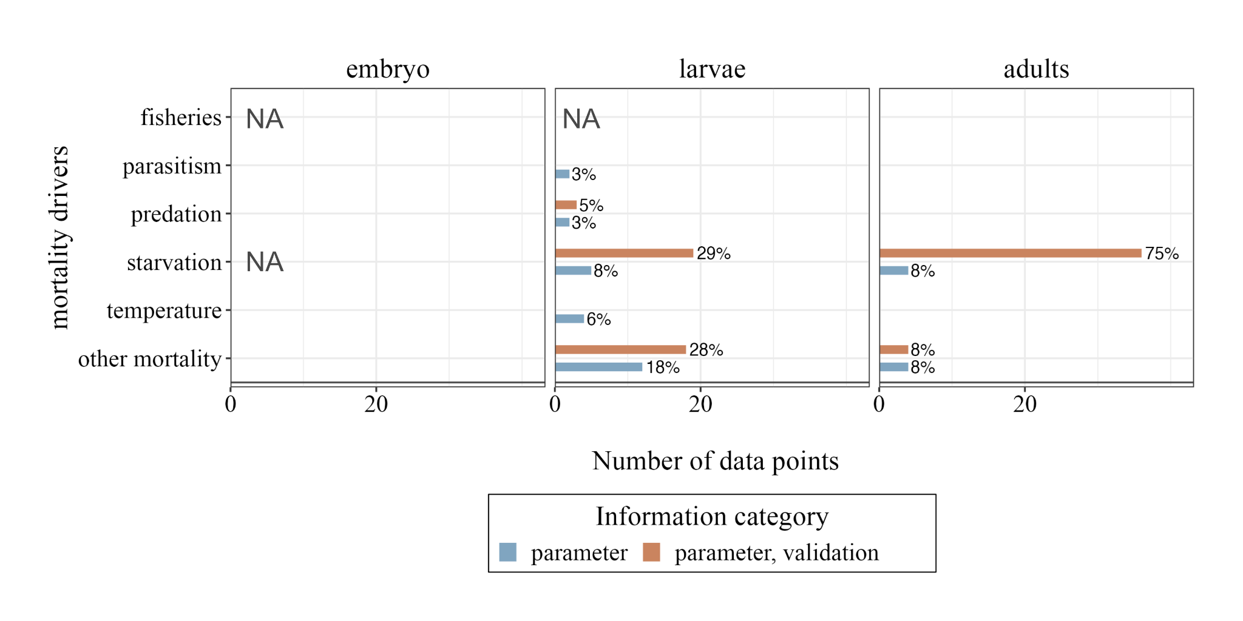

Figure 10. Number of data points assigned to different drivers of mortality for Antarctic krill (Euphausia superba) life stages. From left to right, the life stages, embryo, larvae, and adult, and associated mortality drivers (fisheries, parasitism, predation, starvation, temperature, and other mortality) feature the total number of data points in bar plots that are colour-coded according to information category (see legend below plot). The proportions (%) of each information category and mortality driver within each life stage are shown next to each bar. The definitions of each information category are in Table 1, and the total number of data points is in Table 2.

4. Discussion
In this study, we developed three conceptual models that incorporate key processes in the stage-dependent maintenance and reproduction of krill, as defined by the expert authors as key drivers of recruitment and population dynamics. In addition, we conducted a systematic literature review, extracting over 3,500 data points from 254 studies to inform the practical development of krill growth, recruitment, and population dynamics models. These data points were then mapped to the sub-units of the three Conceptual Models and to different causes of mortality to identify important processes with sparse information. With this approach, we outlined a “map of the data landscape” to inform model development in the context of processes important to krill recruitment. By characterising the amount and type of information available for the three Conceptual Models and for mortality, we identified existing data and information gaps that should be prioritised for future research to improve the collection of observational data and the translation of process studies into mechanistic understanding, thereby reducing uncertainty.

4.1 Data insights
It is clear that there is a large body of literature covering many aspects of krill biology. However, we found that only a minority of the collected and reported data can be appropriately used as direct model parameters in our Conceptual Models. Continued interdisciplinary exchange and collaboration, as has been done in many studies and through initiatives such as the ICED Krill Modelling Workshop, will therefore be important to improve compatibility between data collection and model requirements to support conservation and management within the Southern Ocean.

Table 3. Synthesis of findings from the systematic review of literature relating to Antarctic krill (Euphausia superba) recruitment processes (spawning, embryo and larval development, overwintering). This table summarises the processes (spawning, embryo and larval development, overwintering, and mortality) with the most and least assigned data. The ‘sub-units with the most assigned data’ column reflect the processes that have comparatively more data available, rather than indicating the most catalogued processes overall. Conversely, the ‘sub-units with the least assigned data’ column highlights areas where data is sparse, underscoring the need for further research.
Process | Sub-units with most assigned data | Sub-units with least assigned data
Spawning | - Biomass and reserves (carbon, lipid, protein content)  - Physiological rates (respiration, assimilation, ingestion) under varying temperatures and food concentrations | - Gonads (development, size)  - Environmental drivers of spawning  - Moulting under varying environmental conditions
Embryo and larval development | - Embryo mass and reserves  - Growth, respiration, and moulting rates | - Variation in embryo density  - Sinking rates and ascent after hatching under varying environmental conditions
Overwintering | - Biomass and reserves (carbon, lipid, protein content)  - Physiological rates (respiration, assimilation, ingestion) under varying temperatures and food concentrations | - Moulting and excretion under varying environmental conditions
Mortality | - Starvation mortality for larval and adult krill  - Other mortality for larval and adult krill | - Most drivers of embryo mortality  - Parasitism and predation mortalities of larvae and adults

The analysis of the data associated with the spawning conceptual model identified limited data availability for processes related to gonad development, excretion, moulting, and spawning output. Many data points were sourced from the Atlantic sector of the Southern Ocean, highlighting the defining geographic boundaries that shape our current knowledge of Antarctic krill.

Functional relationships among body size, feeding history, and the magnitude, timing, and frequency of spawning events are critical for predicting spawning output, the first step in influencing annual recruitment success. A mechanistic understanding of spawning stock size, the number of spawning episodes per season, the length of the season, and the total number of eggs released constitutes essential baseline information for estimating the number of embryos produced within a krill population. Morphological metrics, such as body length and weight (i.e., wet, dry, and carbon weight), were abundant in our data, allowing conversions among them as needed. Simplistic approaches, such as predicting egg production as a function of body size, as done in the mechanistic growth models of Jager and Ravagnan (2015) and Bahlburg et al. (2021), ignore known drivers of reproductive success, such as intake of critical fatty acids (Yoshida, 2009; Schmidt et al., 2012; Steinke et al., 2022), and thus cannot reproduce the high variability observed in the body length-fecundity relationship (Kawaguchi, 2016). Another model that allows for flexible spawning output (Constable and Kawaguchi, 2018) does not specifically include lipid content or fatty acid composition. Our analysis shows that empirical data directly supporting the conceptualisation, and especially the parameterisation, of such processes are sparse.

Moulting also plays an important role in the krill maturity cycle (Kawaguchi et al., 2007), in addition to its relevance for bioenergetics. Two functional relationships have been published to determine moulting rates under a range of environmental conditions (Kawaguchi et al., 2006; Tarling et al., 2006) but predict divergent results when applied across temperature gradients (Bahlburg et al., 2023). Investigation of the potential drivers of this model suggests divergence and points to the need for additional observations related to the drivers of moulting (Table 3).

The development of non-feeding larvae was conceptualized as a model with a relatively large number of data points, despite covering a relatively short period in the life history of krill. Much of the early development of embryos and non-feeding larvae is synthesised in the mechanistic model of Hofmann et al. (1992), which has been applied in later studies to explore larval krill development and advection at different scales and habitats (Hofmann and Hüsrevoğlu, 2003; Piñones and Fedorov, 2016; Thorpe et al., 2019). This model provides a relatively complete description of development from the embryo to the feeding larval stages, but its predictions are sensitive to the initial embryo diameter, which ranges from 576 to 627 μm (Quetin and Ross, 2001). Given the relatively large number of observations for this period in the life history of krill, a re-evaluation of the model of Hofmann et al. (1992) with updated data and uncertainty estimates may be a useful next step to address the current model's sensitivities.

The overwintering of krill recruits was the conceptual model to which the fewest data points were assigned. Lowe et al. (2012) developed the only existing mechanistic model that specifically simulates larval krill development during winter. This model is based on experimental work from the Western Antarctic Peninsula, and whether it is generalisable to other regions remains to be tested. The paucity of information during winter results from logistical challenges but obtaining data from the winter period is critical because it is a bottleneck for krill population dynamics due to the scarcity of food. Other existing growth models that cover the entire seasonal range (Jager and Ravagnan, 2015; Ryabov et al., 2017; Constable and Kawaguchi, 2018) do so by making relatively simple assumptions about the overwintering physiology of larval and adult krill, although a recent model attempted to add more detail (Bahlburg et al., 2021). Most of these models include seasonal switches that set winter metabolism to a fixed fraction of summer metabolism for a set period, which does not account for the diversity of overwintering strategies observed across different krill habitats (Tarling, 2020; Bernard et al., 2022). Meyer et al. (2002) provided an important overview of the overwintering strategies of larval krill, but many questions remain, particularly about feeding ecology and habitat requirements. For example, photoperiod was the environmental factor to which the fewest data points were assigned in the context of krill's physiological functions during winter. However, photoperiod may be the key cue for endogenous clocks that synchronise krill's physiological functions with environmental conditions (Teschke et al., 2011; Biscontin et al., 2017; Piccolin et al., 2018), thereby having a substantial impact on model predictions (Groeneveld et al., 2015). Recent research has addressed knowledge gaps in the winter-feeding ecology and development of juvenile krill (Bernard et al., 2022; Steinke et al., 2022), but further studies, possibly in close coordination with modellers, could be of great value in developing more informed models.

4.2 Addressing mortality
We also screened the compiled dataset for information relating to different drivers of krill mortality. Fewer data points were assigned to mortality than to the three sub-units considered above. Most data points addressed starvation mortality in larval and adult krill, whereas those on temperature-induced mortality were much fewer. This may be of minor importance for adult krill in general, but it is likely to increase in importance at the northern limit of their range, for example, near South Georgia, where krill might encounter water temperatures exceeding their thermal tolerance (Tarling, 2020; Michael et al., 2021). Furthermore, the role of parasitism or disease in krill mortality is largely unknown, and little information on these factors is available. Similarly, predation mortality plays an important role for krill populations, but few data points could be found in our dataset to parameterise this process in mechanistic models. Recent efforts, however, have been made to shed more light on region- and taxon-specific krill predator consumption rates (Warwick-Evans et al., 2022; Savoca et al., 2021). A final and increasingly important cause of krill mortality is commercial fishing. Despite krill catch being well documented in CCAMLR quotas and vessel-specific landings, no data points in our review applied to fishing mortality.

4.3 Limitations of this study

It is important to acknowledge the limitations of our study. Most notably, the number of data points attributed to individual Conceptual Model processes is not a perfect measure of uncertainty or knowledge state. Some data points may provide more valuable information than others; for instance, some may represent single observations, while others may summarize statistics from numerous samples. Nevertheless, the number of available data points reflects the empirical effort invested in investigating specific model processes. We have addressed information quality by introducing additional criteria to assess the quality of different data points. Furthermore, having a large number of observations to parameterize various model processes helps obtain uncertainty estimates, which are essential for robust model predictions (Bahlburg et al., 2023).

Another challenge we faced was the manual assignment of data points to model sub-units. This assignment was conducted independently by the two corresponding authors to minimize individual biases. However, a comparison of the initial assignments revealed some differences in data interpretation. While this may indicate that there is not always a clear connection between empirical data and model processes, it also suggests that the results might contain some bias. Additionally, reaching consensus on the three conceptual models and their structures proved complex. Therefore, the models presented in this study represent one possible structure among many alternatives. Finally, despite our thorough efforts, it is possible that our literature review may have overlooked relevant studies, and any research published after November 2021 is not included in our analysis.

4.4 Modelling krill in the face of uncertainty
Our analysis identified sources of information, ranging from sparse to plentiful, that are important for modelling key aspects of krill life history, which ultimately drive population dynamics (Table 3). To improve models of krill population dynamics, the modelling community would greatly benefit from increased information on those processes for which little is currently available. We argue that experimental research aimed at addressing these processes should be more closely aligned with the data needs of predictive models.

However, conducting such experimental studies is expensive, time-consuming, and not always possible. Models (including zooplankton models) should thus be developed and used despite, and in clear recognition and articulation of, existing uncertainties (Johnston et al., 2022). There are different ways of incorporating uncertainty into modelling, and, in some sense, all existing models already offer suggestions on how to do so. This includes justified simplifications and assumptions, such as downscaling of metabolic activity in winter to fixed days of the year (Hofmann et al., 2000; Constable and Kawaguchi, 2018). Other solutions may involve "reverse engineering" causal relationships between krill population dynamics and the environment when these are unknown prior to the simulation start. For example, a recent study calibrated a stage-specific population model to reproduce krill population dynamics in the Western Antarctic Peninsula by allowing interannual variation in stage-specific mortality rates, which are often fixed parameters (Ryabov et al., 2023). The authors then related mortality rate variability to environmental conditions, allowing them to identify environmental drivers of population dynamics and recruitment in the modelled population. When functional relationships are unknown or cannot be parameterised, statistical modelling approaches that fit observations to environmental drivers (using Bayesian or frequentist techniques), or hybrids of mechanistic and regression models, can be useful for making predictions in the absence of mechanistic understanding of all relevant processes (Munch et al., 2018). For example, some of the most widely used instantaneous krill growth rate models are based on regressions (Atkinson et al., 2006). However, special care should be taken when extrapolating such models usedbeyond the range of data with to parameterise them (Bahlburg et al., 2023).

In other disciplines, such as Earth System modelling, model ensemble runs have been established to reduce the specificity of simulation results to individual model design choices and incorporate the expected variance introduced by the spatial and temporal specificity of the individual models. Similar options using krill models were explored in Bahlburg et al. (2023) but have not yet yielded promising results. If none of the above options are applicable, modelling studies should at least make uncertainty estimates clearly explicit and investigate the robustness of their simulation results to them (Johnston et al., 2022, Bahlburg et al., 2023). This includes uncertainty in design choices (e.g., including or excluding certain mechanisms) and, if possible, in parameter values. While this will not close existing knowledge gaps, it will at least acknowledge the uncertainties associated with existing krill models. In cases where data are particularly sparse, or when modelling efforts need to scale across broader spatial and temporal dimensions, another approach is qualitative modelling, which does not rely on specific parameter values but instead assumes relationships between model entities and their directions (positive, negative, neutral). In a complementary study (Sylvester et al., 2024, preprint; not peer-reviewed), a qualitative model was used to investigate the overwintering success of larval krill under different climate change scenarios, demonstrating the potential of this method in the absence of more detailed information.

Finally, there are many reasons to be optimistic about the development of krill recruitment models to inform Southern Ocean conservation and management and to better understand the role of krill in Southern Ocean ecosystems and beyond. Ongoing international synthesis efforts, such as this study, ICED and the Scientific Committee for Antarctic Research (SCAR) including its Research Programmes and Expert Groups, such as the SCAR Krill Expert Group (SKEG) (Murphy et al., 2018; Meyer et al., 2020), Marine Ecosystem Assessment for the Southern Ocean (MEASO) (Brasier et al., 2019; McCormick et al., 2021), the European Union PolarRes project, that is producing downscaled Southern Ocean climate models with outputs and spatial scales relevant to interpreting ecological change, together with others on krill distribution (Atkinson et al., 2017), behaviour (Tarling and Fielding 2016; Kawaguchi et al. 2023), overwintering physiology (Meyer 2012) and feeding mechanisms (Hamner 1988), are laying a foundation for future advancements (see Johnston et al., 2022). Moreover, the research community is increasingly producing FAIR (Findable, Accessible, Interoperable, and Reusable) data products to not only enhance data quality and accessibility (Fredston and Lowndes, 2024) but also foster greater collaboration and transparency (Roche et al., 2021), both of which are essential for addressing uncertainties in krill modelling (Flores et al., 2012; Atkinson et al., 2019). Additionally, the improved accessibility of remote sensing data allows previously published data to be augmented with additional environmental information, greatly enhancing their utility for model development (Zhong et al., 2024). By leveraging these advancements, together with international and multidisciplinary approaches, and maximising the body of research reviewed here, the scientific community is well-positioned to focus efforts where they will be most impactful and, ultimately, actionable as climate change progresses, baleen whale populations recover, and krill fishing continues.

Data statement
The R code used for processing the krill literature data and data visualisation can be accessed under https://nextcloud.awi.de/s/N2AxBktDCmyor9J. The zip-file contains a Markdown-file (.qmd) that contains, and executes all R-Code used in this study. Running the qmd-file produces the html-file, which provides the full documentation of the analysis. All relevant datasets, including the extracted data points from the literature, are contained in the folder data.

Author Contributions
AAB and DB led the conceptualisation, coordination, and data analysis of this project as well as the writing of the manuscript. SH, DG, DOS, CL, ER and AR contributed to the development of the conceptual models and data analysis. All authors participated in the development of the study concept, reviewed the selected krill literature, provided feedback on the study design and analysis at intermediate stages, and contributed to the writing.

Funding
DB received funding from the German Research Foundation (DFG, grant number 411096565). AAB was supported by the University of British Columbia’s Graduate Four-Year Fellowship (award number: 6456). JAC was supported by the U.S. National Science Foundation Office of Polar Programs (2026045 and 2203176). SET and CL were supported by NC-ALI funding to the Ecosystems CONSEC programme at the British Antarctic Survey. DBG was supported by the Australian Research Council Special Research Initiative, Australian Centre for Excellence in Antarctic Science (SR200100008). SH was supported by an Australian Research Council Laureate Fellowship awarded to Philip Boyd (FL160100131) and by the Strategic Science Investment Fund to NIWA (New Zealand), as well as the Antarctic Science Platform, Project 3 (ANTA1801, New Zealand).

Conflict of Interest
The authors have no conflicts of interest to declare.

Acknowledgements
This study forms an outcome of the Integrating Climate and Ecosystem Dynamics in the Southern Ocean’s (ICED, a regional programme of the Integrated Marine Biosphere Project, IMBeR, and a co-sponsored programme of the Scientific Committee on Antarctic Research, SCAR) Krill Modelling Workshop (Murphy et al, 2022) and subsequent collaborations between ICED and the SCAR Krill Expert Group (SKEG). We would like to express our sincere gratitude to everyone who supported this herculean effort, including the participants of the ICED Krill Modelling Workshop and early-career researchers (ECRs) who volunteered their time to support the organisers. This study would not have been possible without the discussions and guidance received during and after the workshop from the krill community. We would also like to thank the ICED Scientific Steering Committee for supporting ECRs in leadership roles and encouraging the next generation of minds. Finally, we would like to thank the 2024 Zooplankton Production Symposium organisers, especially Dr. Kerrie Swadling (UTAS, Australia), for providing the space to unveil this work at the Symposium and now, in this Special Issue.

References
Atkinson, A., Shreeve, R. S., Hirst, A. G., Rothery, P., Tarling, G. A., Pond, D. W., Korb, R. E., Murphy, E. J., and Watkins, J. L. 2006. “Natural Growth Rates in Antarctic Krill (Euphausia superba): II. Predictive Models Based on Food, Temperature, Body Length, Sex, and Maturity Stage.” Limnology and Oceanography 51 (2): 973–87. https://doi.org/10.4319/lo.2006.51.2.0973.

Atkinson, A., Hill, S. L., Pakhomov, E. A., Siegel, V., Anadon, R., Chiba, S., Daly, K. L., et al. 2017. “KRILLBASE: a circumpolar database of Antarctic krill and salp numerical densities, 1926–2016.” Earth System Science Data, 9, 193–210, https://doi.org/10.5194/essd-9-193-2017, 2017.

Atkinson, A., Hill, S. L., Pakhomov, E. A., Siegel, V., Reiss, C., Loeb, V., Steinberg, D. K., et al. "Krill (Euphausia superba) distribution contracts southward during rapid regional warming." Nature Climate Change, 9(2), 142-147. DOI:10.1038/s41558-018-0370-z

Bahlburg, D., Meyer, B., and Berger, U. 2021. “The Impact of Seasonal Regulation of Metabolism on the Life History of Antarctic Krill.” Ecological Modelling 442 (January). https://doi.org/10.1016/j.ecolmodel.2021.109427.

Bahlburg, D., Thorpe, S.E., Meyer, B., Berger, U., Murphy, E.J., 2023. “An intercomparison of models predicting growth of Antarctic krill (Euphausia superba): The importance of recognizing model specificity.” PLoS One 18, 1–29. https://doi.org/10.1371/journal.pone.0286036

Bernard, K. S., Steinberg, D. K, and Schoefield, O. M. E. 2012. “Summertime grazing impact of the dominant macrozooplankton off the Western Antarctic Peninsula” Deep-Sea Research I 62, 111-122.

Bernard, K. S., Steinke, K. B., and Fontana, J. M. 2022. “Winter Condition, Physiology, and Growth Potential of Juvenile Antarctic Krill.” Frontiers in Marine Science 9. https://www.frontiersin.org/articles/10.3389/fmars.2022.990853.

Biscontin, A., Wallach, T., Sales, G., Grudziecki, A., Janke, L., Sartori, E., Bertolucci, C., et al. 2017. “Functional Characterization of the Circadian Clock in the Antarctic Krill, Euphausia superba.” Scientific Reports 7 (1): 17742. https://doi.org/10.1038/s41598-017-18009-2.

Brasier, M.J., Constable, A., Melbourne-Thomas, J., Trebilco, R., Griffiths, H., Van de Putte, A., Sumner, M., 2019. “Observations and models to support the first Marine Ecosystem Assessment for the Southern Ocean (MEASO).” Journal of Marine Systems 197, 103182. https://doi.org/10.1016/j.jmarsys.2019.05.008
Cavan, E. L., A. Belcher, A. Atkinson, S. L. Hill, S. Kawaguchi, S. McCormack, B. Meyer, et al. 2019. “The Importance of Antarctic Krill in Biogeochemical Cycles.” Nature Communications 10 (1): 4742. https://doi.org/10.1038/s41467-019-12668-7

Conroy, J. A., Reiss, C. S., Gleiber, M. R., and Steinberg, D. K. 2020. “Linking Antarctic Krill Larval Supply and Recruitment along the Antarctic Peninsula.” Integrative and Comparative Biology 60 (6): 1386–1400. https://doi.org/10.1093/icb/icaa111.

Constable, A. J. and de la Mare, W. K. 1996. “A generalised model for evaluating yield and the long-term status of fish stocks under conditions of uncertainty.” CCAMLR Sci. 3, 31–54.

Constable, A. J. and Kawaguchi, S. 2018. “Modelling Growth and Reproduction of Antarctic Krill, Euphausia superba, Based on Temperature, Food and Resource Allocation amongst Life History Functions.” ICES Journal of Marine Science 75 (2): 738–50. https://doi.org/10.1093/icesjms/fsx190.

Constable, A.J., de la Mare, W. K., Agnew, D.J., Everson, I., Miller, D., 2000. “Managing fisheries to conserve the Antarctic marine ecosystem: Practical implementation of the Convention on the Conservation of Antarctic Marine Living Resources (CCAMLR).” ICES Journal of Marine Science, 57, 778–791. https://doi.org/10.1006/jmsc.2000.0725

Cresswell, K. A., Tarling, G. A., Thorpe, S. E., Burrows, M. T., Wiedenmann, J., and Mangel, M. 2009. “Diel Vertical Migration of Antarctic Krill (Euphausia superba) Is Flexible during Advection across the Scotia Sea.” Journal of Plankton Research 31 (10): 1265–81. https://doi.org/10.1093/plankt/fbp062.

Daly, K. L. 1990. “Overwintering development, growth and feeding of larval Euphausia superba in the Antarctic marginal zone.” Limnology and Oceanography, 35: 1564-1576.

Daly, K. L. 2004. “Overwintering development, growth and feeding of larval Euphausia superba an interannual comparison under varying environmental conditions west of the Antarctic Peninsula.” Deep-Sea Res II, 52:2139-2168.

De La Mare, William K. 1994. “Modelling Krill Recruitment.” CCAMLR Science 1: 49–54.

Fach, B. A., Hofmann, E. E., and Murphy, E. J. 2002. “Modeling Studies of Antarctic Krill Euphausia superba Survival during Transport across the Scotia Sea.” Marine Ecology Progress Series 231: 187–203. https://doi.org/10.3354/meps231187.

Fach, B. A., Meyer, B., Wolf-Gladrow, D., and Bathmann, U. 2008. “Biochemically Based Modeling Study of Antarctic Krill Euphausia superba Growth and Development.” Marine Ecology Progress Series 360 (May): 147–61. https://doi.org/10.3354/meps07366

Flores, H. et al. 2012. “Impact of climate change on Antarctic krill.” Marine Ecology Progress Series, 458, pp. 1–19. doi: 10.3354/meps09831.

Fredston, A. L. and Lowndes, J. S. 2024. “Welcoming More Participation in Open Data Science for the Oceans.” Annual Review of Marine Science 16:537-549. https://doi.org/10.1146/annurev-marine-041723-094741

George, R. Y. 1984. “Ontogenetic adaptations in growth and respiration of Euphausia superba in relation to temperature and pressure.” Journal of Crustacean Biology, 4, (Special Issue No. 1), 252-262.

Gohel, D. and Skintzos, P. 2024. “flextable: Functions for Tabular Reporting.” R package version 0.9.6, https://davidgohel.github.io/flextable/, https://ardata-fr.github.io/flextable-book/.

Green, D. B., Bestley, S., Corney, S. P., Trebilco, R., Lehodey, P., and Hindell, M. A. 2021. “Modeling Antarctic Krill Circumpolar Spawning Habitat Quality to Identify Regions With Potential to Support High Larval Production.” Geophysical Research Letters 48 (12): e2020GL091206. https://doi.org/10.1029/2020GL091206.

Groeneveld, J., Johst, K., Kawaguchi, S., Meyer, B., Teschke, M., and Grimm, V. 2015. “How Biological Clocks and Changing Environmental Conditions Determine Local Population Growth and Species Distribution in Antarctic Krill (Euphausia superba): A Conceptual Model.” Ecological Modelling 303 (May): 78–86. https://doi.org/10.1016/j.ecolmodel.2015.02.009.

Hempel, I. and Hempel, G. 1986. “Field observations on the development ascent of larval Euphausia superba (Crustacea).” Polar Biology, 6: 121-126.

Hester, J., Wickham, H., and Bryan, J. 2023. “vroom: Read and Write Rectangular Text Data Quickly.” R package version 1.6.5, https://github.com/tidyverse/vroom

Hill, S. L., Phillips, T., and Atkinson, A. 2013. “Potential Climate Change Effects on the Habitat of Antarctic Krill in the Weddell Quadrant of the Southern Ocean.” PLoS One, 8 (8): e72246. https://doi.org/10.1371/journal.pone.0072246
​​
Hill, S.L., Atkinson, A., Arata, J.A., Belcher, A., Nash, S.B., Bernard, K.S., Cleary, A., Conroy, J.A., Driscoll, R., Fielding, S., Flores, H., Forcada, J., Halfter, S., Hinke, J.T., Hückstädt, L., Johnston, N.M., Kane, M., Kawaguchi, S., Krafft, B.A., Krüger, L., La, H.S., Liszka, C.M., Meyer, B., Murphy, E.J., Pakhomov, E.A., Perry, F., Piñones, A., Polito, M.J., Reid, K., Reiss, C., Rombola, E., Saunders, R.A., Schmidt, K., Sylvester, Z.T., Takahashi, A., Tarling, G.A., Trathan, P.N., Veytia, D., Watters, G.M., Xavier, J.C., Yang, G., 2024. “Observing change in pelagic animals as sampling methods shift: the case of Antarctic krill.” Frontiers in Marine Science 11, 1–20. https://doi.org/10.3389/fmars.2024.1307402

Hofmann, E. E., Capella, J. E., Ross, R. M., and Quetin, L. B. 1992. “Models of the Early Life History of Euphausia superba - Part I. Time and Temperature Dependence during the Descent-Ascent Cycle.” Deep Sea Research Part A. Oceanographic Research studies 39 (7): 1177–1200. https://doi.org/10.1016/0198-0149(92)90063-Y.

Hofmann, E. E. and Lascara, C. M. 2000. “Modeling the Growth Dynamics of Antarctic Krill Euphausia Superba.” Marine Ecology Progress Series 194: 219–31. https://doi.org/10.3354/meps194219.

Hofmann, E. E. and Hüsrevoğlu, Y. S. 2003. “A Circumpolar Modeling Study of Habitat Control of Antarctic Krill (Euphausia superba) Reproductive Success.” Deep Sea Research Part II: Topical Studies in Oceanography, The US JGOFS Synthesis and Modeling Project: Phase II, 50 (22): 3121–42. https://doi.org/10.1016/j.dsr2.2003.07.012.

Ikeda, T. and Dixon, P. 1982. “Body shrinkage as a possible overwintering mechanism of the Antarctic krill Euphausia superba Dana.” Journal of Experimental Marine Biology and Ecology, 62: 143-151.

Jager, T. and Ravagnan, E. 2015. “Parameterising a Generic Model for the Dynamic Energy Budget of Antarctic Krill Euphausia superba.” Marine Ecology Progress Series 519 (January): 115–28. https://doi.org/10.3354/meps11098.

Johnston, N. M. et al. 2022. “Status, change and futures of zooplankton in the Southern Ocean.” Frontiers in Marine Science, 9:624692. doi: 10.3389/fevo.2021.624692.

Kawaguchi, S., Candy, S. G., King, R., Naganobu, M., and Nicol, S. 2006. “Modelling Growth of Antarctic Krill. I. Growth Trends with Sex, Length, Season, and Region.” Marine Ecology Progress Series 306 (January): 1–15. https://doi.org/10.3354/meps306001.

Kawaguchi, S. 2016. “Reproduction and Larval Development in Antarctic Krill (Euphausia superba).” In Biology and Ecology of Antarctic Krill, edited by Volker Siegel, 225–46. Advances in Polar Ecology. Cham: Springer International Publishing. https://doi.org/10.1007/978-3-319-29279-3_6.

Kawaguchi, S., Yoshida, T., Finley, L., Cramp, P., and Nicol, S. 2007. “The Krill Maturity Cycle: A Conceptual Model of the Seasonal Cycle in Antarctic Krill.” Polar Biology 30 (6): 689–98. https://doi.org/10.1007/s00300-006-0226-2.

Kawaguchi, S., Meyer, B., Conroy, J., Zhang, H., and Rombolá, E. F. 2022. “Antarctic Krill and Its Fishery: Current Status and Challenges.” https://doi.org/10.48361/B1VP-MT19.

Kawaguchi, S., Atkinson, A.., Bahlburg, D., Bernard, K. S., Cavan. E. L., Cox, M. J., Hill, S. L., Meyer, B., and Veytia, D. 2023. “Climate change impacts on Antarctic krill behaviour and population dynamics.” Nature Reviews Earth & Environment. https://doi.org/10.1038/s43017-023-00504-y

Kawaguchi, S., Atkinson, A., Bahlburg, D., Bernard, K. S., Cavan, E. L., Cox, M. J., Hill, S. L., et al. 2024. “Climate change impacts on Antarctic krill behaviour and population dynamics.” Nature Reviews Earth and Environment 5, 43–58. https://doi.org/10.1038/s43017-023-00504-y

Lehette, Pascal, Antonio Tovar-Sánchez, Carlos M. Duarte, and Santiago Hernández-León. 2012. “Krill Excretion and Its Effect on Primary Production.” Marine Ecology Progress Series 459 (July): 29–38. https://doi.org/10.3354/meps09746.

Lowe, Alexander T., Robin M. Ross, Langdon B. Quetin, Maria Vernet, and Christian H. Fritsen. 2012. “Simulating Larval Antarctic Krill Growth and Condition Factor during Fall and Winter in Response to Environmental Variability.” Marine Ecology Progress Series 452 (April): 27–43. https://doi.org/10.3354/meps09409.

Maschette, D., Wotherspoon, S., Ziegler, P., Thanassekos, S., Reid, K., Kawaguchi, S., Welsford, D., 2023. “Grym: A new open-source implementation of the generalised yield model for flexible stock assessments.” CCAMLR Sci. 24, 69–94.

McBride, M. M. et al. 2021. “Antarctic krill Euphausia superba: spatial distribution, abundance, and management of fisheries in a changing climate.” Marine Ecology Progress Series, 668, pp. 185–214. doi: 10.3354/meps13705.

Meyer, B., A. Atkinson, D. Stöbing, B. Oettl, W. Hagen, and U. V. Bathmann. 2002. “Feeding and Energy Budgets of Antarctic Krill Euphausia superba at the Onset of Winter—I. Furcilia III Larvae.” Limnology and Oceanography 47 (4): 943–52. https://doi.org/10.4319/lo.2002.47.4.0943.

Meyer, B., Auerswald, L., Siegel, V., Spahić, S., Pape, D., Fach, B. A., et al. 2010. “Seasonal variation in body composition, metabolic activity, feeding, and growth of adult krill Euphausia supbera in the Lazarev Sea. Marine Ecology Progress Series, 398:1-18. DOI:10.3354/meps08371

Meyer, B., Atkinson, A., Bernard, K. S., Brierley, A. S., Driscoll, R., Hill, S. L., et al. 2020. “Successful Ecosystem-Based Management of Antarctic Krill Should Address Uncertainties in Krill Recruitment, Behaviour and Ecological Adaptation.” Communications Earth & Environment 1 (1): 1–12. https://doi.org/10.1038/s43247-020-00026-1.

Michael, K., Suberg, L. A., Wessels, W., Kawaguchi, S., and Meyer, B. 2021. “Facing Southern Ocean Warming: Temperature Effects on Whole Animal Performance of Antarctic Krill (Euphausia superba).” Zoology 146 (June): 125910. https://doi.org/10.1016/j.zool.2021.125910.

Mori, M., and Butterworth, D. S. 2006. “A First Step towards Modelling the Krill–Predator Dynamics of the Antarctic Ecosystem.” CCAMLR Sci 13: 217–77.

Munch, S. B., Giron-Nava, A., and Sugihara, G. 2018. Nonlinear dynamics and noise in fisheries recruitment: A global meta-analysis. Fish and Fisheries. 19: 964–973. https://doi.org/10.1111/faf.12304

Murphy, E. J., J. L. Watkins, K. Reid, P. N. Trathan, I. Everson, J. P. Croxall, J. Priddle, M. A. Brandon, A. S. Brierley, and E. Hofmann. 1998. “Interannual Variability of the South Georgia Marine Ecosystem: Biological and Physical Sources of Variation in the Abundance of Krill.” Fisheries Oceanography 7 (3–4): 381–90. https://doi.org/10.1046/j.1365-2419.1998.00081.x.
McCormack, S.A., Griffith, G., Hill, S.L., Hoover, C., Johnston, N.M., Marina, T.I., Melbourne-Thomas, J., Trebilc, R., Murphy, E.J., Pakhomov, E., Pinkerton10, M., Plagányi, É., Saravia, L.A., Subramaniam1, R., Van de Putte, A.P., Constable, A.J., 2021. “Southern Ocean food web modelling: progress, prognoses, and future priorities for research and policy makers.” Frontiers in Ecoogy and Evolution 9, 1–21. https://doi.org/10.3389/fevo.2021.62476
Murphy, E. J., Thorpe, S. E., Watkins, J. L., and Hewitt, R. 2004. “Modeling the krill transport pathways in the Scotia Sea: spatial and environmental connections generating the seasonal distribution of krill.” Deep Sea Research Part II: Topical Studies in Oceanography, 51(12-23), 1435-1456. https://doi.org/10.1016/j.dsr2.2004.06.019

Murphy, E. J., Cavanagh, R. D., Johnston, N. M., Reid, K., and Hofmann, E. E. (2008). “Integrating climate and ecosytem dynamics in the Southen Ocean (ICED): a circumpolar ecosystem programme,” in Global Ocean Ecosystem Dynamics GLOBEC Report No. 26. Integrated Marine Biogeochemistry and Ecosystem Research IMBER Report No.2, ed. M. Barange, Globec International Project Office.

Murphy, E. J., Thorpe, S. E., Tarling, G. A., Watkins, J. L., Fielding, S., and Underwood, P. 2017. “Restricted Regions of Enhanced Growth of Antarctic Krill in the Circumpolar Southern Ocean.” Scientific Reports 7 (July): 6963. https://doi.org/10.1038/s41598-017-07205-9.

Murphy, E., J., Corney, S., Hofmann, E., Meyer, B., Johnston, N., Thorpe, S. E., et al. 2022. “Using Models to Improve Our Understanding of Antarctic Krill and Their Ecological Role in the Southern Ocean.” Zenodo. https://doi.org/10.5281/ZENODO.6780069.

Nicol, S., Virtue King, R., Davenport, S. R., McGaffin, A. F., and Nichols, P. 2004. “Condition of Euphausia crystallorophias off East Antarctica in winter in comparison to other seasons.” Deep Sea Research Part II 51:2215–2224

Pakhomov, E. A., P. W. Froneman, and R. Perissinotto. 2002. “Salp/Krill Interactions in the Southern Ocean: Spatial Segregation and Implications for the Carbon Flux.” Deep Sea Research Part II: Topical Studies in Oceanography, The Southern Ocean I: Climatic Changes in the Cycle of Carbon in the Southern Ocean, 49 (9): 1881–1907. https://doi.org/10.1016/S0967-0645(02)00017-6.

Perissinotto, R., E. A. Pakhomov, C. D. McQuaid, and P. W. Froneman. 1997. “In Situ Grazing Rates and Daily Ration of Antarctic Krill Euphausia Superba Feeding on Phytoplankton at the Antarctic Polar Front and the Marginal Ice Zone.” Marine Ecology Progress Series 160 (December): 77–91. https://doi.org/10.3354/meps160077.

Perry, F. A., Kawaguchi, S., Atkinson, A., Sailley, S. F., Tarling, G. A., Mayor, D. J., et al. 2020. “Temperature-Induced Hatch Failure and Nauplii Malformation in Antarctic Krill.” Frontiers in Marince Science, Sec. Marine Ecosystem Ecology, 7. https://doi.org/10.3389/fmars.2020.00501

Piccolin, Fabio, Lavinia Suberg, Robert King, So Kawaguchi, Bettina Meyer, and Mathias Teschke. 2018. “The Seasonal Metabolic Activity Cycle of Antarctic Krill (Euphausia Superba): Evidence for a Role of Photoperiod in the Regulation of Endogenous Rhythmicity.” Frontiers in Physiology 9. https://www.frontiersin.org/articles/10.3389/fphys.2018.01715.

Pietzsch, Bruno Walter, Aaron Schmidt, Jürgen Gröneveld, Dominik Bahlburg, Bettina Meyer, and Uta Berger. 2022. “The Impact of Salps on the Antarctic Krill Population - An Individual-Based Modelling Study.” Preprint. In Review. https://doi.org/10.21203/rs.3.rs-2271484/v1.

Piñones, Andrea, and Alexey V. Fedorov. 2016. “Projected Changes of Antarctic Krill Habitat by the End of the 21st Century.” Geophysical Research Letters, 43 (16): 8580–89. https://doi.org/10.1002/2016GL069656.

Price, H. J., Boyd, K. R., and Boyd, C. M. 1988. Omnivorous feeding behaviour of the Antarctic krill Euphausia superba. Marine Biology, 97: 67-77.

Roche, D. G., O’Dea, R. E., Kerr, K. A., Rytwinski, T., Schuster, R., Nguyen, V. M., Young, N., et al. 2021. “Closing the knowledge-action gap in conservation with open science.” Conservation Biology, 1523-1739. https://doi.org/10.1111/cobi.13835

Quetin, L. B. and Ross, R. M. 1989. “Effects of oxygen, temperature, and age on the metabolic rate of the embryos and early larval stages of the Antarctic krill Euphausia superba Dana.” Journal of Experimental Marine Biology and Ecology 125 (1), 43–62. https://doi.org/10.1016/0022-0981(89)90215-3

Quetin, L. B. and Ross, R. M. 1991. “Behavioral and physiological characteristics of the antarctic krill, Euphausia superba.” Integrative and Comparative Biology, 31, 49–63. https://doi.org/10.1093/icb/31.1.49

Quetin, L. B. and Ross, R. M. 2001. “Environmental Variability and Its Impact on the Reproductive Cycle of Antarctic Krill1.” American Zoologist, 41 (1): 74–89. https://doi.org/10.1093/icb/41.1.74.

Quetin, L. B. and Ross, R. M. 2003. “Episodic Recruitment in Antarctic Krill Euphausia Superba in the Palmer LTER Study Region.” Marine Ecology Progress Series, 259 (September): 185–200. https://doi.org/10.3354/meps259185.

Ratnarajah, L., and Bowie, A. R. 2016. “Nutrient Cycling: Are Antarctic Krill a Previously Overlooked Source in the Marine Iron Cycle?” Current Biology 26 (19): R884–87. https://doi.org/10.1016/j.cub.2016.08.044.

Ross, R. M., and Quetin, L. B. 1986. “How productive are Antarctic krill?” Bioscience, 36: 264-269.

Ross R. M., Quetin, L. B., and Kirsch, E. 1988. “Effect of temperature on developmental times and survival of early larval stages of Euphausia superba Dana.” Journal of Experimental Marine Biology and Ecology 121(1): 55-71. https://doi.org/10.1016/0022-0981(88)90023-8

Richerson, K., Watters, G. M., Santora, J. A., Schroeder, I. D., and Mangel, M. 2015. “More than Passive Drifters: A Stochastic Dynamic Model for the Movement of Antarctic Krill.” Marine Ecology Progress Series 529 (June): 35–48. https://doi.org/10.3354/meps11324.

Ryabov, A. B., de Roos, A. M., Meyer, B., Kawaguchi, S., and Blasius, B. 2017. “Competition-Induced Starvation Drives Large-Scale Population Cycles in Antarctic Krill.” Nature Ecology & Evolution 1 (7): 1–8. https://doi.org/10.1038/s41559-017-0177.

Ryabov, A. B., Berger, U., Blasius, B., and Meyer, B. 2023. “Driving Forces of Antarctic Krill Abundance.” Science Advances 9 (50): eadh4584. https://doi.org/10.1126/sciadv.adh4584.

Schauberger, P. and Walker, A. 2024. “openxlsx: Read, Write and Edit xlsx Files.” R package version 4.2.7, https://github.com/ycphs/openxlsx, https://ycphs.github.io/openxlsx/index.html.

Schmidt, K., Atkinson, A., Venables, H. J., and Pond, D. W. 2012. “Early Spawning of Antarctic Krill in the Scotia Sea Is Fuelled by ‘Superfluous’ Feeding on Non-Ice Associated Phytoplankton Blooms.” Deep Sea Research Part II: Topical Studies in Oceanography, DISCOVERY 2010: Spatial and Temporal Variability in a Dynamic Polar Ecosystem, 59–60 (January): 159–72. https://doi.org/10.1016/j.dsr2.2011.05.002.

Siegel, V., and Loeb V. 1995. “Recruitment of Antarctic Krill Euphausia superba and Possible Causes for Its Variability.” Marine Ecology Progress Series 123: 45–56. https://doi.org/10.3354/meps123045.

Siegel, V. (2000). “Krill (Euphausiacea) life history and aspects of population dynamics.” Canadian Journal of Fisheries and Aquatic Sciences, 57(S3), 130-150. doi:10.1139/f00-195.

Steinke, K. B., Bernard, K. S., Fontana, J. M., Copeman, L. A., and Garcia, L. M. 2022. “The Energetic Cost of Early Reproductive Development in Juvenile Antarctic Krill at the Western Antarctic Peninsula.” Frontiers in Marine Science 9 (December): 1009385. https://doi.org/10.3389/fmars.2022.1009385.

Sylvester, Z. T., Long, M. C., and Brooks, C. M. 2021. “Detecting Climate Signals in Southern Ocean Krill Growth Habitat.” Frontiers in Marine Science 8. https://www.frontiersin.org/articles/10.3389/fmars.2021.669508.

Sylvester, Z., Veytia, D., Bahl, A. A., Bahlburg, D., Benkort, D., Bestley, S., Cagdas, B. et al. (2024, preprint: not peer reviewed). “Untangling the Complexities of Larval Antarctic Krill Overwintering Success Under Climate Change.” ICES Journal of Marine Science.

Tarling, G. A. 2020. “Routine Metabolism of Antarctic Krill (Euphausia Superba) in South Georgia Waters: Absence of Metabolic Compensation at Its Range Edge.” Marine Biology 167 (8): 108. https://doi.org/10.1007/s00227-020-03714-w.

Tarling, G. A., Shreeve, R. S., Hirst, A. G., Atkinson, A., Pond, D. W., Murphy, E. J., and Watkins, J. L. 2006. “Natural Growth Rates in Antarctic Krill (Euphausia Superba): I. Improving Methodology and Predicting Intermolt Period.” Limnology and Oceanography 51 (2): 959–72. https://doi.org/10.4319/lo.2006.51.2.0959.

Teschke, M., Wendt, S., Kawaguchi, S., Kramer, A., and Meyer, B. 2011. “A Circadian Clock in Antarctic Krill: An Endogenous Timing System Governs Metabolic Output Rhythms in the Euphausid Species Euphausia Superba.” PLoS One 6 (10): e26090. https://doi.org/10.1371/journal.pone.0026090.

Thorpe, S. E., Murphy, E. J., and Watkins, J. L. 2007. “Circumpolar connections between Antarctic krill (Euphasia superba Dana) populations: Investigating the roles of ocean and sea ice transport.” Deep Sea Research Part I: Oceanographic Research studies. 54(5), 792-810. https://doi.org/10.1016/j.dsr.2007.01.008

Thorpe, S. E., Tarling, G. A., and Murphy, E. J. 2019. “Circumpolar Patterns in Antarctic Krill Larval Recruitment: An Environmentally Driven Model.” Marine Ecology Progress Series 613 (March): 77–96. https://doi.org/10.3354/meps12887.

Veytia, D., Corney, S., Meiners, K. M., Kawaguchi, S., Murphy, E. J., and Bestley, S. 2020. “Circumpolar Projections of Antarctic Krill Growth Potential.” Nature Climate Change 10 (6): 568–75. https://doi.org/10.1038/s41558-020-0758-4.

Warwick-Evans, V., N. Kelly, L. Dalla Rosa, A. Friedlaender, J. T. Hinke, J. H. Kim, N. Kokubun, et al. 2022. “Using Seabird and Whale Distribution Models to Estimate Spatial Consumption of Krill to Inform Fishery Management.” Ecosphere 13 (6): e4083. https://doi.org/10.1002/ecs2.4083.

Whitehouse, M. J., A. Atkinson, P. Ward, R. E. Korb, P. Rothery, and S. Fielding. 2009. “Role of Krill versus Bottom-up Factors in Controlling Phytoplankton Biomass in the Northern Antarctic Waters of South Georgia.” Marine Ecology Progress Series 393 (October): 69–82. https://doi.org/10.3354/meps08288.

Wiedenmann, J, K Cresswell, and M Mangel. 2008. “Temperature-Dependent Growth of Antarctic Krill: Predictions for a Changing Climate from a Cohort Model.” Marine Ecology Progress Series 358 (April): 191–202. https://doi.org/10.3354/meps07350.

Wiedenmann, John, Katherine A. Cresswell, and Marc Mangel. 2009. “Connecting Recruitment of Antarctic Krill and Sea Ice.” Limnology and Oceanography 54 (3): 799–811. https://doi.org/10.4319/lo.2009.54.3.0799.

Wickham et al., (2019). Welcome to the tidyverse. Journal of Open Source Software, 4(43), 1686, https://doi.org/10.21105/joss.01686

Willis, Jay. 2014. “Whales Maintained a High Abundance of Krill; Both Are Ecosystem Engineers in the Southern Ocean.” Marine Ecology Progress Series 513 (October): 51–69. https://doi.org/10.3354/meps10922.

Yoshida, T. 2009. “Environmental Influences on Reproduction in Antarctic Krill, Euphausia Superba.” PhD Thesis, University of Tasmania. https://eprints.utas.edu.au/11285/.

Zhong, C., Chen, P., Zhang, Z., Xie, C., Zhang, S., Sun, M., and Qu, D. 2024. “The use of spaceborne lidar to map Antarctic krill distributions and biomass in the Southern Ocean.” Frontiers in Marine Science section Ocean Observation 11. https://doi.org/10.3389/fmars.2024.1287229

