Mapping the data landscape for developing and parameterizing Antarctic krill models

Co-lead: Bahl, A. A.* (1,2) and Bahlburg, D.* (3,4)
Co-authors : Green, D. (5), Halfter, S. (5), Liszka, C. (6), O’Sullivan, D. (7), Rombolá, E. F. (8), Ryabov, A. (9), Thorpe, S. E. (6), Pakhomov, E. A. (1,2,11), Kawaguchi, S., Hofmann, E. E. (10), Johnston, N. (6), Veytia, D., Sylvester, Z. (12), Young, E. (6), Conroy, J. A. (14), Bernard, K. (13), Murphy, E. J. (6)

Affiliations:
- Department of Earth, Ocean and Atmospheric Sciences, University of British Columbia, 2207 Main Mall, Vancouver, B.C., V6T1Z4, Canada
- Institute for the Oceans and Fisheries, University of British Columbia, 2202 Main Mall, Vancouver, B.C., V6T1Z4, Canada
- Technical University Dresden, Forest Biometrics and Forest Systems Analysis, Pienner Straße 8, D-01737 Tharandt
- Helmholtz Centre for Environmental Research Leipzig/Halle, Department of Ecological Modelling, Permoserstraße 15, D-04318 Leipzig
- Institute for Marine and Antarctic Studies, University of Tasmania, Hobart, Australia
- British Antarctic Survey, High Cross, Madingley Road, Cambridge, CB3 0ET, UK
- Marine Institute, Rinville West, Rinville, Co. Galway, H91 R673, Ireland
- Instituto Antártico Argentino: Buenos Aires, Buenos Aires, Argentina
- Institute for Chemistry and Biology of Marine Environments, Carl-von-Ossietzky University Oldenburg, Oldenburg, Germany
(10) Center for Coastal Physical Oceanography, Old Dominion University, Norfolk, VA, United States
- Hakai Institute, P.O. Box 309, Heriot Bay, BC, V0P 1H0, Canada
- Environmental Studies Program, University of Colorado Boulder, Boulder, CO, United States
- College of Earth, Ocean and Atmospheric Sciences, Oregon State University, Corvallis, OR 97330, United States
- Virginia Institute of Marine Science, William & Mary, Gloucester Point, VA, United States

Abstract

1. Introduction
As a key prey item for higher trophic levels (Mori and Butterworth 2006; Warwick-Evans et al. 2022), a major grazer on lower trophic levels (Perissinotto et al. 1997; Pakhomov, Froneman, and Perissinotto 2002; Whitehouse et al. 2009), and a major contributor to nutrient cycling and carbon export (Lehette et al. 2012; Ratnarajah and Bowie 2016; Cavan et al. 2019), Antarctic krill (Euphausia superba, Dana 1850, hereafter krill) is an extraordinarily important species in the Southern Ocean ecosystem. However, regional impacts of climate change (Meredith and King 2005; Turner et al. 2015), a growing commercial krill fishery (Kawaguchi et al. 2022), and the population recovery of major krill consumers such as humpback and fin whales (Viquerat and Herr 2017; Pallin et al. 2018; Herr et al. 2022) are putting increasing pressure on the Southern Ocean and krill populations. Therefore, in keeping with the Southern Ocean's status as a specially protected area under the promise of the Antarctic Treaty System, there is a great need for the policy and research community to understand the functioning of krill populations and to develop strategies to mitigate potential threats that could compromise the ecological integrity of this pristine region (Johnston et al., 2021; McBride et al., 2021).

A popular tool in krill research are numerical models, which typically relate krill growth to environmental conditions in some way. They come in many design principles and have been developed for different purposes such as predicting the descent, ascent and development of embryos (Hofmann et al. 1992), growth and the life cycle of individual krill (Hofmann and Lascara 2000; Atkinson et al. 2006; Jager and Ravagnan 2015; Constable and Kawaguchi 2018) or population and biomass dynamics (Wiedenmann et al. 2008; Ryabov et al. 2017). Other models incorporated krill behavior (Cresswell et al. 2009; Richerson et al. 2015), additional physiological detail (Fach et al. 2008; Groeneveld et al. 2015; Bahlburg et al. 2021) or explicitly simulated the interaction of krill with other species (Willis 2014; Pietzsch et al. 2022). Krill models have been successfully applied to predict krill growth and habitat quality on regional (Wiedenmann et al. 2008; Ryabov et al. 2017) and circumpolar scales (Green et al. 2021) in present (Murphy et al. 2017) and future climates (Hill et al. 2013; Veytia et al. 2020; Sylvester et al. 2021). It is clear that krill models are versatile, widespread and established as a means of advancing our understanding of krill and its ecology.

Therefore, the Integrating Climate and Ecosystem Dynamics of the Southern Ocean (ICED) program held a workshop on May 17-20, 2021, to discuss current and future krill modelling approaches with the purpose of defining high-priority knowledge gaps necessary for improving our understanding of krill and their ecological role in the Southern Ocean (Murphy et al. 2022). During the workshop, discussions and surveys among the participants were used to identify important issues of current krill growth models as well as the most pressing research questions to be addressed in the near future. The following three themes emerged: 1) the importance of model development, such as identifying which parameters are most sensitive or lacking data validation and thus require prioritization; 2) a proper mechanistic understanding of krill recruitment was identified as a key knowledge gap; 3).
The definition of recruitment itself can vary depending on the reference, but generally refers to the number of one-year-old krill juveniles that have survived their first winter and are part of the population in their second summer (Meyer et al. 2020). Understanding krill recruitment is critical to understanding the drivers of variability in krill abundance and the spatial connectivity of krill populations, and is therefore highly relevant for an effective management of the krill fishery and other human interventions in the Southern Ocean ecosystem (Flores et al., 2012). One single model concept is unlikely to answer all questions related to krill recruitment, and thus, we must rely on different models with different characteristics and focus areas. With that said, consensus amongst different model types requires a commonality: to consider the size of the spawning population, fecundity and spawning output, and larval and juvenile survival during the first year of life. Furthermore, they rely on the availability of empirical data that inform the conceptualization and calibration of model components addressing these mechanisms of recruitment. Empirical data are also needed to select model parameter values, quantify their uncertainty, and to test model predictions against observations.

Every modeler is familiar with the challenges associated with finding appropriate data for model development. Ideally, these data should be reliable, closely related to actual model parameters, and representative of the spatial and temporal scales being considered. For example, when the metabolism of krill needs to be parameterized in a model, measurements of metabolic rates are required in comparable units, derived using comparable methodological approaches across krill individuals of different body sizes at different temperatures, seasons and potentially regions (CITE). It can be very difficult for modelers to find this data, and for processes that are less commonly investigated than metabolic rates, the data may not even exist. Facilitating access to data and identifying mechanisms that currently lack appropriate data for model parameterization is therefore of great importance for the development of robust krill recruitment models in the future.

This study proposes a theoretical framework in the form of three conceptual models for krill ecology and life history, emphasizing processes and mechanisms that could be incorporated into future krill recruitment models. We conducted a systematic literature review of studies published from 1974 to 2021 related to krill recruitment. The resultant catalog includes almost 3,000 entries aimed at providing valuable resources for future researchers seeking: 1) identification of pertinent data; 2) extraction and application of meaningful information for the purposes of conceptualizing and parameterizing model mechanisms; 3) visualization of variability within available data sets; and 4) highlighting mechanistic uncertainties requiring further investigation. The primary objective of this study was not closely limited to the extraction and synthesis of pertinent krill recruitment information, but also encompassed the depiction of three crucial mechanisms through conceptual models. The information included in this study pinpoint areas where inadequate data exist and thus require enhanced sampling and measurement efforts.

2. Materials and Methods
The following four mechanisms were defined to formalize recruitment: Egg and larval development, build-up of body reserves, spawning, and overwintering, and therefore guided the methods described hereafter.

2.1 Systematic Literature review
A systematic literature review was conducted to extract a representative subset of literature related to Antarctic krill recruitment. Following the standardized PRISMA (Preferred Reporting Items for Systematic Reviews and Meta-Analyses) protocol (O’Dea et al. 2021), the reviewed literature was initially selected by querying literature databases, “Web of Knowledge” and “Scopus” (accessed on November 5th, 2021) using the following keywords:

- Spawning: “euphausia superba” OR “antarctic krill” AND “spawning”
- Overwintering: "euphausia superba" OR "antarctic krill" AND "winter"
- Larval development:
  - "euphausia superba" OR "antarctic krill" AND "larva"
  - "euphausia superba" OR "antarctic krill" AND "embryo”
- Build-up of body reserves in autumn:
  - "euphausia superba" OR "antarctic krill" AND "fall"
  - "euphausia superba" OR "antarctic krill" AND "autumn"
  - "euphausia superba" OR "antarctic krill" AND "lipid"

Keywords were chosen to identify studies using derivatives or slightly different terminology on a similar topic (e.g. “larva” matches papers containing the words “larva”, “larvae” or “larval development”, “winter” matches papers mentioning “winter” and “overwinter” or “overwintering”). From this process, a total of 16,739 publications were collected, including duplicates within (due to different databases/search terms) and between topics (the reader is referred to a full scheme of the paper selection process in figure 1). This initial selection was exported to csv-files and further processed using R statistical software (R Core Team 2021). The full processing can be found under
https://github.com/dbahlburg/Paper1UncertaintiesRecruitment.

To refine the literature selection from the initial database query, papers were filtered with the following topic-specific keywords, which required inclusion in either the paper title or abstract:
- Spawning: spawning OR vitellogenesis OR egg OR fecundity
- Overwintering: winter OR sea ice
- Build-up of body reserves in autumn: fall OR autumn OR lipid
- Egg and larval development: larva OR egg OR embryo OR ontogen

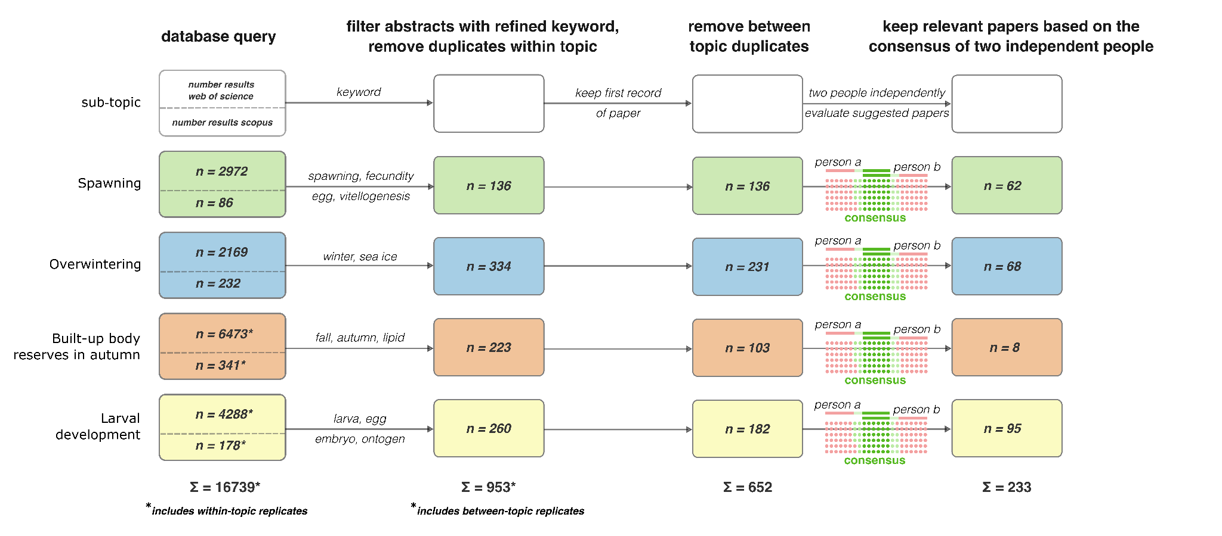
Figure 1. Description of the steps taken to screen literature to be included in the systematic review of krill recruitment subtopics.

Furthermore, duplicates within and between topics were removed from the literature list by matching the paper titles. If the same paper was listed under multiple topics, it was assigned to the first topic where it was found (topics were sorted alphabetically). Since all papers were later reviewed in the light of all sub-topics, no relevant information was lost this way. After removing all duplicates, the literature list was reduced to 652 entries. Next, both lead authors independently went through the literature list and classified each paper as “relevant” or “not relevant” according to the title and abstract. This was done since many of the 652 papers still contained information clearly irrelevant for the purpose of this study (e.g. many papers which dealt with krill lipids stemmed from aquaculture or pharmaceutical research where krill lipids are used in animal feed or for human consumption). The final selection was then defined as the consensus of both reviewers which means that a paper had to be independently classified as “relevant” twice, resulting in a total of 233 papers (Fig. 1). Final decisions are protocolled in an excel sheet stored in the GitHub repository mentioned above.

2.2 Conceptual model creation and mapping the data landscape
Numerical models for simulating krill population dynamics are highly diverse in structure, level of included detail, and are subject to ongoing innovation and development. Providing suites of parameters tailored to specific types of models is, therefore, not only beyond the scope of this study but likely not useful given the different data requirements of different models. Instead, we present a suite of conceptual models that were kept general and that incorporate fundamental mechanisms relevant for describing krill growth and life history within a bioenergetic framework. These processes (spawning, egg and larval development and overwintering) are key for simulating krill population dynamics and therefore, highly relevant for the general development of krill population models. The logic behind the three models is as follows:
- a mechanistic understanding of spawning and the size of the spawning stock provide the baseline information for the number of embryos that are being produced by a krill population
- egg and larval development determine the survival and abundance of larval krill before the onset of winter
- the overwintering of the summer cohort determines the number of recruits, which is an important metric for management

The three conceptual models focus on processes that maintain physiological activity, growth and reproduction of krill, but do not explicitly consider mortality. Therefore, we created an additional table that considers stage-specific drivers of krill mortality. In total, the three conceptual models and the mortality table consist of 120 sub-units/parameters, some of which are related to environmental drivers (such as respiration rates and temperature or photoperiod). We then screened the >2800 datapoints extracted from the systematic literature review and assigned the corresponding model sub-units to the datapoints. Some datapoints did not relate to any of the sub-units and were left blank, while others could relate to more than one sub-unit. In addition, we assigned an information category to characterize the type of information provided by the datapoint for the respective model sub-unit. The assigned information categories were: "parameter", "correlation", and "validation". The category "parameter" means that the data point represents a value that could be used directly as a model parameter. "Correlation" refers to the result of a correlation test that suggests a relationship between two variables, but could not be used directly as a model parameter, and "validation" refers to datapoints that could not be used directly as model parameters, but might still be useful to validate model predictions (such as krill abundance data). The boundaries between these information scores can sometimes be blurred and context-dependent, and we elaborate on this in the discussion.
With this approach, we outlined a “map of the data landscape” available to inform krill model development. By characterizing the amount and type of information available for the three different models, mortality and their respective sub-units, we identified existing data and information gaps that should be addressed by future research.

3. Results
3.1. The dataset obtained from the systematic literature review
The majority of the 233 studies came from the Antarctic Peninsula or Atlantic sector of the Southern Ocean (167 out of 233 studies), followed by the Central (16 studies) and Eastern Indian sectors (7 studies, Figure 2). In addition, most of the studies presented data from summer (110 studies) followed by fall (60 studies), winter (51 studies) and spring (33 studies).

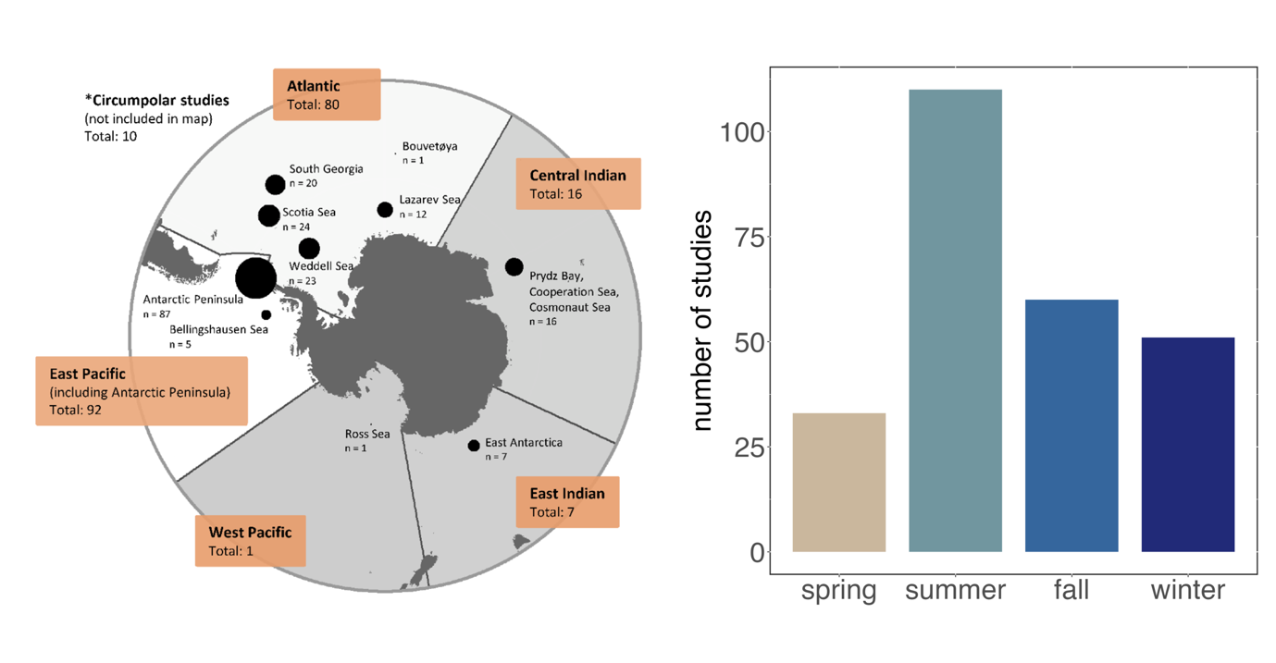
Figure 2 Left panel: Spatial distribution by ocean sector of the 233 studies that were assessed in the systematic literature review. Right panel: Seasonal distribution of the 233 studies.

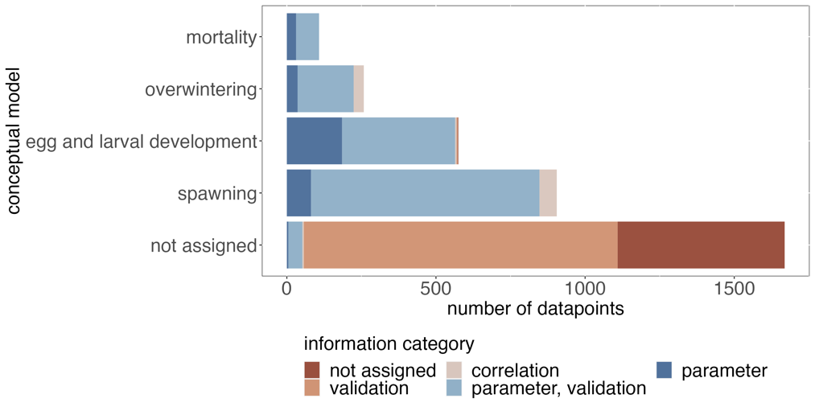
Each of the 233 papers was reviewed for datapoints relevant for describing/quantifying the applicable conceptual models and a total of 2883 datapoints were extracted from these studies. Since some of the datapoints were assigned to multiple sub-units of the conceptual models and mortality, the total number of sub-unit assignments was 3515. About 48% of the almost 3500 assignments were not related to any of the conceptual models (Figure 3). Of these 1669 data points, about two-thirds were classified as "validation" data, meaning that they may still be useful for validating model predictions, but do not directly contribute to their development. The majority of these data were krill abundance data from different habitats or regions. Of the conceptual models and mortality information, most assignments were made to "spawning", followed by "egg and larval development", "overwintering", and "mortality" (Figure 3). In each of these groups, the majority of data points were classified as "parameter, validation", meaning that they typically provided information that could be used either as a model parameter or as validation data of a model submechanism, depending on the model structure. Such data points typically provided information such as observations of growth rates that were reported in no functional relationship to other factors such as food availability or temperature. In addition, growth rates can be related not only to environmental conditions, but are the net outcome of the energy budget, and information at this level of detail (energy budgets) was rarely found. In summary, less than half of the data points were directly related to the sub-units of the three conceptual models and mortality, and most of those that were provided information that was not specific enough to act as stand-alone model parameters.
Figure 3 Number of datapoints that were assigned to each of the three conceptual models or to mortality.

3.2 Analyzing the data points assigned to each of the conceptual models
3.2.1 Spawning
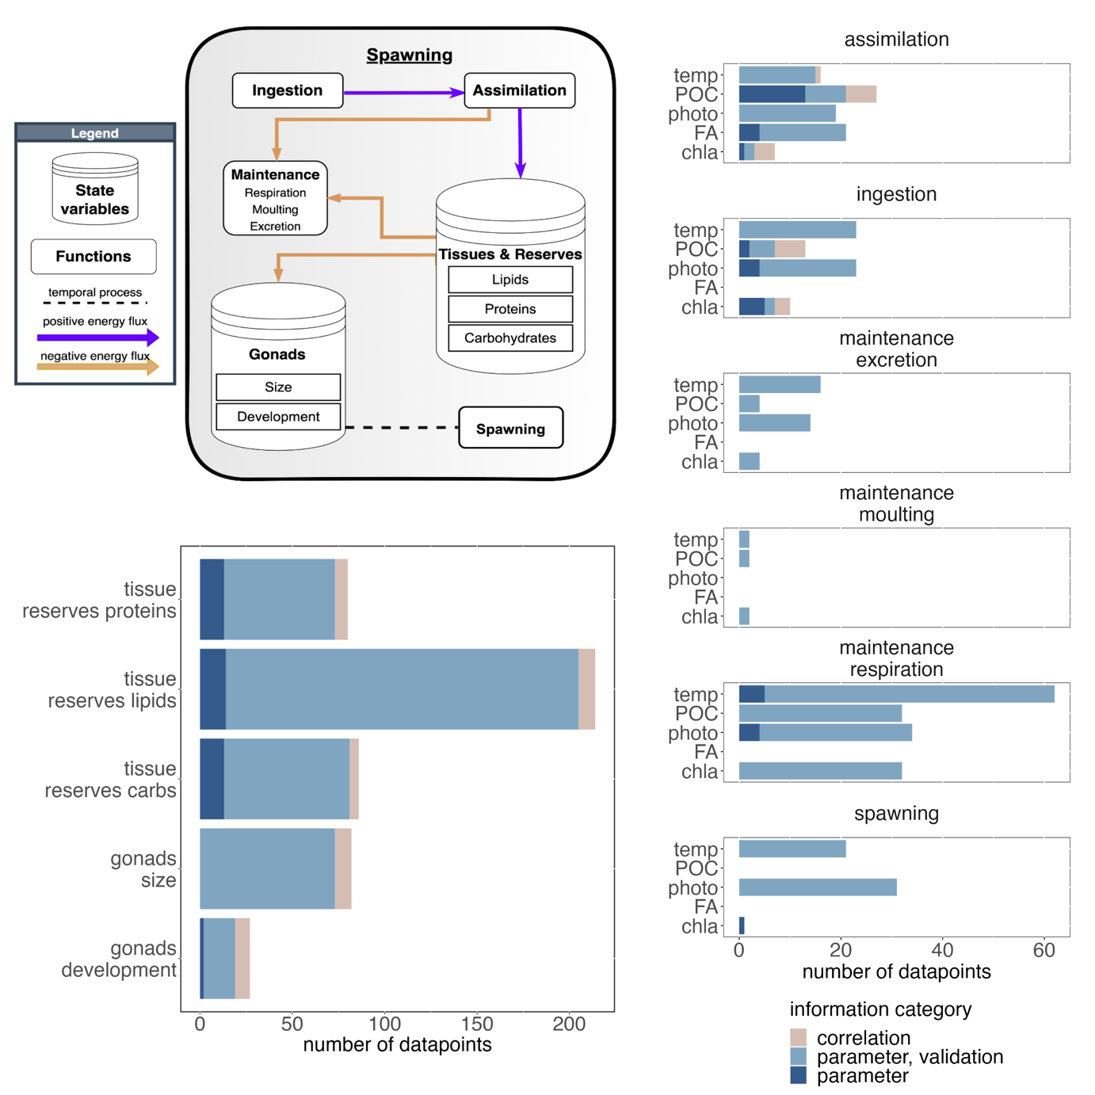
The conceptual model of spawning provides an overview of the key mechanisms that drive egg production and release (Figure 4). The box represents an individual krill, but could be scaled up to a population of adult female krill. In this conceptual model, the female krill is represented by its reserves, which are partitioned into lipids, proteins and carbohydrates, and its gonads, which are characterised by their size (or mass) and developmental stage. If other morphological information such as body length was required, it could be approximated using some of the many regression functions relating body length to carbon weight or total body weight. The partitioning of body reserves into lipids, proteins and carbohydrates recognises the importance of these components for gonadal and ovarian development. Essential fatty acids, often found in large diatoms, are essential for female krill to develop their gonads in spring and deficiencies can limit successful spawning. Female krill gonads follow an ovarian cycle, which was conceptualized by Kawaguchi et al. (2007). Depending on the stage of maturity within this cycle, there may be specific energetic requirements for gonad development that deplete krill reserves in different ways. The total number of released embryos is ultimately determined by the size/mass of the gonads at spawning and the number of spawnings the female is able to complete during the reproductive season.
Figure 4 Top left panel: Conceptual model for spawning. Bottom left panel: information categories of data points assigned to model sub-units that did not relate to environmental conditions. Right panel: information categories of data points assigned to model sub-units that related to environmental conditions. Abbreviations: temp – temperature, POC – particulate organic carbon, photo – photoperiod, FA – fatty acid composition food, chla – chlorophyll a

The reserves (lipids, proteins, carbohydrates) available to meet the energetic costs of spawning and maintenance are replenished by ingestion and assimilation of food and depleted by the amount allocated to gonad development, maintenance (respiration, moulting) and excretion. Metabolic rates such as ingestion, respiration or moulting often interact directly with environmental factors such as temperature, so we also screened the compiled dataset for data that could provide information on potential functional relationships.
A total of 905 data points were assigned to the conceptual model of spawning. Of those assigned to model sub-units that were not related to environmental factors, the majority related to lipid reserves of adult female krill during the spawning season. Eight times fewer data points were assigned to gonad development (27 data points for gonad development vs. 214 for lipid reserves) and slightly less than 100 data points related to protein and carbon reserves as well as gonad size (Figure 4). The minority of these data points provided correlational information and most were classified as “parameter, validation”, meaning that they typically did not provide information that could be used directly as parameters in functional relationships, but rather as reference values against which, for example, model predictions of krill lipid content could be validated.
Of the model sub-units that directly relate to environmental conditions, the highest number of data points were assigned to respiration, ingestion and assimilation. In these three sub-units, there was a comparatively high coverage of the different environmental factors such as temperature, POC, photoperiod, fatty acid composition of the food and chlorophyll a (Figure 4), with >20 datapoints assigned to most of them, respectively. Much less data points could be assigned to the environmental drivers of spawning, excretion, and especially moulting in dependence of environmental conditions. Similar to the model sub-units that did not relate to environmental drivers, the majority of the assigned data points had the information category “parameter, validation”, meaning that they typically could not be used as stand-alone model parameters.

3.2.2 Egg and larval development
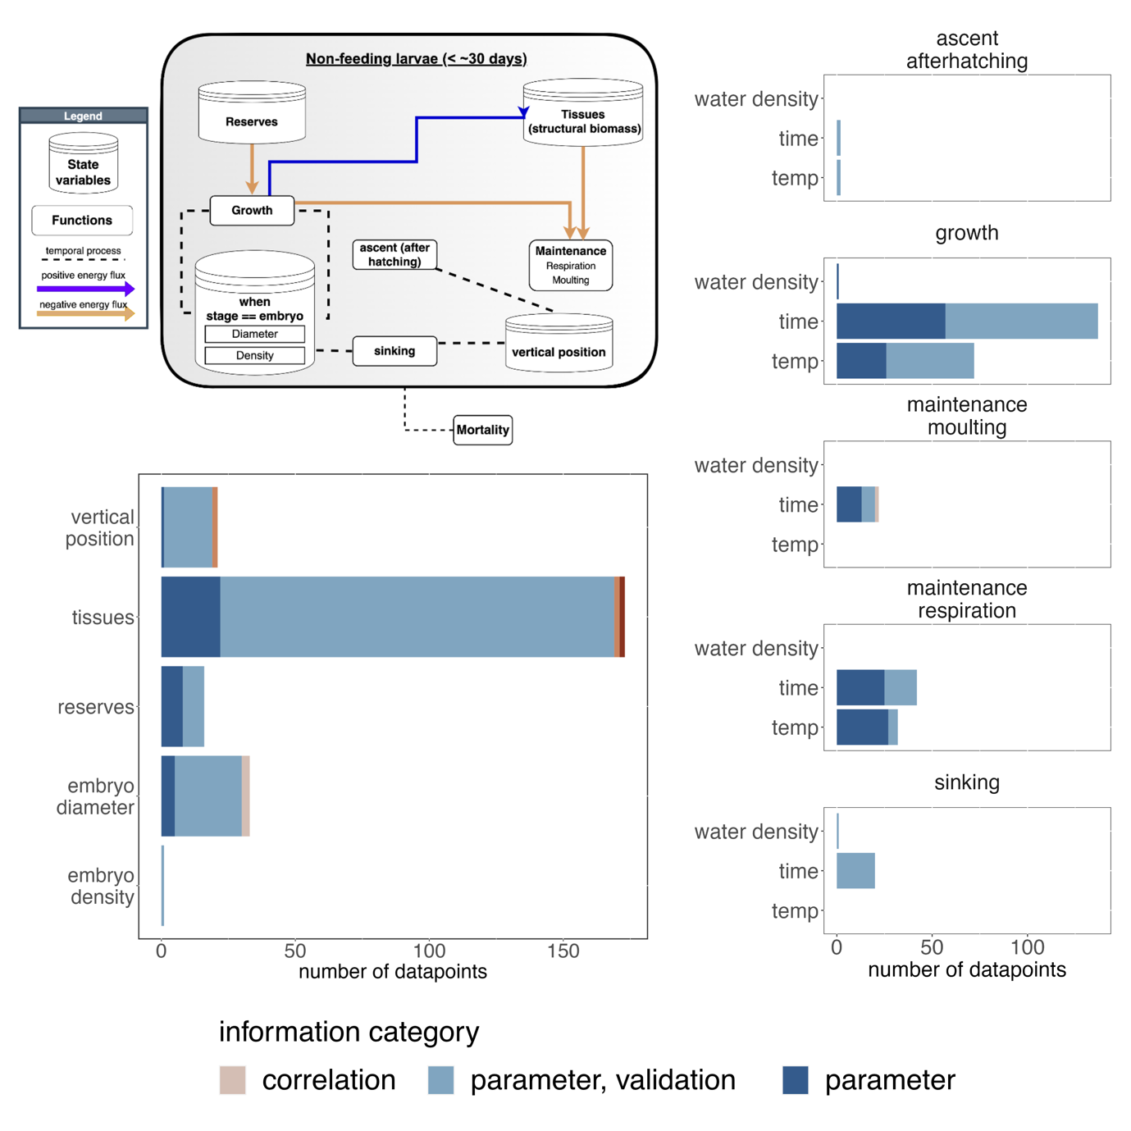
During spawning, mature female krill release embryos into the water column. These embryos do not yet feed, but instead metabolize internal reserves that were previously stored during the egg formation process (Figure 5). Immediately after spawning, the embryos begin to sink in the water column due to their negative buoyancy. The embryo diameter and density as well as the water density determine the rate of sinking, and therefore the range of environmental conditions experienced, which in turn drive developmental rate. Once the embryo is fully developed, it hatches and starts ascending the water column as a nauplius I larva. The nauplius I and its subsequent stages are non-feeding stages that still metabolize the energy reserves provided upon birth (Figure 5). While developing through the different nauplius stages, the larvae undergo an ascent in the water column. Mortality of non-feeding krill larvae is mainly determined by environmental conditions (e.g. unfavorable temperatures), local
Figure 5 Top left panel: conceptual model for egg and larval development. Bottom left panel: information categories of data points assigned to model sub-units that did not relate to environmental conditions. Right panel: information categories of data points assigned to model sub-units that related to environmental conditions. Abbreviations: temp – temperature

topography (increased mortality has been associated with shallow waters where the embryo reaches the sea floor before hatching), and predation. After reaching the metanauplius stage, the larvae begin to assimilate food from the environment. Although the time of reaching the metanauplius stage can be as early as summer, depending on the timing of spawning, the processes that drive growth and development of feeding krill larvae are covered in the conceptual model for overwintering (Figure 6).
In total, 575 data points were assigned to the conceptual model for egg and larval development. Similar to the other conceptual models, most of these data points were classified as “parameter, validation” although some sub-units such as time and temperature dependent growth or tissues had comparatively higher proportions of data points that had the highest information category “parameter” (up to 42% in case of time-dependent growth, Figure 5).
Less than 50 datapoints were assigned to vertical position of the embryo, its reserves as well as the embryo diameter. Only one data point was found that related to the density of embryos, which in combination with embryo diameter is important to determine sinking rates (Figure 5). Analogously, only 2 data points were assigned to the temperature, and time-dependent ascent of the nauplius I larva after hatching. 21 data points informing sinking rates could be found in the compiled dataset although 20 of them only reported sinking rates with no direct relation to embryo diameter, embryo density and water temperature. Whereas over 200 datapoints could be assigned to growth of the embryo, only 22 related to moulting, which is an important component in the growth of crustaceans. Time- and temperature dependent respiration rates were could be extracted from 42 and 33 data points, respectively, with the majority of datapoints being closely related to actual model parameters (“parameter” information category).

3.2.3 Overwintering
In contrast to adult krill, larval and juveniles do not accumulate significant amount of lipids in fall and rely on the uptake of food to meet maintenance costs throughout the winter. Therefore, the overwintering model includes similar mechanisms required for maintenance as the adult female spawning model in spring/summer. Maintenance functions such as respiration, moulting, and excretion imply energetic costs that are covered by assimilated food and available body reserves. Similar to the spawning conceptual model, reserves are partitioned into lipids, proteins and carbohydrates. The conceptual model structure is relatively simple, and it hides the complex interactions of the >1 year krill and the physical environment during winter. These interactions are considered in the physiological rates such as assimilation, ingestion and respiration, which were related to different environmental drivers such as the availability of sea ice biota or heterotrophic carbon as food sources (Figure 6).
Of the 258 data points that were assigned to overwintering, most (around 60) related to the lipid reserves of subadult krill during winter (Figure 6). Of these, most were classified as “parameter, validation”, meaning that many of the data were primarily useful for model validation but could not directly be used for the parameterization of lipid reserve dynamics. Less than half as many data points could be assigned to protein and carbon reserves (Figure 6).
A relatively similar number of data points related to physiological rates such as assimilation, ingestion, and respiration (42-58 data points). No data points were found related to moulting and excretion, which are listed in the conceptual model. Data related to assimilation, ingestion, and respiration were relatively common in the context of food availability in the form of particulate organic carbon, ice algae, or heterotrophic carbon. Physiological rates in direct relation to photoperiod, a potentially important factor in the physiological activity of adult krill, were reported in increased numbers for respiration (n = 13, Figure 2), but less so for ingestion or assimilation (n = 5, n = 0, respectively).
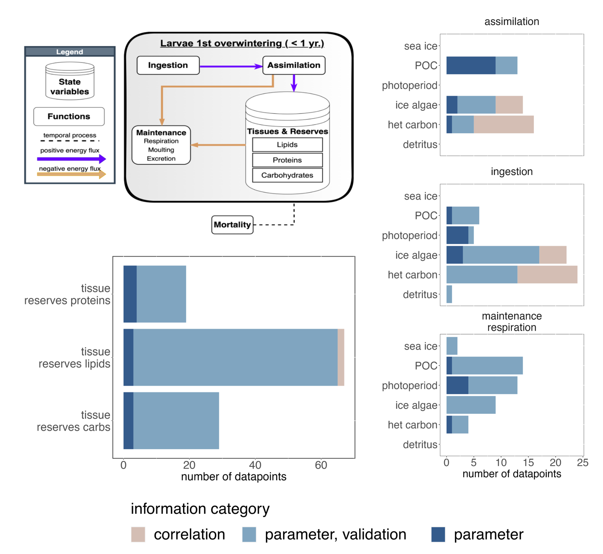
Figure 6 Top left panel: conceptual model for the overwintering of the <1 year age class. Bottom left panel: information categories of data points assigned to model sub-units that did not relate to environmental conditions. Right panel: information categories of data points assigned to model sub-units that related to environmental conditions. Abbreviations: POC – particulate organic carbon, het carbon – heterotrophic carbon

3.2.4 Mortality
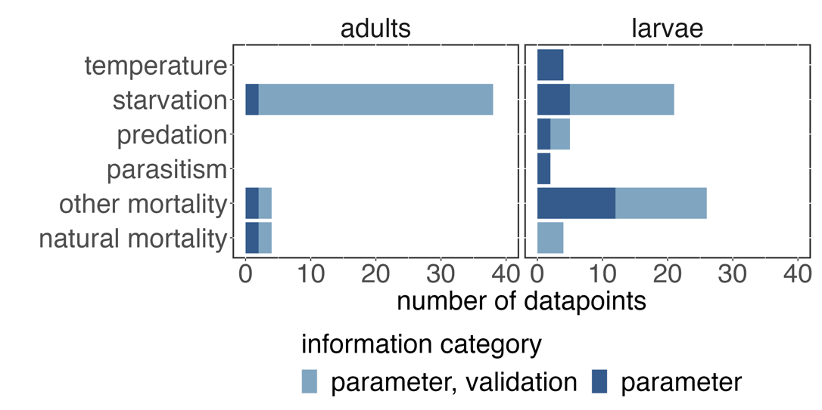
The conceptual models analyzed in the previous subsections included mechanisms responsible for maintenance and reproduction in different life-history stages of krill. However, population dynamics are a result of the balance between reproduction, survival and mortality, and therefore we also examined the compiled dataset for data points that could be related to
Figure 7 Data points assigned to different drivers of mortality for adult and larval krill

the drivers of mortality for adult and larval krill. parameterization of stage-specific drivers of krill mortality (Figure 7). Within the compiled dataset, no data points informed thermal tolerance, predation mortality, or parasitism mortality in adult krill. The dataset yielded four data points related to estimates of natural mortality rates in adults, and starvation mortality was the most commonly studied mechanism with a total of 38 data points. For larvae, most data points could be assigned to starvation and other mortality, which included information on mortality risks from UV radiation or critical partial pressure. About 5 data points could be assigned to the thermal tolerance of larval krill as well as predation risk, parasitism and natural mortality.

4. Discussion
In our study, we developed three conceptual models that incorporate important mechanisms of stage-dependent maintenance, reproduction and mortality of krill, which are key drivers of recruitment and population dynamics. In addition, we conducted a systematic literature review to extract nearly 2900 data points from 233 studies that could be used to inform the practical development of krill growth, recruitment and population dynamics models. These data points were then mapped to the sub-units of the three conceptual models and to different sources of mortality to identify important mechanisms with sparse information.
Before discussing the results of our analysis, it is important to note some of the caveats associated with our approach. Most importantly, the number of data points that can be attributed to individual model mechanisms is certainly an imperfect measure of uncertainty or state of knowledge. Some data points may be more informative than others, and some may represent single observations while others represent summary statistics of many samples. Nevertheless, the number of available data points is indicative of the empirical effort that has been made to investigate specific model mechanisms, and we have attempted to address the information value problem by introducing additional criteria that give some indication of the information quality of different data points. In addition, having many observations to parameterize different model mechanisms helps to obtain uncertainty estimates, which are critical for robust model predictions (Bahlburg et al. 2023).
Another issue was the manual assignment of data points to model subunits. This process was done independently by the two corresponding authors to account for individual biases, and a comparison of the initial assignments revealed considerable differences in the interpretation of the data points. While might be an indication that there is often no direct link between empirical data and model mechanisms, it also means that the results are likely to contain some bias. We attempted to address this issue by iterating through the data point assignments after several consultations to reach consensus. Finally, agreeing on the three conceptual models and their structure was not straightforward. Depending on individual backgrounds, different mechanisms may be considered more relevant than others, and the models presented in this study represent one, arguably incomplete, option of how they might be structured. We acknowledge that different structures of the conceptual models are possible, but we have tried to include as many mechanisms as possible to still allow for meaningful analysis within the scope of this study.
The most striking feature of the dataset was that nearly half of the extracted data points were not related to any of the 120 model sub-units suitable for model development, and the majority of the data points would not be useful as stand-alone model parameters. Although krill recruitment and population dynamics have always been important topics in krill research (e.g. De La Mare 1994; Siegel and Loeb 1995; Murphy et al. 1998; Quetin and Ross 2003; Wiedenmann et al. 2009; Meyer et al. 2020; Conroy et al. 2020), and mechanistic krill models have existed for more than 20 years (Hofmann et al. 1992; Hofmann and Lascara 2000; Fach et al. 2002), the collection of empirical data is often not done with data requirements for model development in mind. This is certainly a two-way problem, with modelers not communicating their data needs clearly enough, or not participating in field research, and empirical researchers not taking model development into account when designing experiments and field campaigns. Organizing workshops that bring together modelers and empiricists, such as the ICED workshop on which this study is based (Murphy et al. 2022), is important to improve the coordination between the different disciplines and hopefully lead to more compatible future study designs.
The analysis of the data associated with the spawning conceptual model identified a "low data status" for mechanisms related to gonad development, excretion, moulting, and mechanisms leading to spawning. The functional relationships between body size, feeding history and timing of spawning are critical for predicting the spawning output of the adult female population, which sets the baseline conditions for the development of recruits. Simplistic approaches, such as predicting egg production as a function of body size, as done in the mechanistic growth models of Jager and Ravagnan (2015) and Bahlburg et al. (2021), ignore known drivers of reproductive success, such as intake of critical fatty acids (Yoshida 2009; Schmidt et al. 2012; Steinke et al. 2022), and thus cannot reproduce the high variability observed in the body length-fecundity relationship (Kawaguchi 2016). Models that allow for flexible spawning output (e.g. the model of Constable and Kawaguchi (2018)), still do not consider the importance of lipids or fatty acids. Our analysis also shows that this is not only a problem of existing models, but that empirical data that would directly support the conceptualization and especially the parameterization of such processes are sparse.
Moulting was another process that had relatively few data points assigned to it. To date, two functions have been published that predict krill moulting frequency in dependence of environmental conditions (Tarling et al. 2006; Kawaguchi et al. 2006). However, a recent analysis showed that the two functions produce different results for a range of environmental conditions (Bahlburg et al. 2023), and more observations are needed to increase the robustness of our understanding of the drivers of moulting. This is important because moulting is not only a process that drives growth and implies energetic costs, but also plays an important role in the maturity cycle of krill (Kawaguchi et al. 2007; Constable and Kawaguchi 2018).
The development of non-feeding larvae was a conceptual model that had a relatively large number of data points assigned to it, although it captures only a relatively short period in the life history of krill. Much of the early development of embryos and non-feeding larvae is synthesized in the mechanistic model of Hofmann et al. (1992), which has been applied in later studies to explore larval krill development and advection at different scales and habitats (Hofmann and Hüsrevoğlu 2003; Piñones and Fedorov 2016; Thorpe et al. 2019). This model provides a relatively complete description of the development from embryo to feeding larval stages but its predictions are sensitive on the initial embryo size, which can vary by more than 50 μm between years (e.g. embryo diameters ranged from 576-627 μm in Quetin and Ross (2001)). Given the relatively large number of observations for this period in the life history of krill, a re-evaluation of the model of Hofmann et al. (1992) with updated data and uncertainty estimates may be a useful future step to address the sensitivities of the current model configuration.
The overwintering of krill recruits was the conceptual model that the fewest number of data points was assigned to. Lowe et al. (2012) developed the only existing mechanistic model that specifically simulated the development of larval krill during winter. However, this model is based on experimental work from the Western Antarctic Peninsula, which means that it might be region-specific and unfortunately, no source is available to apply this model in new contexts. The paucity of information during winter is a result of logistical challenges, but it is critical because winter is often considered a bottleneck for krill population dynamics due to the harsh environment and scarcity of food. Most other existing growth models that cover the entire seasonal range (Jager and Ravagnan 2015; Ryabov et al. 2017; Constable and Kawaguchi 2018; Bahlburg et al. 2021) do so by making relatively simple assumptions about the overwintering physiology of larval and adult krill although the model of Bahlburg et al. (2021) attempted to add more detail. Most of these models include seasonal switches that reduce winter metabolism to a fixed fraction of summer metabolism for a fixed period of time, which does not account for the diversity of overwintering strategies observed in different krill habitats, that can cover a wide range of latitudes and environmental conditions (Tarling 2020). Meyer et al. (2002) provided an important overview of overwintering strategies of larval krill, but many questions remain, particularly about feeding ecology and habitat requirements. For example, photoperiod was the environmental factor with the least number of data points assigned to in the context of physiological functions of krill during winter. However, photoperiod may be the key cue for the entrainment of endogenous clocks that synchronize physiological functions of krill with environmental conditions (Teschke et al. 2011; Biscontin et al. 2017; Piccolin et al. 2018), which would have great impact on model predictions (Groeneveld et al. 2015). Recent research has addressed knowledge gaps regarding the winter feeding ecology and development (Bernard et al. 2022; Steinke et al. 2022), but further studies, possibly in close coordination with modelers, could be of great value in developing better informed models.
Finally, we also screened the compiled dataset for information relating to different drivers of krill mortality. Mortality contained the group of sub-units to which the least number of data points were assigned. Our analysis showed that there are comparatively many data points that address starvation mortality in larval and adult krill. Data points assigned to temperature-induced mortality were much less frequent, but may also be of minor importance for adult krill, except in their northern distribution range in the South Georgia regions, where krill might face water temperatures outside their thermal tolerance (Michael et al. 2021). The role of parasitism or diseases for krill mortality are largely unknown and almost no information relating to these factors could be found. On the other hand, predation mortality will play an important role for krill populations but not many data points could be found in our dataset that could be used to parameterize this process in mechanistic models. Past modelling studies have addressed krill consumption by predators (Mori and Butterworth 2006) but the results are rarely transferrable into more regional contexts and lack the detail, such as the roles of sea ice or swarming behaviour to reduce predation risk, that might be required in simulation studies. A final and increasingly important source of krill mortality is commercial fishing. However, since catch quotas are set by CCAMLR and vessel-specific landings and locations are known, this source of mortality is well quantified.

Modelling krill in the face of uncertainty
Our analysis identified mechanisms that are important for modelling krill population dynamics, but for which little data are available for model development and parameterization. These mechanisms would benefit most from new experiments and field studies that are more closely aligned with the data needs of the modelling community.
However, conducting such studies is expensive, time-consuming, and sometimes impossible, and it is also clear that not all studies can and should be tailored to the needs of modellers. It is the responsibility of modellers to explore approaches that can produce robust results despite the existing unknowns. One of these approaches can be qualitative models, which do not rely on specific parameter values, but rather assume relationships between different model entities and their direction (positive, negative, neutral). Qualitative models allow to explore the sensitivity of simulation results to competing hypotheses and Sylvester et al. (2023) demonstrate the use of such model to predict the future overwinter survival of krill larvae. The work of Sylvester et al. (2023) was developed as a complementary study to this one and represents the second output of the ICED modelling workshop.
When functional relationships are unknown or cannot be parameterized, statistical modelling approaches that fit observations to environmental drivers (using Bayesian or frequentist techniques) or hybrids of mechanistic and regression models can be useful for making predictions in the absence of mechanistic understanding of all relevant processes. However, special care should be taken when extrapolating such models outside the range of data with which they were parameterized.
Another approach could be to use model ensemble runs to reduce the specificity of simulation results to individual model design choices and to include the expected variance that is introduced by the spatial and temporal specificity of the individual models. In general, future modelling studies should make uncertainty estimates more explicit and investigate the robustness of their simulation results to these. A recent krill growth model comparison project analyzed the sensitivity of simulation results to different krill growth models of choice and found strong differences between models (Bahlburg et al. 2023). While the study only considered inter-model variance, intra-model variance due to uncertainties in parameter estimates will be equally important. Murphy et al. (2017) conducted a sensitivity analysis of their results to different parameter constellations in their model, and we argue that this should be more common in future modelling studies, potentially even as a core component of the analysis. While this will not close the existing knowledge gaps, it will at least allow to explicitly acknowledge the uncertainties associated with existing krill models.

Data statement
The R code used for processing the krill literature data and data visualization can be accessed under https://github.com/dbahlburg/Paper1UncertaintiesRecruitment. We used the following packages for data processing and visualization: […]. The full dataset compiled from the reviewed literature is available under https://docs.google.com/spreadsheets/d/1IQIxcE-LpCL4RjPTmSA9AlcQQCC58IcnplSyOeRQoGs/edit?usp=sharing

Author Contributions
AB and DB led the conceptualization, coordination and data analysis of this project as well as the writing of the manuscript. In addition, SH, DG, DOS, CL, ER and AR contributed to the development of the conceptual models and data analysis. All authors participated in the development of the study concept, reviewed the selected krill literature, provided feedback on the study design and analysis at intermediate stages, and contributed to the writing.

Funding
DB received funding from the German Research Foundation (DFG, grant number 411096565).

Conflict of Interest
The authors declare no conflict of interest

Acknowledgments

References
Atkinson, Angus, Rachael S. Shreeve, Andrew G. Hirst, Peter Rothery, Geraint A. Tarling, David W. Pond, Rebecca E. Korb, Eugene J. Murphy, and Jonathon L. Watkins. 2006. “Natural Growth Rates in Antarctic Krill (Euphausia Superba): II. Predictive Models Based on Food, Temperature, Body Length, Sex, and Maturity Stage.” Limnology and Oceanography 51 (2): 973–87. https://doi.org/10.4319/lo.2006.51.2.0973.
Bahlburg, Dominik, Bettina Meyer, and Uta Berger. 2021. “The Impact of Seasonal Regulation of Metabolism on the Life History of Antarctic Krill.” Ecological Modelling 442 (January). https://doi.org/10.1016/j.ecolmodel.2021.109427.
Bahlburg, Dominik, Sally Thorpe, Bettina Meyer, Uta Berger, and Eugene Murphy. 2023. “Intercomparison of Growth Models for Antarctic Krill ( Euphausia Superba ): Towards a Generalised Understanding.” Preprint. Ecology. https://doi.org/10.1101/2023.05.09.540012.
Bernard, Kim S., Kirsten B. Steinke, and Julia M. Fontana. 2022. “Winter Condition, Physiology, and Growth Potential of Juvenile Antarctic Krill.” Frontiers in Marine Science 9. https://www.frontiersin.org/articles/10.3389/fmars.2022.990853.
Biscontin, Alberto, Thomas Wallach, Gabriele Sales, Astrid Grudziecki, Leonard Janke, Elena Sartori, Cristiano Bertolucci, et al. 2017. “Functional Characterization of the Circadian Clock in the Antarctic Krill, Euphausia Superba.” Scientific Reports 7 (1): 17742. https://doi.org/10.1038/s41598-017-18009-2.
Cavan, E. L., A. Belcher, A. Atkinson, S. L. Hill, S. Kawaguchi, S. McCormack, B. Meyer, et al. 2019. “The Importance of Antarctic Krill in Biogeochemical Cycles.” Nature Communications 10 (1): 4742. https://doi.org/10.1038/s41467-019-12668-7.

Conroy, John A, Christian S Reiss, Miram R Gleiber, and Deborah K Steinberg. 2020. “Linking Antarctic Krill Larval Supply and Recruitment along the Antarctic Peninsula.” Integrative and Comparative Biology 60 (6): 1386–1400. https://doi.org/10.1093/icb/icaa111.
Constable, Andrew John, and So Kawaguchi. 2018. “Modelling Growth and Reproduction of Antarctic Krill, Euphausia Superba, Based on Temperature, Food and Resource Allocation amongst Life History Functions.” Edited by Stéphane Plourde. ICES Journal of Marine Science 75 (2): 738–50. https://doi.org/10.1093/icesjms/fsx190.
Cresswell, Katherine A., Geraint A. Tarling, Sally E. Thorpe, Michael T. Burrows, John Wiedenmann, and Marc Mangel. 2009. “Diel Vertical Migration of Antarctic Krill (Euphausia Superba) Is Flexible during Advection across the Scotia Sea.” Journal of Plankton Research 31 (10): 1265–81. https://doi.org/10.1093/plankt/fbp062.
De La Mare, William K. 1994. “Modelling Krill Recruitment.” CCAMLR Science 1: 49–54.
Fach, Ba, Ee Hofmann, and Ej Murphy. 2002. “Modeling Studies of Antarctic Krill Euphausia Superba Survival during Transport across the Scotia Sea.” Marine Ecology Progress Series 231: 187–203. https://doi.org/10.3354/meps231187.
Fach, Bettina A., Bettina Meyer, Dieter Wolf-Gladrow, and Ulrich Bathmann. 2008. “Biochemically Based Modeling Study of Antarctic Krill Euphausia Superba Growth and Development.” Marine Ecology Progress Series 360 (May): 147–61. https://doi.org/10.3354/meps07366.
Flores, H. et al. (2012) ‘Impact of climate change on Antarctic krill’, Marine Ecology Progress Series, 458, pp. 1–19. doi: 10.3354/meps09831.
Green, David B., Sophie Bestley, Stuart P. Corney, Rowan Trebilco, Patrick Lehodey, and Mark A. Hindell. 2021. “Modeling Antarctic Krill Circumpolar Spawning Habitat Quality to Identify Regions With Potential to Support High Larval Production.” Geophysical Research Letters 48 (12): e2020GL091206. https://doi.org/10.1029/2020GL091206.
Groeneveld, Jürgen, Karin Johst, So Kawaguchi, Bettina Meyer, Mathias Teschke, and Volker Grimm. 2015. “How Biological Clocks and Changing Environmental Conditions Determine Local Population Growth and Species Distribution in Antarctic Krill (Euphausia Superba): A Conceptual Model.” Ecological Modelling 303 (May): 78–86. https://doi.org/10.1016/j.ecolmodel.2015.02.009.
Hill, Simeon L., Tony Phillips, and Angus Atkinson. 2013. “Potential Climate Change Effects on the Habitat of Antarctic Krill in the Weddell Quadrant of the Southern Ocean.” PLOS ONE 8 (8): e72246. https://doi.org/10.1371/journal.pone.0072246.
Hofmann, Ee, and Cm Lascara. 2000. “Modeling the Growth Dynamics of Antarctic Krill Euphausia Superba.” Marine Ecology Progress Series 194: 219–31. https://doi.org/10.3354/meps194219.
Hofmann, Eileen E., Jorge E. Capella, Robin M. Ross, and Langdon B. Quetin. 1992. “Models of the Early Life History of Euphausia Superba—Part I. Time and Temperature Dependence during the Descent-Ascent Cycle.” Deep Sea Research Part A. Oceanographic Research Papers 39 (7): 1177–1200. https://doi.org/10.1016/0198-0149(92)90063-Y.
Hofmann, Eileen E, and Yusuf Sinan Hüsrevoğlu. 2003. “A Circumpolar Modeling Study of Habitat Control of Antarctic Krill (Euphausia Superba) Reproductive Success.” Deep Sea Research Part II: Topical Studies in Oceanography, The US JGOFS Synthesis and Modeling Project: Phase II, 50 (22): 3121–42. https://doi.org/10.1016/j.dsr2.2003.07.012.
Jager, T, and E Ravagnan. 2015. “Parameterising a Generic Model for the Dynamic Energy Budget of Antarctic Krill Euphausia Superba.” Marine Ecology Progress Series 519 (January): 115–28. https://doi.org/10.3354/meps11098.
Johnston, N. M. et al. (2022) ‘Status, change and futures of zooplankton in the Southern Ocean’, Frontiers in Marine Science, 9(June). doi: 10.3389/fevo.2021.624692.
Kawaguchi, S, Sg Candy, R King, M Naganobu, and S Nicol. 2006. “Modelling Growth of Antarctic Krill. I. Growth Trends with Sex, Length, Season, and Region.” Marine Ecology Progress Series 306 (January): 1–15. https://doi.org/10.3354/meps306001.
Kawaguchi, So. 2016. “Reproduction and Larval Development in Antarctic Krill (Euphausia Superba).” In Biology and Ecology of Antarctic Krill, edited by Volker Siegel, 225–46. Advances in Polar Ecology. Cham: Springer International Publishing. https://doi.org/10.1007/978-3-319-29279-3_6.
Kawaguchi, So, Toshihiro Yoshida, Luke Finley, Paul Cramp, and Stephen Nicol. 2007. “The Krill Maturity Cycle: A Conceptual Model of the Seasonal Cycle in Antarctic Krill.” Polar Biology 30 (6): 689–98. https://doi.org/10.1007/s00300-006-0226-2.
Kawaguchi, So, Bettina Meyer, Jack Conroy, Haiting Zhang, and Emilce Florencia Rombolá. 2022. “Antarctic Krill and Its Fishery: Current Status and Challenges.” https://doi.org/10.48361/B1VP-MT19.
Lehette, Pascal, Antonio Tovar-Sánchez, Carlos M. Duarte, and Santiago Hernández-León. 2012. “Krill Excretion and Its Effect on Primary Production.” Marine Ecology Progress Series 459 (July): 29–38. https://doi.org/10.3354/meps09746.
Lowe, Alexander T., Robin M. Ross, Langdon B. Quetin, Maria Vernet, and Christian H. Fritsen. 2012. “Simulating Larval Antarctic Krill Growth and Condition Factor during Fall and Winter in Response to Environmental Variability.” Marine Ecology Progress Series 452 (April): 27–43. https://doi.org/10.3354/meps09409.
McBride, M. M. et al. (2021) ‘Antarctic krill Euphausia superba: spatial distribution, abundance, and management of fisheries in a changing climate’, Marine Ecology Progress Series, 668, pp. 185–214. doi: 10.3354/meps13705.
Meyer, B., A. Atkinson, D. Stöbing, B. Oettl, W. Hagen, and U. V. Bathmann. 2002. “Feeding and Energy Budgets of Antarctic Krill Euphausia Superba at the Onset of Winter—I. Furcilia III Larvae.” Limnology and Oceanography 47 (4): 943–52. https://doi.org/10.4319/lo.2002.47.4.0943.
Meyer, Bettina, Angus Atkinson, Kim S. Bernard, Andrew S. Brierley, Ryan Driscoll, Simeon L. Hill, Enrique Marschoff, et al. 2020. “Successful Ecosystem-Based Management of Antarctic Krill Should Address Uncertainties in Krill Recruitment, Behaviour and Ecological Adaptation.” Communications Earth & Environment 1 (1): 1–12. https://doi.org/10.1038/s43247-020-00026-1.
Michael, Katharina, Lavinia A. Suberg, Wiebke Wessels, So Kawaguchi, and Bettina Meyer. 2021. “Facing Southern Ocean Warming: Temperature Effects on Whole Animal Performance of Antarctic Krill (Euphausia Superba).” Zoology 146 (June): 125910. https://doi.org/10.1016/j.zool.2021.125910.
Mori, M, and D S Butterworth. 2006. “A First Step towards Modelling the Krill–Predator Dynamics of the Antarctic Ecosystem.” CCAMLR Sci 13: 217–77.
Murphy, E. J., J. L. Watkins, K. Reid, P. N. Trathan, I. Everson, J. P. Croxall, J. Priddle, M. A. Brandon, A. S. Brierley, and E. Hofmann. 1998. “Interannual Variability of the South Georgia Marine Ecosystem: Biological and Physical Sources of Variation in the Abundance of Krill.” Fisheries Oceanography 7 (3–4): 381–90. https://doi.org/10.1046/j.1365-2419.1998.00081.x.
Murphy, Eugene, Corney, Stuart, Hofmann, Eileen, Meyer, Bettina, Johnston, Nadine, Thorpe, Sally, Brooks, Cassandra, et al. 2022. “Using Models to Improve Our Understanding of Antarctic Krill and Their Ecological Role in the Southern Ocean.” Zenodo. https://doi.org/10.5281/ZENODO.6780069.
Murphy, Eugene J., Sally E. Thorpe, Geraint A. Tarling, Jonathan L. Watkins, Sophie Fielding, and Philip Underwood. 2017. “Restricted Regions of Enhanced Growth of Antarctic Krill in the Circumpolar Southern Ocean.” Scientific Reports 7 (July): 6963. https://doi.org/10.1038/s41598-017-07205-9.
Pakhomov, E. A., P. W. Froneman, and R. Perissinotto. 2002. “Salp/Krill Interactions in the Southern Ocean: Spatial Segregation and Implications for the Carbon Flux.” Deep Sea Research Part II: Topical Studies in Oceanography, The Southern Ocean I: Climatic Changes in the Cycle of Carbon in the Southern Ocean, 49 (9): 1881–1907. https://doi.org/10.1016/S0967-0645(02)00017-6.
Perissinotto, R., E. A. Pakhomov, C. D. McQuaid, and P. W. Froneman. 1997. “In Situ Grazing Rates and Daily Ration of Antarctic Krill Euphausia Superba Feeding on Phytoplankton at the Antarctic Polar Front and the Marginal Ice Zone.” Marine Ecology Progress Series 160 (December): 77–91. https://doi.org/10.3354/meps160077.
Piccolin, Fabio, Lavinia Suberg, Robert King, So Kawaguchi, Bettina Meyer, and Mathias Teschke. 2018. “The Seasonal Metabolic Activity Cycle of Antarctic Krill (Euphausia Superba): Evidence for a Role of Photoperiod in the Regulation of Endogenous Rhythmicity.” Frontiers in Physiology 9. https://www.frontiersin.org/articles/10.3389/fphys.2018.01715.
Pietzsch, Bruno Walter, Aaron Schmidt, Jürgen Gröneveld, Dominik Bahlburg, Bettina Meyer, and Uta Berger. 2022. “The Impact of Salps on the Antarctic Krill Population - An Individual-Based Modelling Study.” Preprint. In Review. https://doi.org/10.21203/rs.3.rs-2271484/v1.
Piñones, Andrea, and Alexey V. Fedorov. 2016. “Projected Changes of Antarctic Krill Habitat by the End of the 21st Century.” Geophysical Research Letters 43 (16): 8580–89. https://doi.org/10.1002/2016GL069656.
Quetin, Langdon B., and Robin M. Ross. 2001. “Environmental Variability and Its Impact on the Reproductive Cycle of Antarctic Krill1.” American Zoologist 41 (1): 74–89. https://doi.org/10.1093/icb/41.1.74.
———. 2003. “Episodic Recruitment in Antarctic Krill Euphausia Superba in the Palmer LTER Study Region.” Marine Ecology Progress Series 259 (September): 185–200. https://doi.org/10.3354/meps259185.
Ratnarajah, Lavenia, and Andrew R. Bowie. 2016. “Nutrient Cycling: Are Antarctic Krill a Previously Overlooked Source in the Marine Iron Cycle?” Current Biology 26 (19): R884–87. https://doi.org/10.1016/j.cub.2016.08.044.
Richerson, Kate, George M. Watters, Jarrod A. Santora, Isaac D. Schroeder, and Marc Mangel. 2015. “More than Passive Drifters: A Stochastic Dynamic Model for the Movement of Antarctic Krill.” Marine Ecology Progress Series 529 (June): 35–48. https://doi.org/10.3354/meps11324.
Ryabov, Alexey B., André M. de Roos, Bettina Meyer, So Kawaguchi, and Bernd Blasius. 2017. “Competition-Induced Starvation Drives Large-Scale Population Cycles in Antarctic Krill.” Nature Ecology & Evolution 1 (7): 1–8. https://doi.org/10.1038/s41559-017-0177.
Schmidt, Katrin, Angus Atkinson, Hugh J. Venables, and David W. Pond. 2012. “Early Spawning of Antarctic Krill in the Scotia Sea Is Fuelled by ‘Superfluous’ Feeding on Non-Ice Associated Phytoplankton Blooms.” Deep Sea Research Part II: Topical Studies in Oceanography, DISCOVERY 2010: Spatial and Temporal Variability in a Dynamic Polar Ecosystem, 59–60 (January): 159–72. https://doi.org/10.1016/j.dsr2.2011.05.002.
Siegel, V, and V Loeb. 1995. “Recruitment of Antarctic Krill Euphausia Superba and Possible Causes for Its Variability.” Marine Ecology Progress Series 123: 45–56. https://doi.org/10.3354/meps123045.
Steinke, Kirsten B., Kim S. Bernard, Julia M. Fontana, Louise A. Copeman, and Lani M. Garcia. 2022. “The Energetic Cost of Early Reproductive Development in Juvenile Antarctic Krill at the Western Antarctic Peninsula.” Frontiers in Marine Science 9 (December): 1009385. https://doi.org/10.3389/fmars.2022.1009385.
Sylvester, Zephyr T., Matthew C. Long, and Cassandra M. Brooks. 2021. “Detecting Climate Signals in Southern Ocean Krill Growth Habitat.” Frontiers in Marine Science 8. https://www.frontiersin.org/articles/10.3389/fmars.2021.669508.
Tarling, Geraint A. 2020. “Routine Metabolism of Antarctic Krill (Euphausia Superba) in South Georgia Waters: Absence of Metabolic Compensation at Its Range Edge.” Marine Biology 167 (8): 108. https://doi.org/10.1007/s00227-020-03714-w.
Tarling, Geraint A., Rachael S. Shreeve, Andrew G. Hirst, Angus Atkinson, Dave W. Pond, Eugene J. Murphy, and Jon L. Watkins. 2006. “Natural Growth Rates in Antarctic Krill (Euphausia Superba): I. Improving Methodology and Predicting Intermolt Period.” Limnology and Oceanography 51 (2): 959–72. https://doi.org/10.4319/lo.2006.51.2.0959.
Teschke, Mathias, Sabrina Wendt, So Kawaguchi, Achim Kramer, and Bettina Meyer. 2011. “A Circadian Clock in Antarctic Krill: An Endogenous Timing System Governs Metabolic Output Rhythms in the Euphausid Species Euphausia Superba.” PLOS ONE 6 (10): e26090. https://doi.org/10.1371/journal.pone.0026090.
Thorpe, Sally E., Geraint A. Tarling, and Eugene J. Murphy. 2019. “Circumpolar Patterns in Antarctic Krill Larval Recruitment: An Environmentally Driven Model.” Marine Ecology Progress Series 613 (March): 77–96. https://doi.org/10.3354/meps12887.
Veytia, Devi, Stuart Corney, Klaus M. Meiners, So Kawaguchi, Eugene J. Murphy, and Sophie Bestley. 2020. “Circumpolar Projections of Antarctic Krill Growth Potential.” Nature Climate Change 10 (6): 568–75. https://doi.org/10.1038/s41558-020-0758-4.Warwick-Evans, V., N. Kelly, L. Dalla Rosa, A. Friedlaender, J. T. Hinke, J. H. Kim, N. Kokubun, et al. 2022. “Using Seabird and Whale Distribution Models to Estimate Spatial Consumption of Krill to Inform Fishery Management.” Ecosphere 13 (6): e4083. https://doi.org/10.1002/ecs2.4083.
Whitehouse, M. J., A. Atkinson, P. Ward, R. E. Korb, P. Rothery, and S. Fielding. 2009. “Role of Krill versus Bottom-up Factors in Controlling Phytoplankton Biomass in the Northern Antarctic Waters of South Georgia.” Marine Ecology Progress Series 393 (October): 69–82. https://doi.org/10.3354/meps08288.

Wiedenmann, J, K Cresswell, and M Mangel. 2008. “Temperature-Dependent Growth of Antarctic Krill: Predictions for a Changing Climate from a Cohort Model.” Marine Ecology Progress Series 358 (April): 191–202. https://doi.org/10.3354/meps07350.
Wiedenmann, John, Katherine A. Cresswell, and Marc Mangel. 2009. “Connecting Recruitment of Antarctic Krill and Sea Ice.” Limnology and Oceanography 54 (3): 799–811. https://doi.org/10.4319/lo.2009.54.3.0799.
Willis, Jay. 2014. “Whales Maintained a High Abundance of Krill; Both Are Ecosystem Engineers in the Southern Ocean.” Marine Ecology Progress Series 513 (October): 51–69. https://doi.org/10.3354/meps10922.

Yoshida, T. 2009. “Environmental Influences on Reproduction in Antarctic Krill, Euphausia Superba.” PhD Thesis, University of Tasmania. https://eprints.utas.edu.au/11285/.

