Early spring Salpa thompsoni population dynamics in the Atlantic sector of the Southern Ocean

Evgeny A. Pakhomov^{1,2}, Alexis A. Bahl^{1,2}, Florian Lüskow^{1,2}, Ryan Mole³, Wilken-Jon von Appen³

- Department of Earth, Ocean and Atmospheric Sciences, University of British Columbia, Vancouver, BC, V6T 1Z4, Canada
- Institute for the Oceans and Fisheries, University of British Columbia, Vancouver, BC, V6T 1Z4, Canada
- Alfred Wegener Institute, Helmholtz Center for Polar and Marine Research, Am Handelshafen 12, Bremerhaven, 27570, Germany

Abstract
The pelagic tunicate Salpa thompsoni is conspicuous in the Southern Ocean and accounts for a large portion of the zooplankton. While salp’s functional role in pelagic ecosystems is recognised, their life cycle during winter and spring remains poorly understood. To uncover the effects of environmental drivers on S. thompsoni population dynamics, we collected physical oceanography and salp population development data in the Atlantic sector of the Southern Ocean during the spring of 2022. Salp abundances were low, i.e., < 5 ind. m⁻², in the 0–150 m and 0–600 m layers. The S. thompsoni population was at the most advanced stages of development, including a diverse stage composition and a bimodal size distribution, in sub-Antarctic waters north of the Polar Front (PF). This indicated ongoing salp reproduction that started at least one month prior to our voyage. Stations located in Antarctic waters south of the APF were characterised by very low salp densities (generally << 2 ind. m⁻²) and early developmental stages. The distribution of biologically diverse salp populations and their development were strongly influenced by the regional physical oceanography. The strong currents and dynamic frontal systems, including eddies, that make up this region appear to be a major driver defining salp population development. It appears that salps north of the APF likely spawn year-round, while salp populations in regions influenced by Antarctic waters show strong seasonal development and their reproduction may seize during the austral winter.

Key words: Southern Ocean, austral spring, Salpa thompsoni, population dynamics
Introduction

Pelagic tunicates, namely Salpa thompsoni, are conspicuous gelatinous species in the Southern Ocean often accounting for a large portion of the zooplankton and micronekton catches north of the Antarctic Divergence and contributing significantly to the carbon sequestration (Foxton 1966, Pakhomov et al. 2002, Pauli et al. 2021, Yang et al. 2022). There is evidence that S. thompsoni populations occur closer to the Antarctic continent impinging into a habitat traditionally occupied by the Antarctic krill Euphausia superba (Loeb et al. 1997, Chiba et al. 1998, Pakhomov et al. 2002, Atkinson et al. 2004). This could potentially be facilitated by the increased fecundity and survivorship of S. thompsoni at higher latitudes due to rising ambient temperatures (Henschke and Pakhomov 2019). It has been hypothesised that as the Southern Ocean warms (de la Mare 1997, Gille 2002, Curran et al. 2003), salp populations may begin establishing at high latitudes and potentially disrupt the dynamics of the Southern Ocean food webs and the biological pump (Pakhomov et al. 2002, 2011, Henschke et al. 2018, Groeneveld et al. 2020).

Due to the main focus on the Antarctic krill during the last century, salps received only modest attention and many aspects of their biology, including interactions with the Antarctic krill, are poorly understood (Pakhomov et al. 2002). Based on data collected during the Discovery Expeditions, Foxton (1966) described a one-year metagenetic life cycle for S. thompsoni with high reproduction intensity during the summer–autumn and its interruption during the winter. However, recently it was suggested that oozooids (solitary forms) can live longer, overwinter and continue asexual reproduction for up to two years providing a plausible explanation for a periodic occurrence of salp-dominating years (Loeb and Santora 2012). Field measurements of in situ growth and development rates produced evidence that S. thompsoni are capable of completing their entire life cycle in two–three months (Pakhomov and Hunt 2017, Lüskow et al. 2020) with models also strongly suggesting that more than one generation per year is needed to reconstruct the Foxton’s annual salp abundance dynamics (Henschke et al. 2018, Groeneveld et al. 2020). Lastly, preliminary observations were that S. thompsoni may successfully reproduce in August 2013 under the sea ice (Pakhomov and Hunt 2014) questioning their winter reproductive disruption.

Currently, the majority of the S. thompsoni life cycle observations were collected during December–April and concentrated in the waters north of the Polar Front with only a few studies south of it (Pakhomov et al. 2002, Henschke and Pakhomov 2019). The October–November 2022 expedition to the Atlantic sector of the Southern Ocean among other topics has targeted S. thompsoni populations for collecting biological data during poorly sampled austral spring. This study aimed first, to study the S. thompsoni horizontal distribution, abundance, and development during the early austral spring; second, to investigate a relationship between the salp population development and the regional physical setting.

Material and Methods

Samples were collected between 14 October and 9 November 2022 on-board R/V Polarstern during the ANT133-1 voyage dedicated to the project “Island Impact: understanding the regional impact of South Georgia on Southern ACC bio-geochemistry and ecosystem function” (Fig. 1, Table 1). At each station, a SeaBird SBE911 CTD (conductivity-temperature-depth) unit with a pressure sensor and dual temperature and conductivity sensors attached to a rosette equipped with 12 l Niskin bottles was deployed to a 100 m depth. Vertical profiles of temperature and salinity were processed using standard manufacturer processing routines and salinity measurements were compared to bottle samples measured against standard seawater using a salinometer. We determined the depth of the surface mixed layer (ML) as the interpolated depth beyond which potential density increased 0.05 kg m⁻³ above the surface density value.

Individual fronts of the Antarctic Circumpolar Current (ACC) were defined using additional high-resolution subsurface hydrographic data gathered during the deployment of a McArtney Triaxus undulating profiler. The profiler was equipped with a SeaBird SBE911+ CTD instrument with dual temperature and conductivity sensors and profiled the upper 250 m of the water column during a transect along 25 °W from 49.06 °S to 54.02 °S. Temperature and salinity data were subsequently gridded for interpretation onto a regular grid with a 5 m vertical resolution and approximately 2.2 km horizontal resolution. Thermohaline properties along the transect clustered around several distinct vertical regimes and abrupt changes between these regimes indicated the crossing of density fronts. The thermohaline structure on either side of each front, with reference to existing literature (Orsi et al. 1995), allowed us to identify which fronts had been crossed. The exact location of each front was identified by the location of the maximum surface density gradient in the transition region between subsequent thermohaline regimes.

Individual fronts of the ACC typically flow along contours of constant sea surface height (SSH), and this can be used to follow their circulation pathways (Sokolov and Rintoul 2009, Chapman 2020). Daily values of SSH obtained from the level-4 Global Ocean Gridded Sea Surface Heights and Derived Variables dataset in near-real time, available from the E.U. Copernicus Marine Service (https://doi.org/10.4870/moi-00149) were used. An interpolation of the position of front crossings onto the nearest daily SSH dataset allowed the contouring of each front with high-resolution data, investigating the regional circulation around South Georgia and determining the hydrographic context of each station. A Teledyne RDI Ocean Surveyor vessel-mounted acoustic Doppler current profiler (ADCP) was also operated throughout the cruise for taking measurements of upper-ocean velocity profiles. Data were processed with the Ocean Surveyor Spectrum Interpreter (OSSI) software and sampled ocean currents between 19 m and approximately 287 m, depending on ocean surface conditions.

Zooplankton, including salps, were sampled using the RMT-8 (Rectangular Midwater Trawl, mouth area 8 m², mesh size 4.5 mm) and IKMT (Isaacs-Kidd Midwater Trawl, mouth area 2.5 m², mesh size 0.5 mm). Trawls were deployed double obliquely at a speed of 2–2.5 knots (1–1.3 m s⁻¹) either in the top mixed payer (~ 0-150 m, IKMT) or in the top ~ 600 m (RMT-8) during the day- and night-time (Table 1). Salps were immediately picked from the entire sample, counted, separated into life cycle stages (oozooids and blastozooids), staged, and measured for the oral-atrial length (OAL). The salp abundance was assessed using volume filtered (a flowmeter was mounted at the mouth of trawls) and depth sampled and expressed either as individuals under m⁻² (Table 1) or individuals per 1000 m³ (figures).

The maturity stages of S. thompsoni have been well described (e.g., Foxton 1966, Daponte et al. 2001, Pakhomov et al. 2011). In brief, five blastozooid stages (from 0 to 4) were classified according to the gradual growth of the embryo. At stage 0, the ovarian sac is spherical with no sign of embryo development. By stage 4, the embryo (≥ 4 mm in length) resembles features of the early oozooid (Foxton 1966, Daponte et al. 2001). Stage S or ‘spent’ was identified by the presence of a placenta scar indicating that the embryo was released. Blastozooids with visible placenta scar and sperm channels on the salp nucleus were classified as males (stage M). Finally, blastozooids with no visible embryos (possibly failed fertilisation) or embryos that showed a remnant of some degree of development (possibly embryos with disrupted development), no visible placenta scar, and no clear visible sperm canals were classified following Chiba et al. (1999) as stage X. The developmental stages of S. thompsoni oozooids were determined according to the morphology of the stolon. Oozooid stages 0 to 4A represent the development from embryo release (0) to the first fully differentiated block (chain) of blastozooids (4A) (Daponte et al. 2001). At stage 4B, the proximal aggregate block is developing, and the distal block is developed and ready for release. Stage 5A signifies the release of the first (stage 4B distal) block and the presence of a scar, through which it was released, allows the distinction of stage 5A from 4A. Stage 5B has both blocks (proximal and distal) fully developed and the distal block is about to be released. According to Daponte et al. (2001), this process may continue until the budding capacity of the stolon is exhausted, passing through stages 6A and 6B and possibly beyond. In our study, however, we did not have the means to distinguish stages beyond 5B.

Results

Oceanographic setting: fronts and circulation

During the Triaxus transect, we identified crossings of the Polar Front (APF), Southern Antarctic Circumpolar Current Front (SACCF), and Southern Boundary (SB) (Fig. 2). The PF was identified where the subsurface temperature minimum layer, which marks the depth of wintertime mixing, descended below 200 m and the Southern Boundary (SB) where the influence of Upper Circumpolar Deep Water (UCDW) disappears to the south. The SACCF is typically defined by the vertical movement of a deep salinity maximum between the PF and SB. As the salinity maximum was out of range of our measurements, we instead identified the SACCF as the front crossed between the PF and SB with a marked surface salinity gradient (Fig. 2).

The SB generally separates colder, continental zone waters to the south, which experience deep wintertime mixing driven by the sea ice formation, from relatively warmer Antarctic surface waters to the north. Antarctic surface waters are affected by UCDW found at depth within the ACC, which rises southward and surfaces between the SB and SACCF. This relatively warm water mass comprises deep waters from the Atlantic, Indian, and Pacific Oceans and carries high nutrient concentrations as a result of remineralisation processes. It is freshened by precipitation as it is moved northward and supplies nutrients to the ACC system.

The SACCF separates younger Antarctic surface water to the south from that to the north, which has experienced more precipitation and is consequently fresher. The PF in turn separates Antarctic surface water from warmer and saltier Subantarctic waters to the north. Between the SB and PF, the presence of a distinct temperature minimum, or Winter Water (WW), layer found at around 150 m marks the depth of the wintertime mixing.

Between the PF and SACCF, the typical vertical thermohaline profiles had surface temperature 1.5 < T < 2.3 °C and absolute salinity 33.82 < S < 33.92 above a WW layer with temperature 1.3 < T < 1.6 °C, which in turn overlaid UCDW. Between the SACCF and PF, surface temperatures of 0.8 < T < 1.2 °C and salinities 34.04 < S < 34.10 overlaid a WW layer with temperature T ≈ 0.8 °C above UCDW. Surface water south of the SB had a temperature of 0.6 < T < 0.9 °C and salinity of 34.08 < S < 34.13. Below the surface mixed layer, the temperature was relatively stable around T ≈ 0.3 °C as salinity increased with depth and no UCDW signal was observed. The water mass characteristics are summarised in Table 1.

Each front was associated with a sea surface height (SSH) contour of absolute dynamic topography: -0.60 m for the PF, -0.96 m for the SACCF, and -1.13 m for the SB. Their paths for a typical day during the measurement campaign, as well as the mean position over the period of August to November 2022, are shown in Fig. 2A. The mean position of the contours aligns well with locations of strong mean SSH-derived geostrophic velocity, and this suggests they are an appropriate indicator for the position of the density fronts (Fig. 2B).

All three fronts cross the Scotia Sea toward the northeast where they reach South Georgia (SG). Here, they are steered by the complex topography of the SG shelf, SG basin, and numerous rises within the region (Fig. 2). The PF enters the basin from the west before being steered northward through the basin and out to the east across the Islas Orcadas Rise. The SACCF encounters the SG shelf directly, and flows around SG into the basin where it exits to the east before being deflected southward by the Islas Orcadas Rise further downstream (Fig. 2). The SB passes east of SG without encountering the shelf or entering the basin, before returning to the south, east of the South Sandwich Islands (Fig. 2). The similarity between the mean paths of the fronts and prominent topographic features highlights the role of topography in determining the regional pathways. Currents within the frontal jets are strong, with speeds up to 0.8 m s⁻¹ (Fig. 2B).

The instantaneous pathway of the fronts can vary significantly, particularly away from prominent topographic features where meanders and eddies are common. Comparison of the circulation (Fig. 2A) with the mean circulation (Fig. 2B) underscores the complexity of the instantaneous pathways. An animation of the SSH contours from August to November 2022 (Appendix 1) further demonstrates the dynamic nature of the regional circulation. Notably, the position of the PF at the north of the SG basin is particularly variable (Appendix 1). Similarly, the position of the SACCF, its meander at Stn. 6, and the eastward reflection are also particularly dynamic, frequently shifting their latitudinal positions, while also exhibiting potential interaction with the circulation confined to the SG basin (Appendix 1).

Oceanographic setting: station hydrography

The map of stations and mean frontal positions (Fig. 2) allowed identification of the hydrographic location of each station. Mean temperatures within the surface mixed layer and at the temperature minimum, where present, for all stations are given in Table 1. Stn. 8 was located north of the mean position of the PF and outside of the Antarctic zone, hence likely to be more heavily influenced by the South Atlantic. The vertical temperature profile was slightly warmer than those south of the PF and a temperature minimum layer was present indicating slightly milder wintertime conditions. The thermohaline conditions at Stn. 3 were very similar to those at Stn. 8, despite the former station appearing to be south of the mean PF position. The mean SSH contour for the PF and Stn. 3 both lay slightly north of the mean peak speeds, i.e., larger arrows southwest of Stn. 3 (Fig. 2B) indicating that the chosen contour does not follow well the PF east of 20 °W. Indeed, the animation (Appendix 1) shows large meanders of the PF passing over Stn. 3. Given these considerations and the thermohaline similarity to Stn. 8, we position Stn. 3 hydrographically as north of the PF.

Stns. 9, 10, and 14 were located between the PF and SACCF: Stns. 9 and 10 within the SG basin, and Stn. 14 above the SG shelf. Stns. 9 and 10 had surface water conditions typical for the regime found north of the PF during the high-resolution transect (Fig. 2A). However, each with a significantly colder WW layer was more typically found south of the SACCF. Surface and WW temperatures at Stn. 14 were similar to those found south of the SACCF. However, the entire water column had significantly reduced salinity (33.83 < S < 34.22) due to freshwater input from SG (Fig. 2A).

Stn. 5 is located between the mean positions of the SACCF and SB, where the surface water is likely to have been in more recent contact with outcropping UCDW, although this appears to be a highly dynamic area with frequent intrusions of eddies and meanders from both the SACCF and SB (Appendix 1). Despite this, conditions at the time of sampling were very typical for those found south of the SB.

Stns. 6 and 17 are situated within the mean position of the SACCF and SB, respectively (Fig. 2A). Horizontal property gradients are likely to be strong in these locations and the water mass sampled is highly dependent on the particular configuration of the front and station at the time of sampling (Fig. 2A). Stn. 6 appears to lie in a standing meander in the mean position of the SACCF, likely caused by interaction with the underlying topography, but which is highly dynamic throughout the period preceding measurement (Appendix 1). This station had a WW layer with properties typical of those south of the SACCF, although the surface was warmer. The vertical profiles of temperature and salinity at this station displayed interleaving and vertical variability typical of mixing between water masses.

Stn. 17 is at times south of the estimated path of the SB (Appendix 1) and is likely to be most influenced by waters from higher latitudes south of the ACC (Fig. 2). During sampling, UCDW was found at a depth, which is typical for waters north of the SB. However, the WW layers were colder and had a broader range of salinities, more typical of waters to the south.

Salpa thompsoni population dynamics

Sapa thompsoni abundances were very low ranging from < 0.1 to 4.8 ind. m⁻² (Table 1). Without a temporal aspect, all sampled stations could oceanographically be assigned to different water masses (see above). The thermal characteristics of particular water masses would change from warmer waters north of the PF to the coldest waters near the SB (Table 1). The mean salp abundance in various water masses varied significantly: 3.55 ± 1.77, 1.27 ± 1.5, 0.07 ± 0.04, and 0.33 ± 0.25 (± 1 SD) ind. m⁻² north of the PF, PF-SACCF, SACCF-SB, and SB, respectively (Table 1).

The development of salps also differed dramatically between station clusters. The most advanced population development, reflected in the size structure and dominating developmental stages, was observed north of the PF at Stns. 3 and 8. At both stations, blastozooids as large as 26–27 mm OAL were present, but while it was a clear bimodal (9–11 and 17–21 mm OAL) distribution at Stn. 3, at Stn. 8, salps were slightly smaller with one strong dominant mode (Fig. 3A and C). It also appears that blastozooids were at more advanced stages of development at Stn. 3, where all stages, from 0 to M, were caught (Fig. 3A). At Stn. 8, mostly early stages (0–2) were encountered (Fig. 3C). It is noteworthy that at Stn. 8, blastozooids at stage X were as numerous as at stage 0 (~ 38% each) signalling to low overall salp abundance and males in particular. At both stations, only large (> 65 mm OAL, Fig. 4A and C) and reproducing oozooids were sampled (Fig. 4A and C). The blastozooid-to-oozooid ratio (BOR) ranged from 31 to 52, with a mean of 42 (Table 1).

At Stns. 6 and 14 that were sandwiched between the PF and SACCF, small-sized (5–11 mm OAL) blastozooids dominated (Fig. 3B and F), which were at early stages of development (Fig. 3B and F). Oozooids were rather small, mainly < 50 mm OAL (Fig. 4B and F) and developing (stages 1–3, Fig. 4B and F). However, at Stn. 6, a few ready-for-reproduction oozooids were caught (Fig. 4B). The oozooid abundance was low at Stn. 14, which was sampled over the SG shelf, and we may have limited confidence in the oozooid development. BOR ranged from 4 to 27, with a mean of 13 (Table 1).

Stns. 9 and 10 were geographically positioned in the SG basin (Fig. 2). Out of 4 trawls, at two only oozooids were sampled, and in the remaining two, BOR ranged from 4 to 7, mean ~ 6 (Table 1). Only a few blastozooids with lengths 8–15 mm OAL and oozooids (OAL = 60–70 mm) were caught (Figs. 3E and 4E). While blastozooids were at early stages of development, oozooids were composed of first maturing specimens (Figs. 3E and 4E). Finally, at Stns. 5 and 17, no blastozooids were caught and only single mid-sized (~ 65 mm OAL) developing oozooids were encountered (Figs. 3G and 4G).

Discussion

After analysing the Discovery Expedition collections across different sectors of the Southern Ocean, Foxton (1966) first proposed a one-year life cycle of S. thompsoni. In brief, a nighttime 0–100 m sampling revealed the lowest blastozooid and oozooid abundances between April and September with a sharp increase in blastozooid numbers during November suggesting the onset of the S. thompsoni asexual reproduction (budding). The blastozooid abundance remained high from November to March with the second abundance peak in February (Foxton 1966). While the February abundance maximum was more prominent, it may reflect the regional population dynamics because November and February maximums were based on sampling the adjacent Atlantic and Indian sectors of the Southern Ocean, at different latitudes and years (Foxton 1966). If we assume that an oozooid can release up to six blastozooid chains (Daponte et al. 2001) and a chain liberation may occur every 6–10 days (Pakhomov and Hunt 2017), it is plausible that two abundance peaks may potentially provide evidence for several, or semi-perpetual food permitting, asexual reproduction events across the salp circum-Antarctic habitat. If we superimpose the oozooid annual dynamics, it becomes evident that an increase in their density was also initiated in November and reached its maximum in March (Foxton 1966). Finally, the average blastozooid-to-oozooid ratio (BOR) increased to 72 and 140 during November and December from July–September ratios of ≤ 11 providing additional evidence for active budding (Foxton 1966). It dropped to ~ 10 in March mostly due to a decline in the blastozooid density and an increase in the oozooid abundance. Indeed, recently it was shown that blastozooid development, from stage 0 to 4, may occur within one to two months (Pakhomov and Hunt 2017, Lüskow et al. 2020). While aware of samples collected over many years in different sectors of the Southern Ocean, the regional variability in the salp development was also well illustrated by Foxton’s (1966) data. For example, October observations showed either uni- or bi-modal S. thompsoni size distributions in geographically not so distant (but potentially hydrographically distant) Atlantic sector regions sampled during different years (Fig. 26 and Table 14 in Foxton 1966).

An increasing number of recent observations challenged some of Foxton’s statements. For example, it was suggested that oozooids may live longer than one year, surviving the second winter and thus periodically occurring “salp years” are a result of an oozooid build-up over a couple of years (Loeb and Santora 2012). There is growing evidence that S. thompsoni may develop from egg to egg in two to three months thus potentially turning over the population at least twice per year (Pakhomov and Hunt 2017, Henschke et al. 2016, Groeneveld et al. 2020, Lüskow et al. 2020) with high regional and water mass-specific dynamics (Henschke et al. 2023). It is still recognised that S. thompsoni cannot yet successfully complete its life cycle in the high Antarctic and salp populations are advected from the northern habitats (Chiba et al. 1998, Pakhomov et al. 2011, Henschke and Pakhomov 2019). On the contrary, limited observations confirm the winter S. thompsoni reproduction under the ice in the northern part of the Weddell Sea (Pakhomov and Hunt 2014). The above thus pose a question, what drives the salp development across the Southern Ocean and whether is it strongly seasonal or perpetual?

Sampling during austral spring 2022 has returned low S. thompsoni abundances, which could not be explained by a limited sampling volume and thus likely reflect the natural salp population density in the area. While being on the lower side, our data compare well with limited spring abundance estimates varying between 0.1 and 34 ind. m⁻² (Foxton 1966, Nast 1986, Lancraft et al. 1991). For comparison, these abundances were at least one order of magnitude lower than mean summer-autumn values reported in the literature that normally varied between 10s and 100s ind. m⁻² and may be as high as 6000 ind. m⁻² (Pakhomov et al. 2002).

According to Foxton (1966), our early spring 2022 survey should have coincided with the initiation of the active S. thompsoni reproduction and thus fits well into Foxton’s proposed life cycle. However, stations clustered into specific inter-frontal zones showed population status from overwintering near the Southern Boundary (Stn. 17) to active reproduction in waters influenced by the Antarctic Circumpolar Current (ACC) waters north of the Polar Front (PF). In our case, the sequence of population development followed neither a temporal nor simple geographic pattern. Instead, the pattern of salp population development showed very strong hydrographic affiliation and only made sense by also considering the physical oceanographic environment. The salp population in regions with colder surface waters was represented only by developing oozooids indicating the end of the winter interruption in the reproduction. In contrast, S. thompsoni populations found south of the PF pointed to the onset of the reproduction, while at stations within the ACC but north of the PF, salps showed advanced development and ongoing reproduction, potentially due to the milder wintertime conditions suggested by a warmer WW layer. The latter salp population already had two clear size modes separated by roughly 11 mm. Assuming a mean growth rate of 0.3–0.4 mm per day (Foxton 1966, Loeb and Santora 2012, Müller et al. 2024), this would imply that the first reproductive event may have occurred about one month prior to our sampling, i.e., beginning to mid-September.

A strong affinity of salp population dynamics to their position relative to the different ACC fronts at first glance connects the salp population development with the composition of water masses and their mixing in the region. The different fronts within the ACC act as mixing barriers (Naveira Garabato et al. 2011), which separate distinct and well-mixed conditions on either side of each front. The temperature of the winter water layer also changes across fronts, suggesting milder or colder conditions dependent upon the relative location within the ACC. Thus, geographically close locations, such as Stns. 8 and 9, could experience significantly different salp population dynamics due to the hydrographic separation across the PF.

The zonally averaged circulation in the ACC indicates the mean northward movement of surface layers from the SB to the PF (Rintoul and Naveira Garabato 2013), driven largely by persistent westward winds, which could hinder the southward movement of salp populations across the fronts. Bi-directional transport can, however, be mediated by eddies (Dufour et al. 2015) and this may facilitate both the northward and southward exchange of salp populations across fronts. Such eddy-driven transport and mixing are particularly elevated downstream of prominent topographic features or above the abyssal plains. Several eddies can be seen detaching both northward and southward from front meanders throughout the study area as rings of closed sea surface height (SSH) contour (Appendix 1) and may act as pathways for local population exchange.

While the oceanographic setting had a high explanatory power, the salp response to the overall productivity could have been complex. Cold water masses showed only populations of developing oozooids, likely indicating the recent end of the wintertime interruption of reproduction. It is noteworthy that despite low concentrations, oozooids belonged to three major modal groups: immature (20–40 mm OAL), maturing (50–80 mm), and mature (> 80 mm) oozooids. Their spatial affiliation was also indicative of the overall population development with immature and maturing oozooids found in waters mainly south of the SACCF suggesting a reproductive interruption of S. thompsoni. Alternatively, stations north of the SACCF, and particularly PF, had the most advanced population development with some indication that S. thompsoni asexual reproduction had been already ongoing at least since September 2022. Observations in the northern Weddell Sea point out that it may have started as early as July–August (Pakhomov and Hunt 2014). The above does not align with Foxton’s observations, although most of the Discovery Expedition sampling was conducted north of the PF (Foxton 1966). More year-round observations are warranted to understand the factors driving the salp population development, but it appears that thermal regime, rather than the availability of food, may be a strong predictor of salp development (Henschke and Pakhomov 2019).

It seems that S. thompsoni in high Antarctic waters, south of the SB, strictly follows Foxton’s cycle. Low numbers could be a result of either a limited oozooid advection into these areas during winter months or blastozooid slow development and high mortality during the autumn-winter season (Henschke and Pakhomov 2019). Indeed, both mechanisms would only be able to support low salp numbers thus preventing dense salp concentrations build-up in the high Antarctic, at least for now (Pakhomov et al. 2002, 2011). In contrast, in waters north of the PF the salp reproductive period is much longer and potentially continuous at least at a background level outside the active reproduction during the summer months. It makes ecological sense because for a successful egg fertilisation, blastozooid males are required and their appearance is connected to the release of the young oozooids (embryos). Preventing a completion of the life cycle in the high Antarctic defaults to a regular advection of salp oozooids into this region (Henschke et al. 2023). Warming of the Southern Ocean may change a physical setting at the higher latitudes, including higher advection of deep, warm waters potentially allowing S. thompsoni to establish reproducing populations in the high Antarctic.

References
Atkinson A, Siegel V, Pakhomov EA, Rothery P. Long-term decline in krill stock and increase in salps within the Southern Ocean. Nature 2004;432:100–103.
Chapman CC, Lea MA, Meyer A, Sallée JB, Hindell M. Defining Southern Ocean fronts and their influence on biological and physical processes in a changing climate. Nature Climate Change 2020;10:209–219.
Chiba S, Horimoto N, Saton R, Yamaguchi Y, Ishimaru T. Macrozooplankton distribution around the Antarctic Divergence off Wilkes Land in the 1996 austral summer: with reference to high abundance of Salpa thompsoni. Proc NIPR Symp Pol Biol 1998;11:33–50.
Chiba S, Ishimaru T, Hosie GW, Wright SW. Population structure change of Salpa thompsoni from austral mid-summer to autumn. Pol Biol 1999;22:341–349.
Curran MAJ, van Ommen TD, Morgan VI, Phillips KL, Palmer AS. Ice core evidence for Antarctic sea ice decline since the 1950s. Science 2003;302:1203–1206.
Daponte MC, Capitanio FL, Esnal GB. A mechanism for swarming in the tunicate Salpa thompsoni (Foxton, 1961). Ant Sci 2001;13:240–245.
De la Mare WK. Abrupt mid-twentieth-century decline in Antarctic sea-ice extent from whaling records. Nature 1997;389:57–60.
Dufour, CO, Griffies SM, de Souza GF, Frenger I, Morrison AK, Palter JB, Sarmiento JL, et al. Role of mesoscale eddies in cross-frontal transport of heat and biogeochemical tracers in the Southern Ocean. J Phys Oceanogr 2015;45: 3057–3081.
Foxton P. The distribution and life history of Salpa thompsoni Foxton with observations on a related species S. gerlachei Foxton. Discovery Rep 1966;34:1–116.
Gille ST. Warming of the Southern Ocean since the 1950s. Science 2002;295:1275–1277.
Groeneveld J, Berger U, Henschke N, Pakhomov EA, Reiss C, Meyer B. Blooms of a key grazer in the Southern Ocean – an individual-based model of Salpa thompsoni. Prog Oceanogr 2020;185:102339.
Henschke N, Pakhomov EA. Latitudinal variations in Salpa thompsoni reproductive fitness. Limnol Oceanogr 2019;64:575–584.
Henschke N, Pakhomov EA, Groeneveld J, Meyer B. Modelling the life cycle of Salpa thompsoni. Ecol Modelling 2018;387:17–26.
Henschke N, Espinasse B, Stock CA, Liu X, Barrier N, Pakhomov EA. The role of water mass advection in staging of the Southern Ocean Salpa thompsoni populations. Sci Rep 2023;13:7088.
Lancraft TM, Hopkins TL, Torres JJ, Donnelly J. Oceanic micronektonic/macrozooplanktonic community structure and feeding in ice covered Antarctic waters during the winter (AMERIEZ 1988). Pol Biol 1991;11:157–167.
Loeb VJ, Santora JA. Population dynamics of Salpa thompsoni near the Antarctic Peninsula: Growth rates and interannual variations in reproductive activity (1993-2009). Prog Oceanogr 2012;96:93–107.
Loeb V, Siegel V, Holm-Hansen O, Hewitt R, Fraser W, Trivelpiece W, Trivelpiece S. Effects of sea-ice extent and krill or salp dominance on the Antarctic food web. Nature 1997;387:897–900.
Lüskow F, Pakhomov EA, Stukel MR, Décima M. Biology of Salpa thompsoni at the Chatham Rise, New Zealand: Demography, growth, and diel vertical migration. Mar Biol 2020;167:175.
Müller SJ, Wessels W, Driscoll S, Pakhomov EA, Auerswald L, Michael K, Meyer B. A temperature-controlled, circular maintenance system for studying growth and development of pelagic tunicates (Salps). Limnol Oceanogr: Methods 2024;22:281–294.
Nast F. Changes in krill abundance and in other zooplankton relative to the Weddell–Scotia Confluence around Elephant Island in November 1983, November 1984 and March 1985. Arch Fischereiwiss 1986;37:73–94.
Naveira Garabato AC, Ferrari R, Polzin KL. Eddy stirring in the Southern Ocean. J Geophys Res 2011;116: C09019.
Orsi AH, Whitworth T, Nowlin WD. On the meridional extent and fronts of the Antarctic Circumpolar Current. Deep Sea Res Part I: Oceanographic Research Papers 1995;42: 641–73.
Pakhomov EA, Hunt BPV. Macrozooplankton and micronekton dynamics during the Antarctic winter. Rep Pol Mar Res 2014;674:31–36.
Pakhomov EA, Hunt BPV. Trans-Atlantic variability in ecology of the pelagic tunicate Salpa thompsoni near the Antarctic Polar Front. Deep-Sea Res II 2017;138:126–140.
Pakhomov EA, Froneman PW, Perissinotto R. Salp/krill interactions in the Southern Ocean: spatial segregation and implications for the carbon flux. Deep-Sea Res II 2002;49:1881–1907.
Pakhomov EA, Dubischar CD, Hunt BPV, Strass V, Cisewski B, Siegel V, von Harbou L, Gurney L, Kitchener J, Bathmann U. Biology and life cycles of pelagic tunicates in the Lazarev Sea, Southern Ocean. Deep-Sea Res II 2011;58:1677–1689.
Pauli N-C, Flintrop CM, Konrad C, Pakhomov EA, Swoboda S, Koch F, Wang X-L, Zhang J-C, Brierley AS, Bernasconi M, Meyer B, Iversen MH. Krill and salp faecal pellets contribute equally to the carbon flux at the Antarctic Peninsula. Nature Comm 2021;12:7168.
Rintoul SR, Naveira Garabato AC. Dynamics of the Southern Ocean circulation. Intern Geophysics 2013;103:471–492.
Sokolov S, Rintoul SR. Circumpolar structure and distribution of the Antarctic Circumpolar Current Fronts: 2. Variability and relationship to sea surface height. J Geophys Res 2009;114:C11019.
Yang G, Atkinson A, Pakhomov EA, Hill SL, Racault M-F. Massive circumpolar biomass of the Southern Ocean zooplankton: Implications for food web structure, carbon export, and marine spatial planning. Limnol Oceanogr 2022;67:2516-2530.

Table 1: Station (Stn.) information, mean temperature (T) data, and Salpa thompsoni abundance values. PS: process station; BOR: blastozooid-to-oozooid ratio; D/N: daytime or nighttime; SG: South Georgia; PF: Polar Front; SSI: South Sandwich Islands; ML: mixed layer, MLD: mixed layer depth, T_{min}: minimum temperature in upper 500 m indicative of wintertime conditions; SACCF: Southern ACC Front, SB: Southern boundary.

Stn. | Trawl Station | Date, 2022 | Latitude | Longitude | D/N | Relative front position | MLD (m) | ML mean  T (°C) | 0–200m mean  T (°C) | T_{min} depth  (m) | T_{min}  (°C) | Gear | Volume filtered (m³) | Depth  sampled (m) | Abun-dance (ind. m⁻²) | BOR
3 | 3-10 (PS-1) | Oct 14 | -49.052 | -9.992 | N | north of PF | 137 | 2.46 | 2.41 | 183 | 2.18 | RMT-8 | 26506 | 0 – 603 | 4.8 | 52
5 | 5-5 | Oct 21 | -54.000 | -25.006 | N | SACCF - SB | 113 | 0.68 | 0.52 | 130 | 0.23 | IKMT | 2396 | 0 – 184 | 0.1 | only O
6 | 6-11 (PS-2) | Oct 22 | -52.322 | -24.975 | D | SACCF | 77 | 1.29 | 1.26 | 153 | 1.02 | RMT-8 | 22902 | 0 – 620 | 0.5 | 16
6 | 6-12 (PS-2) | Oct 22 | -52.297 | -25.006 | D |  |  |  |  |  |  | IKMT | 2342 | 0 – 169 | 0 | –
6 | 6-18 (PS-2) | Oct 22 | -52.318 | -24.851 | N |  |  |  |  |  |  | RMT-8 | 23585 | 0 – 611 | 0.9 | 6
6 | 6-19 (PS-2) | Oct 22 | -52.302 | -24.885 | N |  |  |  |  |  |  | IKMT | 2354 | 0 – 160 | 3.7 | 27
8 | 8-1 (north of PF) | Nov 1 | -50.534 | -41.735 | D | north of PF | 81 | 2.65 | 2.41 | 150 | 1.91 | RMT-8 | 25483 | 0 – 611 | 2.3 | 31
9 | 9-1 (PS-3) | Nov 2 | -51.302 | -39.929 | D | PF – SACCF  (SG Basin) | 73 | 1.67 | 1.21 | 126 | 0.71 | IKMT | 2447 | 0 – 125 | 0.1 | only O
9 | 9-12 (PS-3) | Nov 3 | -51.295 | -40.002 | N |  |  |  |  |  |  | RMT-8 | 24941 | 0 – 555 | 0.7 | 4
9 | 9-13 (PS-3) | Nov 3 | -51.316 | -40.060 | N |  |  |  |  |  |  | IKMT | 2300 | 0 – 555 | 0.2 | only O
10 | 10-1 (SG basin) | Nov 3 | -51.631 | -39.144 | N | PF – SACCF  (SG Basin) | 50 | 1.96 | 1.59 | 107 | 0.94 | RMT-8 | 27964 | 0 – 149 | 0.3 | 7
14 | 14-15 (SG shelf) | Nov 5 | -54.190 | -35.908 | N | PF – SACCF  (SG Shelf) | 76 | 1.28 | 1.08 | 98 | 0.74 | IKMT | 1189 | 0 – 50 | 2.5 | only B
14 | 14-16 (SG shelf) | Nov 6 | -54.183 | -35.893 | N |  |  |  |  |  |  | RMT-8 | 13452 | 0 – 140 | 0.03 | 4
17 | 17-10 (SSI) | Nov 9 | -56.369 | -24.913 | N | SB | 79 | 0.97 | 0.69 | 122 | 0.37 | IKMT | 4665 | 0 – 222 | 0.04 | only O

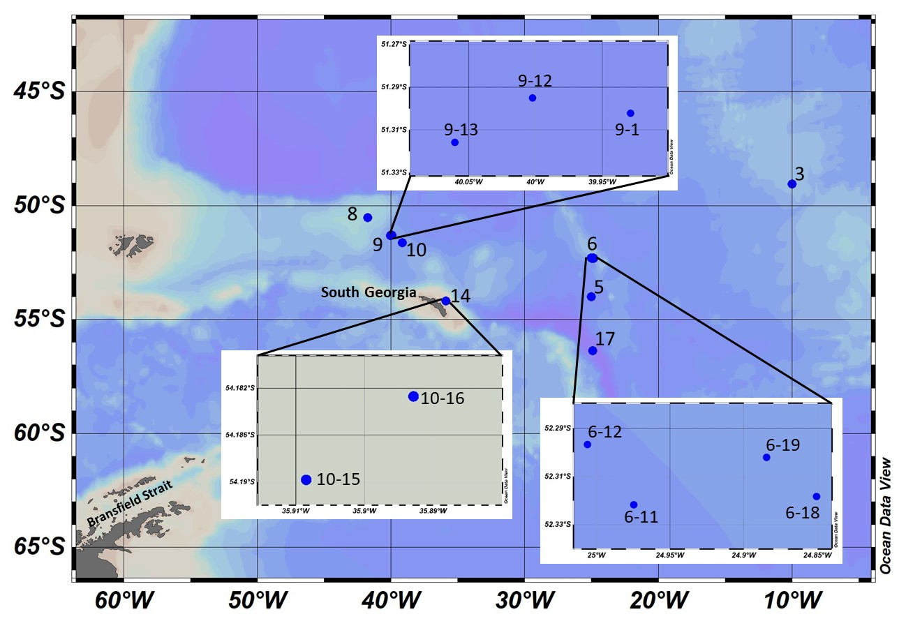

Figure 1: Sampling positions during the ANT133-1 voyage in October–November 2022 in the Atlantic sector of the Southern Ocean.

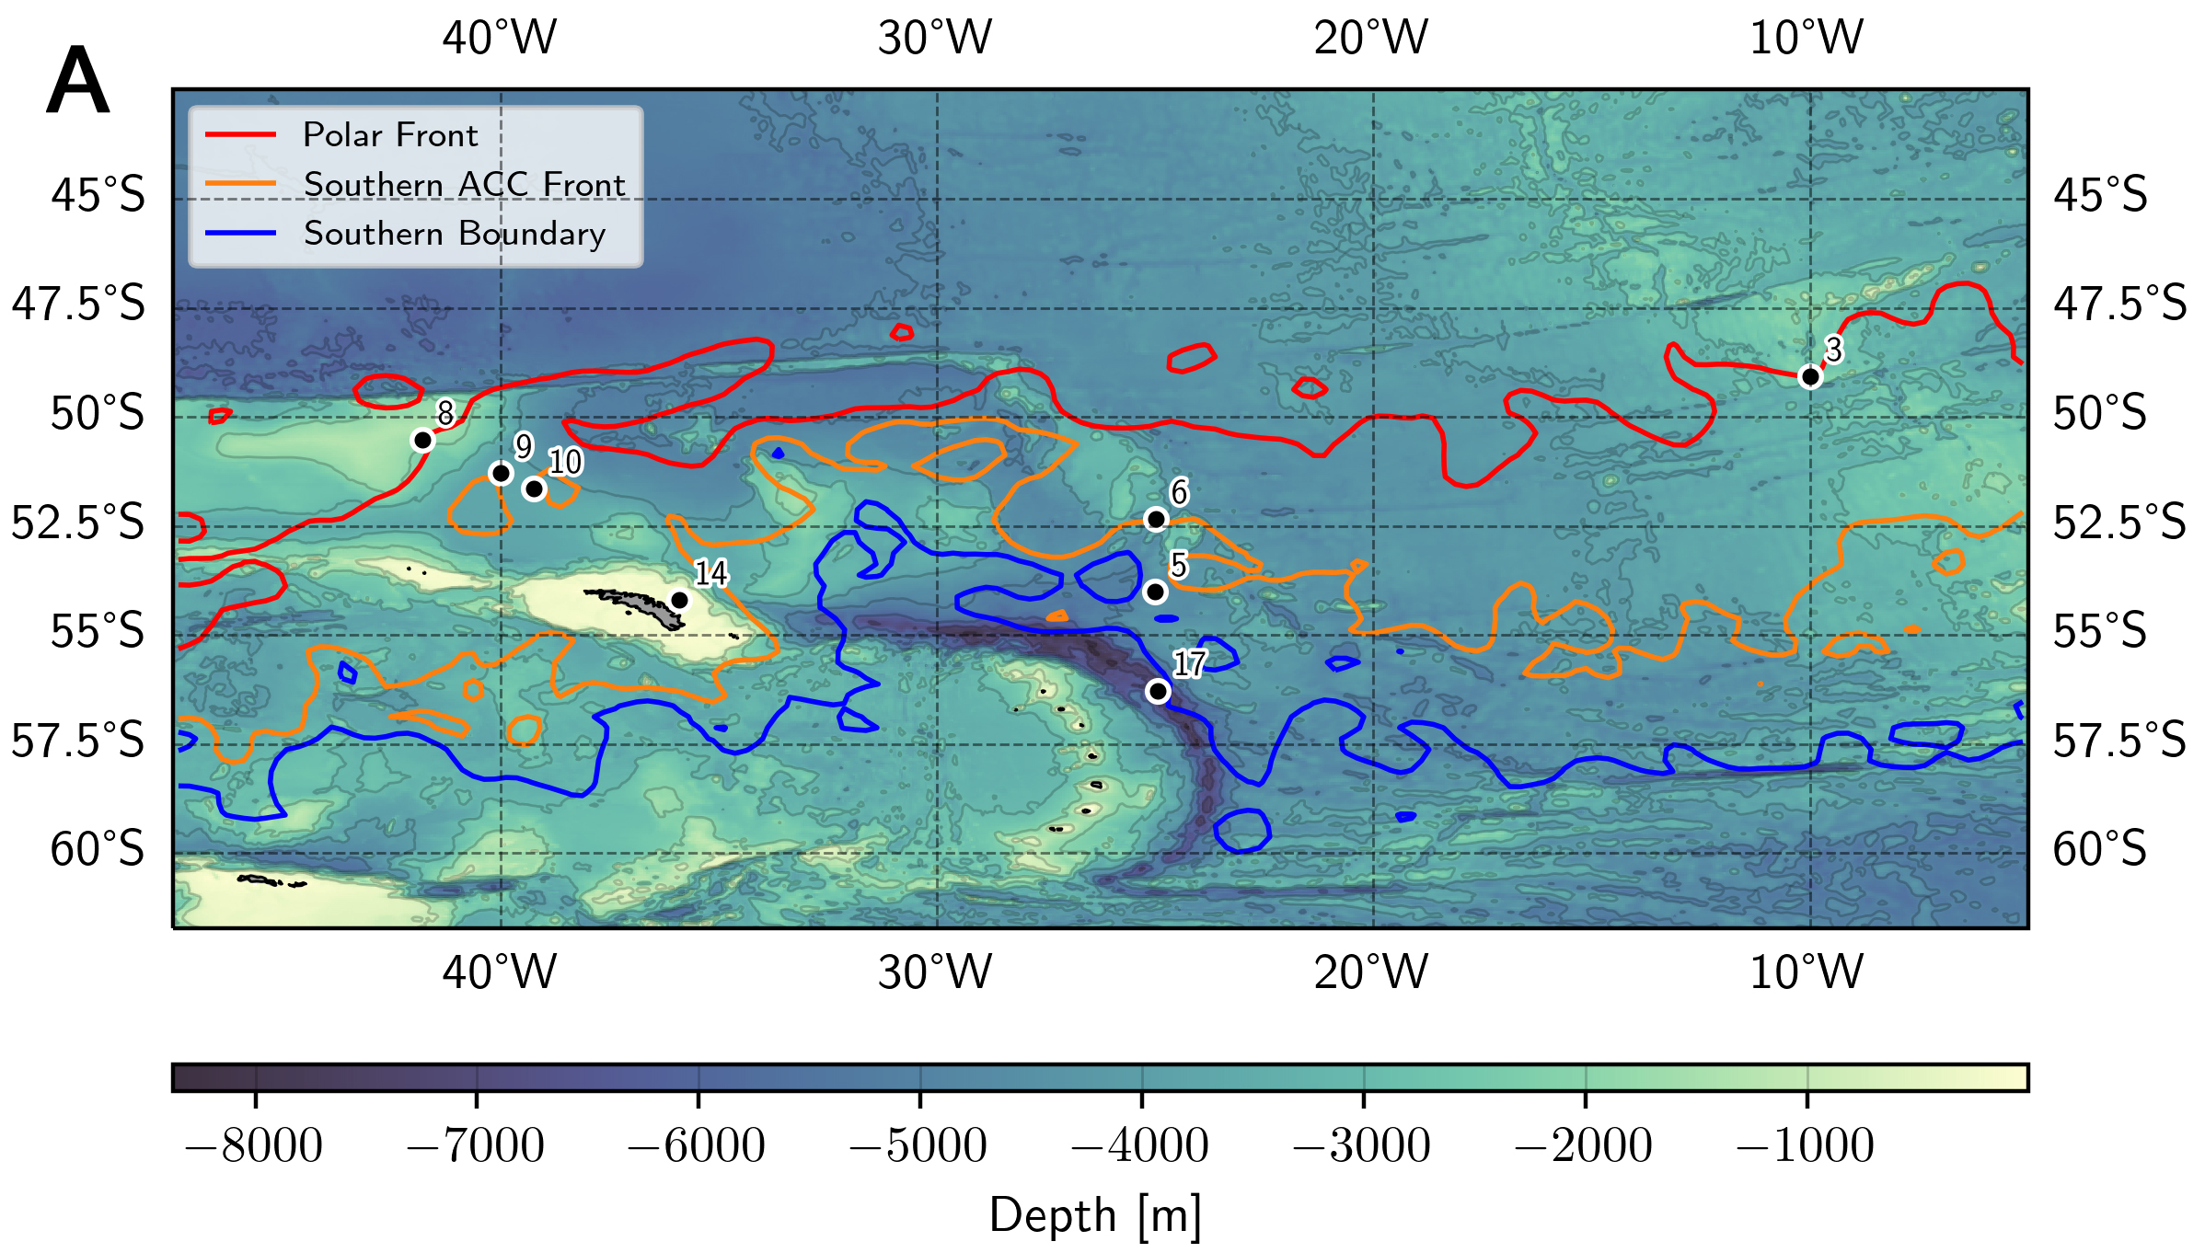
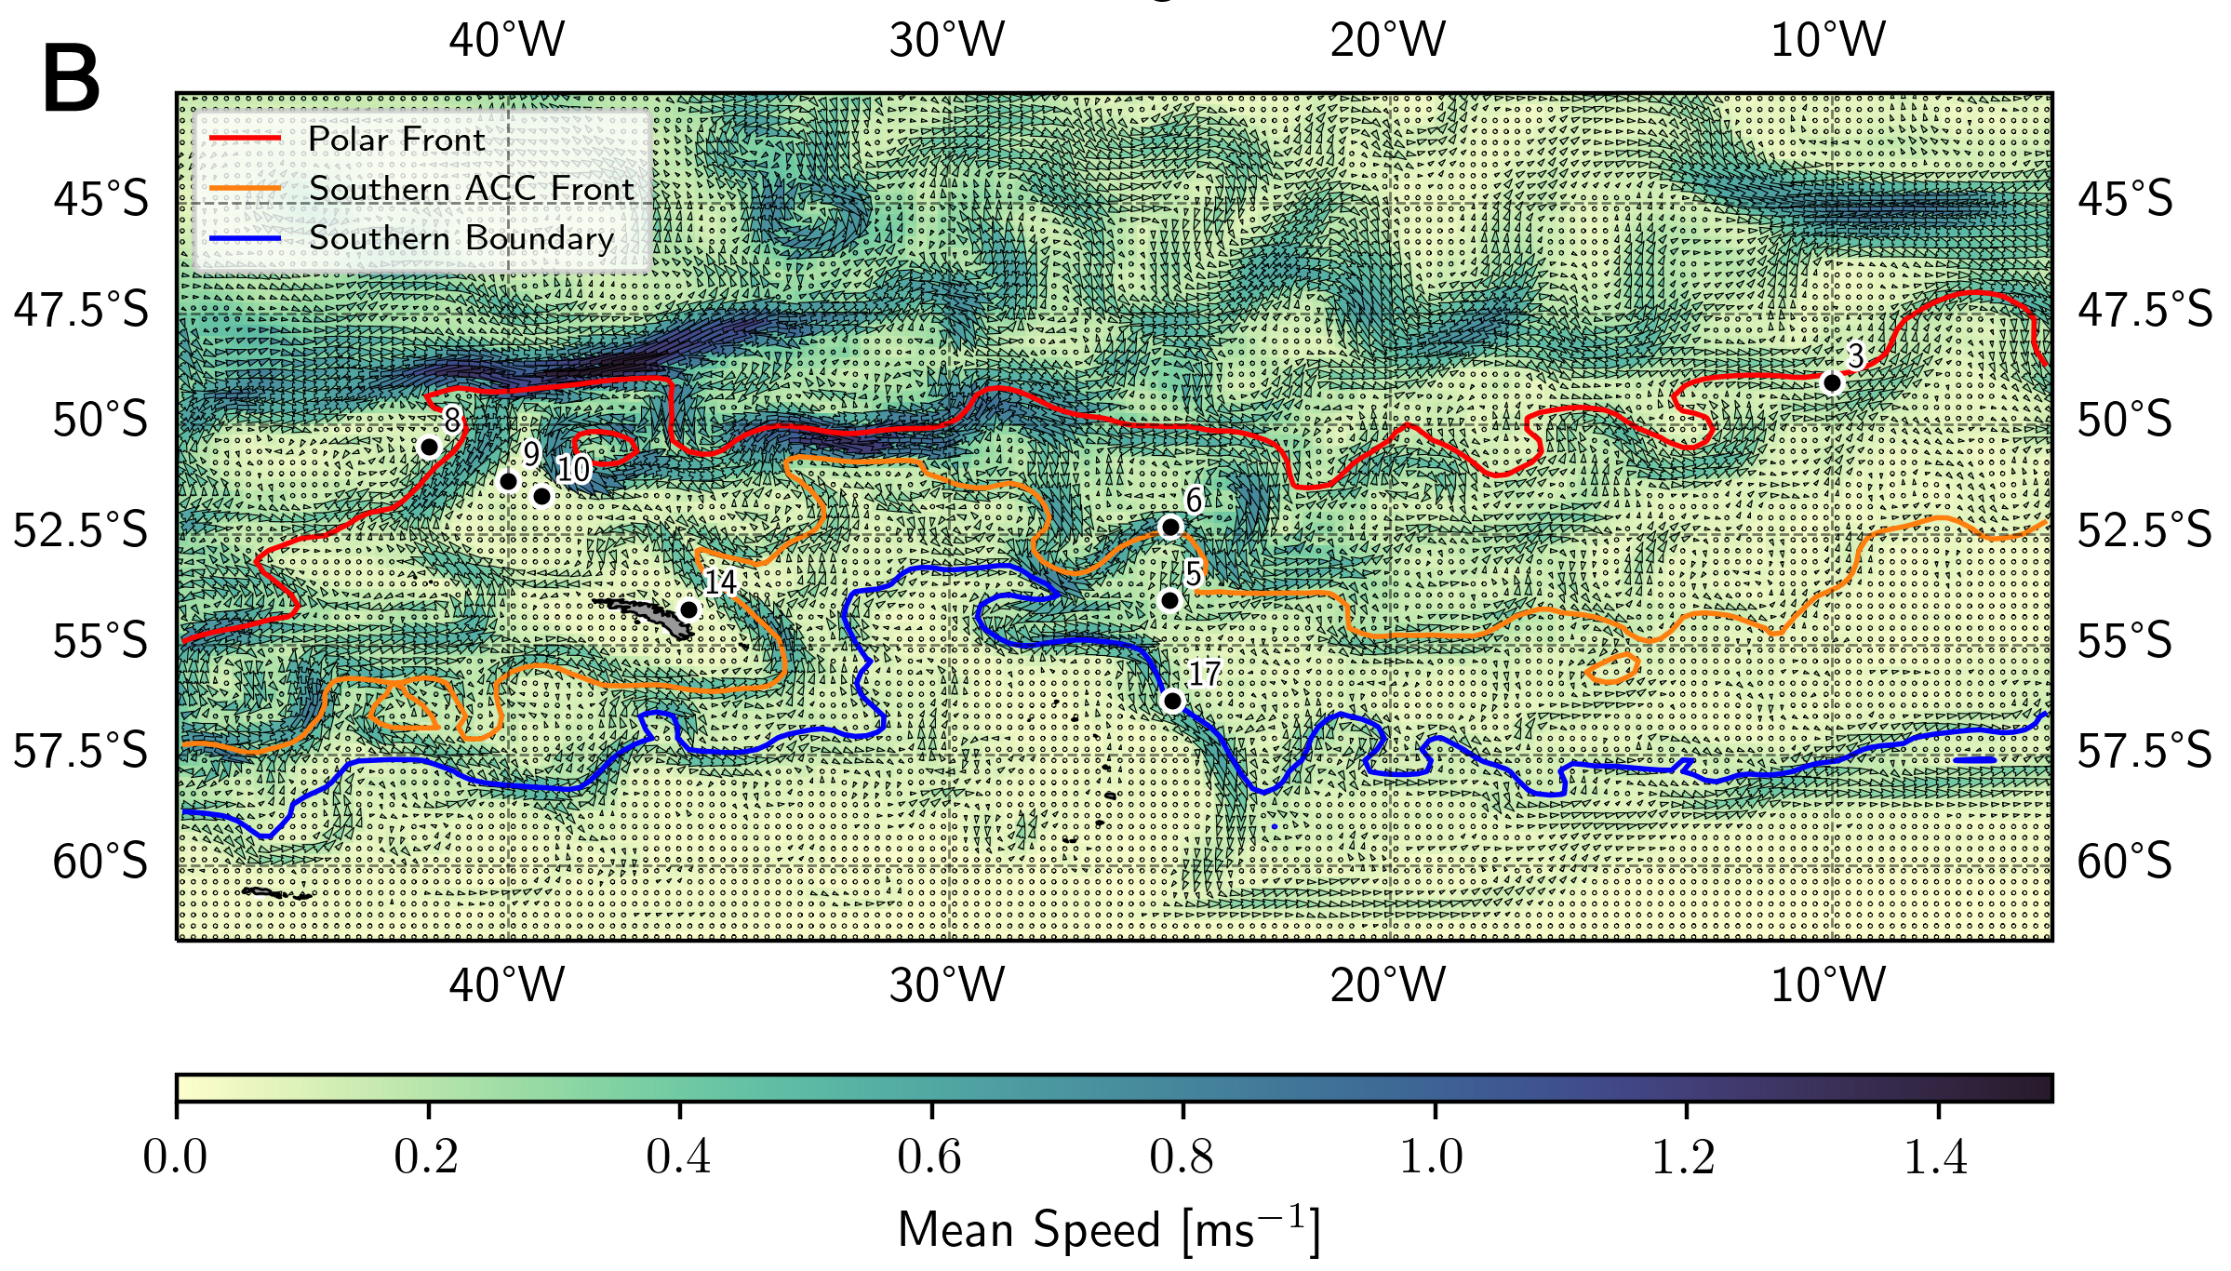
Figure 2: Frontal systems on 2 November 2022 (A) and generalised currents (B) during austral spring 2022 in the Atlantic sector of the Southern Ocean.

Appendix 1. Animation of the frontal system positions during austral spring 2022 in the Atlantic sector of the Southern Ocean.

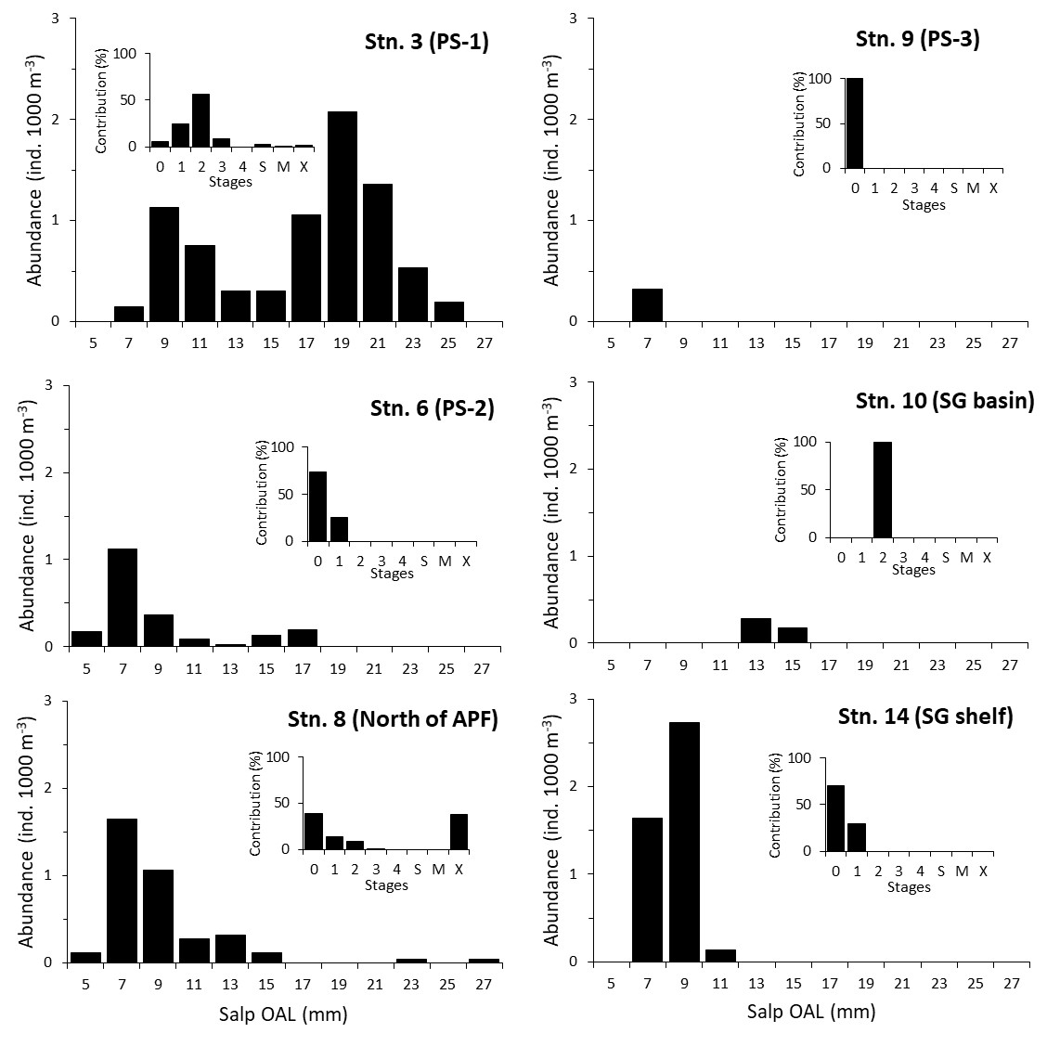

Figure 3: Length-frequency distribution and developmental stage composition (inserts) of Salpa thompsoni blastozooids during the austral spring 2022 in the Atlantic sector of the Southern Ocean. Length is measured as oral-atrial length (OAL).

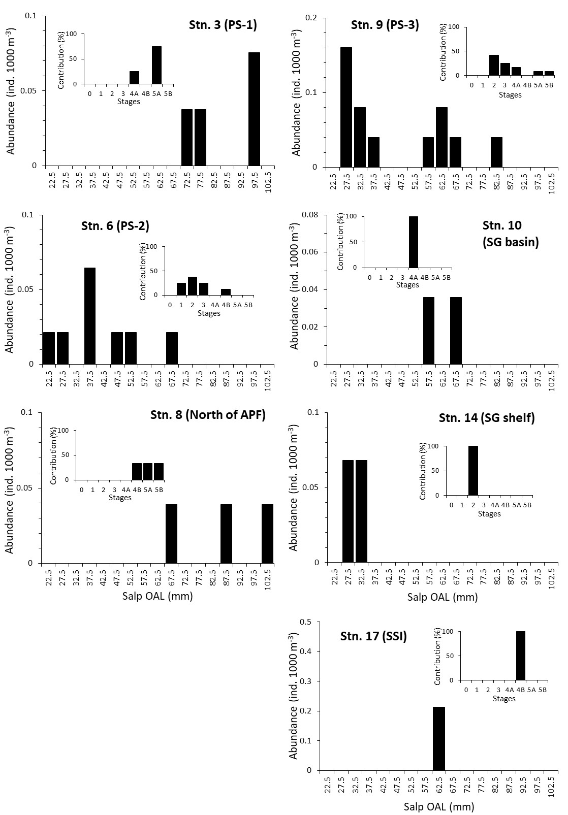
Figure 4: Length-frequency distribution and developmental stage composition (inserts) of Salpa thompsoni oozooids during the austral spring 2022 in the Atlantic sector of the Southern Ocean. Length is measured as oral-atrial length (OAL).

