Probing strongly coupled liquids with plasmonics

balle@LAPTOP-OD042CML

Table of Contents
1. Intro
2. Surface plasmon polaritons (SPP).
3. Long-range surface plasmon polaritons

Intro
You can find a very simple presentation in these lecture notes. These kind of effects have been known since the 1960s and have been studied both theoretically and experimentally.
Nowadays, have become even more relevant due to easier access to experimental techniques. An important advantage they have is due their sensitivity.

Surface plasmon polaritons (SPP).
This is the simplest case of a perfect interface between two different materials, e.g. air and metal, and solve Maxwell's equations:
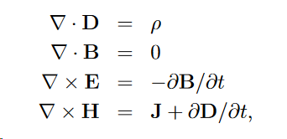
with
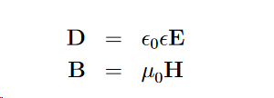
Here one is making implicitly the assumption that $\epsilon = \epsilon ( \omega)$, otherwise you would need to account or terms like
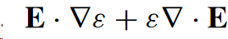
as discussed by Maier, after Eq. (2.1)
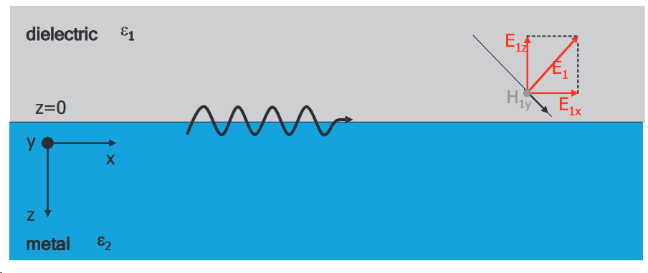
Here the crucial point is that, the dielectic function at a given frequency has to be negative, leading a mode solutio for the TM (transverse magnetic) polarization that has an evanescent profile along the axis perpedincular to the plane z, whereas it can still progpagte along the plane.
You start with following plane wave ansatz for each material:
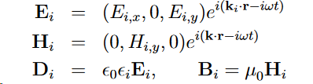
to solve Maxwell's eqs. and the following continuity relation at the air-metal interface
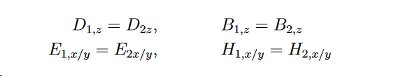
This will have the relation:
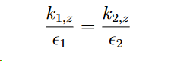
These are indeed imaginary both. The other one left (we took $k_y=0$ for siplicity) is the x-component $k_x$ which is, obviusly, the both materials.
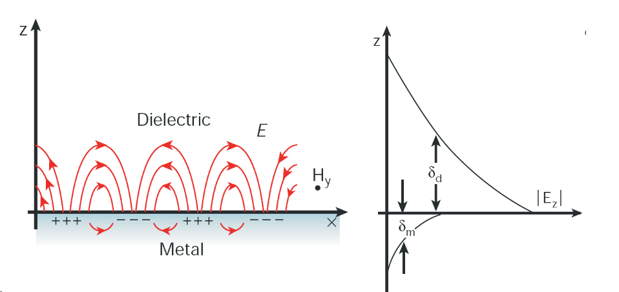
And so the dispersion relation of the mode is given by:
\begin{equation}
k_x^2 = \frac{\omega^2}{c^2 } \frac{\epsilon_1 \epsilon_2} {\epsilon_1+ \epsilon_2}
\end{equation}

An argument of why only TM are of interest is given in Maier:
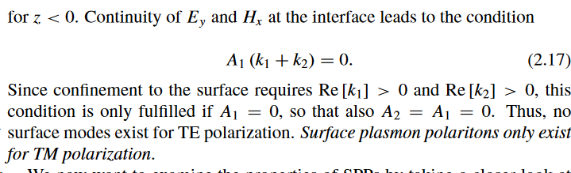
This is applicable for infinite surface case, at least. One might need to review this also when dealing with a nonlocal dielectric function.
This is almost always solved using a Drude-like plasmon to the get:
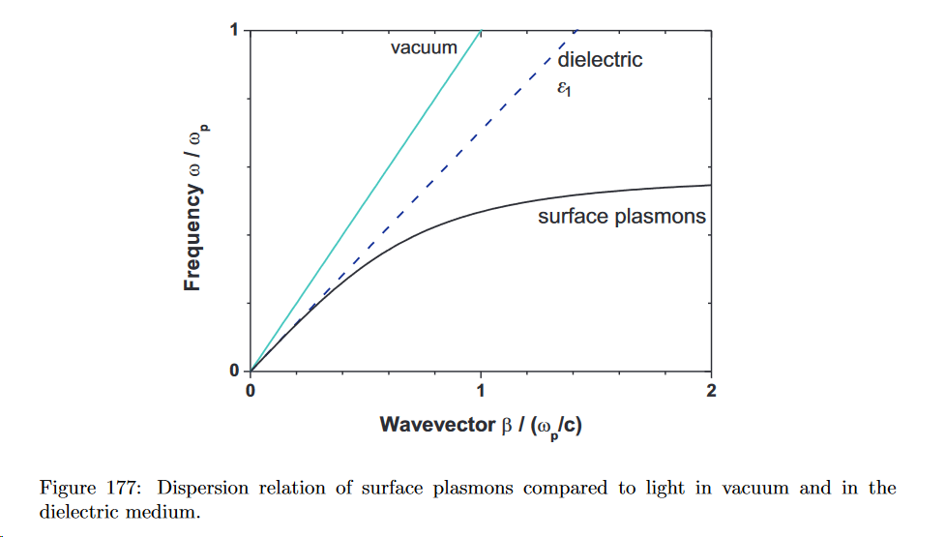
The dielectric line with respoect to air or vacuum is important because SPP don't couple to any modes outside. The only way to excite them is through a prism of deielectric material whose dielectric constant is bigger than the air's one, working under total internal reflection.

Long-range surface plasmon polaritons

