Participant 1#

1. Observing the willing participant playing a video game too close to the tv monitor for a long time which could lead into blindness if not careful. He is failing to understand why it is important to play not so near the monitor.

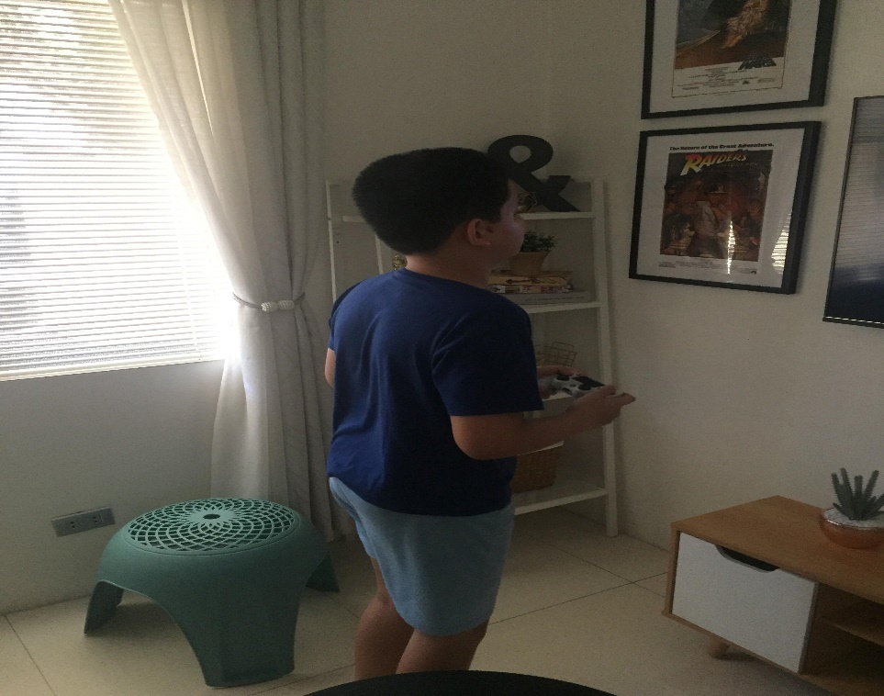

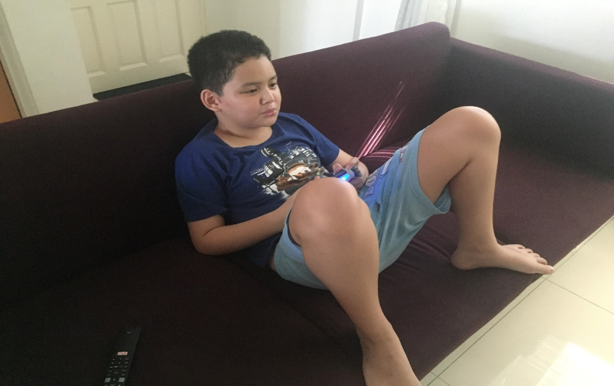

2. While observing him play, he only pays attention to the game and ignore the outside world. You will have to shut at him for him to react to you.

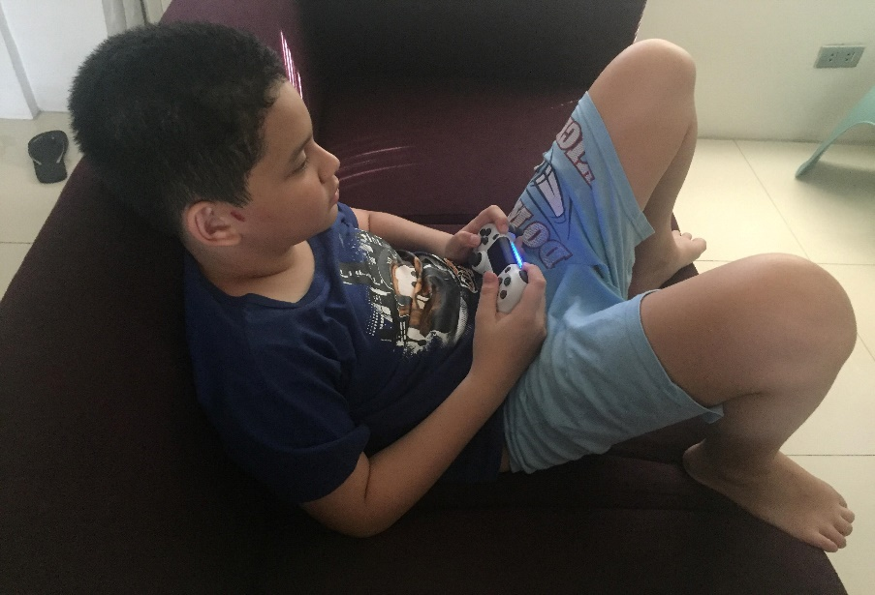3. The participant is easily angry when playing the game. He shouts when he does not get what he wants in the game. Because of this it creates a violent tendency for him to shout more and more even after being scolded.

Participant #2

1. Observing the second participant playing a casual game in her Smart Phone and she forgets that she was playing for far too long and doesn’t want to stop playing.

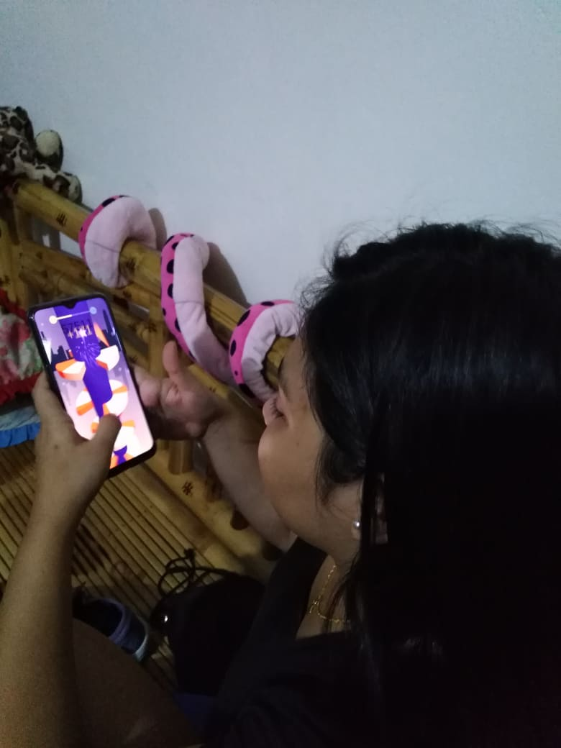

2.The participant doesn’t want to be distracted, she wants to stay focus on the game she is playing thus she doesn’t know what is going on in the surroundings.

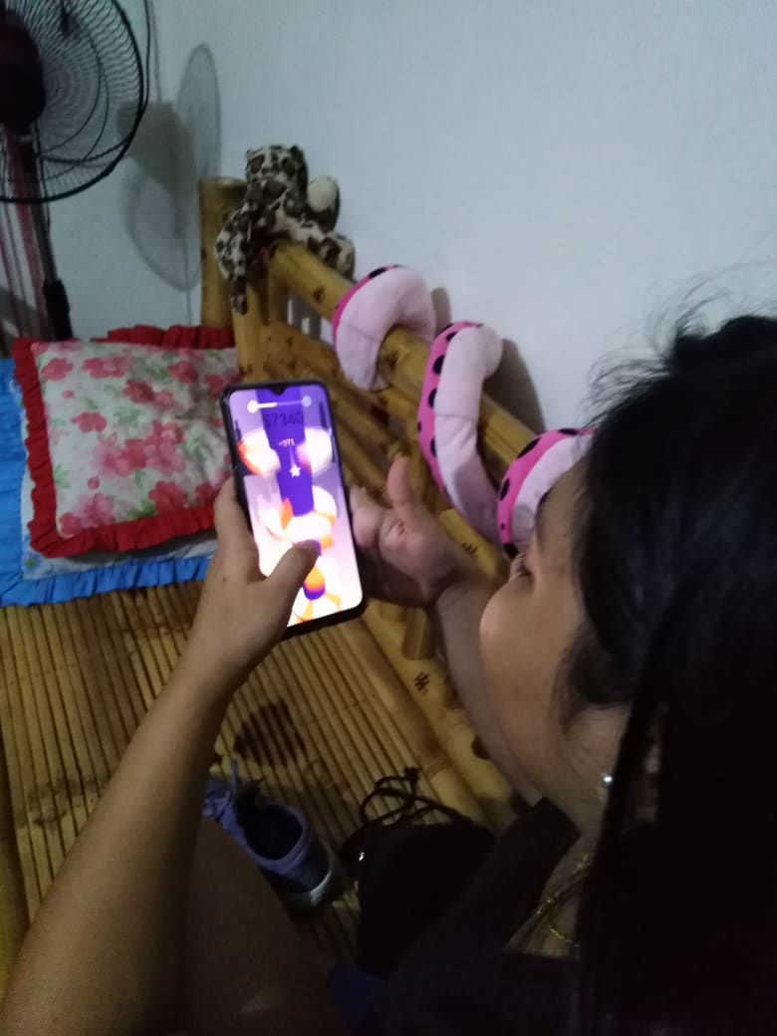

3. the participant gets irratated everytime she looses. If the desire goal in the game wont be met she’ll panic and get irrateted towards her device or herself

