1. Create a VPC. Assign a CIDR block to your VPC

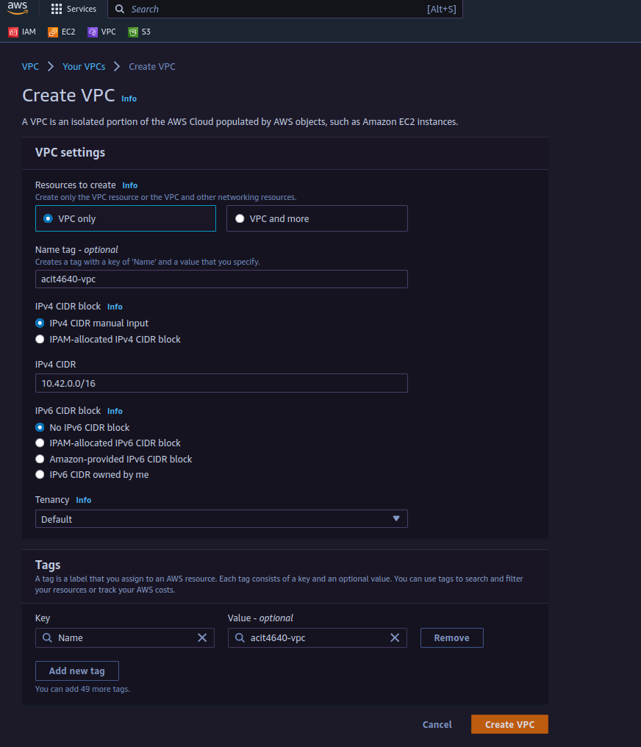

2. Create a subnet. Attach your subnet to the previously created VPC the assign another CIDR block to the subnet

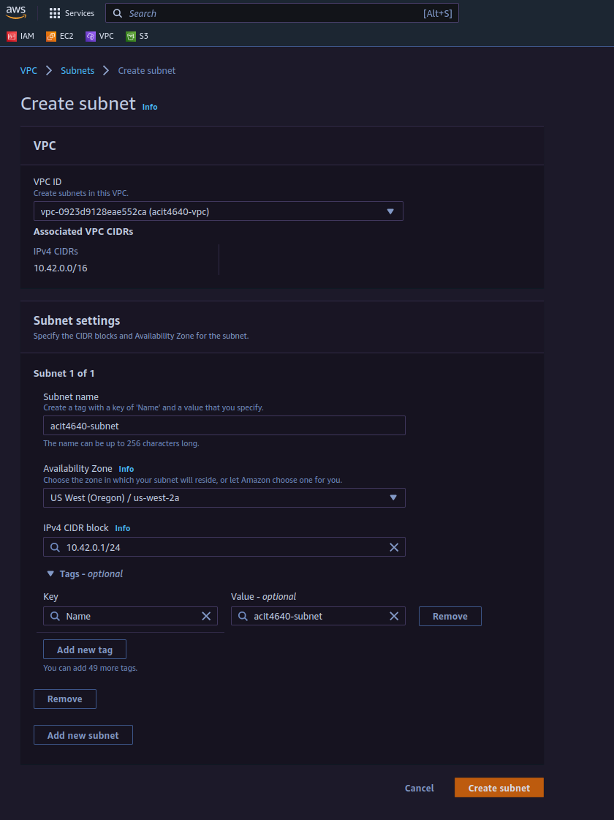

3. After creating the subnet we need to create an internet gateway.

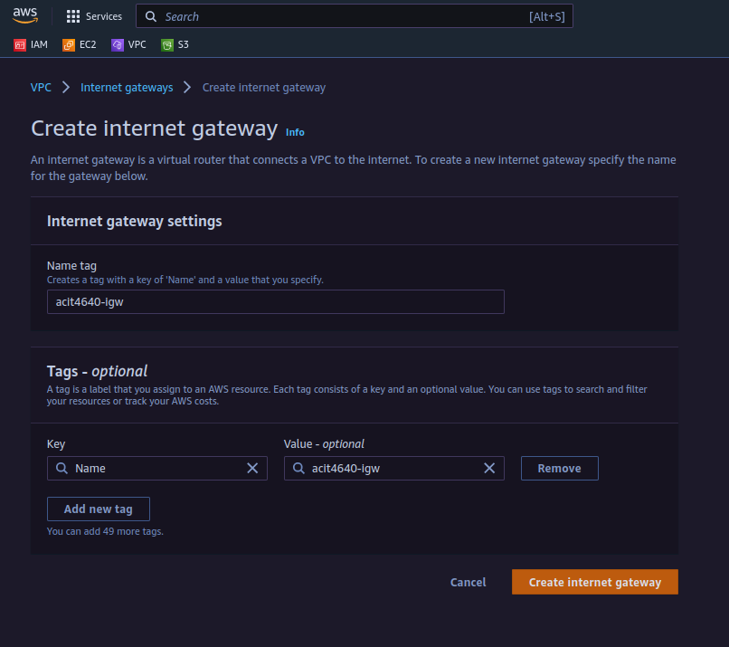

4. Make sure to attach the internet gateway after it has been created. The internet gateway has to be attached to the previously created VPC in step 1.

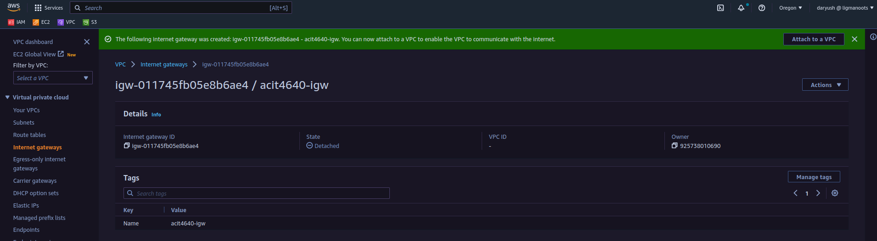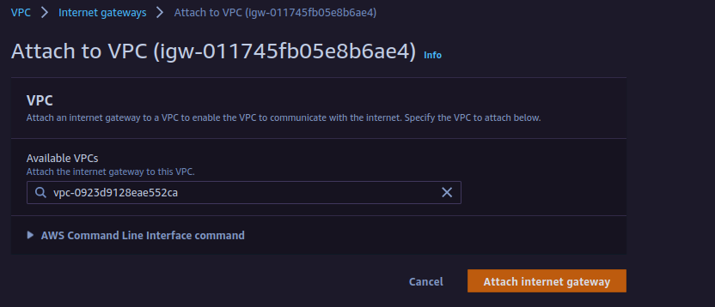

5. Next we need to create the routing table. You can leave the default route as it is we will be adding a new one. Attach the VPC to the routing table.

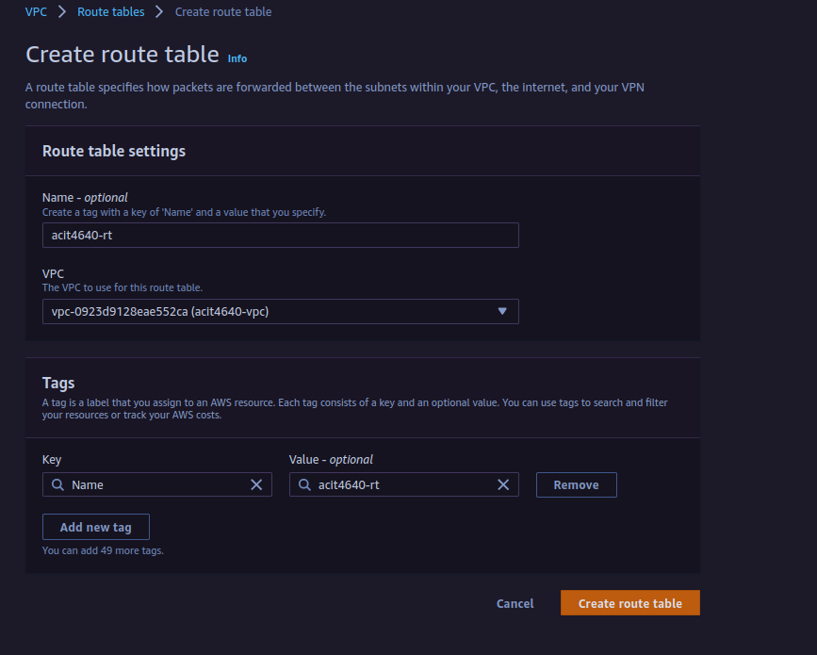

6. After creating the routing table click subnet associations and in the explicit subnet associations click edit subnet associations. The click the box where your route is shown and then save the association by clicking save associations.

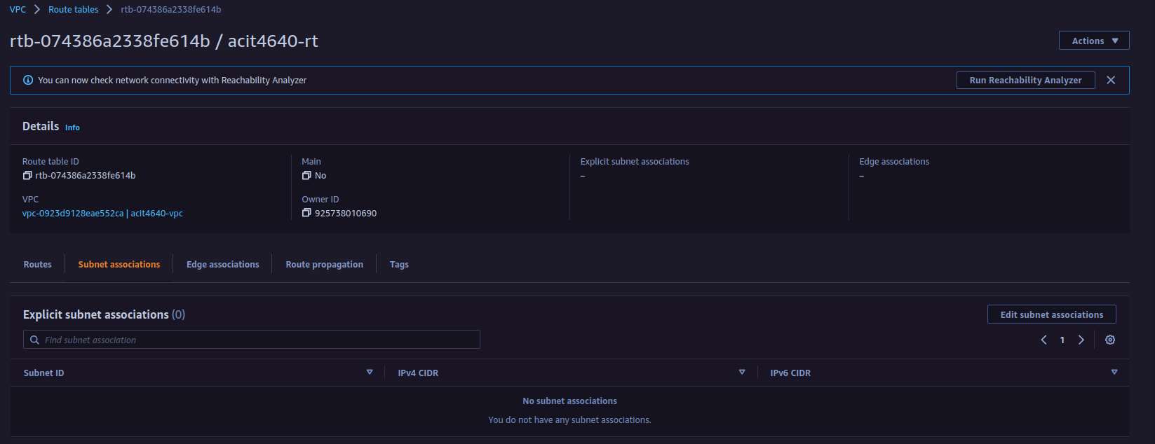

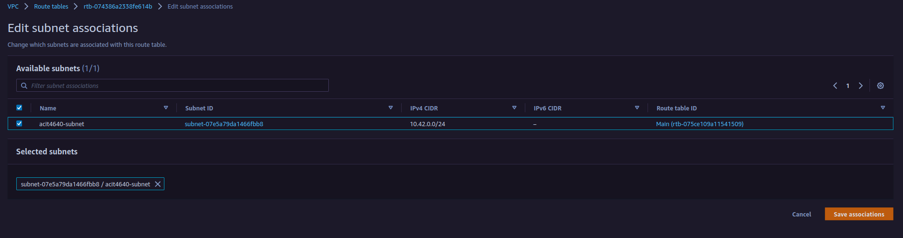

7. We then need to create a security group. Click create a security group. In the description write allow http and ssh. We then need to edit the inbound rules to allow http and ssh connections. Under source click the dropdown menu and click anywhere IPv4. The click create security group.

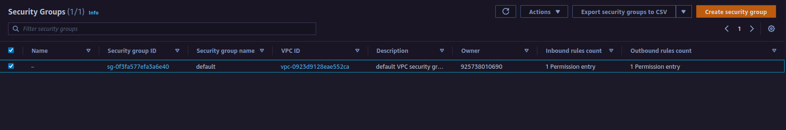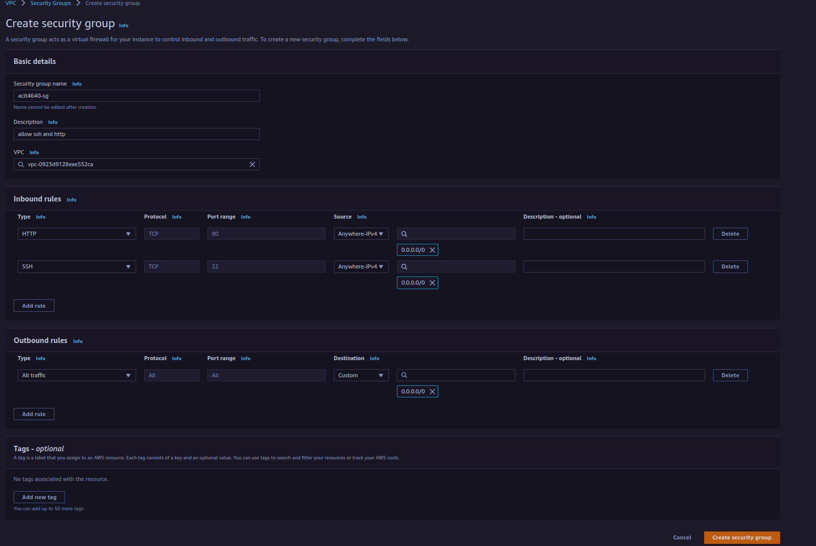

8. Now that we have finished setting up the networking we can set up our EC2 instance. Navigate to the EC2 instance and click launch instance. The OS we will be using is Ubuntu 22.04. Under application and OS images click Ubuntu. Double check that you are using the correct version of Ubuntu and running a t2.micro under instance type. Under the Key pair we need to click create a new key pair. A new window will pop up and ask you to give your key a name. Select ed25519 for key pair type and then use the .pem format then click create key pair. The under network settings we need to attach our security group that we created. Click select existing security group then under the drop-down menu add your security group. Everything else can stay as the default configuration. Finally, we can launch our instance. Click launch instance in the menu on the right.

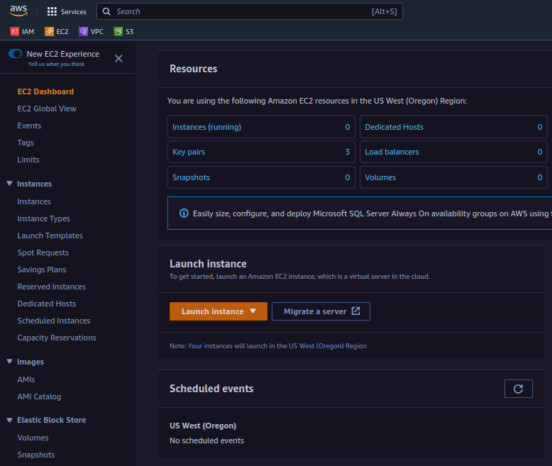

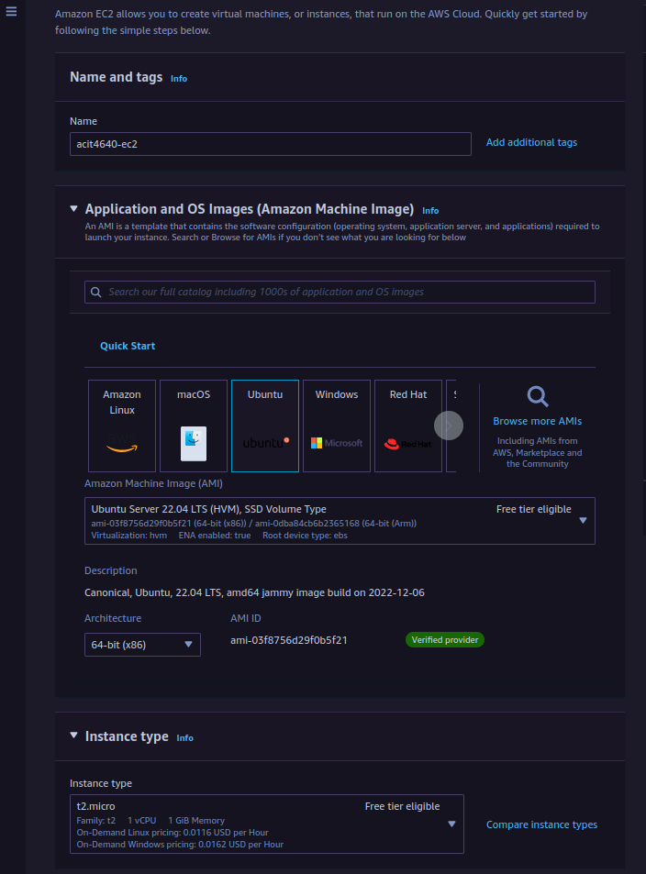

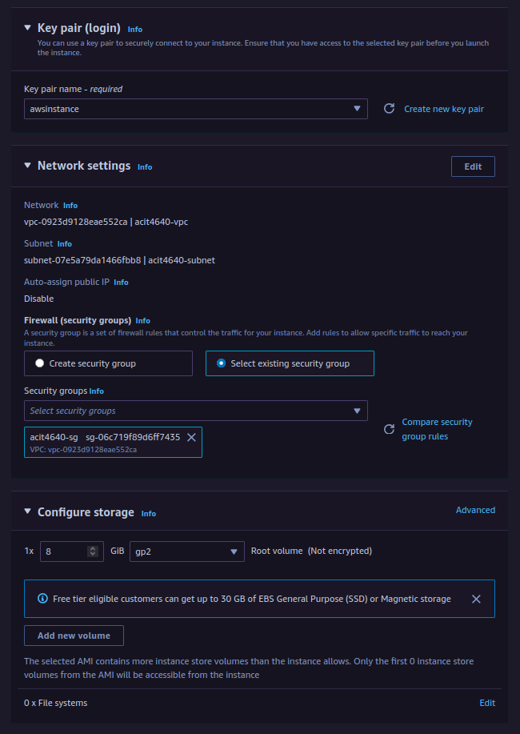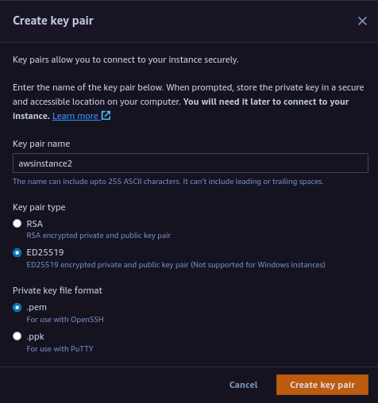

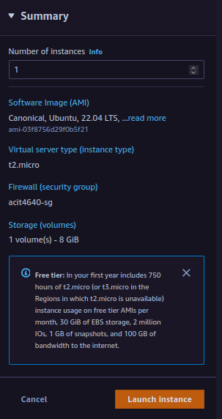

9. Now we need to ssh into our vm copy the ip and open up a terminal. Go into the directory where you saved your pem key file and type ssh -i <your private key> ubuntu@ip

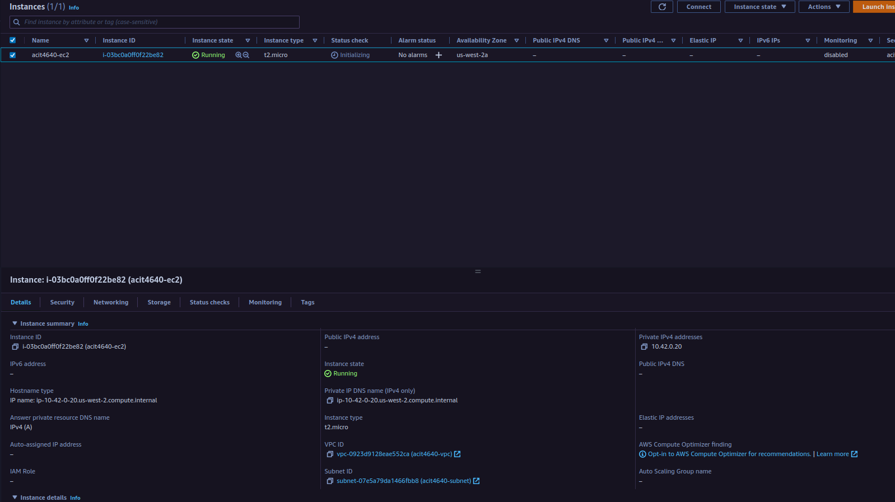

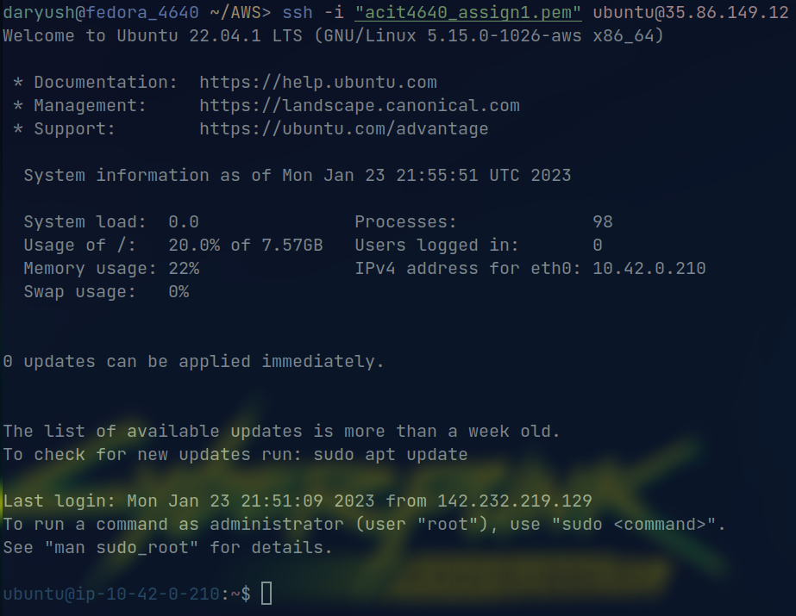

Part 2

Install the mysql-server and php8.1 packages in the EC2 instance.

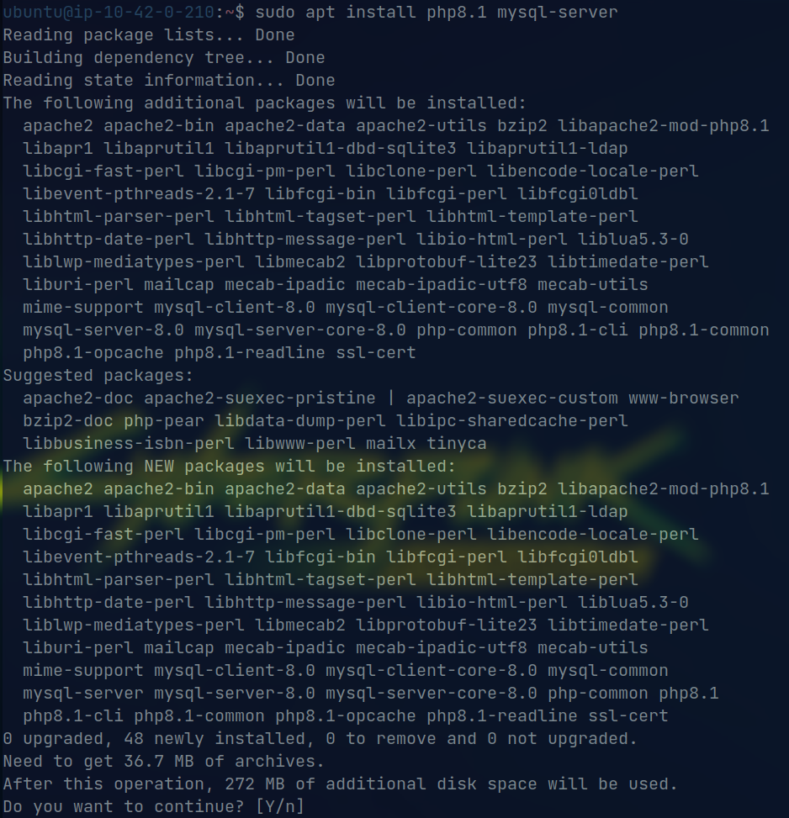

We now need to install composer you will be running 4 commands.

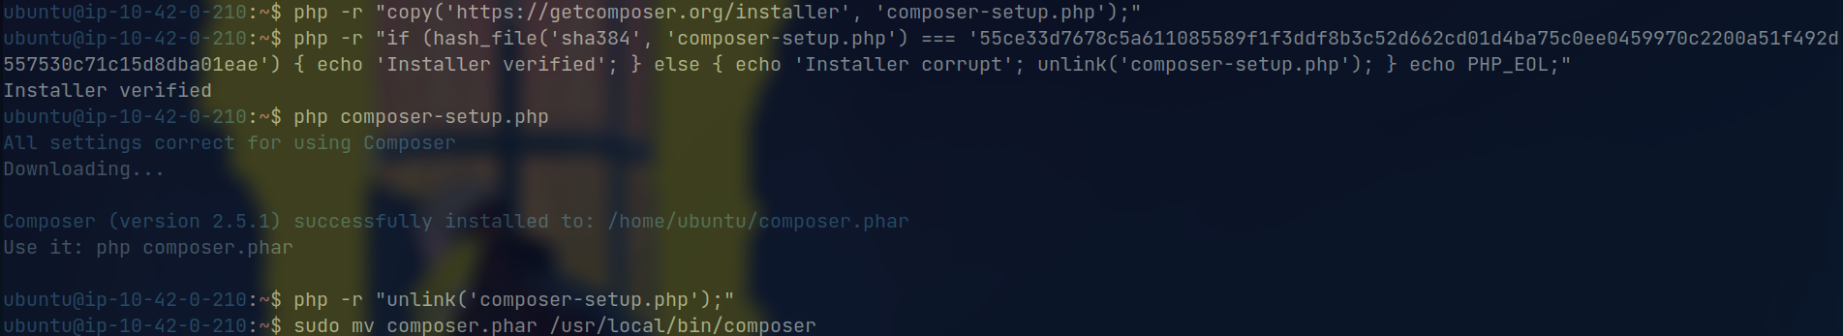

Now we can finally install bookstack. First we need to clone the Bookstack repo. git clone https://github.com/BookStackApp/BookStack.git --branch release –single-branch. Clone this repo in the /var/www/



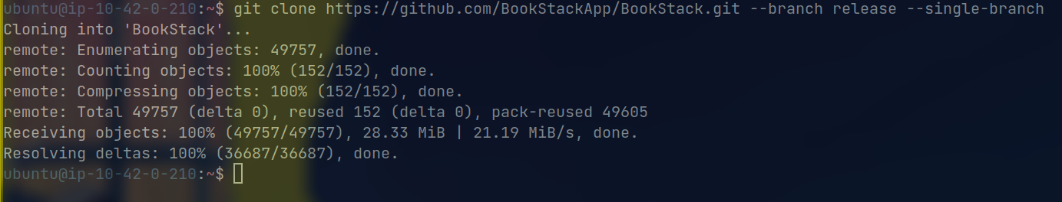

2. After cloning the repo cd into the application folder and run composer install –no-dev. copy the .env.example file to .env and fill with your own database and mail details.

